**MaterialProperty:PhaseChangeHysteresis**

Material property phase change hysteresis uses an equation based approach for modeling dynamic phase change materials “PCM's” with minimal inputs.

The inputs are designed to match the results of the ATSM test method Designation: C1784 – 14 Standard Test Method for Using a Heat Flow Meter Apparatus for Measuring Thermal Storage Properties of Phase Change Materials and Products. This test method makes a series of measurements to determine the thermal energy storage of a test specimen over a temperature range. First, both HFMA plates are held at the same constant temperature until steady state is achieved. Steady state is deﬁned by the reduction in the amount of energy entering the specimen from both plates to a very small and nearly constant value. Next, both plate temperatures are changed by identical amounts and held at the new temperature until steady state is again achieved. The energy absorbed or released by the specimen from the time of the temperature change until steady state is again achieved will be recorded. Using a series of temperature step changes, the cumulative enthalpy stored or released over a certain temperature range is determined. The speciﬁc heats of the solid and liquid phases are determined from the slope of the temperature-dependent enthalpy function during sensible heating/cooling, before and after the phase change process. This test method applies to PCMs and composites, products and systems incorporating PCMs, including those with PCM dispersed in or combined with a thermal insulation material, boards or membranes containing concentrated or dispersed PCM, etc. Speciﬁc examples include solid PCM composites and products, loose blended materials incorporating PCMs, and discretely contained PCM. This test method may be used to characterize material properties, which may or may not be representative of actual conditions of use.

The Material Property Phase Change Hysteresis object matches the C1784 test method by individually modeling both melting and freezing curves the dual curve PCM model provides hysteresis capabilities. Material Property Phase Change Hysteresis inputs are the peak melting temperature, melt high temperature difference melt low temperature difference, peak freezing temperature, freezing high temperature difference, freezing low temperature difference, latent heat of fusion, latent heat of solidification, liquid state specific heat, solid state specific heat and temperature coefficient for thermal conductivity. The dual curve method enables the algorithm to include the effects of hysteresis by a straight line shift between curves when temperatures change directions.

The model has surface nodal outputs for temperature and phase change state at the timestep and averaged for the reporting frequency, surface outputs for heat flux and PCM cooling and heating enthalpy, zone and building outputs for PCM cooling and heating enthalpy.

**Dual Enthalpy Curve Mathematical Model:**

The model uses polynomial fitting curves to describe the properties of PCM adapted from the Ginzburg-Landau theory of phase transitions. Dependent upon the composition, congruency and if the material is eutectic; PCM's can exhibit discontinuity at the melting temperature (Figure 1 Curve A) thus enthalpy is not a unique function of temperature, or can exhibit enthalpy as a continuous function of temperature (Figure 1 Curve B). This results in a ‘mushy’ phase change state between solid and liquid regions. To address this “mushy region” explicit equations adapted from the work of Egolf and Manz (1994) are used for the enthalpy as a function of temperature. This method is applicable to PCMs that show different widths of melting or freezing regions and different specific heats in the solid and liquid phases. Performance of the curve depends on the width of the melting and freezing regions. For a narrow melting or freezing range, the curve is steep (Figure 1 Curve A) and includes minimal characteristic rounding above and below the melting region.

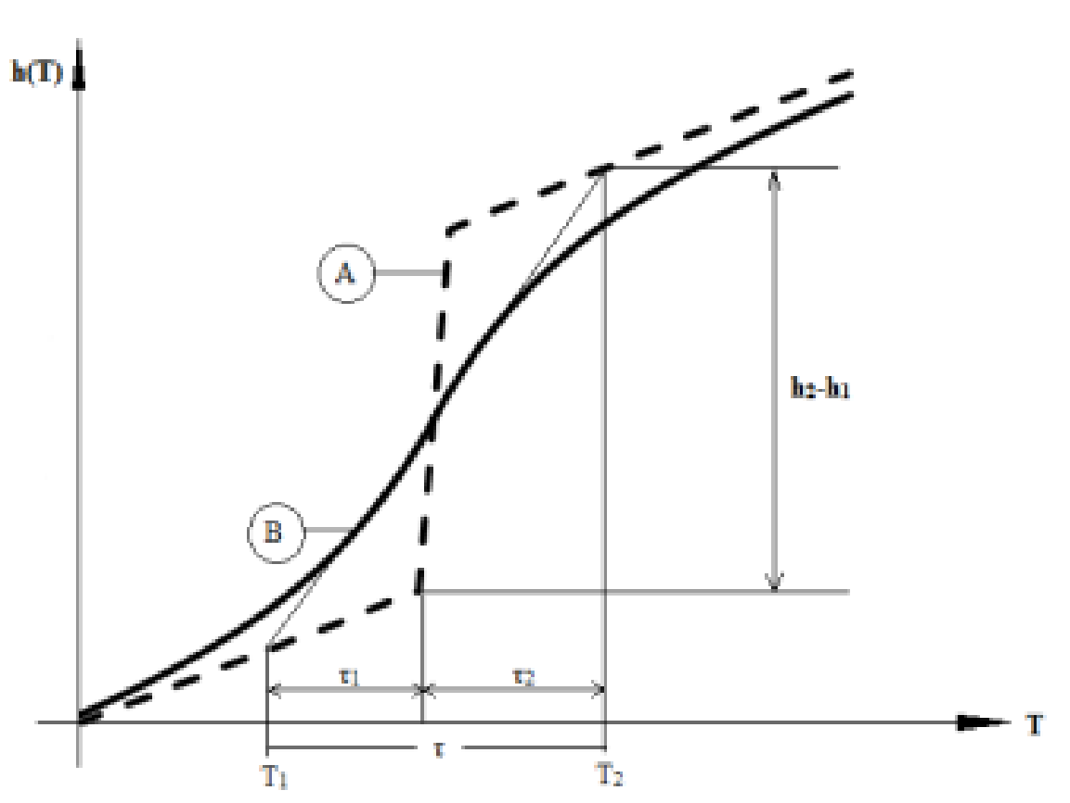**Figure 1** Discontinuous (A) and continuous (B) functions for enthalpy (Adapted from Egolf and Manz 1994)

$$h\left(T\right)=\left\{\begin{matrix}C_{p,1}T+η_{1} & T≤T_{m} \\ C_{p,1}T_{m}+\left(h_{2}-h_{1}\right)+C_{p,2}\left(T-T_{m}\right)-η_{2} & T>T_{m}\end{matrix}\right.$$

$$η_{n}=\left(\frac{h_{2}-h_{1}}{2}\right)e^{\left(\frac{-2\left|T-T_{m}\right|}{τ_{n}}\right)}$$

Where:

* $C_{p,1}$ specific heat in solid state (J/g-C)
* $C_{p,2}$ specific heat in liquid state (J/g-C)
* $T_{m}$ melting temperature (C)
* $h_{2}-h_{1}$ latent heat stored (J/g)
* $τ_{n}$ melting range (C)

**Figure 2: Equations used in the Hysteresis PCM model:** Above are the equations for enthalpy as a function of temperature used in the model for both the melting and freezing curves adapted from the work of Egolf and Manz (1994). Figure 3a shows the transition between melting and freezing is a straight line model (y = mx + c) between the two curves. Hysteresis modeling is accomplished as the current thermo-physical state of PCM is based upon the temperature of the material sampled at a previous time; if the temperature shows an increase the model assumes melting curve, whereas if it decreases, the model assumes freezing curve. The transition process is modeled as a straight line between the two curves. Reference: Bony and Citherlet 2007.

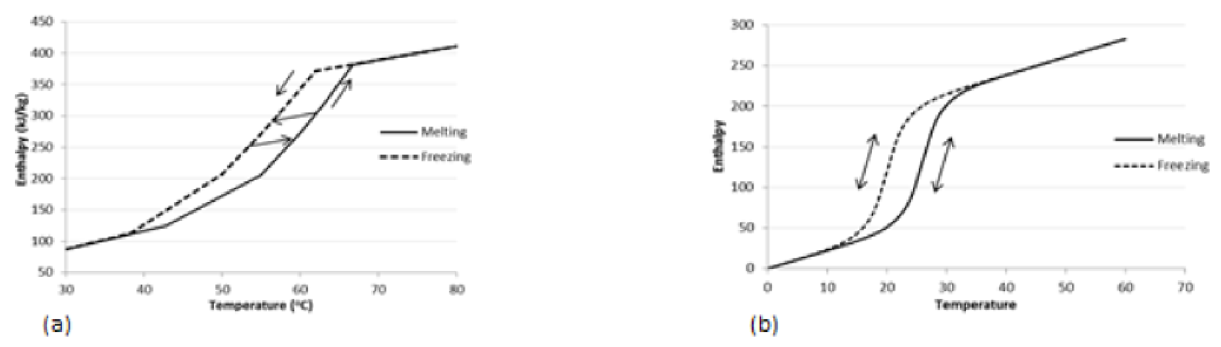

Figure 3 Hysteresis method

**Input correlations**

The following inputs use the corresponding formulas to calculate their values.

***Temperature Coefficient of Thermal Conductivity***

Units for this parameter are W/m-K2. The thermal conductivity is obtained from:



***Latent Heat of Fusion***

*(h2 - h1)*  (See Figure 4)

***Latent Heat of Solidification***

*(h2’ – h1’)* (See Figure 4)

***Peak Melting Temperature***

***(Tm)*** (See Figure 4)

***Peak Freezing Temperature***

***(Tf)*** (See Figure 4)

***Melting Curve Low Temperature Difference (τ1)***

 (See Figure 4) The total melting range *τ* of the material is the sum of *τ1* and *τ2*

***Melting Curve High Temperature Difference (******)***

 *(*See Figure 4)The total melting range *τ* of the material is the sum of *τ1* and *τ2*

***Freezing Curve Low Temperature Difference (***

 *(*See Figure 4)The total freezing range *τ’* of the material is the sum of *τ1’*and *τ2’*

***Freezing Curve High Temperature Difference (***

 (See Figure 4) The total freezing range *τ’* of the material is the sum of *τ1’*and *τ2’*

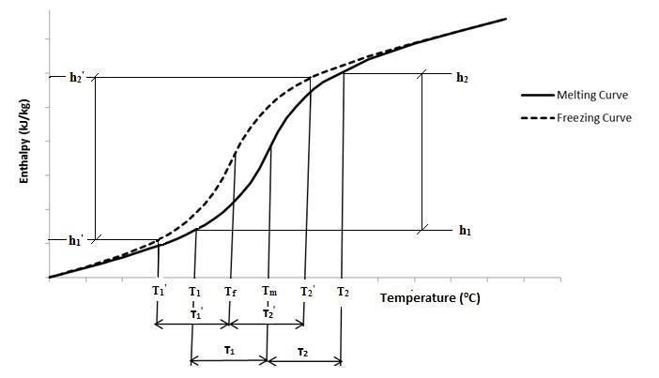

***Figure 4: Enthalpy vs. Temperature graph showing Energy Plus input parameters***