2017/07/12 Group Meeting

CF. Lee

Fred Dryer

Ed Law

Princeton, Conell, UCSD, NASA drop tower, Wriester, Michigan

1. Literature Review for microexplosion.
2. code reading (understand what happened) & running :compare to 0D and analyze the results
3. Check the superheat criterion, and further check aerosol synthesis

2017/07/14 & Weekend

# Superheat mechanism :

## 1.

“That is, after establishment of the concentration boundary layer at the droplet surface, the droplet temperature attains a high value because it is controlled by the more abundant, higher-boiling-point component at the surface. On the other hand the droplet interior has relatively higher concentration of the more volatile, lower-boiling-point component. Thus it is possible that the liquid elements in the droplet interior can be heated beyond the local boiling point and thereby possess substantial amount of superheat.

“According to thermodynamics there is a maximum limit on the amount of superheat a liquid can accumulate. Therefore if the droplet temperature is sufficiently high such that this limit is reached, then the liquid element will homogeneously nucleate and gasify, leading to intense internal pressure build-up and thereby the catastrophic fragmentation of the droplet. Experimentally, microexplosion has been frequently observed (Lasheras, Fernandez-Pello & Dryer 1980;Wang, Liu&Law 1984;Wang&Law, 1985). ……

“Theoretical assessment (Law 1978b) of the potential occurrence of microexplosion can be obtained by first calculating the temperature and species distributions within the droplet. Homogeneous nucleation will initiate at a location r where the temperature $T(r, t)$ exceeds the local concentration-weighted limit of superheat, $T_{L}[X_{l,i}(r,t)]$, which is a thermodynamic property of the mixture. Empirically it has been found (Blander & Katz 1975) that the limits of superheat of many liquids are about 90 percent of their respective critical temperatures.”

------- C.K. Law, *Combustion Physics*

## 2.

The microexplosion is due to the droplets being heated to the limit of superheat and then the droplet explode.

Eberhart and Schnyder, 1973: a modified equation of state, relating the limits of superheat as a function of pressure.

Law: $\left(1-{T_{Li}}/{T_{ci}}\right)=0.111{\left(1-p/{p_{ci}}\right)}^{0.858}$

Smaller $p/{p_{ci}}$: ${T_{Li}}/{T_{ci}}≅0.889+0.0952(p/{p_{ci}})$

----Law, 1978, AIChE Journal, *Internal boiling and superheating in vaporizing multicomponent*

# Microexplosion

## 1.

Although the existence of micro-explosion for a single fuel droplet has been well documented [7–15], the presence of such phenomena in either a combusting or non-combusting spray and how it facilitates atomization is still open to question.

[7] Botero ML, Huang Y, Zhu DL, Molina A, **Law CK**. Synergistic combustion of droplets of ethanol diesel and biodiesel mixtures. Fuel 2012;94:342–7.

[8] Mura E, Massoli P, Josset C, Loubar K, **Bellettre J**. Study of the micro-explosion temperature of water in oil emulsion droplets during the Leidenfrost effect. Exp Therm Fluids Sci 2012;43:63–70.

[9] **Gong JS, Fu WB**. A study on the effect of more volatile fuel on evaporation and ignition for emulsified oil. Fuel 2001;80:437–45.

[10] Tsue T, Kadota T, **Segawa D**. Statistical analysis on onset of microexplosion for an emulsion droplet. Proc Combust Inst 1996;24:1629–35.

[11] Tsue T, Yamasaki H, Kadota T, **Segawa D**, Kono M. Effect of gravity on onset of microexplosion for an oil-in-water emulsion droplet. Proc Combust Inst 1998;26:2587–93.

[12] Kadota T, Tanaka H, **Segawa D**, Nakaya S, Yamasaki H. Microexplosion of an emulsion droplet during Leidenfrost burning. Proc Combust Inst 2007;31:2125–31.

[13] Watanabe H, Harada T, Matsushita Y, Aoki H, **Miura T**. The characteristics of puffing of the carbonated emulsified fuel. Int J Heat Mass Transfer 2009;52:3676–84.

[14] Watanabe H, Suzuki Y, Harada T, Matsushita Y, Aoki H, **Miura T**. An experimental investigation of the breakup characteristics of secondary atomization of emulsified fuel droplet. Energy 2010;35:806–13.

[15] Morozumi Y, **Saito Y**. Effect of physical properties on microexplosion occurrence in water-in-oil emulsion droplets. Energy Fuels 2010;24:1854–9.

The presence of micro-explosion in atomized emulsion sprays were demonstrated in separate experiments by a number of investigators [16,18–25].

* For the non-combusting spray, Mattiello et al. [16] studied the water/fuel–oil emulsion flames by laser light scattering, the analysis of the scattered light intensities of the polarization ratio supported the occurrence of micro-explosion in the flame.
* Wu et al. [17] used laser holography shadowgraph to visualize the spray in a diesel/water/ethanol emulsion in which an apparent raised part could be seen in the main jet body which suggested the occurrence of micro-explosion.
* Watanabe and Okazaki [18] used extremely high speed imaging to visualize the secondary atomization in an emulsified-fuel spray flow by shadow imaging; they reported puffing and partial-micro-explosion, but complete micro-explosion was rarely observed.
* For the combusting spray, the direct flame photographs, temperature profiles and microexplosion frequencies have been shown by Fuchihata et al. [19–21]. They reported observation of small droplets with diameters less than 50 lm exploding in the spray flame.
* In the study of Raul et al. [22], some ‘‘glowing spots’’ were observed inside the burning spray and might have resulted from micro-explosion.
* In the single droplet tests [15], it has been illustrated that micro-explosion can occur over a broad range of temperatures and waiting times and its occurrence is statistically based.

[16] Mattiello M, Cosmai L, **Pistone L**. Experiment evidence for microexplosions in water/fuel oil emulsion flames inferred by laser light scattering. Symp Combust 1992;24:1573–8.

[17] Wu DY, Sheng HZ, Zhang HC, **Wei XL**. Study on micro-explosions procedure of diesel/water/methanol emulsions droplet. J Xi’an Jiaotong Univ 2007;41:772–5.

[18] Watanabe H, **Okazaki K**. Visualization of secondary atomization in emulsified fuel spray flow by shadow imaging. Proc Combust Inst 2013;34:1651–8.

[19] Mizutani Y, **Fuchihata M**, Matsuoka Y, Muraoka M. Observation of microexplosion in spray flames of light oil-water emulsions. Trans Jpn Soc Mech Eng B 2000;66:1544–9.

[20] **Fuchihata M**, Ida T, Mizutani Y. Observation of microexplosions in spray flames of light oil-water emulsions (2nd report, influence of temporal and spatial resolution in high speed videography). Trans Jpn Soc Mech Eng B 2003;69:1503–8.

[21] Takeda S, **Fuchihata M**, Ida T. Observation of microexplosions in spray flames of light oil-water emulsions (3rd report, influence of the diameter of dispersed water droplets on the spray flame structure). Trans Jpn Soc Mech Eng B 2008;74:1649–53.

[22] Raul O, Anna L, Magnus N, Sven A, **Ingemar D**. Optical studies of spray development and combustion of water-in-diesel emulsion and micro emulsion fuels. Fuel 2010;89:122–32.

[23] Park JW, Huh KY, **Park KH**. Experimental study on the combustion characteristics of emulsified diesel in a rapid compression and expansion machine. PI Mech Eng D – J Aut 2000;214:579–86.

[24] Lin YS, **Lin HP**. Study on the spray characteristics of methyl esters from waste cooking oil at elevated temperature. Renew Energy 2010;35:1900–7.

[25] Sheng HZ, Chen L, Zhang ZP, **Wu CK**. The droplet group microexplosion in water-in-oil emulsion sprays and their effects on diesel engine combustion. Symp Combust 1994;25:175–81

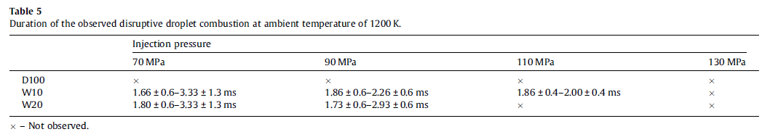

Where “not observed” does not mean that there is no micro-explosion.

The study shows longer initial liquid penetration for emulsified diesel under low ambient temperature. The most important finding is that micro-explosion can affect the primary breakup with higher ambient temperature.

----Chia-fon F. Lee, *Study on the spray and combustion characteristics of water–emulsified diesel*

## 2.

* Micro-explosion of freely falling droplets has been experimentally observed for both miscible fuel mixtures [3,4,5], as well as water/oil emulsions [6].
* Its occurrence has also been inferred from measurements of the droplet size distribution in combusting water/oil emulsion sprays [7].
* Wang and Law [4] conducted a series of micro-explosion experiments using alcohol-alkane mixtures under elevated pressures. It is reported that alcohol/diesel blends can potentially enhance atomization in diesel engine due to micro-explosion.
* Numerical models are proposed to describe the mechanism of micro-explosion for water in fuel emulsions [8,9,10].
* Most studies in micro-explosion focused on the effects of pressure, composition, temperature, initial droplet size, internal phase structure of emulsified droplets and gravity on micro-explosion [4,8,9,10].
* Some papers studied **the superheat limit**, which accounts for the onset of micro-explosion [10, 11].
* However, few works investigated the breakup process and the consequent outcomes before the year 2000. Based on a linear stability analysis, Zeng and Lee [2, 12] suggested a model describing the instability of micro-explosion and proposed **a breakup criterion** for the determination of the averaged size and velocity of secondary droplets.

**2.**Zeng, Y., Lee, C. F., *Proceedings of the Combustion Institute*. 31 (2007) 2185-2193.

**3.** Lasheras, J. C., Fernandez-Pello, A. C., Dryer, F. L., *Combust. Sci. Tech.* 22 (1980) 195-209.

**4.** Wang, C. H. and Law, C. K., Combustion and Flame 59 (1985) 53-62.

**5.** Lasheras, J. C., Fernandez-Pello, A. C., Dryer, F. L., *Eighteenth Symposium (International) on Combustion.* The Combustion Institute, Pittsburgh, 1981, 293-305.

**6.** Lasheras, J. C., Fernandez-Pello, A. C., Dryer, F. L., *Combust. Sci. Tech.* 21 (1979) 1-4.

**7.** Mizutani, Y., Taki, A., *ASME* paper 80-WA/HT-36 (1980).

**8.** Fu, W. B., Hou, L. Y., Wang, L. and Ma, F. H., Fuel Proceeding Tech. 79 (2002) 107-119.

**9.** Tsao, K. and Wang, C., “Puffing and Micro-Explosion Phenomena of Water Emulsion Fuels,” SAE Technical Paper 860304, 1986, doi: 10.4271/860304.

**10.** Law, C. K., Combustion Science and Tech. 17 (1977) 29-38.

**11.** Avedisian, C. T. and Glassman, I., ASME J. Heat Transfer 103 (1981) 272-280.

**12.** Zeng, Y., Ph.D. Thesis, University of Illinois, Mechanical Engineering (2000).

Based on the minimal surface energy (MSE) method, the article numerically calculated the normalized onset radius (NOR) of different kinds of fuel, and analyzed their dependency.

Can use NOR data, and possibly the fuel data source.

PDF not introduced. (*A generic probability distribution*)

-----Chia-Fon Lee, *Micro-Explosion Modeling of Biofuel-Diesel Blended Droplets*

## 3.

Gas-phase flame synthesis is broadly used in fabrication and other things.

-----Shuiqing Li, *Flame aerosol synthesis of nanostructured materials and functional devices: Processing, modeling, and diagnostics*

## 4.

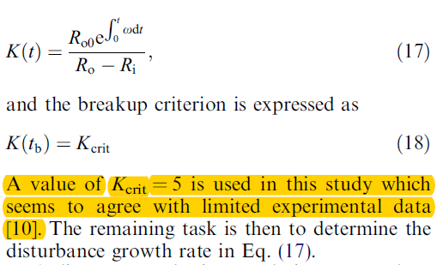

A linear instability analysis was carried out, including the analysis of composition and ambient pressure, and an example.

Superheat limit: Avedisian and Glassman [12]

NOR

[12] C.T. Avedisian, I. Glassman, ASME J. Heat Transfer 103 (1981) 273.

------Yangbing Zeng, Chia-fon F. Lee, *Modeling droplet breakup processes under micro-explosion conditions*

## 5.

Necessary condition for complete micro-explosion: A certain amount of dispersed water and well-progressed coalescence. Have puffing.

Mainly visualization.

------Hirotatsu Watanabe, Ken Okazaki, *Visualization of secondary atomization in emulsified-fuel spray flow by shadow imaging*

## 6.

Distribution function of total waiting time. Rate of micro-explosion to the inversed emulsion temperature.

Under Leidenfrost effect.

------Toshikazu Kadota, Hajime Tanaka, Daisuke Segawa, Shinji Nakaya, Hiroshi Yamasaki, *Microexplosion of an emulsion droplet during Leidenfrost burning*

## 8.

3 cases of oil/water mixture with different water content.

Phase separation --> Microexplosion

Microgravity.

------Daisuke Segawa, Hiroshi Yamasaki, Toshikazu Kadota , Hidemitsu Tanaka, Hiroshi Enomoto, Mitsuhiro Tsue, *Water-coalescence in an oil-in-water emulsion droplet burning under microgravity*

2017/07/17

Superheat limit is correct.

Aerosol synthesis is another application of multicomponent droplets.

As for statistical models, we hope to develop a determined model, while reserved for such things.

Phase separation: expect phenomenon from calculation. Some tricks to show the step function.

2017/07/18

XML reading of transport properties in the format of CHEMKIN

Molecular weight * 1,(M(j))

Thermal conductivity * 4,

Dynamic viscosity * 4,

Mass diffusion coefficients (fittingGamma) * 4 * (n-j-1), sum = 4 * (n-1) * n / 2,

Thermal diffusion coefficients:

M(j) <= 20 then (fittingTeta) * 4 * n.

**To change initial contition of droplet, change it through the Line 282 of Droplet.hpp and all things related to it.**

What’s the meaning of the **output**? (So as to draw it.)

Droplet::PrintSystem in Droplet.hpp is about printing the output, which will be called each completed time step.

Pavan: **XML** data shall be used as it was. So there is no need to pick each data out.

How do **DAE** solver work?

Pavan: Refer to the literature on DASSL solver, by Linda R. Petzold.

## 9.

Mainly about the four stages of the combustion of droplets comprised of heavy oil and oil mixture, the start-up, inner evaporation, thermal decomposition and polymerization.

Have pictures, and time-temperature figure.

Microgravity, NASA.

------M. Ikegami, G. Xu, K. Ikeda, S. Honma, H. Nagaishi, D.L. Dietrich, Y. Takeshit, *Distinctive combustion stages of single heavy oil droplet under microgravity*

Group Meeting:

Calculate a case of combustion.

Use the example of Chia-Fon Lee.

Calculate superheat temperature limit for all types of chemicals, and get a visualized feeling of the process, including the temperature and the components.

2017/07/21

## 10.

Problems we met:

1. Still can’t compile it. Need to learn how to compile and use in Linux system
2. Have a problem with NLS solver, saying that it has a segmentation fault. Some possible solutions:
   1. Read through the NLS solver, and debug for them, or find another solver for it.
   2. Try more times, with different settings, including using different solvers, different mechanisms, different temperature or different interface conditions. Submit some cases to calculate in a faster way.
3. Need to learn more on chemical process. In Law’s book.
4. More literature reading on microexplosion.

Possible steps:

1. Change conditions and try. Make sure it will work. If possible, post process and get figure.
2. Read literature and books.
3. Read the solver and their paper on it.

2017/07/25

A comprehensive review on water addition for both separate and emulsified systems has recently been reported (Dryer, 1976).

When **diffusional burning** around individual droplets is also possible, the chemical activities at the flame are expected to be diminished due to the reduced chemical heat release at the flame for unit mass of liquid vaporized.

An interesting phenomenon termed "microexplosion" (Ivanov and Nefedov, 1965) has also been postulated to occur during the combustion of a high-boiling-point fuel emulsified with water.

**Process**: Water micro-droplets are heated beyond its boiling point and may even approach its limit of superheat. --> homogeneously nucleates --> boils disruptively --> disintegration of parent droplet --> a secondary atomization process.

Very little systematic research has been conducted on emulsified fuel combustion. Ivanov and Nefedov (1965), and recently Dryer (1975), Dryer et al. (1976), and Jacques et al. (1976) did observe explosive combustion of oil/water emulsion droplets suspended on thin fibers, although these explosions are now believed (Dryer el al., 1976) to be artificial in that they are caused by heterogeneous nucleation at the suspension fiber rather than homogeneous nucleation within the liquid phase.

High-boiling-point fuels, such as diesel and residual oil.

The **model** of Jacques et al. (1976): the only effect of water in this model is in causing a delay in the cracking process.

In the model the dependence of **the combustion characteristics** such as the flame size and temperature, **the droplet** temperature and **its surface** regression rate, and **the concentrations** of the various species, will be studied as functions of **the ambient parameters** such as the pressure, and **the emulsion parameters** such as the fuel type and the water content.

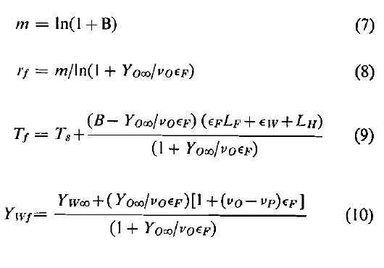

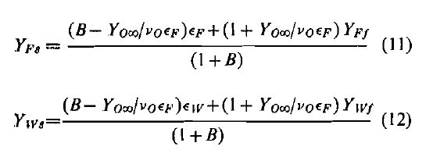

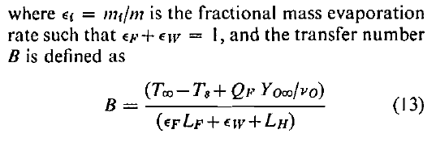

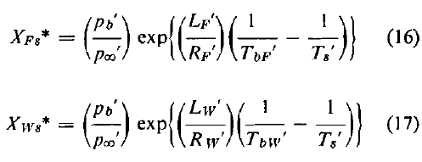

Get analytic solution!

Assuming: homogeneous, no temperature jump, quasi-steady, stoichiometrical reaction.

(Why is the chemical heat release from the fuel vaporization everywhere?)

& the Clausius-Clapeyron relation

If the pressure is high enough, and water fraction is large enough, then the droplet is able to micro-explode, which is simply a model prediction.

Bubble nucleation in liquids can be discussed in terms of either the kinetic limit of superheat or the thermodynamic limit of superheat (Blander and Katz, 1975). The kinetic limit is the temperature, for a given pressure, at which spontaneous boiling within the liquid interior can be initiated. The thermodynamic limit is the transition point separating the liquid from the metastable and unstable states.

**Criterion** for micro-explosion:

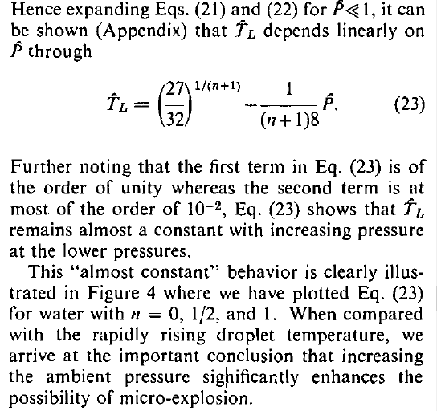

Assumption:

1. does not account for the droplet heating process and hence can only indicate whether, but not when, micro-explosion occurs.

with the highest value occurring at the droplet surface where micro-explosion will initiate.

1. The model assumes the fuel is pure, which subsequently leads to the assumption that the droplet composition is constant
2. Only consider nucleation within the water micro-droplets.
3. Only consider the influence of the fractional amount of water.
4. Only consider water micro-droplets with size not too small.

--------C.K. Law, *A Model for the Combustion of Oil/Water Emulsion Droplets*

2017/07/26

## 11.

the nucleation of vapor bubbles in the liquid phase --> the micro-explosion phenomena of emulsion confined in a glass capillary

Discussed are the phenomenological burning processes, the burning rate constant, the ignition process, the flame phenomena including soot concentration profile in the droplet flame and the spheroidal evaporation on a hot surface. Also mentioned are the in-droplet transfer processes including the phase separation, the micro-explosion phenomena, the conditions for the microexplosion to occur and the empirical equation for the rate of micro-explosion based on the probability model.

Classification:

Depending on the nature and quantity of surfactant, either micro- or macro-emulsion can be produced

oil-in-water (O/W) and water-in oil (W/O) types.

The micro-explosion phenomena is caused by the volatility difference between the water and the base fuel.

--------T. Kadota, H. Yamasaki, *Recent advances in the combustion of water fuel emulsion*

## A small talk with Pavan:

It would be much better to develop some small conclusions based on the models by others.

It shouldn’t take long to have an overview of others’ models, no longer than an afternoon.

The problem we are focusing on is not only the problem of water-emulsified droplets, but all those with at least two phase.

It might be a good idea to try relate NOR with surface tension, how surface tension act during the onset of microexplosion.

I am able to get some properties of gas and else from Peter or someone else.

Problems and ideas:

Till now, mostly people are focused on water-emulsified droplets, since they are more possible to micro-explode. Also, people are more focused on experiments.

Microexplosion in multicomponent fuel need more literature review.

2017/07/27

## 3.

Phenomenon:

Bubble generation and bubble growth.

Breakup time and outcome

Bubble nucleation --> bubble growth --> perturbation --> meet the breakup criterion (the growth of perturbation is large enough.)

Equations:

Volume, concentration, and heat.

A linear perturbation analysis in the PhD thesis, and a breakup criterion.

--------Yangbing Zeng, Chia-fon F. Lee, *Modeling droplet breakup processes under micro-explosion conditions*

## 7.

Free falling droplet. A lot of data on shrinkage of diameter, evolution of flame standoff ratio, on same and very different boiling point mixtures, volume shrinkage, picture on droplet stability, bubble expansion,

Experimental results on two-component fuels substantiate a **three-staged combustion** behavior, with diffusion being the dominant liquid-phase transport mechanism: that is, there exists **an initial period** during which the volatile component in the surface layer is preferentially gasified while the droplet temperature is relatively cold; **a short, transition, period** during which the droplet temperature increases rapidly, the burning rate is extremely low, the flame size shrinks, and the flame temperature diminishes; and **a final, quasi-steady period** during which the droplet interior concentration distribution remains constant, the surface region is more concentrated with the less volatile component, and the droplet temperature is relatively high.// Experimental results on microexplosion show that its occurrence depends sensitively on the mixture concentration as well as the stability of the droplet generation mode, and that frequently nucleation appears to initiate in the vicinity of the droplet center.

-----C. H. WANG, X. Q. LIU, and C. K. LAW, 1984, *Combustion and Microexpiosion of Freely Falling Multicomponent Droplets*

## 12.

The occurrence of micro-explosion and flash boiling has been known for more than two decades, and extensive experimental studies have been performed to investigate the underlying fundamental processes.

Micro-explosions were first observed for water-in-oil droplets [63]. The initial motivation for adding water to the fuel was to improve the anti-knock performance of engines [13]. It was found that this technique also reduces the NOx, smog, and soot formation [13]. For droplets composed of fuel blends, micro-explosion was also observed [64]. Wang et al. [64] found that the occurrence of micro-explosion for multicomponent droplets depends on the droplet generation mode and the nature of the components. They concluded that micro-explosion can occur in droplets composed of alcohol and alkane, with alcohol being the more volatile component. Micro-explosions can be used to promote the atomization of heavy fuels by adding certain amounts of light fuels [65]. Most studies on micro-explosion focused on the vaporization and combustion behavior of isolated droplets undergoing micro-explosion [63-72], and the effects of ambient pressure, ambient temperature, internal circulation, and amount of volatile components on the occurrence of micro-explosion were also carefully studied. Generally, high ambient pressure promotes the occurrence of micro-explosions and also advances the instant of micro-explosion [65, 6 6 ]. This is because that at higher pressures, the droplets can reach higher temperatures while the superheat limit does not change much. Ambient temperature is a crucial factor for a micro-explosion, and a micro-explosion can only occur for a certain range of ambient temperatures. If the ambient temperature is too high, the droplet vaporizes so fast that it completely vaporizes before a micro-explosion can occur. If the temperature is too low, the droplet never has a chance of generating superheat regions [13]. Internal circulation within the droplet suppresses the occurrence of micro-explosion because it tends to minimize the gradients of temperature and species mass fractions inside the droplet due to better mixing [65]. The amount of volatile components determines the energy available for micro-explosion, and microexplosion does not occur if the amount of volatile components is too large since the droplet will vaporize too quickly and the maximum surface temperature is decreased in this case [13]. The dependence of the micro-explosion intensity on composition is parabola-like with the optimum being around equal concentration for binary droplets [64, 72]. For a multicomponent droplet, the highest temperature occurs at the droplet surface, and the highest mass fraction of the lightest components occurs at the center of droplet in general. Therefore, the micro-explosion should occur somewhere between the center and the surface [64]. Wang et al. [64] observed two modes for micro-explosion, namely the one-bubble mode and the two-bubble mode. The one-bubble mode is much more common than the two-bubble model, and spherical symmetry was observed for the one-bubble mode [64], Shen [13] found that micro-explosions in a spray environment occur in groups, and reasoned that this is because whenever one droplet explodes in a turbulent eddy, it initiates the explosion of all other droplets in this eddy.

--------Yangbing Zeng, thesis, 2000, *Modeling of Multicomponent Fuel Vaporization in Internal Combustion Engines*

2017/07/28

## 13.

Mathematical model:

Only using mass and energy conservation. Energy only include the sensible enthalpy.

--------Hirotatsu Watanabe, Yoshiyuki Suzuki, Takuji Harada, Hideyuki Aoki, Takatoshi Miura, *Development of a mathematical model for predicting water vapor mass generated in micro-explosion*

## 14.

Jackson and Avedisian (1998) studied experimentally the combustion of water-heptane emulsion droplets in a convection-free environment. Spherically symmetric droplet combustion was closely achieved, which makes their data the best available to test models for emulsion droplet combustion. Their experimental results showed droplet microexplosions only near the end of the droplet lifetimes, which were attributed to the presence of low-volatile surfactants. They applied their theoretical model to predict quasi-steady burning rates with good agreement to the experimental data. However, their data certainly show the presence of two-stage combustion of emulsion droplets, which needs further explanation using a transient droplet combustion model.

--------L.F.T. LEITE & P.L.C. LAGE, 2000, *Modeling of Emulsion Droplet Vaporization and*

*Combustion Including Microexplosion Analysis*

## 15.

A period exists near the end of burning during which the droplet diameter is nearly constant, followed by a disruptive burning event.

and a preferential vaporization process was revealed from the image analysis by an abrupt change in the vaporization rate. A period exists near the end of burning during which the droplet diameter is nearly constant, followed by a disruptive burning event.

Combustion conditions, with soot shell.

Spherically symmetric droplet experiment achieved, stages observed, attributed to surfactant

Use drop tower.

--------Jackson and Avedisian (1998), *Combustion of unsupported water-in-n-heptane emulsion droplets in a convection-free environment*

## 16.

Kinetic limit, spinodal limit instead of simply superheat limit.

Sphere layers model. Interesting.

--------D. Tarlet, J. Bellettre, M. Tazerout, C. Rahmouni, *Prediction of micro-explosion delay of emulsified fuel droplets*

## 17.

The microexplosion occurrence was modeled considering the homogeneous bubble nucleation rate.

Stochastic model.

--------M Mikami, N Kojima, *An experimental and modeling study on stochastic aspects of microexplosion of binary-fuel droplets*

2017/08/07

Now we should start thinking about the growth of a bubble.

We need to examine the deduction of the perturbation equation.

We need to examine all the parameters of the equation.

We need to examine the deduction of the modified Rayleigh equation.

We need to examine the relative magnitude among all items.

Then we need to get all the thermodynamic properties and solve the equation.

## 12.

Bubble growth can be well predicted by the Rayleigh equation or the modified version of the Rayleigh equation coupled with the energy equation for the boundary layer around the bubble [97-100]. The involved forces include the pressure force (pressure differential across the bubble surface), the surface tension force, and the viscous force. Bubble growth is initially determined by the competition between the pressure force and the surface tension force, and noticeable bubble growth occurs after a delay time. The delay time is dependent on the superheat degree, and Lienhard and Day [75] proposed a formula to compute this delay time. With bubble growth, a boundary layer develops around the bubble, which significantly reduces the bubble temperature and in turns reduces the pressure differential across the bubble surface. When the bubble grows to a relatively large size, the surface tension force becomes unimportant. Several analytical solutions have been developed for bubble growth with the assumption of negligible surface tension [101, 102]. However, these analytical solutions seems unsuitable for modeling

--------Yangbing Zeng, thesis, 2000, *Modeling of Multicomponent Fuel Vaporization in Internal Combustion Engines*

## 18.

K = coefficient of surface dilational viscosity ~ MT-1

--------L. E. SCRIVEN, Dynamics of a fluid interface Equation of motion for Newtonian surface fluids

2017/08/08

Carefully look at the question again.

Chia-fon Lee :

It is easy to develop a linear perturbation equation which can be analytically solved.

It is also easy to develop from Rayleigh equation to get how the radius of the bubble change.

Now, how can we give the boundary conditions?

Diffusivity: Assume that the process is so fast that diffusivity can be ignored.

Evaporation: Do not know how strong the evaporation would be on both surfaces. The surface radius of the outside one is decided by the radius inside. The evaporation of the outside is assumed not to affect the radius too much. The evaporation of the inside is might be slow due to the low temperature.

2017/08/14

How does disturbance model work?

The pressure inside the droplet is calculated by isothermal process. Changed into adiabatic process.