H.264编码完后对比特流进行ccm编码，

1计算ccm编码需要的符号数。

首先要知道不同snr下的QP值。

2计算当ccm用的符号数和turbo相同的时候的psnr

和softcast及数字的性能都比一下

RCM的谱效率——>信道进行RCM编码的符号数——>H.264在不同QP下量化后的比特数——>确定量化步长

简单的说：根据谱效率，确定QP，得到psnr。

换一个小一点的视频跑。

（用的符号数（带宽）和softcast一样，数字视频需要预留20%的符号重传，720p）

|  |  |  |  |  |
| --- | --- | --- | --- | --- |
| Snr（db） | h.264+Turbo（QP） | h.264+RCM（QP） | h.264+Turbo（PSNR） | h.264+RCM（PSNR） |
| 5 | 29 | 32 | 36.4584 | 34.1538 |
| 10 | 23 | 23 | 46.0928 | 46.0928 |
| 15 | 18 | 16 | 50.5324 | 52.2465 |
| 20 | 15 | 13 | 53.3595 | 56.0781 |
| 25 |  | 12 |  | 57.1122 |

CCM和HARQ的谱效率比较：

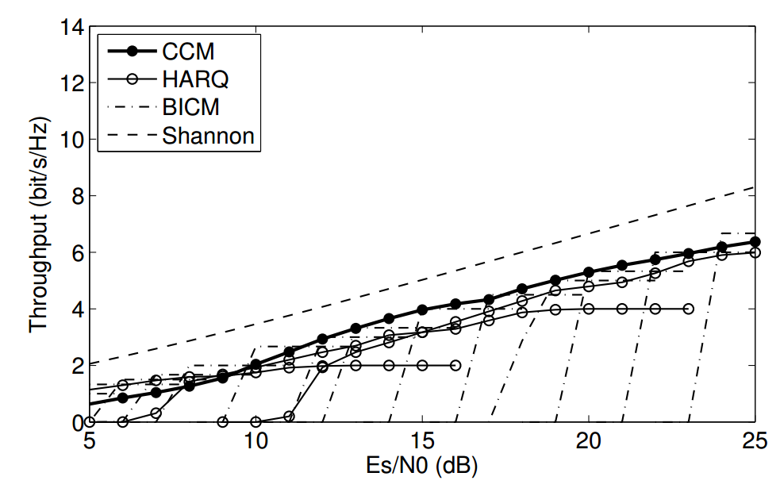



Softcast的psnr（720p）

|  |  |
| --- | --- |
| Snr | Psnr |
| 5 | 28.9666 |
| 10 | 33.4019 |
| 15 | 38.1020 |
| 20 | 42.9567 |
| 25 | 47.7032 |

比较一下衰落信道的性能

Awgn信道下的rcm的goodput

|  |  |  |  |  |  |  |  |  |  |  |
| --- | --- | --- | --- | --- | --- | --- | --- | --- | --- | --- |
| Snr | 5 | 6 | 7 | 8 | 9 | 10 | 11 | 12 | 13 | 14 |
| Goodput | 0.7040 | 0.8826 | 1.0686 | 1.3552 | 1.6654 | 2.0408 | 2.4399 | 2.8381 | 3.3862 | 3.8473 |

|  |  |  |  |  |  |  |  |  |  |  |
| --- | --- | --- | --- | --- | --- | --- | --- | --- | --- | --- |
| 15 | 16 | 17 | 18 | 19 | 20 | 21 | 22 | 23 | 24 | 25 |
| 4.1330 | 4.4321 | 4.7542 | 5.1134 | 5.4069 | 5.5930 | 5.7041 | 5.9842 | 5.8598 | 6.0239 | 6.1673 |

Lte的谱效率

|  |  |  |  |  |  |  |  |  |  |  |
| --- | --- | --- | --- | --- | --- | --- | --- | --- | --- | --- |
| Snr | 5 | 6 | 7 | 8 | 9 | 10 | 11 | 12 | 13 | 14 |
| Goodput | 1.1758 | 1.4766 | 1.9141 | 1.9141 | 2.4063 | 2.4063 | 2.7305 | 2.7305 | 3.3223 | 3.3223 |

|  |  |  |  |  |  |  |  |  |  |  |
| --- | --- | --- | --- | --- | --- | --- | --- | --- | --- | --- |
| 15 | 16 | 17 | 18 | 19 | 20 | 21 | 22 | 23 | 24 | 25 |
| 3.9023 | 3.9023 | 4.5234 | 4.5234 | 5.1152 | 5.5547 | 5.5547 | 5.5547 | 5.5547 | 5.5547 | 5.5547 |

使用RCM的QP

|  |  |  |  |  |  |  |  |  |  |  |
| --- | --- | --- | --- | --- | --- | --- | --- | --- | --- | --- |
| Snr | 5 | 6 | 7 | 8 | 9 | 10 | 11 | 12 | 13 | 14 |
| QP | 31 | 30 | 28 | 26 | 24 | 22 | 21 | 19 | 18 | 16 |

|  |  |  |  |  |  |  |  |  |  |  |
| --- | --- | --- | --- | --- | --- | --- | --- | --- | --- | --- |
| 15 | 16 | 17 | 18 | 19 | 20 | 21 | 22 | 23 | 24 | 25 |
| 16 | 15 | 14 | 14 | 13 | 13 | 13 | 13 | 13 | 12 | 12 |

使用RCM的PSNR

|  |  |  |  |  |  |  |  |  |  |  |
| --- | --- | --- | --- | --- | --- | --- | --- | --- | --- | --- |
| Snr | 5 | 6 | 7 | 8 | 9 | 10 | 11 | 12 | 13 | 14 |
| QP | 34.9943 | 35.7197 | 37.3113 | 38.7695 | 40.3002 | 41.7392 | 42.4070 | 43.7352 | 44.3024 | 45.8051 |

|  |  |  |  |  |  |  |  |  |  |  |
| --- | --- | --- | --- | --- | --- | --- | --- | --- | --- | --- |
| 15 | 16 | 17 | 18 | 19 | 20 | 21 | 22 | 23 | 24 | 25 |
| 45.8051 | 46.7010 | 47.7373 | **47.7373** | 49.0803 | 49.0803 | 49.0803 | 49.0803 | 49.0803 | 49.9747 | 49.9747 |

使用TURBO的QP(需要重传)

|  |  |  |  |  |  |  |  |  |  |  |
| --- | --- | --- | --- | --- | --- | --- | --- | --- | --- | --- |
| Snr | 5 | 6 | 7 | 8 | 9 | 10 | 11 | 12 | 13 | 14 |
| QP | 29 | 27 | 25 | 25 | 23 | 23 | 22 | 22 | 20 | 20 |

|  |  |  |  |  |  |  |  |  |  |  |
| --- | --- | --- | --- | --- | --- | --- | --- | --- | --- | --- |
| 15 | 16 | 17 | 18 | 19 | 20 | 21 | 22 | 23 | 24 | 25 |
| 18 | 18 | 17 | 17 | 16 | 15 | 15 | 15 | 15 | 15 | 15 |

使用TURBO的PSNR

|  |  |  |  |  |  |  |  |  |  |  |
| --- | --- | --- | --- | --- | --- | --- | --- | --- | --- | --- |
| Snr | 5 | 6 | 7 | 8 | 9 | 10 | 11 | 12 | 13 | 14 |
| QP | 36.4584 | 38.0614 | 39.6214 | 39.6214 | 40.9714 | 40.9714 | 41.7392 | 41.7392 | 42.9805 | 42.9805 |

|  |  |  |  |  |  |  |  |  |  |  |
| --- | --- | --- | --- | --- | --- | --- | --- | --- | --- | --- |
| 15 | 16 | 17 | 18 | 19 | 20 | 21 | 22 | 23 | 24 | 25 |
| 44.3024 | 44.3024 | 44.9313 | 44.9313 | 45.8051 | 46.7010 | 46.7010 | 46.7010 | 46.7010 | 46.7010 | 46.7010 |





A-BICM在低端的谱效率

|  |  |  |  |  |  |  |
| --- | --- | --- | --- | --- | --- | --- |
| Snr | 5 | 6 | 7 | 8 | 9 | 10 |
| Goodput | 1.1662 | 1.2903 | 1.4953 | 1.6512 | 1.9002 | 2.1978 |

低端使用A-BICM后的QP

|  |  |  |  |  |  |  |
| --- | --- | --- | --- | --- | --- | --- |
| Snr | 5 | 6 | 7 | 8 | 9 | 10 |
| QP | 27 | 27 | 25 | 24 | 23 | 22 |

低端使用A-BICM后的PSNR

|  |  |  |  |  |  |  |
| --- | --- | --- | --- | --- | --- | --- |
| Snr | 5 | 6 | 7 | 8 | 9 | 10 |
| PSNR | 38.0614 | 38.0614 | 39.6214 | 40.3002 | 40.9714 | 41.7392 |





352*288的视频

使用RCM的QP

|  |  |  |  |  |  |  |  |  |  |  |
| --- | --- | --- | --- | --- | --- | --- | --- | --- | --- | --- |
| Snr | 5 | 6 | 7 | 8 | 9 | 10 | 11 | 12 | 13 | 14 |
| QP | 20 | 19 | 19 | 18 | 17 | 16 | 15 | 14 | 13 | 12 |

|  |  |  |  |  |  |  |  |  |  |  |
| --- | --- | --- | --- | --- | --- | --- | --- | --- | --- | --- |
| 15 | 16 | 17 | 18 | 19 | 20 | 21 | 22 | 23 | 24 | 25 |
| 11 | 11 | 10 | 9 | 9 | 9 | 8 | 8 | 8 | 8 | 8 |

使用RCM的PSNR

|  |  |  |  |  |  |  |  |  |  |  |
| --- | --- | --- | --- | --- | --- | --- | --- | --- | --- | --- |
| Snr | 5 | 6 | 7 | 8 | 9 | 10 | 11 | 12 | 13 | 14 |
| QP | 34.9943 | 35.7197 | 37.3113 | 38.7695 | 40.3002 | 41.7392 | 42.4070 | 43.7352 | 44.3024 | 45.8051 |

|  |  |  |  |  |  |  |  |  |  |  |
| --- | --- | --- | --- | --- | --- | --- | --- | --- | --- | --- |
| 15 | 16 | 17 | 18 | 19 | 20 | 21 | 22 | 23 | 24 | 25 |
| 45.8051 | 46.7010 | 47.7373 | **47.7373** | 49.0803 | 49.0803 | 49.0803 | 49.0803 | 49.0803 | 49.9747 | 49.9747 |

使用TURBO的QP(需要重传)

|  |  |  |  |  |  |  |  |  |  |  |
| --- | --- | --- | --- | --- | --- | --- | --- | --- | --- | --- |
| Snr | 5 | 6 | 7 | 8 | 9 | 10 | 11 | 12 | 13 | 14 |
| QP | 29 | 27 | 25 | 25 | 23 | 23 | 22 | 22 | 20 | 20 |

|  |  |  |  |  |  |  |  |  |  |  |
| --- | --- | --- | --- | --- | --- | --- | --- | --- | --- | --- |
| 15 | 16 | 17 | 18 | 19 | 20 | 21 | 22 | 23 | 24 | 25 |
| 18 | 18 | 17 | 17 | 16 | 15 | 15 | 15 | 15 | 15 | 15 |

使用TURBO的PSNR

|  |  |  |  |  |  |  |  |  |  |  |
| --- | --- | --- | --- | --- | --- | --- | --- | --- | --- | --- |
| Snr | 5 | 6 | 7 | 8 | 9 | 10 | 11 | 12 | 13 | 14 |
| QP | 36.4584 | 38.0614 | 39.6214 | 39.6214 | 40.9714 | 40.9714 | 41.7392 | 41.7392 | 42.9805 | 42.9805 |

|  |  |  |  |  |  |  |  |  |  |  |
| --- | --- | --- | --- | --- | --- | --- | --- | --- | --- | --- |
| 15 | 16 | 17 | 18 | 19 | 20 | 21 | 22 | 23 | 24 | 25 |
| 44.3024 | 44.3024 | 44.9313 | 44.9313 | 45.8051 | 46.7010 | 46.7010 | 46.7010 | 46.7010 | 46.7010 | 46.7010 |