# How to create a database for DocumentDB using the Azure portal

To use Microsoft Azure DocumentDB, you must have a [DocumentDB account](/documentation/articles/documentdb-create-account), a database, a collection, and documents. This topic describes how to create a database for DocumentDB in the Microsoft Azure portal. For information on how to create a database using one of the SDKs, see [Other ways to create a DocumentDB database](/documentation/articles/#other-ways-to-create-a-documentdb-database).

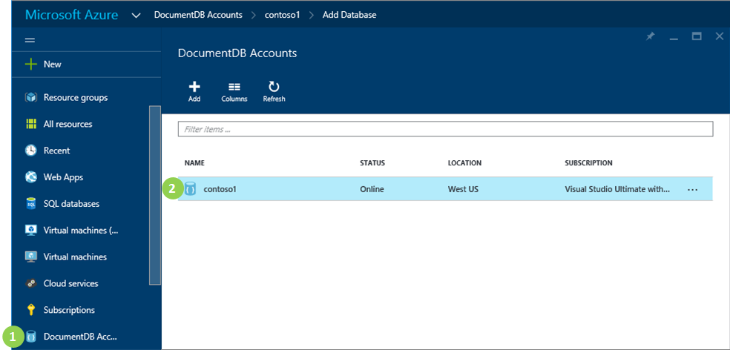

Screen shot showing how to create a database, highlighting DocumentDB Accounts on the Browse blade, and a DocumentDB account on the DocumentDB Accounts blade

1. In the [Azure Portal](https://portal.azure.com/), in the Jumpbar, click **DocumentDB Accounts**. If **DocumentDB Accounts** is not visible, click **Browse** and then click **DocumentDB Accounts**.
2. In the **DocumentDB Accounts** blade, select the account in which to add a DocumentDB NoSQL database. If you don’t have any accounts listed, you’ll need to [create a DocumentDB account](/documentation/articles/documentdb-create-account).

* Screen shot showing how to create a database, highlighting the Add Database button, the ID box, and the OK button
* Screen shot showing how to create a database, highlighting the Add Database button, the ID box, and the OK button

1. In the **DocumentDB account** blade, click **Add Database**.
2. In the **Add Database** blade, enter the ID for your new database. When the name is validated, a green check mark appears in the **ID** box.
3. Click **OK** at the bottom of the screen to create the new database.
4. The new database now appears in the **Databases** lens on the **DocumentDB Account** blade.

* Screen shot of the new database in the DocumentDB Account blade
* Screen shot of the new database in the DocumentDB Account blade

## Other ways to create a DocumentDB database

Databases do not have to be created using the portal, you can also create them using the [DocumentDB SDKs](/documentation/articles/documentdb-sdk-dotnet) or the [REST API](/documentation/articles/https://msdn.microsoft.com/library/mt489072.aspx). For information on working with databases by using the .NET SDK, see [.NET database examples](/documentation/articles/documentdb-dotnet-samples#database-examples). For information on working with databases by using the Node.js SDK, see [Node.js database examples](/documentation/articles/documentdb-nodejs-samples#database-examples).

## Next steps

Now that you know how to create a database for DocumentDB, the next step is to [create a collection](/documentation/articles/documentdb-create-collection).

Once your collection is created, you can [add JSON documents](/documentation/articles/documentdb-view-json-document-explorer) by using the Document Explorer in the Portal, [import documents](/documentation/articles/documentdb-import-data) into the collection by using the DocumentDB Data Migration Tool, or use one of the [DocumentDB SDKs](/documentation/articles/documentdb-sdk-dotnet) to perform CRUD operations. DocumentDB has .NET, Java, Python, Node.js, and JavaScript API SDKs. For .NET code samples showing how to create, remove, update and delete documents, see [.NET document examples](/documentation/articles/documentdb-dotnet-samples#document-examples). For information on working with documents by using the Node.js SDK, see [Node.js document examples](/documentation/articles/documentdb-nodejs-samples#document-examples).

After you have documents in a collection, you can use [DocumentDB SQL](/documentation/articles/documentdb-sql-query) to [execute queries](/documentation/articles/documentdb-sql-query#executing-sql-queries) against your documents by using the [Query Explorer](/documentation/articles/documentdb-query-collections-query-explorer) in the Portal, the [REST API](https://msdn.microsoft.com/library/azure/dn781481.aspx), or one of the [SDKs](/documentation/articles/documentdb-sdk-dotnet).