# Request increased DocumentDB account limits

[Microsoft Azure DocumentDB](https://azure.microsoft.com/services/documentdb/) has a set of default limits and quota enforcements. Several quotas can be adjusted by contacting Azure support. This article shows how to request an account limit increase.

After reading this article, you’ll be able to answer the following questions:

* Which DocumentDB account quotas can be adjusted by contacting Azure support?
* How can I request a DocumentDB account quota adjustment?

## DocumentDB account quotas

The following table describes the DocumentDB quotas. The quotas that have an asterisk (*) can be adjusted by contacting Azure support:

[AZURE.INCLUDE [azure-documentdb-limits](../includes/azure-documentdb-limits.md)]

## Request a quota adjustment

The following steps show how to request a quota adjustment.

1. In the [Azure Portal](https://portal.azure.com), click **Browse**, and then click **Help + support**.

* 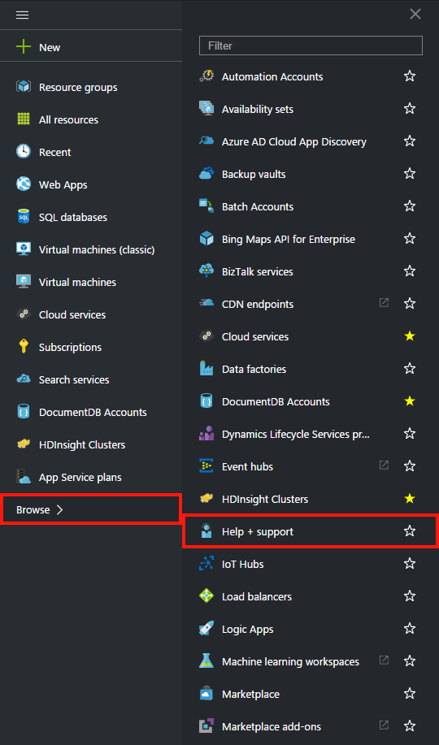
* Screenshot of launching help and support

1. In the **Help + support** blade, click **Get Support**.

* 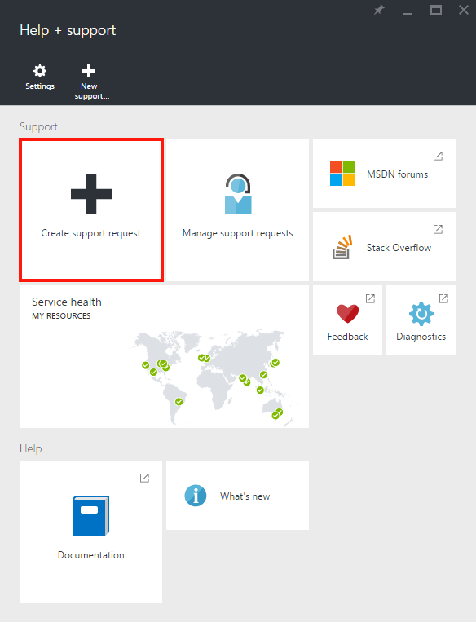
* Screenshot of creating a support ticket

1. In the **New support request** blade, click **Basics**. Next, set **Issue type** to **Quota**, **Subscription** to your subscription that hosts your DocumentDB account, **Service** to **DocumentDB**, and **Support plan** to **Quota SUPPORT - Included**. Finally, click **Next**.

* 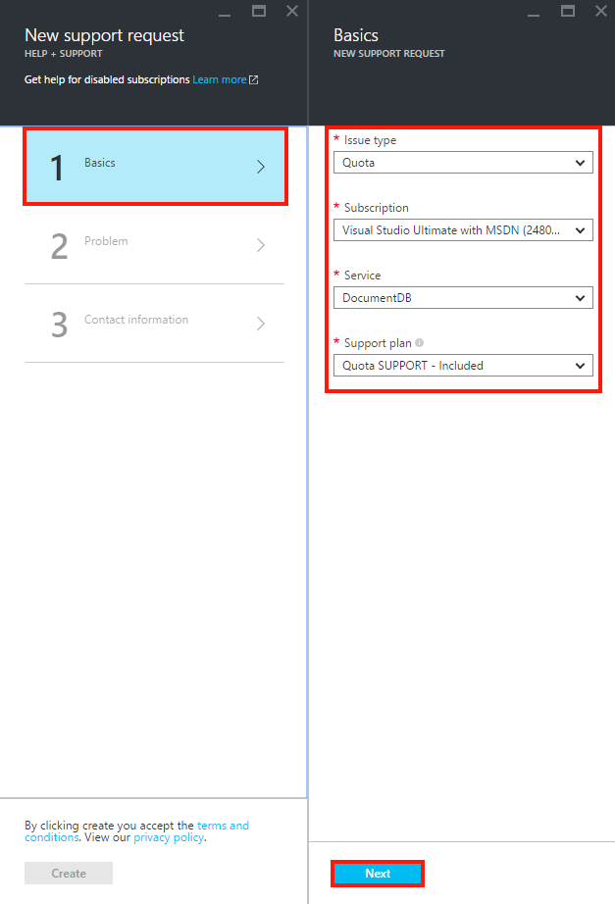
* Screenshot of support ticket request type

1. In the **Problem** blade, choose a severity. Set **Problem type** to **DocumentDB** and include information about your quota increase in **Details**. Click **Next**.

* 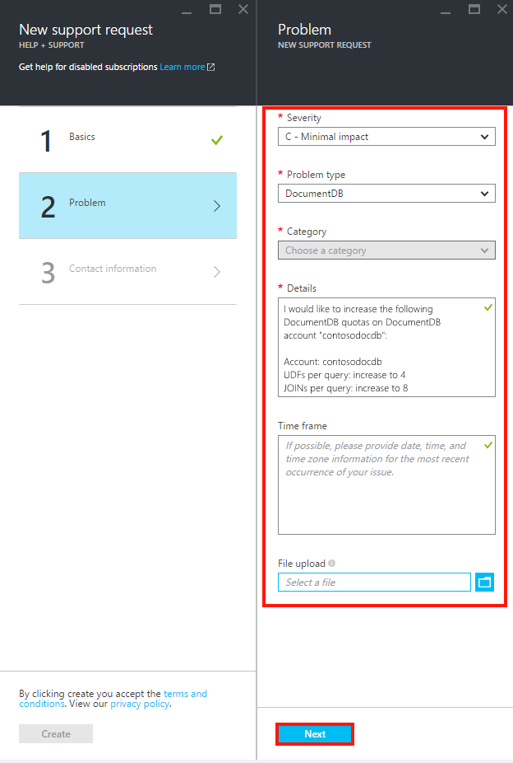
* Screenshot of support ticket subscription picker

1. Finally, fill in your contact information in the **Contact information** blade.

* 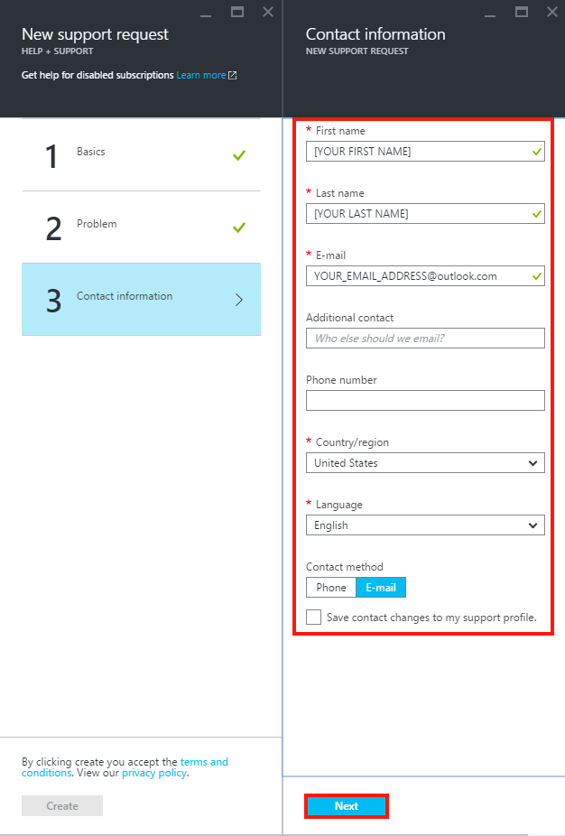
* Screenshot of support ticket resource picker

Once the support ticket has been created, you should receive the support request number via email. You can also view the support request by clicking **Manage support requests** in the **Help + support** blade.

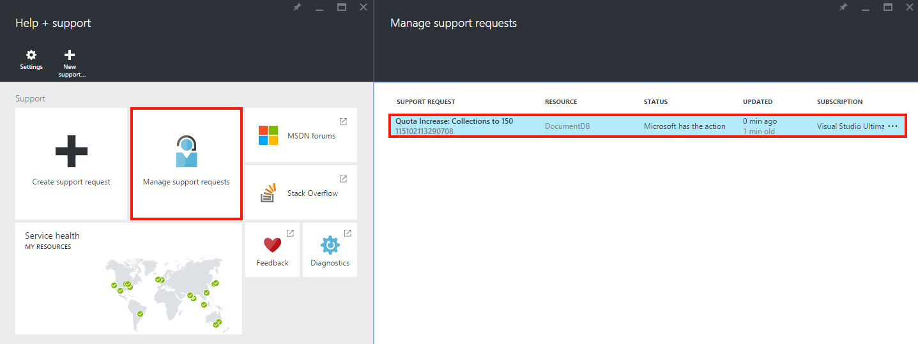

Screenshot of support requests blade

## Next steps

* To learn more about DocumentDB, click [here](http://azure.com/docdb).