# How to manage a DocumentDB account

Learn how to work with keys and consistency levels. Also, learn how to delete an account in the Azure Portal.

## View, copy, and regenerate access keys

When you create a DocumentDB account, the service generates two master access keys that can be used for authentication when the DocumentDB account is accessed. By providing two access keys, DocumentDB enables you to regenerate the keys with no interruption to your DocumentDB account.

In the [Microsoft Azure Portal](https://portal.azure.com/), access the **Keys** blade from the **Essentials** bar in your **DocumentDB Account** blade to view, copy, and regenerate the access keys that are used to access your DocumentDB account.

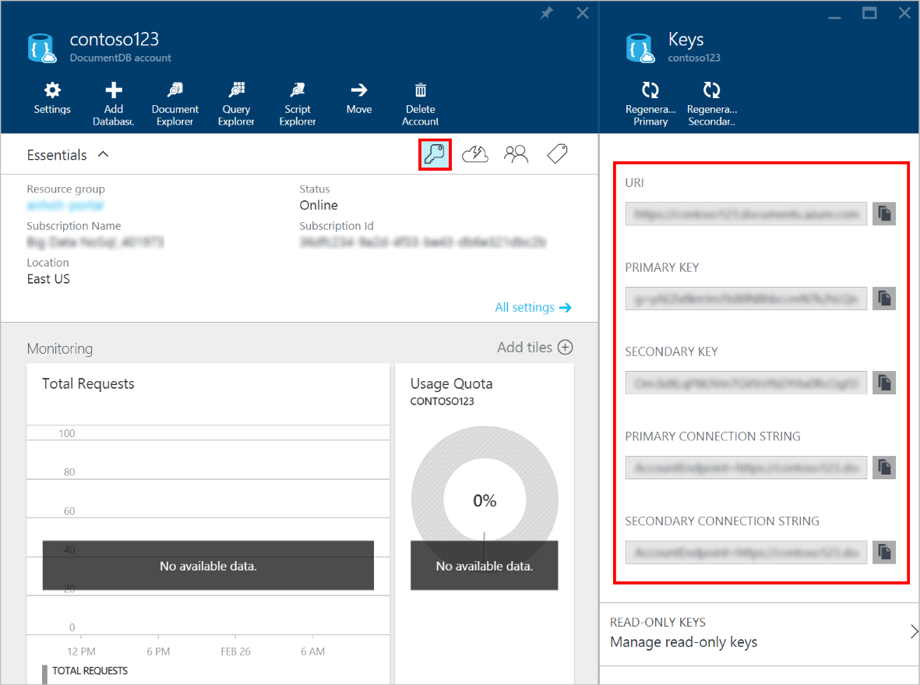

Azure Portal screenshot, Keys blade

Another option is to access the **Keys** entry from the **All Settings** blade,.

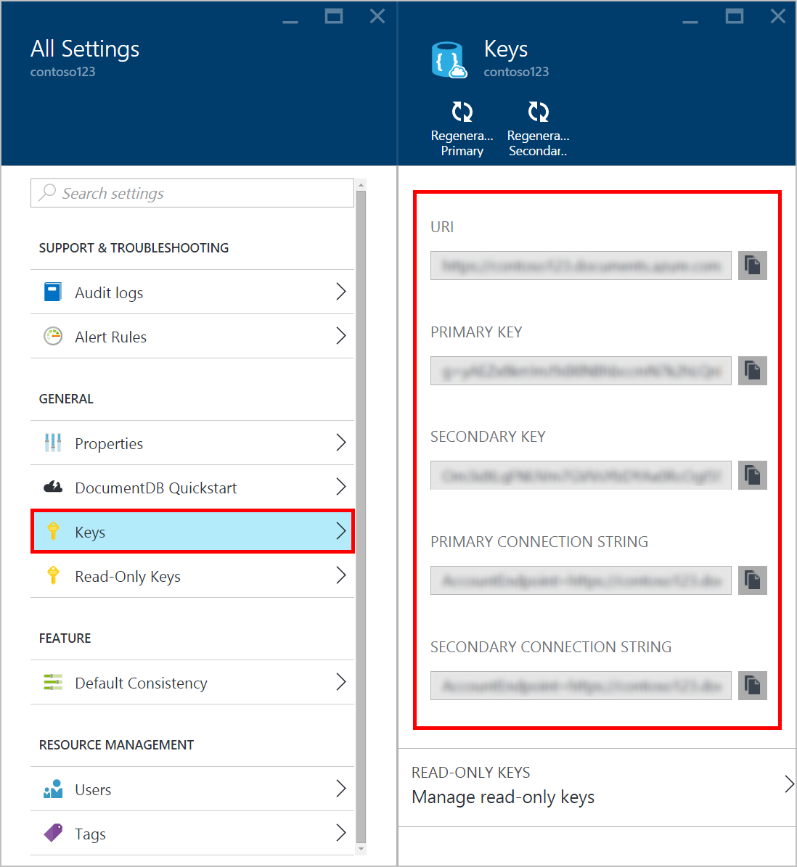

All Settings, Keys blade

Note that the **Keys** blade also includes primary and secondary connection strings that can be used to connect to your account from the [Data Migration Tool](documentdb-import-data.md).

It also includes read-only keys to provide users with read only-access to DocumentDB. Reads and queries are read-only operations, while creates, deletes, and replaces are not.

### View and copy an access key in the Azure Portal

1.      In the [Azure Portal](https://portal.azure.com/), access your DocumentDB account.

2.      In the **Essentials** bar from the **DocumentDB Account** blade, click **Keys**.

3.      On the **Keys** blade, click the **Copy** button to the right of the key you wish to copy.

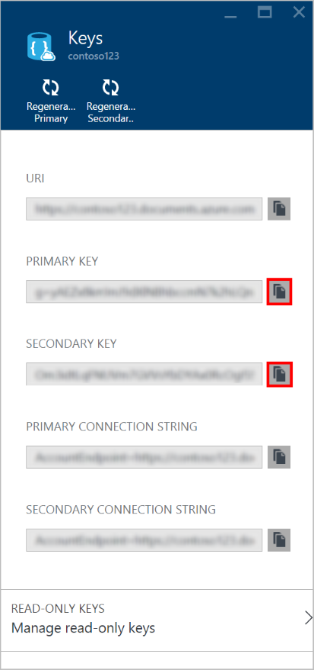

### Regenerate access keys

You should change the access keys to your DocumentDB account periodically to help keep your connections more secure. Two access keys are assigned to enable you to maintain connections to the DocumentDB account using one access key while you regenerate the other access key.

[AZURE.WARNING] Regenerating your access keys affects any applications that are dependent on the current key. All clients that use the access key to access the DocumentDB account must be updated to use the new key.

If you have applications or cloud services using the DocumentDB account, you will lose the connections if you regenerate keys, unless you roll your keys. The following steps outline the process involved in rolling your keys.

1.      Update the access key in your application code to reference the secondary access key of the DocumentDB account.

2.      Regenerate the primary access key for your DocumentDB account. In the [Azure Portal](https://portal.azure.com/), access your DocumentDB account.

3.      In the **Essentials** bar from the **DocumentDB Account** blade, click **Keys**.

4.      On the **Keys** blade, click the **Regenerate Primary** command, then click **Ok** to confirm that you want to generate a new key.

5.      Once you have verified that the new key is available for use (approximately 5 minutes after regeneration), update the access key in your application code to reference the new primary access key.

6.      Regenerate the secondary access key.

*Note that it can take several minutes before a newly generated key can be used to access your DocumentDB account.*

## Manage DocumentDB consistency settings

DocumentDB supports four well-defined user-configurable data consistency levels to allow developers to make predictable consistency-availability-latency trade-offs.

* **Strong** consistency guarantees that read operations always return the value that was last written.
* **Bounded Staleness** consistency guarantees that reads are not too out-of-date. It specifically guarantees that the reads are no more than *K* versions older than the last written version.
* **Session** consistency guarantees monotonic reads (you never read old data, then new, then old again), monotonic writes (writes are ordered), and that you read the most recent writes within any single client’s viewpoint.
* **Eventual** consistency guarantees that read operations always read a valid subset of writes and will eventually converge.

*Note that by default, DocumentDB accounts are provisioned with Session level consistency.  For additional information on DocumentDB consistency settings, see the* [*Consistency Level*](http://go.microsoft.com/fwlink/p/?LinkId=402365) *section.*

### To specify the default consistency for a DocumentDB account

1.      In the [Azure Portal](https://portal.azure.com/), access your DocumentDB account.

2.      In the account blade, if the **Settings** blade is not already opened, click the **Settings** icon on the top command bar.

3.      In the **All Settings** blade, click on the **Default Consistency** entry under **Feature**.

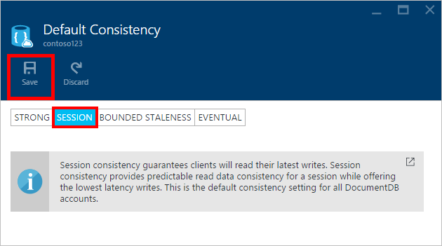

Default consistency session

4.      In the **Default Consistency** blade, select the new consistency level and click **Save**.

5.      The progress of the operation may be monitored via the Azure Portal Notifications hub.

*Note that it can take several minutes before a change to the default consistency setting takes effect across your DocumentDB account.*

## How to: Delete a DocumentDB account in the Azure Portal

To remove a DocumentDB account from the Azure Portal that you are no longer using, use the **Delete** command on the **DocumentDB Account** blade.

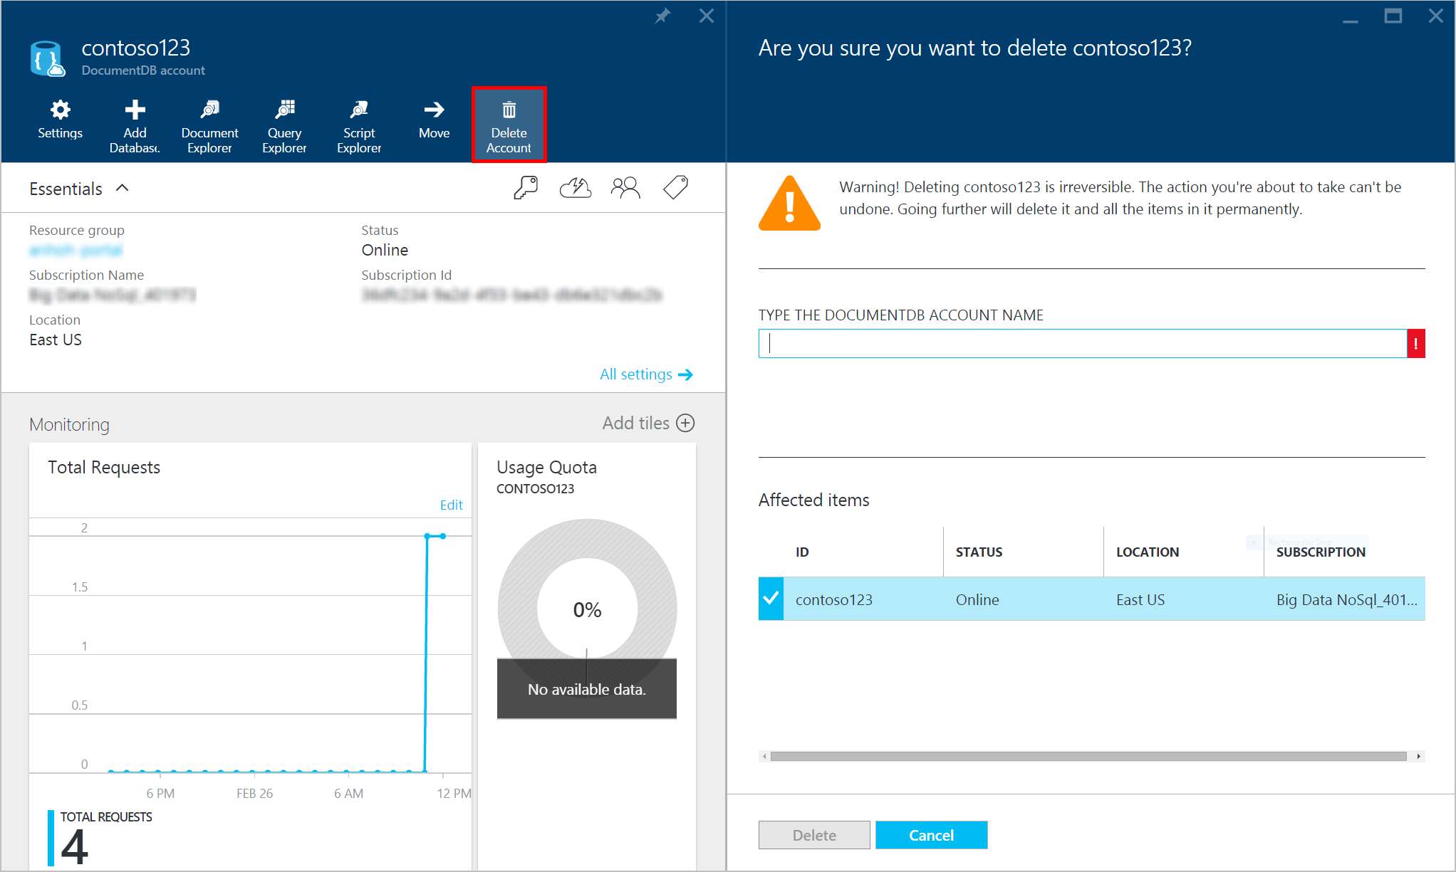

How to delete a DocumentDB account in the Azure Portal

1.      In the [Azure Portal](https://portal.azure.com/), access the DocumentDB Account you wish to delete.

2.      On the **DocumentDB Account** blade, click the **Delete** command.

3.      On the resulting confirmation blade, type the DocumentDB Account name to confirm that you want to delete the account.

4.      Click the **Delete** button on the confirmation blade.

## Next steps

Learn how to [get started with your DocumentDB account](http://go.microsoft.com/fwlink/p/?LinkId=402364).

To learn more about DocumentDB, see the Azure DocumentDB documentation on [azure.com](http://go.microsoft.com/fwlink/?LinkID=402319&clcid=0x409).