# Monitor a DocumentDB account usage in the Azure portal

You can monitor your DocumentDB accounts in the [Microsoft Azure Portal](https://portal.azure.com/). For each DocumentDB account, both performance metrics, such as requests and server errors, and usage metrics, such as storage consumption, are available.

## View performance metrics for a DocumentDB account

1. In the [Azure portal](https://portal.azure.com/), click **Browse**, **DocumentDB Accounts**, and then click the name of the DocumentDB account for which you would like to view performance metrics.
2. Within the **Monitoring** lens you can, by default, see:
   * Total requests for the current day.
   * Storage usage for the account.

* If your table displays **No data available** see the Troubleshooting section.
* 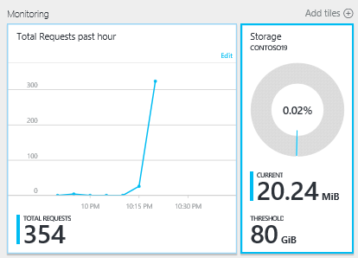
* Screen shot of the Monitoring lens which shows the total requests for today and storage usage

1. Clicking on the **Total Requests** or **Storage** tile opens a detailed **Metric** blade.
2. The **Metric** blade shows you details about the metrics you have selected. At the top of the blade is a graph and below that a table that shows aggregation values of the selected metrics such as average, minimum, maximum, and total. The metric blade also shows the list of alerts which have been defined, filtered to the metrics that appear on the current metric blade (this way, if you have a number of alerts, you’ll only see the relevant ones presented here).

* 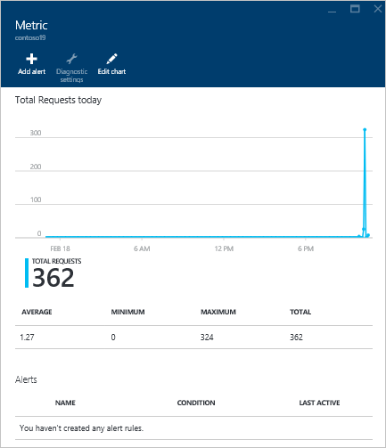
* Screenshot of the Metric blade

## Customize performance metric views for a DocumentDB account

1. To customize the metrics that display in a particular part, right-click the metric chart, and then select **Edit Chart**.  
   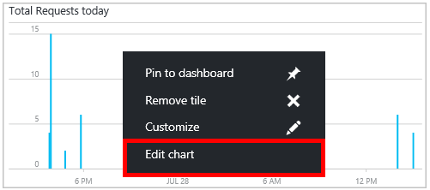
2. On the **Edit Chart** blade, there are options to modify the metrics that display in the part, as well as their time range.  
   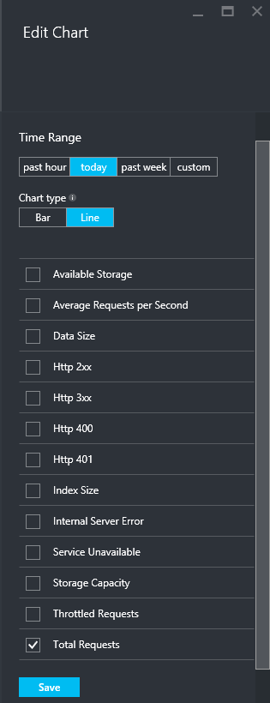
3. To change the metrics displayed in the part, simply select or clear the available performance metrics, and then click **Save** at the bottom of the blade.
4. To change the time range, choose a different range (for example, **Custom**), and then click **Save** at the bottom of the blade.

* 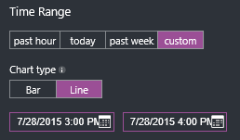
* Screen shot of the Time Range part of the Edit Chart blade showing how to enter a custom time range

## Create side-by-side performance metric charts

The Azure Portal allows you to create side-by-side metric charts.

1. First, right-click on the chart you want to clone and modify and select **Customize**.

* 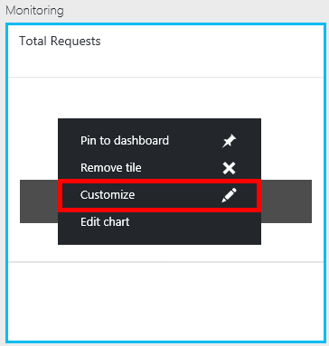
* Screen shot of the Total Requests chart with the Customize option highlighted

1. Click **Clone** on the menu to copy the part and then click **Done customizing**.

* 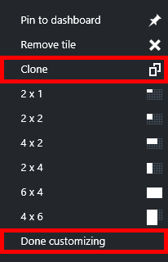
* Screen shot of the Total Requests chart with the Clone and Done customizing options highlighted

You may now treat this part as any other metric part, customizing the metrics and time range displayed in the part. By doing this, you can see two different metrics chart side-by-side at the same time.  
 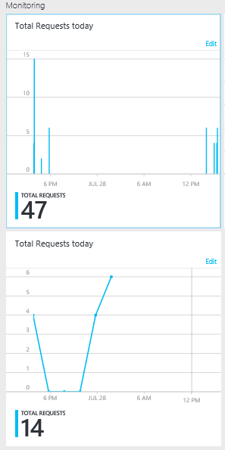

## Set up performance metric alerts for a DocumentDB account

1. In the [Azure Portal](https://portal.azure.com/), click **Browse All**, **DocumentDB Accounts**, and then click the name of the DocumentDB account for which you would like to setup performance metric alerts.
2. If the **All Settings** blade is not open, click the **Settings** Command at the top left to open the blade. 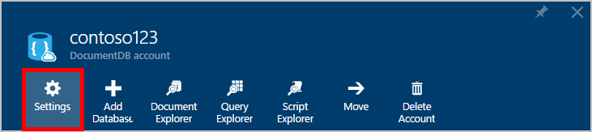
3. In the **All Settings** blade, click **Alert Rules** to open the Alert rules blade.  
   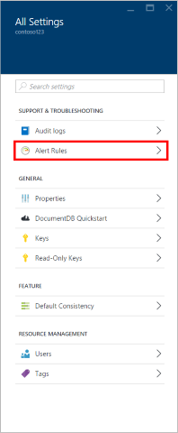
4. In the Alert rules blade, click **Add alert**.  
   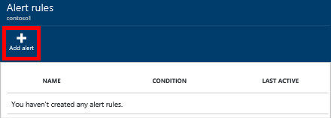
5. In the **Add an alert rule** blade, specify:
   * The name of the alert rule you are setting up.
   * A description of the new alert rule.
   * The metric for the alert rule.
   * The condition, threshold, and period that determine when the alert activates. For example, a server error count greater than 5 over the last 15 minutes.
   * Whether the service administrator and coadministrators are emailed when the alert fires.
   * Additional email addresses for alert notifications.  
     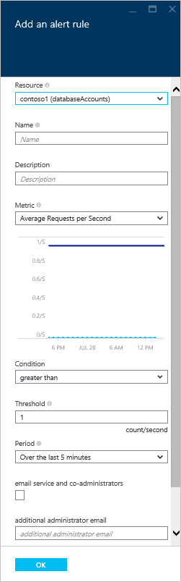

## Other ways to monitor DocumentDB

The account level metrics available in the portal, such as account storage usage and total requests, are not available via the DocumentDB APIs. However, you can retrieve usage data at the collection level. To retrieve collection level data, do the following:

* To use the REST API, [perform a GET on the collection](https://msdn.microsoft.com/library/mt489073.aspx). The quota and usage information for the collection is returned in the x-ms-resource-quota and x-ms-resource-usage headers in the response.
* To use the .NET SDK, use the [DocumentClient.ReadDocumentCollectionAsync](https://msdn.microsoft.com/library/microsoft.azure.documents.client.documentclient.readdocumentcollectionasync.aspx) method, which returns a [ResourceResponse](https://msdn.microsoft.com/library/dn799209.aspx) that contains a number of usage properties such as **CollectionSizeUsage**, **DatabaseUsage**, **DocumentUsage**, and more.

## Troubleshooting

If your monitoring tiles display the **No data available** message, and you recently made requests or added data to the database, you can edit the tile to reflect the recent usage.

### Edit a tile to refresh current data

1. To customize the metrics that display in a particular part, right-click the metric chart, and then select **Edit Chart**.  
   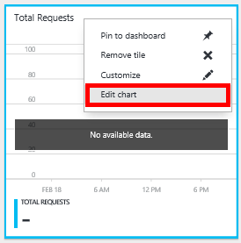
2. On the **Edit Chart** blade, in the **Time Range** section, click **past hour**, and then click **Save**.  
   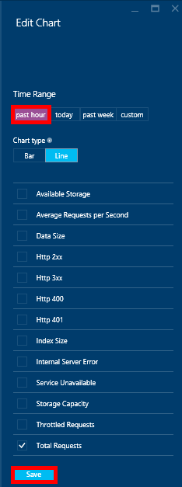
3. Your tile should now refresh showing your current data and usage.  
   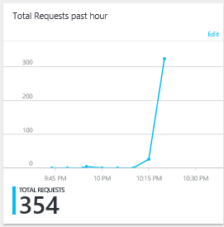

## Next steps

To learn more about DocumentDB capacity, see [Manage DocumentDB capacity](/documentation/articles/documentdb-manage).