# NoSQL vs SQL

SQL Server and relational databases (RDBMS) have been the go-to databases for over 20 years. However, the increased need to process higher volumes and varieties of data at a rapid rate has altered the nature of data storage needs for application developers. In order to enable this scenario, NoSQL databases that enable storing unstructured and heterogeneous data at scale have gained in popularity.

NoSQL is a category of databases distinctly different from SQL databases. NoSQL is often used to refer to data management systems that are “Not SQL” or an approach to data management that includes “Not only SQL”. There are a number of technologies in the NoSQL category, including document databases, key value stores, column family stores, and graph databases, which are popular with gaming, social, and IoT apps.

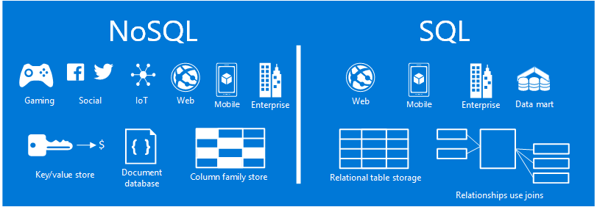

NoSQL vs SQL overview diagram demonstrating common scenarios and data models

The goal of this article is to help you learn about the differences between NoSQL and SQL, and provide you with an introduction to the NoSQL and SQL offerings from Microsoft.

## When to use NoSQL?

Let’s imagine you’re building a new social engagement site. Users can create posts and add pictures, videos and music to them. Other users can comment on the posts and give points (likes) to rate the posts. The landing page will have a feed of posts that users can share and interact with.

So how do you store this data? If you’re familiar with SQL, you might start drawing something like this:

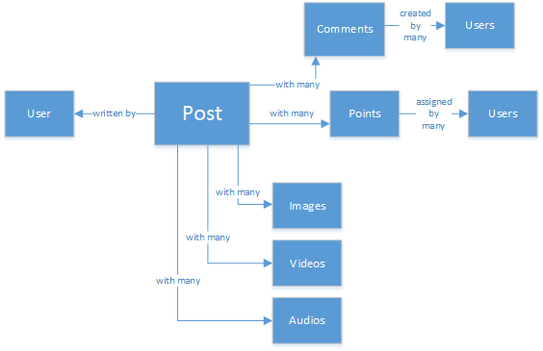

NoSQL vs SQL diagram showing the relational data model for a social engagement site

So far, so good, but now think about the structure of a single post and how to display it. If you want to show the post and the associated images, audio, video, comments, points, and user info on a website or application, you’d have to perform a query with eight table joins just to retrieve the content. Now imagine a stream of posts that dynamically load and appear on the screen and you can easily predict that it’s going to require thousands of queries and many joins to complete the task.

Now you could use a relational solution like SQL Server to store the data - but there’s another option, a NoSQL option that simplifies the approach. By transforming the post into a JSON document like the following and storing it in DocumentDB, an Azure NoSQL document database service, you can increase performance and retrieve the whole post with one query and no joins. It’s a simpler, more straightforward, and more performant result.

{  
 "id":"ew12-res2-234e-544f",  
 "title":"post title",  
 "date":"2016-01-01",  
 "body":"this is an awesome post stored on NoSQL",  
 "createdBy":User,  
 "images":["http://myfirstimage.png","http://mysecondimage.png"],  
 "videos":[  
 {"url":"http://myfirstvideo.mp4", "title":"The first video"},  
 {"url":"http://mysecondvideo.mp4", "title":"The second video"}  
 ],  
 "audios":[  
 {"url":"http://myfirstaudio.mp3", "title":"The first audio"},  
 {"url":"http://mysecondaudio.mp3", "title":"The second audio"}  
 ]  
}

In addition, this data can be partitioned by post id allowing the data to scale out naturally and take advantage of NoSQL scale characteristics. Also NoSQL systems allow developers to loosen consistency and offer highly available apps. Finally, this solution does not require developers to define, manage and maintain schema in the data tier allowing for rapid iteration.

You can then build on this solution using other Azure services:

* [Azure Search](https://azure.microsoft.com/services/search/) can be used via the web app to enable users to search for posts.
* [Azure App Services](https://azure.microsoft.com/services/app-service/) can be used to host applications and background processes.
* [Azure Blob Storage](https://azure.microsoft.com/services/storage/) can be used to store full user profiles including images.
* [Azure SQL Database](https://azure.microsoft.com/services/sql-database/) can be used to store massive amounts of data such as login information, and data for usage analytics.
* [Azure Machine Learning](https://azure.microsoft.com/services/machine-learning/) can be used to build knowledge and intelligence that can provide feedback to the process and help deliver the right content to the right users.

This social engagement site is just one one scenario in which a NoSQL database is the right data model for the job. If you’re interested in reading more about this scenario and how to model your data for DocumentDB in social media applications, see [Going social with DocumentDB](documentdb-social-media-apps.md).

## NoSQL vs SQL comparison

The following table compares the main differences between NoSQL and SQL.

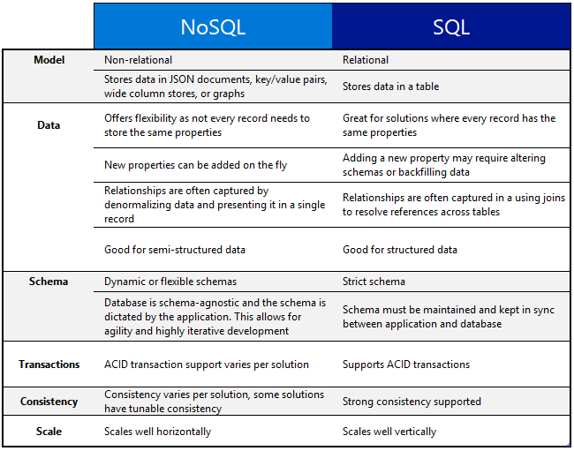

NoSQL vs SQL diagram showing when to use NoSQL and when to use SQL. SQL vs NoSQL comparison

If a NoSQL database best suits your requirements, continue to the next section to learn more about the NoSQL services available from Azure. Otherwise, if a SQL database best suits your needs, skip to What are the Microsoft SQL offerings?

## What are the Microsoft Azure NoSQL offerings?

Azure has four fully-managed NoSQL services:

* [Azure DocumentDB](https://azure.microsoft.com/services/documentdb/)
* [Azure Table Storage](https://azure.microsoft.com/services/storage/)
* [Azure HBase as a part of HDInsight](https://azure.microsoft.com/services/hdinsight/)
* [Azure Redis Cache](https://azure.microsoft.com/services/cache/)

The following comparison chart maps out the key differentiators for each service. Which one most accurately describes the needs of your application?

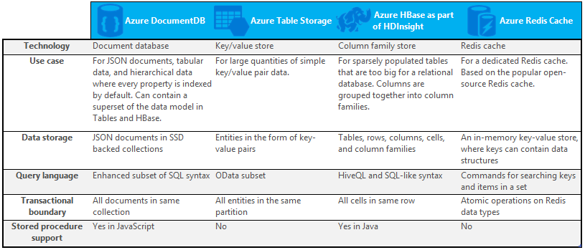

NoSQL vs SQL diagram showing when to use NoSQL offerings from Microsoft Azure, including DocumentDB, Table Storage, HBase as a part of HDInsight, and Redis Cache

If one or more of these services might meet the needs of your application, learn more with the following resources:

* [DocumentDB learning path](https://azure.microsoft.com/documentation/learning-paths/documentdb/) and [DocumentDB use cases](/documentation/articles/documentdb-use-cases)
* [Get started with Azure table storage](/documentation/articles/storage-dotnet-how-to-use-tables)
* [What is HBase in HDInsight](/documentation/articles/hdinsight-hbase-overview)
* [Redis Cache learning path](https://azure.microsoft.com/documentation/learning-paths/redis-cache/)

Then go to Next steps for free trial information.

## What are the Microsoft SQL offerings?

Microsoft has five SQL offerings:

* [Azure SQL Database](https://azure.microsoft.com/services/sql-database/)
* [SQL Server on Azure Virtual Machines](https://azure.microsoft.com/services/virtual-machines/sql-server/)
* [SQL Server](https://www.microsoft.com/server-cloud/products/sql-server-2016/)
* [Azure SQL Data Warehouse (Preview)](https://azure.microsoft.com/services/sql-data-warehouse/)
* [Analytics Platform System (on-premises appliance)](https://www.microsoft.com/en-us/server-cloud/products/analytics-platform-system/)

If you’re interested in SQL Server on a Virtual Machine or SQL Database, then read [Choose a cloud SQL Server option: Azure SQL (PaaS) Database or SQL Server on Azure VMs (IaaS)](../sql-database/data-management-azure-sql-database-and-sql-server-iaas.md) to learn more about the differences between the two.

If SQL sounds like the best option, then go to [SQL Server](https://www.microsoft.com/server-cloud/products/) to learn more about what our Microsoft SQL products and services have to offer.

Then go to Next steps for free trial and evaluation links.

## Next steps

We invite you to learn more about our SQL and NoSQL products by trying them out for free.

* For all Azure services, you can sign up for a [free one-month trial](https://azure.microsoft.com/pricing/free-trial/) and receive $200 to spend on any of the Azure services.
  + [Azure DocumentDB](https://azure.microsoft.com/services/documentdb/)
  + [Azure HBase as a part of HDInsight](https://azure.microsoft.com/services/hdinsight/)
  + [Azure Redis Cache](https://azure.microsoft.com/services/cache/)
  + [Azure SQL Data Warehouse (Preview)](https://azure.microsoft.com/services/sql-data-warehouse/)
  + [Azure SQL Database](https://azure.microsoft.com/services/sql-database/)
  + [Azure Table Storage](https://azure.microsoft.com/services/storage/)
* You can spin up an [evaluation version of SQL Server 2016 on a virtual machine](https://azure.microsoft.com/marketplace/partners/microsoft/sqlserver2016ctp33evaluationwindowsserver2012r2/) or download an [evaluation version of SQL Server](https://www.microsoft.com/en-us/evalcenter/evaluate-sql-server-2016).
  + [SQL Server](https://www.microsoft.com/server-cloud/products/sql-server-2016/)
  + [SQL Server on Azure Virtual Machines](https://azure.microsoft.com/services/virtual-machines/sql-server/)