# DocumentDB protocol support for MongoDB

Microsoft Azure DocumentDB databases can now be used as the data store for apps written for MongoDB. Using existing drivers for MongoDB and this preview functionality, applications written for MongoDB can easily and transparently communicate with DocumentDB. Developers can use their current tools and skill set for MongoDB to build applications that leverage DocumentDB’s fully managed and scalable NoSQL databases.

We are currently on-boarding customers to preview this new functionality. If you want to be considered for the preview, follow the directions below to request access to the preview program and we will contact you once you’re approved.

## Prerequisites

Before requesting access to the preview program, you must have the following.

* **An Azure subscription**. See [Create your free Azure account today](https://azure.microsoft.com/free/).

## Request access to the DocumentDB protocol support for MongoDB Preview

To request access to the preview, perform the following steps.

1. Sign in to the [Azure Portal](https://portal.azure.com).
2. Click **NEW**, click **Data + Storage**, click **See all**, click **More**, and then click **DocumentDB - Protocol Support for MongoDB**.

* 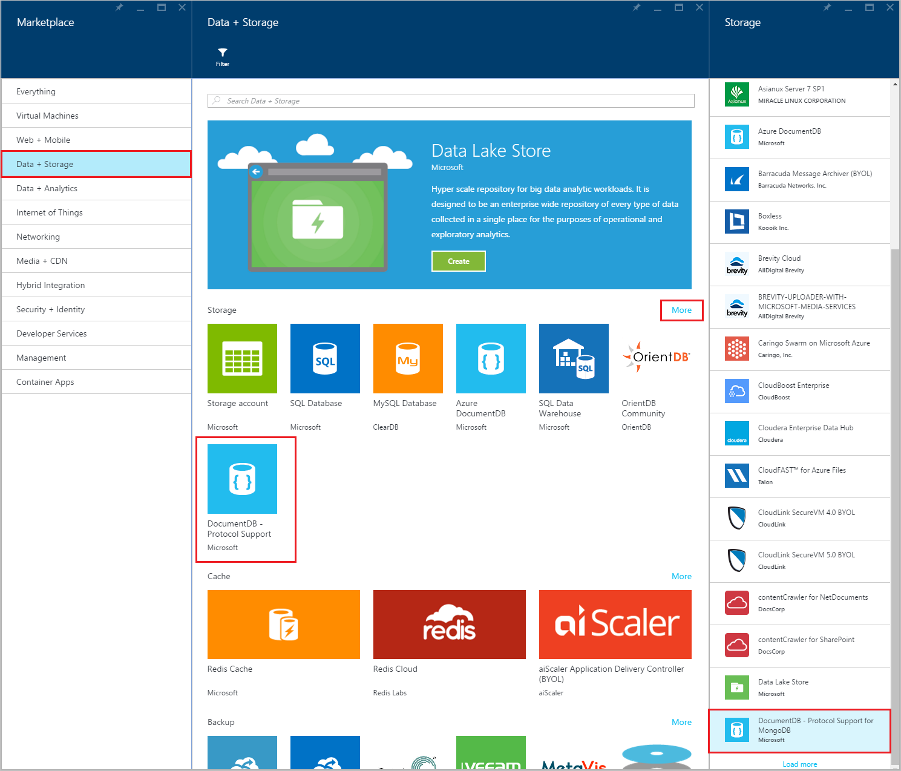
* Screen shot of the Marketplace and Data + Storage blades, highlighting DocumentDB - Protocol Support for MongoDB, Mongo database

1. Alternatively, search the **Data + Storage** category for “DocumentDB protocol”.

* 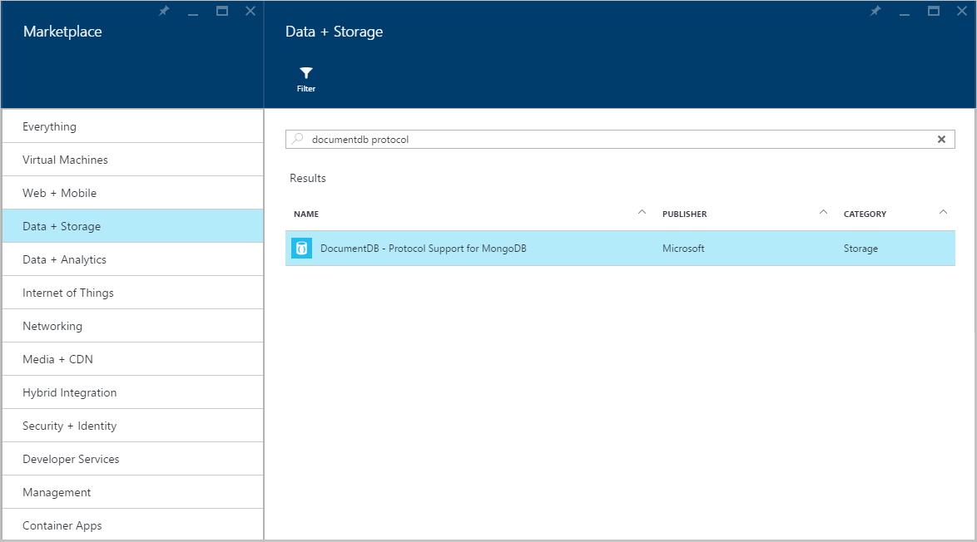
* Screen shot of the Marketplace and Data + Storage search blades, highlighting DocumentDB - Protocol Support for MongoDB, Mongo database

1. Click **Create** to launch the preview signup process.

* 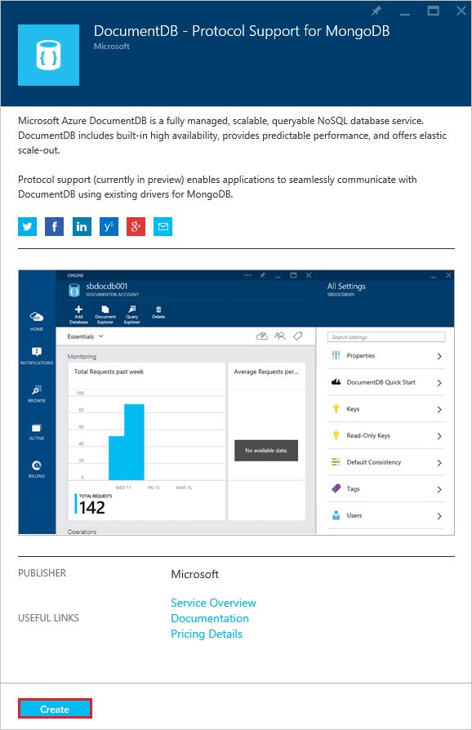
* The DocumentDB - Protocol Support for MongoDB blade in the Azure portal

1. In the **New DocumentDB Account** blade, click **Sign up to preview**. Read the information and then click **OK**. You will receive an e-mail once your subscription has been enabled for the Public Preview.

* 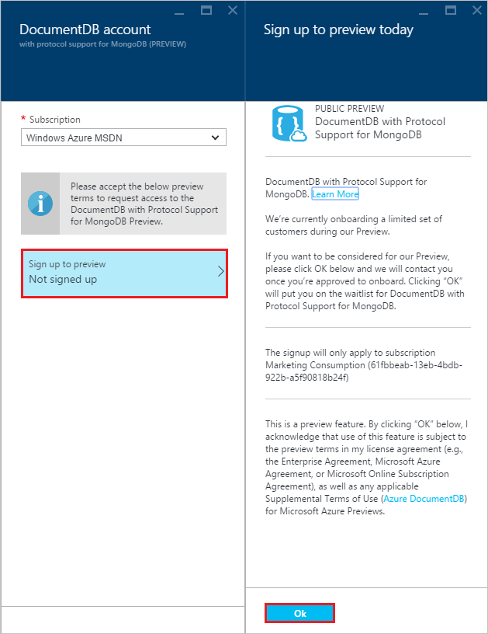
* The Sign up to preview today blade for DocumentDB - Protocol Support for MongoDB in the Azure portal

## Next steps

* Once you’ve been approved for the preview, you will receive a welcome email with instructions on how to create your account and get started.