# Python Flask Web Application Development with DocumentDB

[AZURE.SELECTOR] - [.NET](/documentation/articles/documentdb-dotnet-application) - [Node.js](/documentation/articles/documentdb-nodejs-application) - [Java](/documentation/articles/documentdb-java-application) - [Python](/documentation/articles/documentdb-python-application)

This tutorial shows you how to use Azure DocumentDB to store and access data from a Python web application hosted on Azure and presumes that you have some prior experience using Python and Azure websites.

This database tutorial covers:

1. Creating and provisioning a DocumentDB account.
2. Creating a Python MVC application.
3. Connecting to and using Azure DocumentDB from your web application.
4. Deploying the web application to Azure Websites.

By following this tutorial, you will build a simple voting application that allows you to vote for a poll.

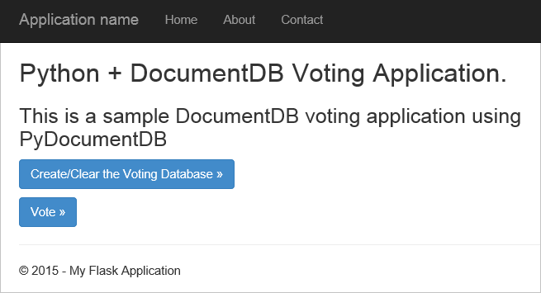

Screen shot of the todo list web application created by this database tutorial

## Database tutorial prerequisites

Before following the instructions in this article, you should ensure that you have the following installed:

* An active Azure account. If you don’t have an account, you can create a free trial account in just a couple of minutes. For details, see [Azure Free Trial](https://azure.microsoft.com/pricing/free-trial/).
* [Visual Studio 2013](http://www.visualstudio.com/) or higher, or Visual Studio Express, which is the free version. The instructions in this tutorial are written specifically for Visual Studio 2015.
* Python Tools for Visual Studio from [GitHub](http://microsoft.github.io/PTVS/). This tutorial uses Python Tools for VS 2015.
* Azure Python SDK for Visual Studio, version 2.4 or higher available from [azure.com](https://azure.microsoft.com/downloads/). We used Microsoft Azure SDK for Python 2.7.
* Python 2.7 from [python.org](https://www.python.org/downloads/windows/). We used Python 2.7.11.

[AZURE.IMPORTANT] If you are installing Python 2.7 for the first time, ensure that in the Customize Python 2.7.11 screen, you select **Add python.exe to Path**.

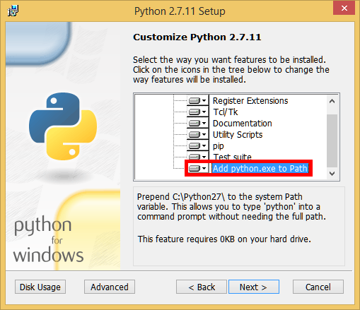

Screen shot of the Customize Python 2.7.11 screen, where you need to select Add python.exe to Path

* Microsoft Visual C++ Compiler for Python 2.7 from the [Microsoft Download Center](https://www.microsoft.com/download/details.aspx?id=44266).

## Step 1: Create a DocumentDB database account

Let’s start by creating a DocumentDB account. If you already have an account, you can skip to Step 2: Create a new Python Flask web application.

[AZURE.INCLUDE [documentdb-create-dbaccount](../includes/documentdb-create-dbaccount.md)]

We will now walk through how to create a new Python Flask web application from the ground up.

## Step 2: Create a new Python Flask web application

1. In Visual Studio, on the **File** menu, point to **New**, and then click **Project**.

* The **New Project** dialog box appears.

1. In the left pane, expand **Templates** and then **Python**, and then click **Web**.
2. Select **Flask Web Project** in the center pane, then in the **Name** box type **tutorial**, and then click **OK**. Remember that Python package names should be all lowercase, as described in the [Style Guide for Python Code](https://www.python.org/dev/peps/pep-0008/#package-and-module-names).

* For those new to Python Flask, it is a web application development framework that helps you build web applications in Python faster.
* 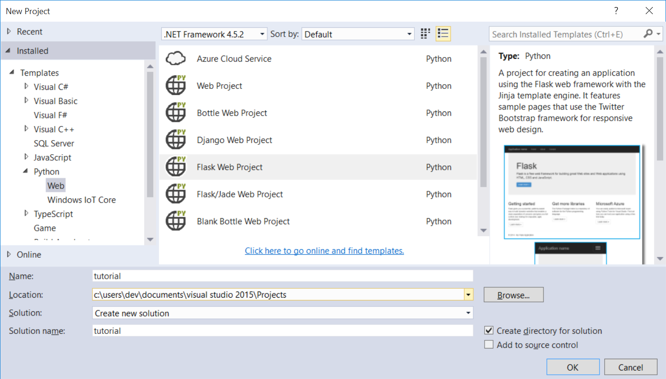
* Screen shot of the New Project window in Visual Studio with Python highlighted on the left, Python Flask Web Project selected in the middle, and the name tutorial in the Name box

1. In the **Python Tools for Visual Studio** window, click **Install into a virtual environment**.

* 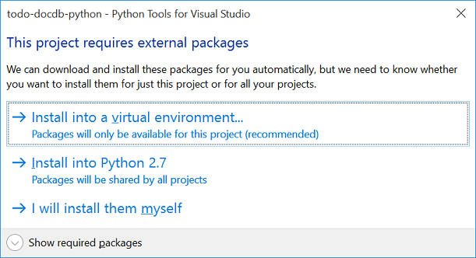
* Screen shot of the database tutorial - Python Tools for Visual Studio window

1. In the **Add Virtual Environment** window, you can accept the defaults and use Python 2.7 as the base environment because PyDocumentDB does not currently support Python 3.x, and then click **Create**. This sets up the required Python virtual environment for your project.

* 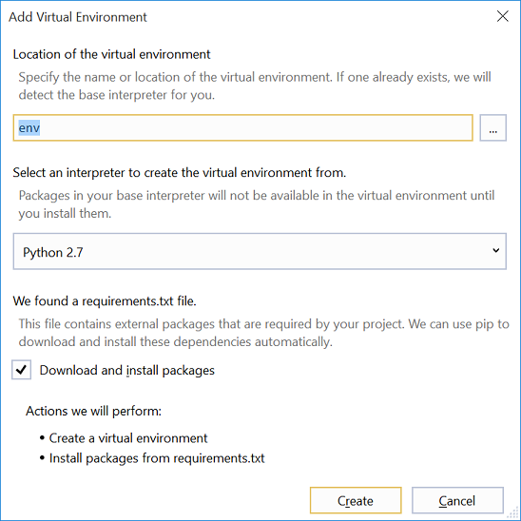
* Screen shot of the database tutorial - Python Tools for Visual Studio window
* The output window displays Successfully installed Flask-0.10.1 Jinja2-2.8 MarkupSafe-0.23 Werkzeug-0.11.5 itsdangerous-0.24 'requirements.txt' was installed successfully. when the environment is successfully installed.

## Step 3: Modify the Python Flask web application

### Add the Python Flask packages to your project

After your project is set up, you’ll need to add the required Flask packages to your project, including pydocumentdb, the Python package for DocumentDB.

1. In Solution Explorer, open the file named **requirements.txt** and replace the contents with the following:

* flask==0.9  
  flask-mail==0.7.6  
  sqlalchemy==0.7.9  
  flask-sqlalchemy==0.16  
  sqlalchemy-migrate==0.7.2  
  flask-whooshalchemy==0.55a  
  flask-wtf==0.8.4  
  pytz==2013b  
  flask-babel==0.8  
  flup  
  pydocumentdb>=1.0.0

1. Save the **requirements.txt** file.
2. In Solution Explorer, right-click **env** and click **Install from requirements.txt**.

* 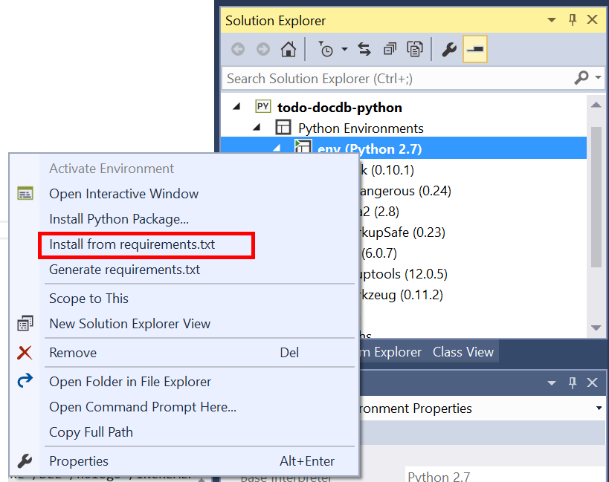
* Screen shot showing env (Python 2.7) selected with Install from requirements.txt highlighted in the list
* After successful installation, the output window displays the following:
* Successfully installed Babel-2.3.2 Tempita-0.5.2 WTForms-2.1 Whoosh-2.7.4 blinker-1.4 decorator-4.0.9 flask-0.9 flask-babel-0.8 flask-mail-0.7.6 flask-sqlalchemy-0.16 flask-whooshalchemy-0.55a0 flask-wtf-0.8.4 flup-1.0.2 pydocumentdb-1.6.1 pytz-2013b0 speaklater-1.3 sqlalchemy-0.7.9 sqlalchemy-migrate-0.7.2
* [AZURE.NOTE] In rare cases, you might see a failure in the output window. If this happens, check if the error is related to cleanup. Sometimes the cleanup fails, but the installation will still be successful (scroll up in the output window to verify this). You can check your installation by Verifying the virtual environment. If the installation failed but the verification is successful, it’s OK to continue.

### Verify the virtual environment

Let’s make sure that everything is installed correctly.

1. Build the solution by pressing **Ctrl**+**Shift**+**B**.
2. Once the build succeeds, start the website by pressing **F5**. This launches the Flask development server and starts your web browser. You should see the following page.

* 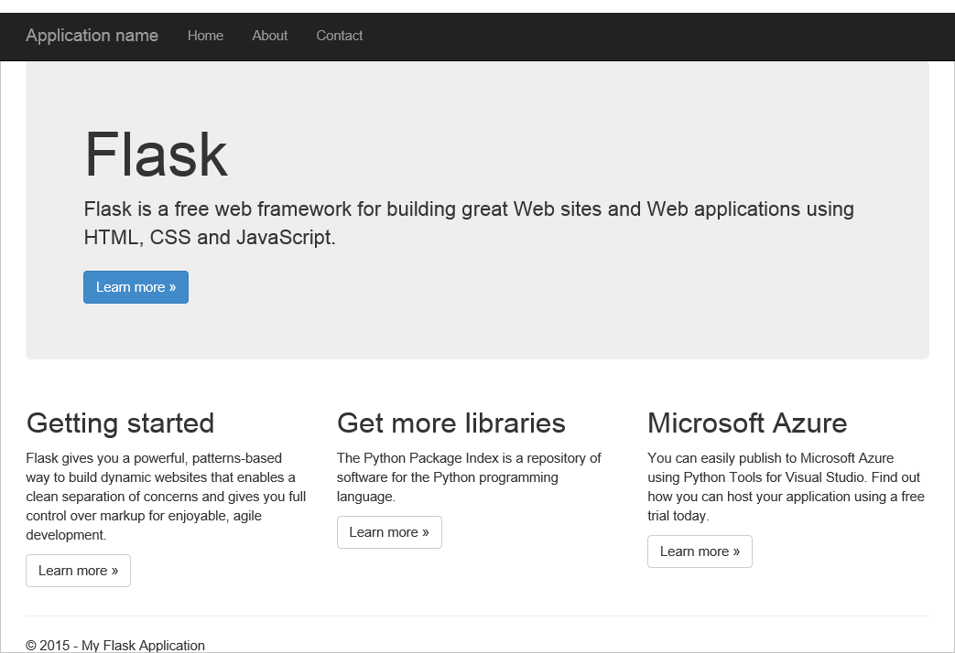
* The empty Python Flask web development project displayed in a browser

1. Stop debugging the website by pressing **Shift**+**F5** in Visual Studio.

### Create database, collection, and document definitions

Now let’s create your voting application by adding new files and updating others.

1. In Solution Explorer, right-click the **tutorial** project, click **Add**, and then click **New Item**. Select **Empty Python File** and name the file **forms.py**.
2. Add the following code to the forms.py file, and then save the file.

from flask.ext.wtf import Form  
from wtforms import RadioField  
  
class VoteForm(Form):  
 deploy_preference = RadioField('Deployment Preference', choices=[  
 ('Web Site', 'Web Site'),  
 ('Cloud Service', 'Cloud Service'),  
 ('Virtual Machine', 'Virtual Machine')], default='Web Site')

### Add the required imports to views.py

1. In Solution Explorer, expand the **tutorial** folder, and open the **views.py** file.
2. Add the following import statements to the top of the **views.py** file, then save the file. These import DocumentDB’s PythonSDK and the Flask packages.

* from forms import VoteForm  
  import config  
  import pydocumentdb.document_client as document_client

### Create database, collection, and document

* Still in **views.py**, add the following code to the end of the file. This takes care of creating the database used by the form. Do not delete any of the existing code in **views.py**. Simply append this to the end.

@app.route('/create')  
def create():  
 """Renders the contact page."""  
 client = document_client.DocumentClient(config.DOCUMENTDB_HOST, {'masterKey': config.DOCUMENTDB_KEY})  
  
 # Attempt to delete the database. This allows this to be used to recreate as well as create  
 try:  
 db = next((data for data in client.ReadDatabases() if data['id'] == config.DOCUMENTDB_DATABASE))  
 client.DeleteDatabase(db['_self'])  
 except:  
 pass  
  
 # Create database  
 db = client.CreateDatabase({ 'id': config.DOCUMENTDB_DATABASE })  
  
 # Create collection  
 collection = client.CreateCollection(db['_self'],{ 'id': config.DOCUMENTDB_COLLECTION }, { 'offerType': 'S1' })  
  
 # Create document  
 document = client.CreateDocument(collection['_self'],  
 { 'id': config.DOCUMENTDB_DOCUMENT,  
 'Web Site': 0,  
 'Cloud Service': 0,  
 'Virtual Machine': 0,  
 'name': config.DOCUMENTDB_DOCUMENT   
 })  
  
 return render_template(  
 'create.html',  
 title='Create Page',  
 year=datetime.now().year,  
 message='You just created a new database, collection, and document. Your old votes have been deleted')

[AZURE.TIP] The **CreateCollection** method takes an optional **RequestOptions** as the third parameter. This can be used to specify the Offer Type for the collection. If no offerType value is supplied, then the collection will be created using the default Offer Type. For more information on DocumentDB Offer Types, see [Performance levels in DocumentDB](/documentation/articles/documentdb-performance-levels).

### Read database, collection, document, and submit form

* Still in **views.py**, add the following code to the end of the file. This takes care of setting up the form, reading the database, collection, and document. Do not delete any of the existing code in **views.py**. Simply append this to the end.

@app.route('/vote', methods=['GET', 'POST'])  
def vote():   
 form = VoteForm()  
 replaced_document ={}  
 if form.validate_on_submit(): # is user submitted vote   
 client = document_client.DocumentClient(config.DOCUMENTDB_HOST, {'masterKey': config.DOCUMENTDB_KEY})  
  
 # Read databases and take first since id should not be duplicated.  
 db = next((data for data in client.ReadDatabases() if data['id'] == config.DOCUMENTDB_DATABASE))  
  
 # Read collections and take first since id should not be duplicated.  
 coll = next((coll for coll in client.ReadCollections(db['_self']) if coll['id'] == config.DOCUMENTDB_COLLECTION))  
  
 # Read documents and take first since id should not be duplicated.  
 doc = next((doc for doc in client.ReadDocuments(coll['_self']) if doc['id'] == config.DOCUMENTDB_DOCUMENT))  
  
 # Take the data from the deploy_preference and increment our database  
 doc[form.deploy_preference.data] = doc[form.deploy_preference.data] + 1  
 replaced_document = client.ReplaceDocument(doc['_self'], doc)  
  
 # Create a model to pass to results.html  
 class VoteObject:  
 choices = dict()  
 total_votes = 0  
  
 vote_object = VoteObject()  
 vote_object.choices = {  
 "Web Site" : doc['Web Site'],  
 "Cloud Service" : doc['Cloud Service'],  
 "Virtual Machine" : doc['Virtual Machine']  
 }  
 vote_object.total_votes = sum(vote_object.choices.values())  
  
 return render_template(  
 'results.html',   
 year=datetime.now().year,   
 vote_object = vote_object)  
  
 else :  
 return render_template(  
 'vote.html',   
 title = 'Vote',  
 year=datetime.now().year,  
 form = form)

### Create the HTML files

1. In Solution Explorer, in the **tutorial** folder, right click the **templates** folder, click **Add**, and then click **New Item**.
2. Select **HTML Page**, and then in the name box type **create.html**.
3. Repeat steps 1 and 2 to create two additional HTML files: results.html and vote.html.
4. Add the following code to **create.html** in the <body> element. It displays a message stating that we created a new database, collection, and document.

* {% extends "layout.html" %}  
  {% block content %}  
  <h2>{{ title }}.</h2>  
  <h3>{{ message }}</h3>  
  <p><a href="{{ url_for('vote') }}" class="btn btn-primary btn-large">Vote &raquo;</a></p>  
  {% endblock %}

1. Add the following code to **results.html** in the <body> element. It displays the results of the poll.

* {% extends "layout.html" %}  
  {% block content %}  
  <h2>Results of the vote</h2>  
   <br />  
    
  {% for choice in vote_object.choices %}  
  <div class="row">  
   <div class="col-sm-5">{{choice}}</div>  
   <div class="col-sm-5">  
   <div class="progress">  
   <div class="progress-bar" role="progressbar" aria-valuenow="{{vote_object.choices[choice]}}" aria-valuemin="0" aria-valuemax="{{vote_object.total_votes}}" style="width: {{(vote_object.choices[choice]/vote_object.total_votes)*100}}%;">  
   {{vote_object.choices[choice]}}  
   </div>  
   </div>  
   </div>  
  </div>  
  {% endfor %}  
    
  <br />  
  <a class="btn btn-primary" href="{{ url_for('vote') }}">Vote again?</a>  
  {% endblock %}

1. Add the following code to **vote.html** in the <body> element. It displays the poll and accepts the votes. On registering the votes, the control is passed over to views.py where we will recognize the vote cast and append the document accordingly.

* {% extends "layout.html" %}  
  {% block content %}  
  <h2>What is your favorite way to host an application on Azure?</h2>  
  <form action="" method="post" name="vote">  
   {{form.hidden_tag()}}  
   {{form.deploy_preference}}  
   <button class="btn btn-primary" type="submit">Vote</button>  
  </form>  
  {% endblock %}

1. In the **templates** folder, replace the contents of **index.html** with the following. This serves as the landing page for your application.

* {% extends "layout.html" %}  
  {% block content %}  
  <h2>Python + DocumentDB Voting Application.</h2>  
  <h3>This is a sample DocumentDB voting application using PyDocumentDB</h3>  
  <p><a href="{{ url_for('create') }}" class="btn btn-primary btn-large">Create/Clear the Voting Database &raquo;</a></p>  
  <p><a href="{{ url_for('vote') }}" class="btn btn-primary btn-large">Vote &raquo;</a></p>  
  {% endblock %}

### Add a configuration file and change the __init__.py

1. In Solution Explorer, right-click the **tutorial** project, click **Add**, click **New Item**, select **Empty Python File**, and then name the file **config.py**. This config file is required by forms in Flask. You can use it to provide a secret key as well. This key is not needed for this tutorial though.
2. Add the following code to config.py, you’ll need to alter the values of **DOCUMENTDB_HOST** and **DOCUMENTDB_KEY** in the next step.

* CSRF_ENABLED = True  
  SECRET_KEY = 'you-will-never-guess'  
    
  DOCUMENTDB_HOST = 'https://YOUR_DOCUMENTDB_NAME.documents.azure.com:443/'  
  DOCUMENTDB_KEY = 'YOUR_SECRET_KEY_ENDING_IN_=='  
    
  DOCUMENTDB_DATABASE = 'voting database'  
  DOCUMENTDB_COLLECTION = 'voting collection'  
  DOCUMENTDB_DOCUMENT = 'voting document'

1. In the [Azure portal](https://portal.azure.com/), navigate to the **Keys** blade by clicking **Browse**, **DocumentDB Accounts**, double-click the name of the account to use, and then click the **Keys** button in the **Essentials** area. In the **Keys** blade, copy the **URI** value and paste it into the **config.py** file, as the value for the **DOCUMENTDB_HOST** property.
2. Back in the Azure portal, in the **Keys** blade, copy the value of the **Primary Key** or the **Secondary Key**, and paste it into the **config.py** file, as the value for the **DOCUMENTDB_KEY** property.
3. In the **__init__.py** file, add the following line.

* app.config.from_object('config')
* So that the content of the file is:
* from flask import Flask  
  app = Flask(__name__)  
  app.config.from_object('config')  
  import tutorial.views

1. After adding all the files, Solution Explorer should look like this:

* 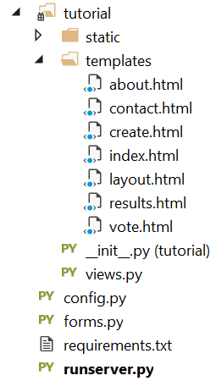
* Screen shot of the Visual Studio Solution Explorer window

## Step 4: Run your web application locally

1. Build the solution by pressing **Ctrl**+**Shift**+**B**.
2. Once the build succeeds, start the website by pressing **F5**. You should see the following on your screen.

* 
* Screen shot of the Python + DocumentDB Voting Application displayed in a web browser

1. Click **Create/Clear the Voting Database** to generate the database.

* 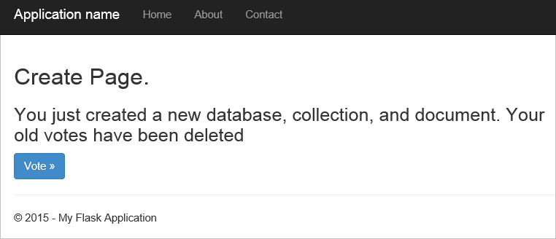
* Screen shot of the Create Page of the web application – development details

1. Then, click **Vote** and select your option.

* 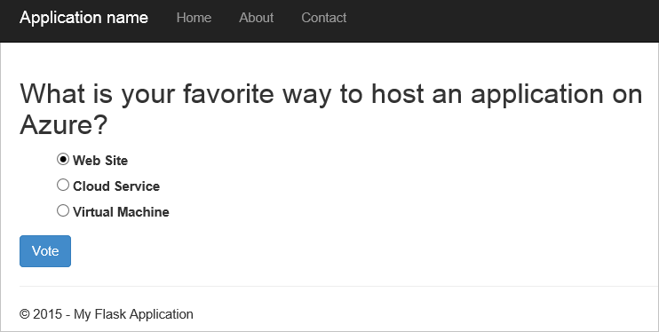
* Screen shot of the web application with a voting question posed

1. For every vote you cast, it increments the appropriate counter.

* 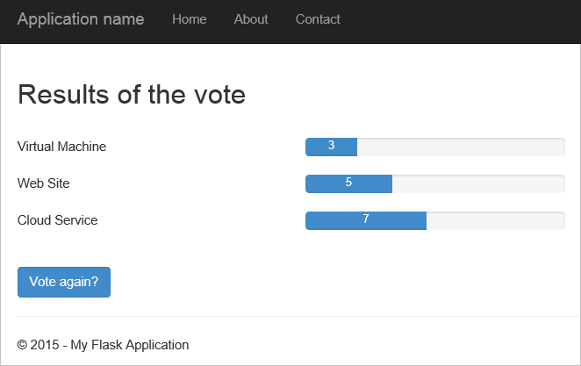
* Screen shot of the Results of the vote page shown

1. Stop debugging the project by pressing Shift+F5.

## Step 5: Deploy the web application to Azure Websites

Now that you have the complete application working correctly against DocumentDB, we’re going to deploy this to Azure Websites.

1. Right-click the project in Solution Explorer (make sure you’re not still running it locally) and select **Publish**.

* 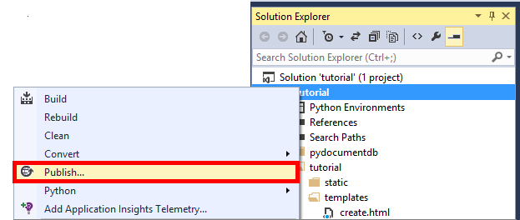
* Screen shot of the tutorial selected in Solution Explorer, with the Publish option highlighted

1. In the **Publish Web** window, select **Microsoft Azure Web Apps**, and then click **Next**.

* 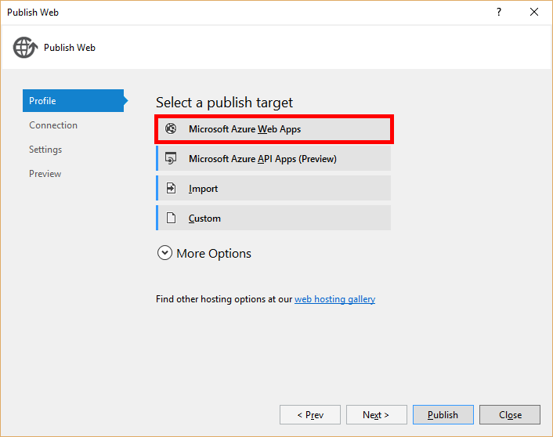
* Screen shot of the Publish Web window with Microsoft Azure Web Apps highlighted

1. In the **Microsoft Azure Web Apps Window** window, click **New**.

* 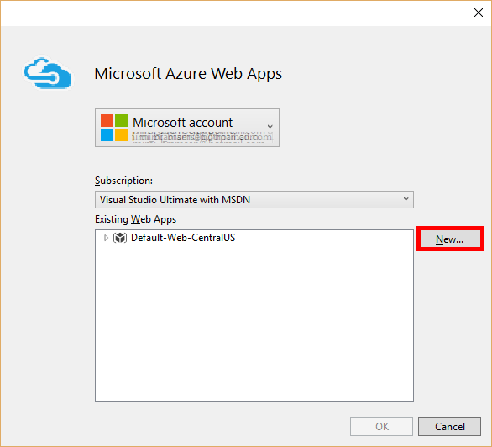
* Screen shot of the Microsoft Azure Web Apps Window window

1. In the **Create site on Microsoft Azure** window, enter a **Web app name**, **App Service plan**, **Resource group**, and **Region**, then click **Create**.

* 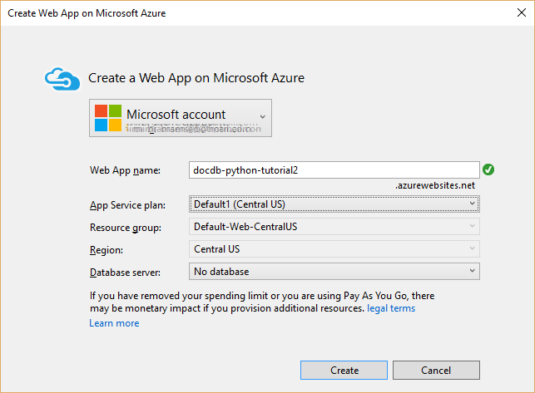
* Screen shot of the Create site on Microsoft Azure window

1. In the **Publish Web** window, click **Publish**.

* 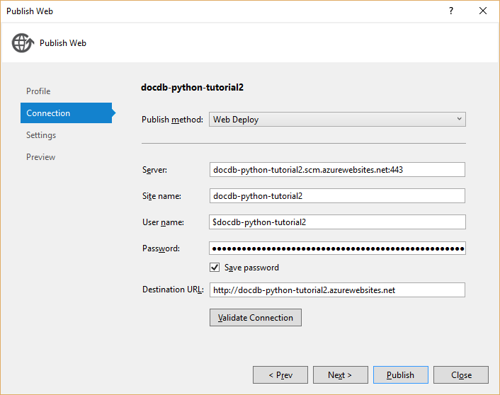
* Screen shot of the Create site on Microsoft Azure window

1. In a few seconds, Visual Studio will finish publishing your web application and launch a browser where you can see your handy work running in Azure!

## Troubleshooting

If this is the first Python app you’ve run on your computer, ensure that the following folders (or the equivalent installation locations) are included in your PATH variable:

C:\Python27\site-packages;C:\Python27\;C:\Python27\Scripts;

If you receive an error on your vote page, and you named your project something other than **tutorial**, make sure that **__init__.py** references the correct project name in the line: import tutorial.view.

## Next steps

Congratulations! You have just completed your first Python web application using Azure DocumentDB and published it to Azure Websites.

We update and improve this topic frequently based on your feedback. Once you’ve completed the tutorial, please using the voting buttons at the top and bottom of this page, and be sure to include your feedback on what improvements you want to see made. If you’d like us to contact you directly, feel free to include your email address in your comments.

To add additional functionality to your web application, review the APIs available in the [DocumentDB Python SDK](/documentation/articles/documentdb-sdk-python).

For more information about Azure, Visual Studio, and Python, see the [Python Developer Center](https://azure.microsoft.com/develop/python/).

For additional Python Flask tutorials, see [The Flask Mega-Tutorial, Part I: Hello, World!](http://blog.miguelgrinberg.com/post/the-flask-mega-tutorial-part-i-hello-world).