# DocumentDB SQL cheat sheet PDF

The **DocumentDB SQL Query Cheat Sheet** helps you quickly write queries for DocumentDB data by displaying common queries, keywords, built-in functions, and operators in an easy to print PDF reference sheet.

DocumentDB supports relational, hierarchical, and spatial querying of JSON documents using [SQL](/documentation/articles/documentdb-sql-query) without specifying a schema or secondary indexes. In addition to the standard ANSI-SQL keywords and operators, DocumentDB supports JavaScript user defined functions (UDFs), JavaScript operators, and a multitude of built-in functions.

## Download the DocumentDB SQL query cheat sheet PDF

Write your queries faster by downloading the SQL query cheat sheet and using it as a quick reference. The SQL cheat sheet PDF shows common queries used to retrieve data from two example JSON documents. To keep it nearby, you can print the single-sided SQL query cheat sheet in page letter size (8.5 x 11 in.).

**Download the SQL cheat sheet here:** [**Microsoft Azure DocumentDB SQL cheat sheet**](http://go.microsoft.com/fwlink/?LinkId=623215)

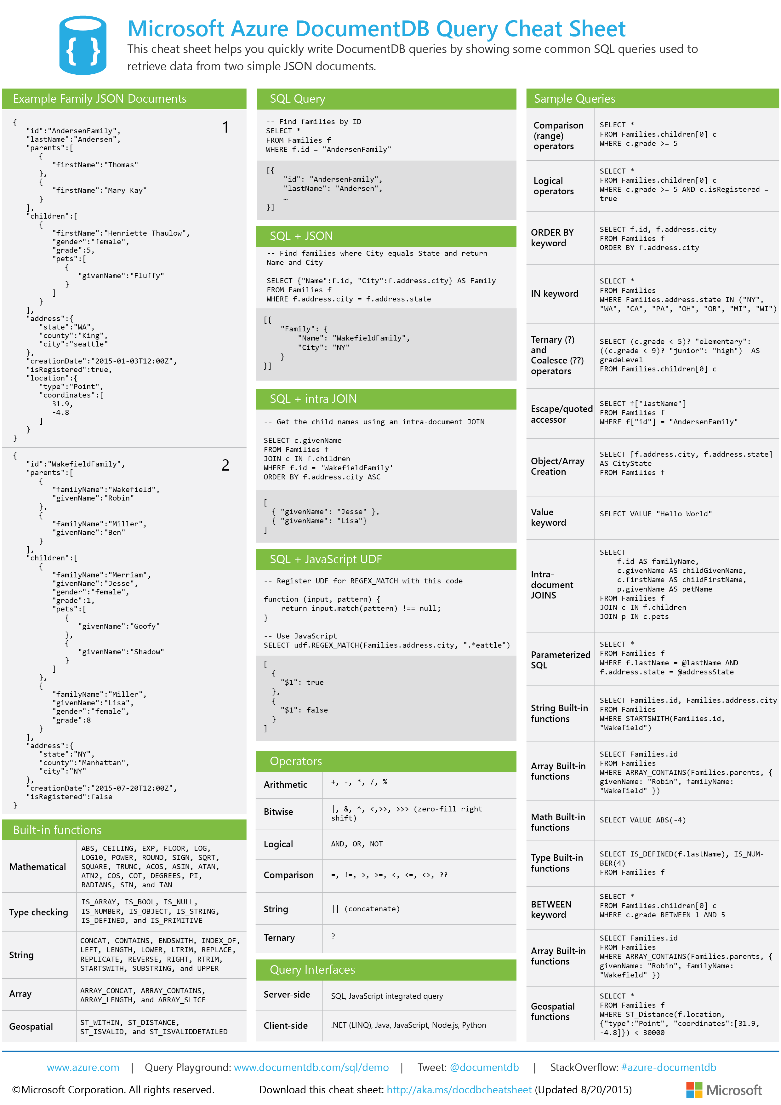

DocumentDB SQL query cheat sheet: A quick reference PDF to the SQL syntax supported by DocumentDB - SQL cheat sheet, SQL cheat sheet PDF, SQL quick reference

## More help with writing SQL queries

* For a walk through of the query options available in DocumentDB, see [Query DocumentDB](/documentation/articles/documentdb-sql-query).
* For the related reference documentation, see [DocumentDB SQL Query Language](https://msdn.microsoft.com/library/azure/dn782250.aspx).