Desk Number ________
Student Number _______________________
Student Name _______________________

School of Science and Engineering
MIDTERM EXAMINATION
Term 2, 2025
CSC1001 Introduction to Computer Science

Examination Duration: 120 minutes
Reading Time: 10 minutes
This examination has __5__ questions.
The score distribution of the 5 question is Question 1(40%), Question 2(20%), Question 3(10%), Question 4(15%), Question 5(15%)
Exam Conditions:
This is a FORMAL Examination
This is a RESTRICTED OPEN BOOK Exam. Maximum of one (1) sheet of handwritten notes double-sided are permitted
Materials Permitted In The Exam Venue:
Maximum of one (1) sheet of handwritten notes double sided are permitted. NO OTHER MATERIALS PERMITTED
Calculators without the functionalities of programming and file storage are permitted.
Materials To Be Supplied To Students:
1 × 6 Page Answer Booklet
You must write all your answers in your answer book.

Question 1. (40%)
Please describe what will be printed for each program as below.

 | Program | Printed Results
1) 3% | Explanation: 2**3 % 5 is 3, and 3 // 2 is 1. Replacing each 7 in "77" with 1 gives "11", or 11.0; the sum is 12.0. | Answer: 12.0
2) 3% | 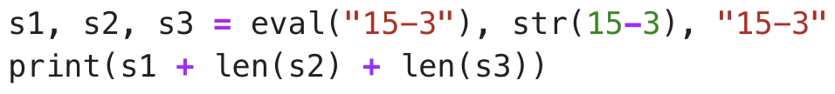  Explanation: eval("15-3") gives 12; str(15-3) is "12"; s3 is "15-3". Their string lengths are 2 and 4, so 12 + 2 + 4 = 18. | Answer: 18
3) 3% | 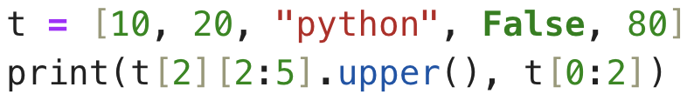  Explanation: t[2] is "python" and [2:5] selects "tho", whose uppercase form is "THO". t[0:2] selects [10, 20]. | Answer: THO [10, 20]
4) 3% | 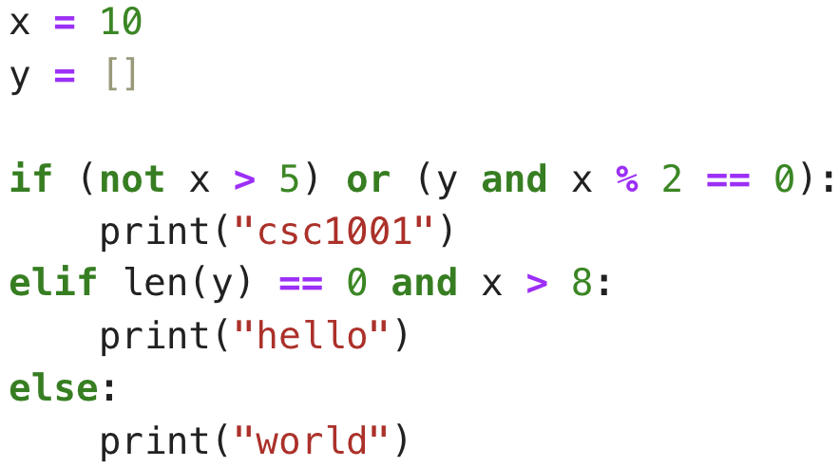  Explanation: x is 10 and y is empty. The first condition is false; len(y)==0 and x>8 are both true, so the elif branch prints hello. | Answer: hello
5) 3% | 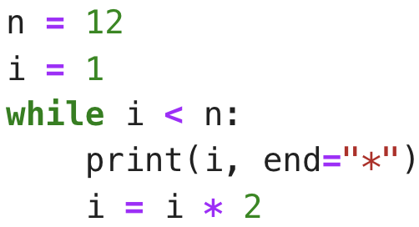  Explanation: i starts at 1 and doubles after each print. The values 1, 2, 4, and 8 are below 12; 16 ends the loop. | Answer: 1*2*4*8*
6) 4% | 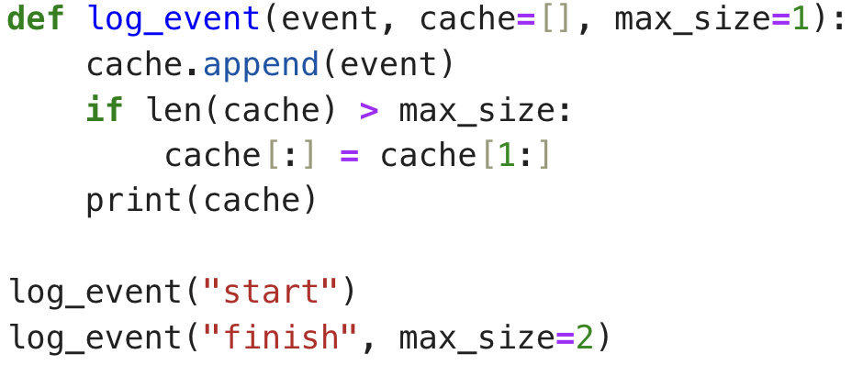  Explanation: Appending finish makes the cache length 2, greater than max_size 1, so the oldest event is removed. | Answer: ["finish"]
7) 4% | 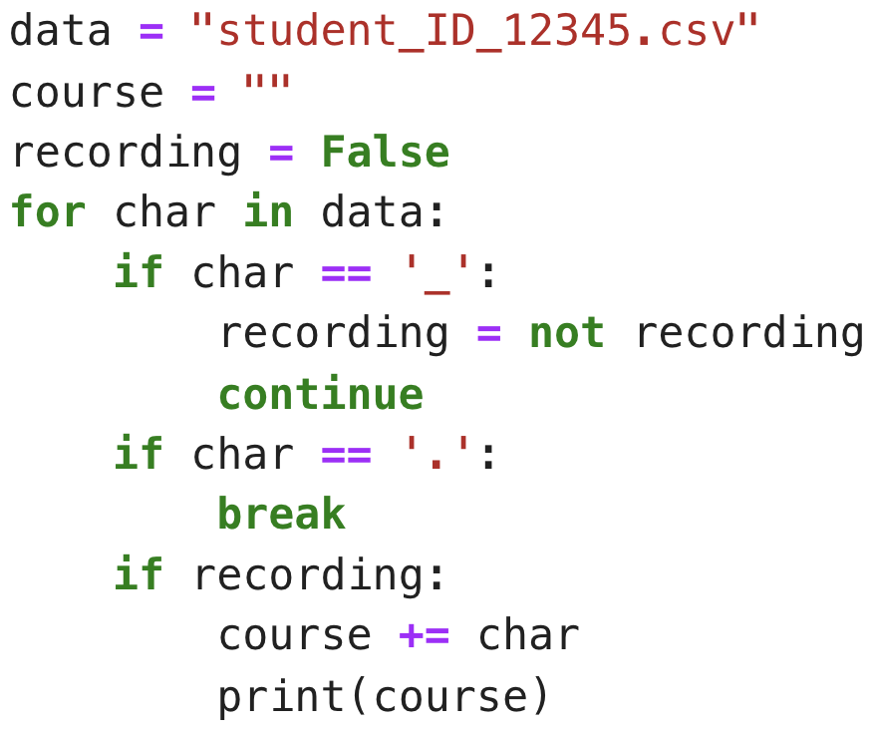  Explanation: The two underscores toggle recording on and then off. Digits follow the second underscore, so none are collected before the period ends the loop; course remains empty. | Answer: "" (empty string)
8) 3% | 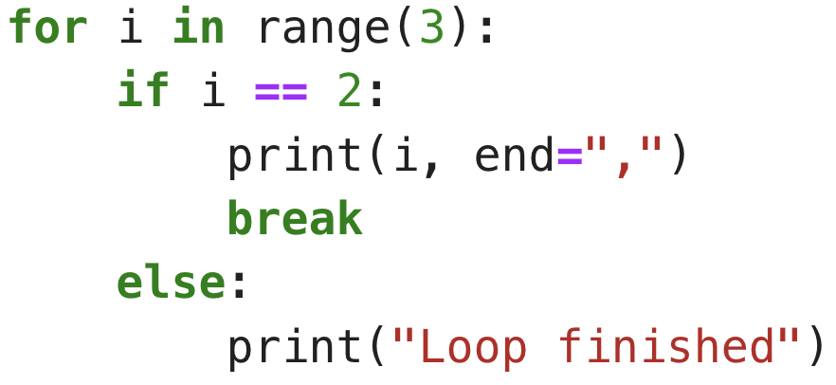  Explanation: For i=0 and i=1 the if condition is false, so the else suite prints Loop finished twice. At i=2 the if branch prints 2, then break ends the loop. | Answer: "Loop finishedLoop finished2,"
9) 3% | 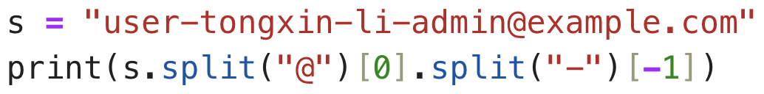  Explanation: Splitting at @ selects the username. Splitting on hyphens and taking the final piece returns admin. | Answer: "admin"
10) 4% | 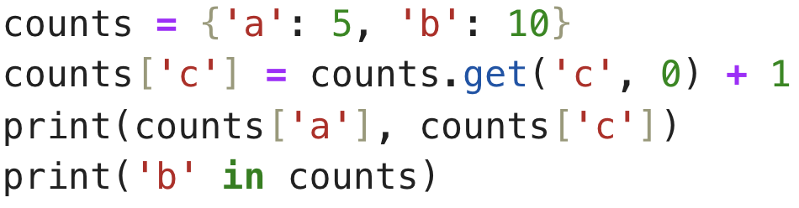  Explanation: The missing count for c defaults to 0 and is incremented to 1. The outputs are a count 5, c count 1, and True for b membership. | Answer: 5 1 True
11) 3% | 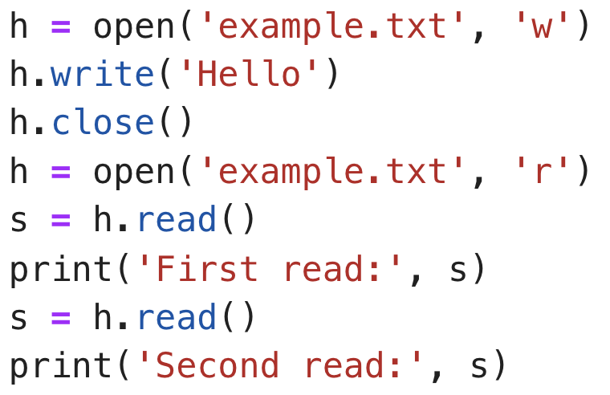  Explanation: The first read consumes Hello. The next read starts at end of file and returns an empty string. | Answer: "First read: Hello" then "Second read: "
12) 4% | 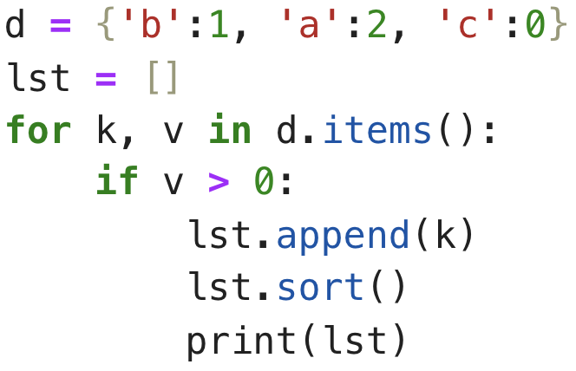  Explanation: Only b and a have positive values. Sorting those keys alphabetically gives [a, b]. | Answer: ["a", "b"]

Question 2. (5*4% = 20%)
Please answer the following short questions.
- Provide the Binary and Hexadecimal representations of the decimal number 29.25.
Answer: Binary = 11101.01; hexadecimal = 1D.4.
Explanation: 29 is 11101₂ and 0.25 is .01₂. Grouping into four-bit digits gives 0001 1101 . 0100 = 1D.4₁₆.

- Please list two advantages of using binary numbers in modern computer systems.
Answer: Binary states are reliable in electronic circuits and support simple, efficient Boolean logic.
Explanation: Two voltage states are easy to distinguish despite electrical noise, and Boolean operations map directly to digital circuits.

- Please describe the differences between arguments and parameters.
Answer: Parameters are names in a function definition; arguments are values passed in a function call.
Explanation: In def f(x), x is a parameter; in f(3), 3 is an argument.
- Will the following be implemented without causing an error? (Yes/No)
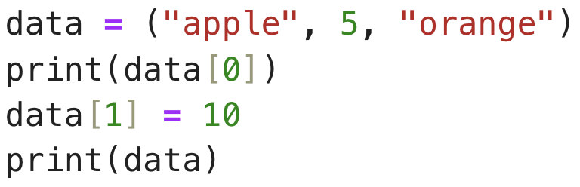
Answer: No. The code causes a TypeError.
Explanation: Tuples are immutable. Reading data[0] is valid, but assigning a new value to data[1] raises TypeError.

Explain the difference between a list and a tuple in Python. Provide one reason to use a tuple instead of a list.
Answer: A list is mutable; a tuple is immutable. A tuple is useful for fixed data that should not change.
Explanation: Lists allow item assignment, while tuple elements cannot be reassigned after creation.

- What is the purpose of the return keyword in a function? What happens if a function does not have a return statement?
Answer: return sends a result to the caller and ends the function. Without an explicit return, the function returns None.
Explanation: The caller can use the returned value. Reaching the end without returning a value produces None.

Question 3. (10%)
Write a Python program that plays a number-guessing game with a user. The game should follow these rules:
- The computer fixes a secret random integer between 1 and 50.
- The user gets a maximum of 5 attempts to guess the number.
- After each guess, the program must provide feedback to the user, telling them if their guess was "Too high!" or "Too low!".
- If the user guesses correctly, the game ends, and the program prints a success message, like "Correct! You guessed it in [N] attempts." where N is the total number of attempts.
- If the user runs out of attempts, the game ends, and the program should reveal the secret number, printing "Sorry, you've run out of attempts. The secret number was [X]." where X is the correct integer.

Answer and explanation:
import random
secret = random.randint(1, 50)
for attempt in range(1, 6):
guess = int(input("Guess a number from 1 to 50: "))
if guess == secret:
print(f"Correct! You guessed it in {attempt} attempts.")
break
elif guess > secret:
print("Too high!")
else:
print("Too low!")
else:
print(f"Sorry, you've run out of attempts. The secret number was {secret}.")
randint(1, 50) includes both endpoints. The loop allows at most five guesses. It gives high/low feedback, breaks on success, and runs its else clause only if all tries finish without a break.

Question 4. (15%)
Please first explain the usage of the built-in string method find(). Then, write a function myFind(main_string, sub_string):
- main_string is the string to be searched.
- sub_string is the string to search for.
- The function should return the ending index of the first occurrence of sub_string within main_string.
- If sub_string is not found, the function should return -1.
You may not use the built-in find() or index() methods in your implementation.
(e.g., if main_string is "hello world csc1001" and sub_string is "world", the result should be 10)

Answer and explanation: The built-in find(sub_string) returns the starting index of the first match, or -1 if absent. The example specifies the final matched character's index: world occupies indices 6 through 10, so it returns 10.
def myFind(main_string, sub_string):
if sub_string == "":
return -1
for i in range(len(main_string) - len(sub_string) + 1):
j = 0
while j < len(sub_string) and main_string[i + j] == sub_string[j]:
j += 1
if j == len(sub_string):
return i + len(sub_string) - 1
return -1
Each possible starting position is checked character by character. A full match returns the index of its last character, matching the example; if none matches, the function returns -1.

Question 5. (15%)
You are in charge of counting the votes for a class election. You have a file, votes.txt, where every line contains the name of the candidate who received a vote.
Example votes.txt content:
Alice
Bob
Alice
Charlie
Alice
Bob
…

Please write a Python program that:

- Reads the votes.txt file.
- Counts the total number of votes for each candidate.
- Creates a new file named results.txt that lists each candidate and their total vote count, sorted alphabetically by the candidate's name.

Answer and explanation:
votes = {}
with open("votes.txt", "r") as source:
for line in source:
name = line.strip()
if name:
votes[name] = votes.get(name, 0) + 1
with open("results.txt", "w") as output:
for name in sorted(votes):
output.write(f"{name} {votes[name]}\n")
strip() removes each line ending. The dictionary tracks vote totals, and sorted(votes) writes candidates alphabetically. The sample results are Alice 3, Bob 2, and Charlie 1.

END OF EXAMINATION

