Desk Number ________
Student Number _______________________
Student Name _______________________

School of Science and Engineering
MIDTERM EXAMINATION
Term 2, 2024
CSC1001 Introduction to Computer Science

Examination Duration: 120 minutes
Reading Time: 10 minutes
This examination has __5__ questions.
The score distribution of the 5 question is Question 1(40%), Question 2(20%), Question 3(10%), Question 4(15%), Question 5(15%)
Exam Conditions:
This is a FORMAL Examination
This is a RESTRICTED OPEN BOOK Exam. Maximum of one (1) sheet of handwritten notes double sided are permitted
Materials Permitted In The Exam Venue:
Maximum of one (1) sheet of handwritten notes double sided are permitted. NO OTHER MATERIALS PERMITTED
Any calculators without the functionalities of programming and file storage are permitted.
Materials To Be Supplied To Students:
1 × 6 Page Answer Booklet
You must write all your answers in your answer book.

Question 1. (40%)
Please describe what will be printed for each program as below.

 | Program | Printed Results
1) 3% | 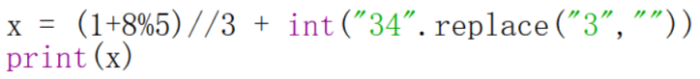  Explanation: 8 % 5 is 3, so (1 + 3) // 3 is 1. Replacing 3 with an empty string in "34" gives "4", so the expression is 1 + 4 = 5. | 5  3分
2) 3% | 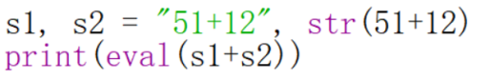  Explanation: s1 is the string "51+12" and s2 is "63". Concatenation gives "51+1263", which eval evaluates as 51 + 1263 = 1314. | 1314  3分
3) 3% | 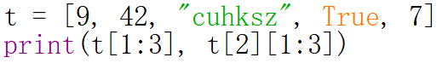  Explanation: t[1:3] selects items at indices 1 and 2, yielding [42, "cuhksz"]. The slice t[2][1:3] selects characters u and h. | [42, ‘cuhksz’] uh  各 1分
4) 3% | 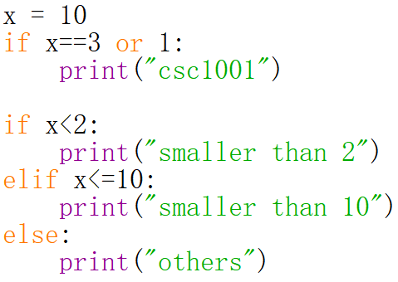  Explanation: x == 3 or 1 is true because 1 is truthy, so "csc1001" prints. Then x < 2 is false and x <= 10 is true, so "smaller than 10" prints. | csc 1001 (1分)  smaller than 10 (2分)
5) 3% | 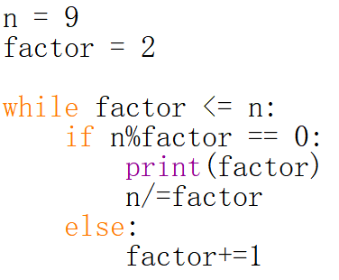  Explanation: The first divisor found is 3, so it prints 3 and integer-divides n from 9 to 3. It prints 3 once more, reduces n to 1, then exits. | 3 (1分)  3 (2分)
6) 3% | 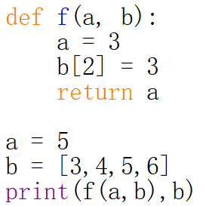  Explanation: Inside f, local a becomes 3 and the shared list is mutated at index 2. The function returns 3; afterward b is [3, 4, 3, 6]. | 3 [3,4,3,6]  1分 +2分
7) 4% | 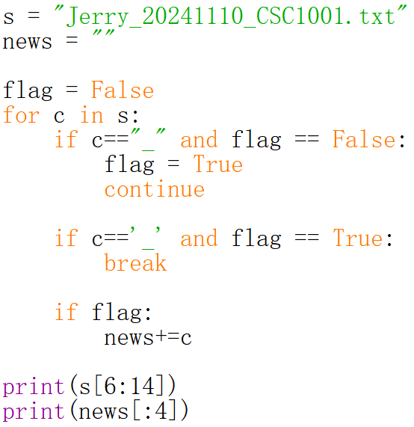  Explanation: The first underscore sets flag to True and is skipped. Characters are accumulated up to the next underscore, which ends the loop. s[6:14] is "20241110" and news[:4] is "2024". | 20241110 (1分)  2024 （2分）
8) 4% | 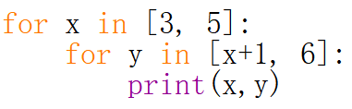  Explanation: For x=3, y iterates through 4, 5, 6. For x=5, y iterates through 6, 7, 8. The nested loops print each pair on a separate line. | 3 4 各1分  3 6  5 6  5 6
9) 3% | 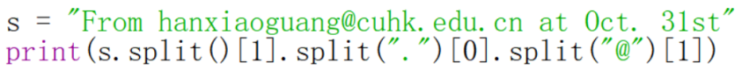  Explanation: Whitespace splitting makes the email address the second word. Splitting it at the period selects hanxiaoguang@cuhk; splitting that at @ and taking index 1 gives cuhk. | cuhk  3分
10) 4% | 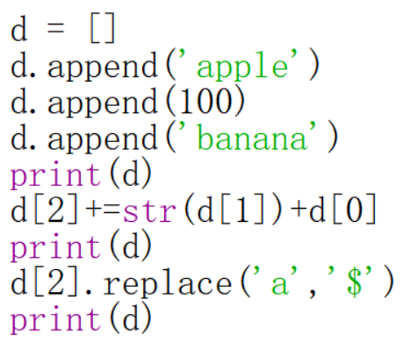  Explanation: The first print shows the initial list. += appends the string 100apple to banana. replace() returns a new string, but its result is not assigned, so the final list stays unchanged. | ['apple', 100, 'banana'] （1分）  ['apple', 100, 'banana100apple'] （1分）  ['apple', 100, 'banana100apple']  （2分）
11) 3% | 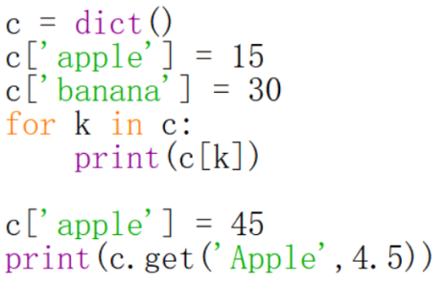  Explanation: The dictionary loop prints values 15 and 30. "Apple" differs from the key "apple", so get returns the default value 4.5. | 15  30  4.5  各 1分
12) 4% | 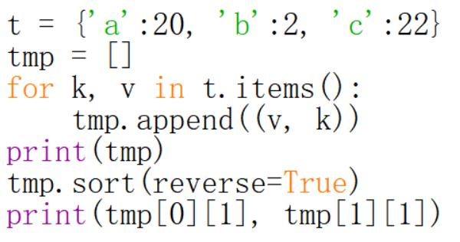  Explanation: The items are sorted in reverse tuple order by value: (22,"c"), (20,"a"), (2,"b"). The last expression prints the first two keys, c a. | [(20, ‘a’), (2, ‘b’), (22, ‘c’)] （2分）  c a （各1分）

Question 2. (5*4% = 20%)
Please answer the following short questions.
- Please provide the Octal and Hexadecimal version of the binary number (11101110.0111).
Octal - 356.34; Hex - EE.7各2分
Explanation: Group binary digits in threes around the radix point: 011 101 110 . 011 100 = octal 356.34. Grouping in fours gives 1110 1110 . 0111 0000 = hexadecimal EE.70, also written EE.7.
- Please explain why python is a high-level programming language.
High development efficiency, easier to understood by programmers. (酌情给分)
Explanation: Python has readable high-level constructs and handles many low-level details, improving development speed and making code easier to understand.
- Please describe the differences between arguments and parameters.
Arguments- 实参； parameters - 形参 （各2分）
Explanation: Parameters are names in a function definition; arguments are the actual values or expressions supplied when the function is called.
- Use an example to explain the differences between “break” and “continue”.
Break stop the loop; continue stop the iteration (各2分)
Explanation: break exits the nearest loop immediately. continue skips the rest of the current iteration and starts the next iteration.
- Providing two ways to read the text from a file.
for line in fhand; fhand.read() (各2分)
Explanation: for line in fhand reads one line at a time; fhand.read() reads the remaining file contents as one string.

Question 3. (10%)
Given a list of valid passwords which are stored in keys (a list). Each password is in string type. Please write a program to instruct users to input a password until it matches one of the strings in keys. If the user enters more than 5 times, you should end the program and print a warning.

while True - 2分
input 函数 - 2分
Check input in keys - 2分
Break - 2分
判断超过5次 - 2分
Explanation and sample solution: Keep an attempt counter, read a password on each pass, and test membership in keys. Stop on a match; after five failed attempts, print a warning.
for attempt in range(5):
password = input("Enter password: ")
if password in keys:
print("Access granted")
break
else:
print("Warning: too many attempts")
Question 4. (15%)
Please first explain the usage of split() function, and then implement a function “def mySplit(s, a)”: s is a string and a is a single character (in string type). Similar to the split() function, the output of the function is a list of sub-strings. (e.g., if s is “apple” and a is ‘p’, the result is [‘a’‘’,‘le’])
解释split的用法 - 3分
for 循环 - 2分
check == a - 2分
累加substring - 3分
append to a new list - 2分
考虑empty - 2分
return - 1分
Explanation and sample solution: split(a) separates a string at each occurrence of delimiter a and returns a list of pieces. Scanning left to right and appending the collected segment at each delimiter preserves empty pieces, including at the beginning, end, or between consecutive delimiters.
def mySplit(s, a):
parts = []
current = ""
for ch in s:
if ch == a:
parts.append(current)
current = ""
else:
current += ch
parts.append(current)
return parts
Question 5. (15%)
You are given a file (score.txt) which is of many lines. For each line, it consists of one student name and her/his score (e.g., Jerry 95). Please write a program to read them and output the ranked name (in a descending order) into a new file (rank.txt): one name per line.
open file - 1分
read - 2 分
take name and score out - 3 分
form a list of tuple type - 3 分
sort - 3 分
save to file - 3 分

Explanation and sample solution: Read each line, split it into the student's name and score, and store (score, name) pairs. Sort by score descending, then write each name to rank.txt in that order.
records = []
with open("score.txt") as source:
for line in source:
name, score = line.split()
records.append((int(score), name))
records.sort(reverse=True)
with open("rank.txt", "w") as output:
for score, name in records:
output.write(name + "\n")
END OF EXAMINATION

