**Tutorial**

**Step one: Copy the file name**

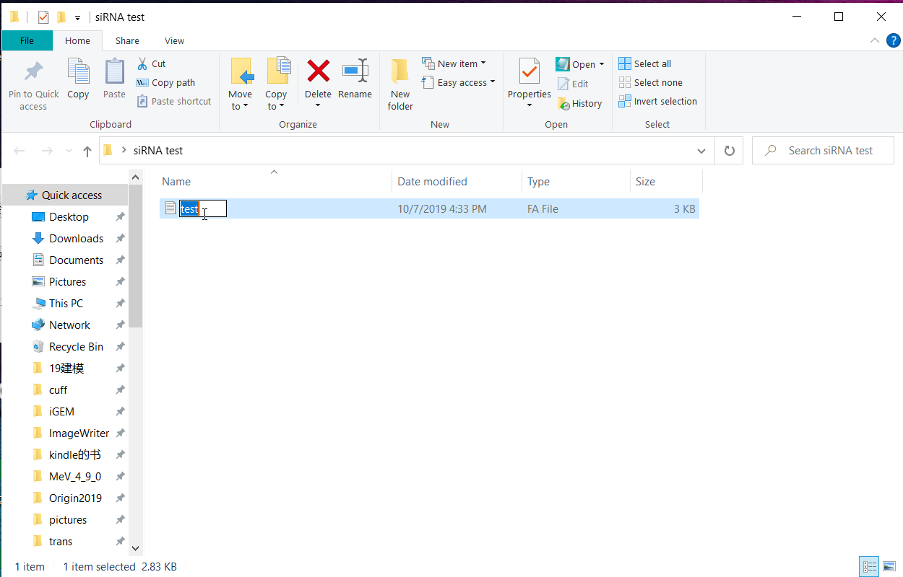

**Step two: Open the file path**

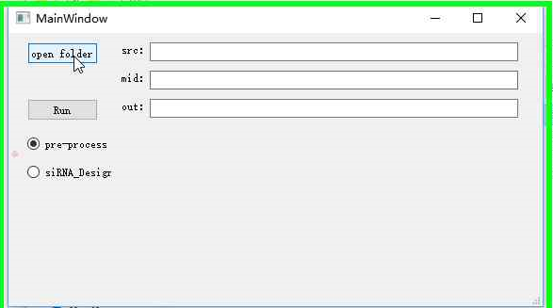

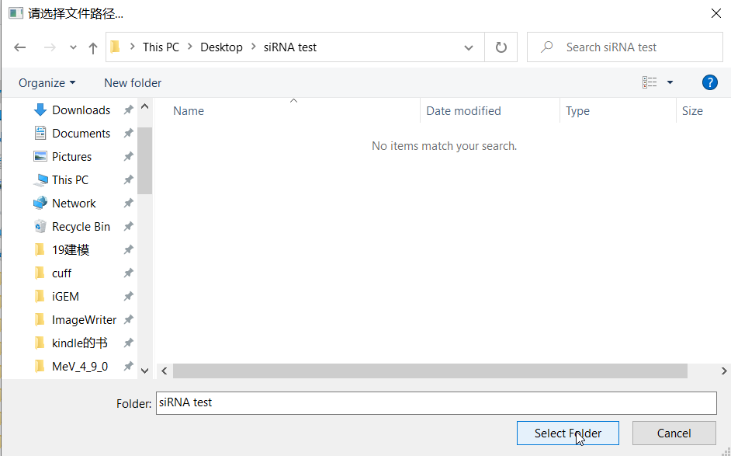

**Step 3: Copy the filename to the end of the src column and select the function to run（pre-process or siRNA_Designer）**

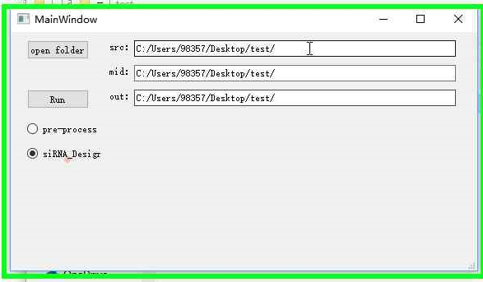

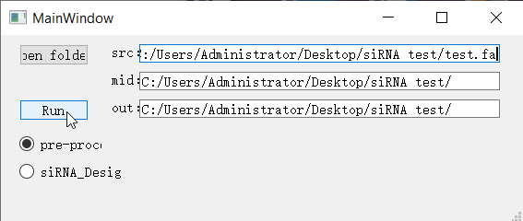

**Step 4: Click run**

**(Note: the column ‘mid’ and ‘out’ can not be filled in at this time. It will output according to the default filename. If you type a name in its, it will output according to your input.)**

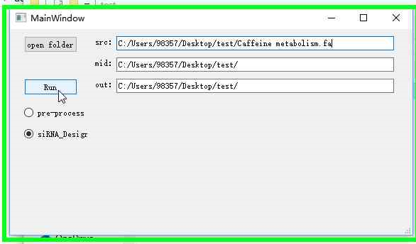

**Result:**