2021 - General or Localised Consensus Beliefs

Start of Block: PLS

Q1   
**PLAIN LANGUAGE STATEMENT AND CONSENT FORM**   
    
**Plain Language Statement**   
    
**Date:** 30th March, 2021   
    
**Full Project Title:** Examining Generality and Processes in Heterodox Beliefs    
    
**Principal Researchers:** Dr Mathew Ling   
    
**Student Researchers:** Nicholas Hall, Nicholas Riggs, Kate Ritson, Alexandra Wake   
     
**1. Background and Purpose**   
    
You have been contacted via Prolific to invite you to participate in our study investigating how beliefs regarding health issues and practices are associated with one another.   
    
Participation will involve answering some questions about your beliefs regarding some health issues and the effectiveness of varied therapies and then some other measures that will allow us to understand your patterns of beliefs including measures of your trust of scientific authorities, experiences in the healthcare sector and about the operation of society. This should on average take 18 minutes to complete.   
    
No identifying information will be collected as part of our research data, and while participation will involve the recording of your prolific ID, this will be removed from the data immediately after download. So we will not be able to identify your particular responses in our data.   
    
We do not anticipate any risks to you from participation, and benefits are likely to be limited to the £2.25 paid via Prolific upon completion of the study. However, we anticipate the results of this study will help us understand what people believe about their health and healthcare, with implications for education, policy, and public health.   
    
**2. Consent to Participate**   
    
Participation is voluntary and you have the right to withdraw from further participation at any stage up to the submission of your data. Submission of the final results will be taken as an indication of your consent. If you should wish to withdraw immediately after submitting your results, please contact the Principal Researcher Dr Mathew Ling (m.ling@deakin.edu.au) with your ProlificID. As your data will be de-identified, it will be impossible to withdraw consent after results are extracted from the server.   
    
If you have questions relating to this research project, you can contact the lead researcher, Dr Mathew Ling via email (m.ling@deakin.edu.au) or telephone +61 3 9244 6475 (Australian phone number).   
    
**3. Declarations and Conflicts of Interests**   
    
All funding for this research is provided by Deakin’s School of Psychology.   
    
**4. Communication of Results and Data**   
    
Results of this study will be used as part of the thesis components of the student researchers’ Honours degree in Psychology. They will also be published in academic journals and via social media to maximise accessibility and benefit of your participation to the public; Results may also be presented at conferences. If you wish to view the results from this study, research outputs will be released at this following address (https://osf.io/s78u4/).   
    
After ensuring you cannot be identified by your responses, and removing your ProlificID or any other identifying features from the dataset, this de-identified data will be published in a public, online data-store at the Open Science Foundation (https://osf.io/h6mnu/). Your identity will never be exposed by this, but this can also allow for unanticipated research findings through secondary analysis.   
    
**5. Distress**   
While it is not expected that participating in the research will cause you to feel distress, we recognise the challenging circumstances the COVID-19 pandemic has caused for many community members. As such, we would like to highlight that if you, or those close to you are experiencing distress, or are in need of additional support, you are encouraged to contact Lifeline at 13 11 14.  
  
   
    
**6. Complaints**   
    
If you have any complaints about any aspect of the project, the way it is being conducted or any questions about your rights as a research participant, then you may contact:   
    
The Manager, Ethics and Biosafety,    
Deakin University   
221 Burwood Highway   
Burwood Victoria 3125   
Telephone: +61 3 9251 7129   
research-ethics@deakin.edu.au   
    
Please quote project number **HEAG-H**   
    
To download a copy of this Participant Information Statement, click here.

End of Block: PLS

Start of Block: Demographics

Q2 We'd like you to tell us a bit about yourself, so we can describe the total group of people who participated in our study. We won't be able to identify you from your responses here.

|  |
| --- |
|  |

age How old are you (in years)?

________________________________________________________________

gender What Gender do you identify as?

________________________________________________________________

education What is the highest level of education you have completed?

* Less than high school (1)
* High school graduate (2)
* Technical school diploma (3)
* Associate Degree (4)
* Bachelors degree (5)
* Masters degree (6)
* Doctorate (7)

End of Block: Demographics

Start of Block: Heterodox beliefs

|  |  |
| --- | --- |
|  |  |

beliefs The following statements are contested by people in the community, please indicate your level of belief regarding each.

|  |  |  |  |  |  |  |  |
| --- | --- | --- | --- | --- | --- | --- | --- |
|  | Definitely false (1) (1) | (2) (2) | (3) (3) | (4) (4) | (5) (5) | (6) (6) | Definitely true (7) (7) |
| 1. Chiropractory is an effective healthcare method (1) |  |  |  |  |  |  |  |
| 1. Herbal remedies are beneficial for health (72) |  |  |  |  |  |  |  |
| 1. Reflexology is an effective healthcare method (73) |  |  |  |  |  |  |  |
| 1. Daily multivitamins are beneficial for health (74) |  |  |  |  |  |  |  |
| 1. Homeopathy is an effective healthcare method (75) |  |  |  |  |  |  |  |
| 1. Aromatherapy is an effective healthcare method (76) |  |  |  |  |  |  |  |
| 1. Some crystals have healing properties (77) |  |  |  |  |  |  |  |
| 1. Traditional Chinese Medicine is an effective healthcare method (78) |  |  |  |  |  |  |  |
| 1. Cannabis is beneficial for health (79) |  |  |  |  |  |  |  |
| 1. Acupuncture is an effective healthcare method (80) |  |  |  |  |  |  |  |
| 1. Hypnosis is beneficial for health (81) |  |  |  |  |  |  |  |
| 1. Mediation is beneficial for health (82) |  |  |  |  |  |  |  |
| 1. Prayer is effective for protecting and restoring health (83) |  |  |  |  |  |  |  |
| 1. Yoga is beneficial for health (84) |  |  |  |  |  |  |  |
| 1. Taichi is beneficial for health (85) |  |  |  |  |  |  |  |
| 1. Therapeutic Massage (e.g Myotherapy, Shiatsu, Bowen Therapy) is an effective healthcare method (86) |  |  |  |  |  |  |  |
| 1. Magnet Therapies (e.g. magnetic bracelets, joint braces, creams, plasters) are an effective healthcare method (87) |  |  |  |  |  |  |  |
| 1. Specific Diets (e.g. Paleo, Alkaline, Atkins, non-coeliac Gluten-free) are beneficial for health (88) |  |  |  |  |  |  |  |
| 1. Vaccinations are beneficial for health (89) |  |  |  |  |  |  |  |
| 1. Antibiotics are beneficial for health (90) |  |  |  |  |  |  |  |
| 1. Conventional Medicine is an effective healthcare method (91) |  |  |  |  |  |  |  |
| 1. Naturopathy is an effective healthcare method (92) |  |  |  |  |  |  |  |
| 1. Humans are contributing to significant changes in the climate (93) |  |  |  |  |  |  |  |
| 1. 5G communications technologies are a health hazard (94) |  |  |  |  |  |  |  |
| 1. Water fluoridation is harmful to humans (95) |  |  |  |  |  |  |  |
| 1. Wind turbines are harmful to health (96) |  |  |  |  |  |  |  |
| 1. Foods made from Genetically Modified Ingredients are harmful (97) |  |  |  |  |  |  |  |
| 1. Recycled water should be added to the drinking supply (98) |  |  |  |  |  |  |  |
| 1. Natural and unprocessed foods (e.g. Raw Milk) are better for health (99) |  |  |  |  |  |  |  |
| 1. Governments have suppressed energy technologies (100) |  |  |  |  |  |  |  |
| 1. Corporations have suppressed technology development that would affect their profits. (101) |  |  |  |  |  |  |  |
| 1. Viruses like COVID-19 are a product of genetic engineering (102) |  |  |  |  |  |  |  |
| 1. Other intelligent species have visited earth (103) |  |  |  |  |  |  |  |
| 1. Governments have exaggerated the risks of COVID-19 to justify restrictions on rights (104) |  |  |  |  |  |  |  |
| 1. Aircraft leave chemical spray trails for nefarious purposes. (105) |  |  |  |  |  |  |  |
| 1. South African anti-Apartheid leader Nelson Mandela died in prison in the 1980s (106) |  |  |  |  |  |  |  |
| 1. There are powerful actors in the bureaucracy, finance sector, that control government more than elected representatives (107) |  |  |  |  |  |  |  |
| 1. There are large creatures (e.g. yeti, phantom cats, Loch Ness Monster) that science does not explain (108) |  |  |  |  |  |  |  |
| 1. Spirits of the dead remain in the world and can be felt or interacted with (109) |  |  |  |  |  |  |  |
| 1. The original moon landing in 1969 was faked (110) |  |  |  |  |  |  |  |

End of Block: Heterodox beliefs

Start of Block: METI

|  |
| --- |
|  |

Q11 Thinking about scientists, how would you describe them on the following pairs of terms?

|  |  |  |  |  |  |  |  |  |
| --- | --- | --- | --- | --- | --- | --- | --- | --- |
|  | 1 (1) | 2 (2) | 3 (3) | 4 (4) | 5 (5) | 6 (6) | 7 (7) |  |
| competent |  |  |  |  |  |  |  | incompetent |
| intelligent |  |  |  |  |  |  |  | unintelligent |
| well educated |  |  |  |  |  |  |  | poorly educated |
| professional |  |  |  |  |  |  |  | unprofessional |
| experienced |  |  |  |  |  |  |  | inexperienced |
| qualified |  |  |  |  |  |  |  | unqualified |
| sincere |  |  |  |  |  |  |  | insincere |
| honest |  |  |  |  |  |  |  | dishonest |
| just |  |  |  |  |  |  |  | unjust |
| fair |  |  |  |  |  |  |  | unfair |
| moral |  |  |  |  |  |  |  | immoral |
| ethical |  |  |  |  |  |  |  | unethical |
| responsible |  |  |  |  |  |  |  | irresponsible |
| considerate |  |  |  |  |  |  |  | inconsiderate |

Q41 On the next page, we'll show you a tweet and ask you some questions about it before proceeding.

End of Block: METI

Start of Block: Exposure

Display This Question:

If CONDITION = Alternative Medicines (e.g. Herbal Remedies)

And CAM > 4

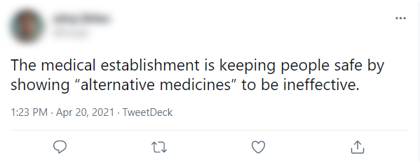

Display This Question:

If CONDITION = Alternative Medicines (e.g. Herbal Remedies)

And CAM <= 4

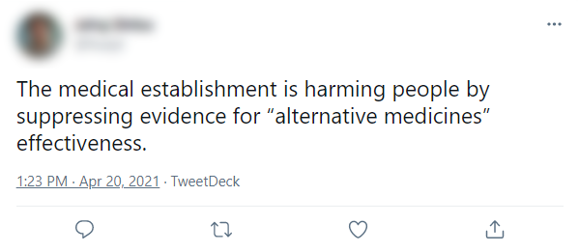

Display This Question:

If CONDITION = Anthropogenic (Human Caused) Climate Change

And Climate >= 4

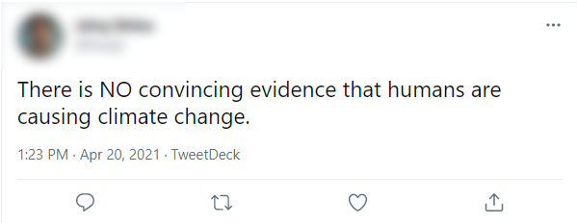

Display This Question:

If CONDITION = Anthropogenic (Human Caused) Climate Change

And Climate < 4

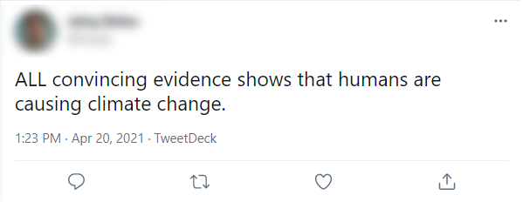

Display This Question:

If CONDITION = Vaccinations

And Vax >= 4

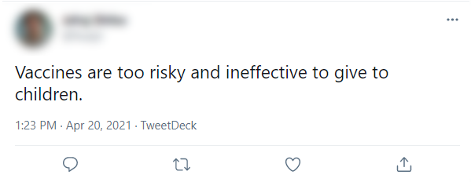

Display This Question:

If CONDITION = Vaccinations

And Vax < 4

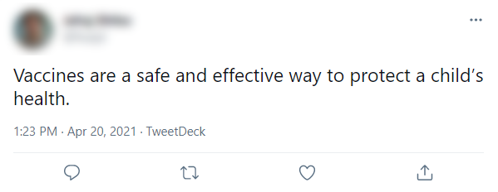

|  |
| --- |
|  |

Exposure_qual Please write your thoughts (minimum 100 characters) about this tweet and the type of person you think authored it.

________________________________________________________________

________________________________________________________________

________________________________________________________________

________________________________________________________________

________________________________________________________________

Q127 Timing

First Click (1)

Last Click (2)

Page Submit (3)

Click Count (4)

End of Block: Exposure

Start of Block: homophily

Q43 Thinking about that tweet on the previous page, how confident are you about  ${e://Field/CONDITION}

|  |  |  |
| --- | --- | --- |
|  | Not at all confident | Very confident |

|  |  |  |  |  |  |  |  |  |  |  |  |
| --- | --- | --- | --- | --- | --- | --- | --- | --- | --- | --- | --- |
|  | 0 | 10 | 20 | 30 | 40 | 50 | 60 | 70 | 80 | 90 | 100 |

|  |  |
| --- | --- |
| Your beliefs about ${e://Field/CONDITION} are correct () |  |
| Your beliefs about ${e://Field/CONDITION} are different from theirs () |  |
| Their beliefs about ${e://Field/CONDITION} are wrong () |  |

Q45 Assuming you found this on your feed. How likely would you be to do each of the following?

|  |  |  |
| --- | --- | --- |
|  | Not at all likely | Very likely |

|  |  |  |  |  |  |  |  |  |  |  |  |
| --- | --- | --- | --- | --- | --- | --- | --- | --- | --- | --- | --- |
|  | 0 | 10 | 20 | 30 | 40 | 50 | 60 | 70 | 80 | 90 | 100 |

|  |  |
| --- | --- |
| Avoid working with the author () |  |
| Avoid talking to the author () |  |
| Avoid hanging out with the author () |  |
| Avoid trusting the author () |  |
| Block the author () |  |

Q46 How much would you like it if the author was your...

|  |  |  |  |  |  |
| --- | --- | --- | --- | --- | --- |
|  | Dislike a great deal |  |  |  | Like a great deal |

|  |  |  |  |  |  |  |  |  |  |  |  |
| --- | --- | --- | --- | --- | --- | --- | --- | --- | --- | --- | --- |
|  | 0 | 10 | 20 | 30 | 40 | 50 | 60 | 70 | 80 | 90 | 100 |

|  |  |
| --- | --- |
| Neighbour () |  |
| Colleague () |  |
| Family member () |  |
| Partner () |  |

End of Block: homophily

Start of Block: Narcissism (NPI-16)

|  |  |
| --- | --- |
|  |  |

NPI For each pair of statements, select the option that most accurately describes you

|  |  |  |  |
| --- | --- | --- | --- |
|  | 1 (1) | 2 (0) |  |
| I know that I am good because everybody keeps telling me so |  |  | When people compliment me I sometimes get embarrassed |
| I like to be the center of attention |  |  | I prefer to blend in with the crowd |
| I think I am a special person |  |  | I am no better or no worse than most people |
| I like having authority over people |  |  | I don’t mind following orders |
| I find it easy to manipulate people |  |  | I don’t like it when I find myself manipulating people |
| I insist upon getting the respect that is due me |  |  | I usually get the respect that I deserve |
| I am apt to show off if I get the chance |  |  | I try not to be a show off |
| I always know what I am doing |  |  | Sometimes I am not sure of what I am doing |
| Everybody likes to hear my stories |  |  | Sometimes I tell good stories |
| I expect a great deal from other people |  |  | I like to do things for other people |
| I really like to be the center of attention |  |  | It makes me uncomfortable to be the center of attention |
| People always seem to recognize my authority |  |  | Being an authority doesn’t mean that much to me |
| I am going to be a great person |  |  | I hope I am going to be successful |
| I can make anybody believe anything I want them to |  |  | People sometimes believe what I tell them |
| I am more capable than other people |  |  | There is a lot that I can learn from other people |
| I am an extraordinary person |  |  | I am much like everybody else |

End of Block: Narcissism (NPI-16)

Start of Block: Comprehensive Thinking Styles Questionnaire

Q1 Please indicate the extent to which you agree or disagree with the following statements.

|  |
| --- |
|  |

Q2 It is important to be loyal to your beliefs even when evidence is brought to bear against them.

* Strongly disagree (1)
* Disagree (2)
* Somewhat disagree (3)
* Somewhat agree (4)
* Agree (5)
* Strongly agree (6)

|  |
| --- |
|  |

Q3 Whether something feels true is more important than evidence.

* Strongly disagree (1)
* Disagree (2)
* Somewhat disagree (3)
* Somewhat agree (4)
* Agree (5)
* Strongly agree (6)

|  |
| --- |
|  |

Q4 Just because evidence conflicts with my current beliefs does not mean my beliefs are wrong.

* Strongly disagree (1)
* Disagree (2)
* Somewhat disagree (3)
* Somewhat agree (4)
* Agree (5)
* Strongly agree (6)

|  |
| --- |
|  |

Q5 There may be evidence that goes against what you believe but that does not mean you have to change your beliefs.

* Strongly disagree (1)
* Disagree (2)
* Somewhat disagree (3)
* Somewhat agree (4)
* Agree (5)
* Strongly agree (6)

|  |
| --- |
|  |

Q6 Even if there is concrete evidence against what you believe to be true, it is OK to maintain cherished belief.

* Strongly disagree (1)
* Disagree (2)
* Somewhat disagree (3)
* Somewhat agree (4)
* Agree (5)
* Strongly agree (6)

|  |
| --- |
|  |

Q7 Regardless of the topic, what you believe to be true is more important than evidence against your beliefs.

* Strongly disagree (1)
* Disagree (2)
* Somewhat disagree (3)
* Somewhat agree (4)
* Agree (5)
* Strongly agree (6)

|  |
| --- |
|  |

Q8 I think there are many wrong ways, but only one right way, to almost anything.

* Strongly disagree (1)
* Disagree (2)
* Somewhat disagree (3)
* Somewhat agree (4)
* Agree (5)
* Strongly agree (6)

|  |
| --- |
|  |

Q9 In my experience, the truth is often black and white.

* Strongly disagree (1)
* Disagree (2)
* Somewhat disagree (3)
* Somewhat agree (4)
* Agree (5)
* Strongly agree (6)

|  |
| --- |
|  |

Q10 Truth is never relative.

* Strongly disagree (1)
* Disagree (2)
* Somewhat disagree (3)
* Somewhat agree (4)
* Agree (5)
* Strongly agree (6)

|  |
| --- |
|  |

Q11 The truth does not change.

* Strongly disagree (1)
* Disagree (2)
* Somewhat disagree (3)
* Somewhat agree (4)
* Agree (5)
* Strongly agree (6)

|  |
| --- |
|  |

Q12 Either something is true or it is false; there is nothing in-between.

* Strongly disagree (1)
* Disagree (2)
* Somewhat disagree (3)
* Somewhat agree (4)
* Agree (5)
* Strongly agree (6)

|  |
| --- |
|  |

Q13 There is no middle ground between what is true and what is false.

* Strongly disagree (1)
* Disagree (2)
* Somewhat disagree (3)
* Somewhat agree (4)
* Agree (5)
* Strongly agree (6)

|  |
| --- |
|  |

Q14 I like to rely on my intuitive impressions.

* Strongly disagree (1)
* Disagree (2)
* Somewhat disagree (3)
* Somewhat agree (4)
* Agree (5)
* Strongly agree (6)

|  |
| --- |
|  |

Q15 I believe in trusting my hunches.

* Strongly disagree (1)
* Disagree (2)
* Somewhat disagree (3)
* Somewhat agree (4)
* Agree (5)
* Strongly agree (6)

|  |
| --- |
|  |

Q16 When I make decisions, I tend to rely on my intuition.

* Strongly disagree (1)
* Disagree (2)
* Somewhat disagree (3)
* Somewhat agree (4)
* Agree (5)
* Strongly agree (6)

|  |
| --- |
|  |

Q17 Using my "gut-feelings" usually works well for me in figuring out problems in my life.

* Strongly disagree (1)
* Disagree (2)
* Somewhat disagree (3)
* Somewhat agree (4)
* Agree (5)
* Strongly agree (6)

|  |
| --- |
|  |

Q18 Intuition is the best guide in making decisions.

* Strongly disagree (1)
* Disagree (2)
* Somewhat disagree (3)
* Somewhat agree (4)
* Agree (5)
* Strongly agree (6)

|  |
| --- |
|  |

Q19 I often go by my instincts when deciding on a course of action.

* Strongly disagree (1)
* Disagree (2)
* Somewhat disagree (3)
* Somewhat agree (4)
* Agree (5)
* Strongly agree (6)

|  |
| --- |
|  |

Q20 I’m not that good at figuring out complicated problems.

* Strongly disagree (1)
* Disagree (2)
* Somewhat disagree (3)
* Somewhat agree (4)
* Agree (5)
* Strongly agree (6)

|  |
| --- |
|  |

Q21 Thinking is not my idea of an enjoyable activity.

* Strongly disagree (1)
* Disagree (2)
* Somewhat disagree (3)
* Somewhat agree (4)
* Agree (5)
* Strongly agree (6)

|  |
| --- |
|  |

Q22 I try to avoid situations that require thinking in depth about something.

* Strongly disagree (1)
* Disagree (2)
* Somewhat disagree (3)
* Somewhat agree (4)
* Agree (5)
* Strongly agree (6)

|  |
| --- |
|  |

Q23 I am not a very analytical thinker.

* Strongly disagree (1)
* Disagree (2)
* Somewhat disagree (3)
* Somewhat agree (4)
* Agree (5)
* Strongly agree (6)

|  |
| --- |
|  |

Q24 Reasoning things out carefully is not one of my strong points.

* Strongly disagree (1)
* Disagree (2)
* Somewhat disagree (3)
* Somewhat agree (4)
* Agree (5)
* Strongly agree (6)

|  |
| --- |
|  |

Q25 Thinking hard and for a long time about something gives me little satisfaction.

* Strongly disagree (1)
* Disagree (2)
* Somewhat disagree (3)
* Somewhat agree (4)
* Agree (5)
* Strongly agree (6)

|  |
| --- |
|  |

Q26 I have been to every country in the world.

* Strongly disagree (1)
* Disagree (2)
* Somewhat disagree (3)
* Somewhat agree (4)
* Agree (5)
* Strongly agree (6)

End of Block: Comprehensive Thinking Styles Questionnaire

Start of Block: Dangerous world

|  |
| --- |
|  |

BDW The next block of questions are about your model of society. Please answer honestly.

|  |  |  |  |  |  |
| --- | --- | --- | --- | --- | --- |
|  | Strongly agree (8) | Somewhat agree (9) | Neither agree nor disagree (10) | Somewhat disagree (11) | Strongly disagree (12) |
| Although it may appear that things are constantly getting more dangerous and chaotic, it really isn’t so. Every era has its problems, and a person’s chances of living a safe, untroubled life are better today than ever before (4) |  |  |  |  |  |
| Any day now chaos and anarchy could erupt around us. All the signs are pointing to it (5) |  |  |  |  |  |
| There are many dangerous people in our society who will attack someone out of pure meanness, for no reason at all (6) |  |  |  |  |  |
| Despite what one hears about “crime in the street,” there probably isn’t any more now than there ever has been (7) |  |  |  |  |  |
| If a person takes a few sensible precautions, nothing bad is likely to happen to him or her; we do not live in a dangerous world (8) |  |  |  |  |  |
| Every day as society become more lawless and bestial, a person’s chances of being robbed, assaulted, and even murdered go up and up (9) |  |  |  |  |  |
| My knowledge and experience tells me that the social world we live in is basically a safe, stable and secure place in which most people are fundamentally good (10) |  |  |  |  |  |
| It seems that every year there are fewer and fewer truly respectable people, and more and more persons with no morals at all who threaten everyone else (11) |  |  |  |  |  |
| The “end” is not near. People who think that earthquakes, wars, and famines mean God might be about to destroy the world are being foolish (12) |  |  |  |  |  |
| My knowledge and experience tells me that the social world we live in is basically a dangerous and unpredictable place, in which good, decent and moral people’s values and way of life are threatened and disrupted by bad people (13) |  |  |  |  |  |

Q89 The next set of questions is about your personal relationship with society.

|  |  |  |  |  |  |  |  |
| --- | --- | --- | --- | --- | --- | --- | --- |
|  | Strongly agree (9) | Agree (10) | Somewhat agree (11) | Neither agree nor disagree (12) | Somewhat disagree (13) | Disagree (14) | Strongly disagree (15) |
| I feel all alone these days. (1) |  |  |  |  |  |  |  |
| My whole world feels like it's falling apart. (2) |  |  |  |  |  |  |  |
| I wish I were somebody important. (3) |  |  |  |  |  |  |  |
| It's hard for me to tell just what is right and wrong these days. (4) |  |  |  |  |  |  |  |
| I don't like to live by society's rules. (5) |  |  |  |  |  |  |  |
| I'll never find the right person to care enough about me. (6) |  |  |  |  |  |  |  |

End of Block: Dangerous world

Start of Block: Closing remarks

Q27 Thank you for completing the survey. We greatly value your participation within this study. If you wish to provide us some comments or feedback on the study, please use the textbox below.

________________________________________________________________

________________________________________________________________

________________________________________________________________

________________________________________________________________

________________________________________________________________

End of Block: Closing remarks