Introduction

## Background

Urban managers have long valued public transport systems. Public transport provides mobility and access to employment, community resources, health care and recreation, and it benefits those who choose to use public transport and those who have no other options (Lee and Averous, 1973; Stuart et al., 2000). It also helps reduce road congestion and travel times, air pollution, and energy and oil consumption, from which anyone can benefit (Levine, Grengs and Merlin, 2019). In addition, public transport is vital for evacuation and shelter in emergencies (Miller, 2019).

In recent years, establishing environmentally friendly and sustainable cities has become an important goal worldwide to mitigate climate crises. As a result, the importance of public transport systems is increasing, and the idea of public transport-oriented land use and development has become more popular. This idea, known as Transit-Oriented Development (TOD), was first proposed by Peter Calthorpe (1993) and called for forming urban centres by developing land within a particular area centred on a railway or bus station. It refers to a dense, mixed-use, pedestrian and cycling-friendly land development oriented towards public transport and not just development next to the rail and bus stations (VTPI, 2019).

Transit-oriented development has many benefits. It has promoted nearby communities and reduced urban sprawl (Chorus and Luca Bertolini, 2011). Furthermore, development through public transport can foster a sense of community and enhance neighbourhood safety and security (Levine, Grengs and Merlin, 2019). There are already many successful examples of TOD worldwide, such as in Singapore, Canada and Hongkong (Jones and Ley, 2016; Loo, Chen and Chan, 2010; Tan and Yi, 2021). In Hong Kong, 45% of the population is within a 500-metre living circle of an MTR line station, especially in Kowloon and Hong Kong Island, where the proportion is as high as 65% (Loo, Chen and Chan, 2010). Moreover, many more new projects and policies are in the pipeline (Chorus and Luca Bertolini, 2011; City of Bellevue, 2018; City of Shoreline, 2016; Miller, 2019; MRSC, 2021; Zhang, Marshall and Manley, 2019).

# Literature Review

## Integrated transport and land use model

Assessing the extent and effectiveness of transport and land development in an area can be an essential reference for future land planning in that area. The development and use of integrated land use and transport models to assess cities can be traced back to the Lowry model of 1964 (Lowry, 1964). Depending on the type of theory on which the model is based, there are three broad models: integrated models based on spatial interaction/gravity models, economic theory models, and micro-simulation models.

The original Lowry model was based on a spatial interaction/gravity model that used classical economic theory to simulate basic urban patterns by assessing work and household activities (Lowry, 1964). This comprehensive model was easy to obtain data for but was too simplistic in its description of urban behaviour. Since then, many scholars have improved or built new models, such as the IRPUD model by Wegener (1982), the LILT model by Mackett (1983) and the ITLUP model by Putnman (2007).

Researchers have begun to use these models to model discrete locational distributions and travel patterns with the emergence of economic models such as discrete choice theory and consequent utility theory (Cascetta, 2009a; Ennio Cascetta, 2009b; Quillian, 2015; Train, 1993). The TRANUS model developed by de la Barra et al. (1984), for example, is a regional economic model that has been widely used around the world. The MEPLAN model developed by Echenique et al. (1990) adds an economic assessment module to the Input-Output model, which treats travel as a derived demand and predicts travel patterns. Furthermore, the PECAS model developed by Hunt and Abraham (2003) is a regional economic model that incorporates micro-simulation and can assess and forecast activity-based travel.

Microscopic models are a relatively recent area of research that uses theories like cellular automata, activity-based and multi-agent systems to effectively simulate the microscopic behaviour of individual decision-makers in land use and transport development, such as MASTER, SLEUTH, CLUE-S models (Mackett, 1990; Silva and Clarke, 2002; Verburg and Overmars, 2009). The MASTER model examines population growth and changes in household structure (Mackett, 1990), while the SLEUTH model uses the principle of meta-automata to simulate urban change patterns and can model the transformation of land from non-urban use (forest, farmland) to urban land use (Silva and Clarke, 2002). Silva and Clarke, 2002).

Many Land-use and Transport models have been developed based on different theories and for various purposes. Although some of these models are well developed, their purpose is not in line with the TOD concept, which encourages public transport, cycling and walking in areas where private car travel is discouraged (Calthorpe, 1993). Most Land-use and Transport models include a transport module that includes public transport and an assessment of private car travel, deviating from the TOD concept of 'transit orientation'.

## The Node-Place Model

Bertolini (1999) first proposed the Node-Place model following the introduction of public transport-oriented development models. The Node-Place model is an analytical model that evaluates both public transport and land-use nodes based on the land-use transport feedback cycle theory (Wegener, 2004). As shown in the figure, the x and y axes of the original Node-Place model represent the transport value of a transport hub (rail station, bus station, or even bicycle sharing station) as a transport node and the human activity value as a place node. Such an approach allows multiple sites to be positioned in the same two-dimensional plane to describe and compare their development. It is worth noting that the value of a node and the value of a place are difficult to describe adequately in terms of a single indicator, and therefore these two indicators are usually expressed as a linear combination of a series of related indicators.

Figure 1: Node-Place model (Bertolini, 1999)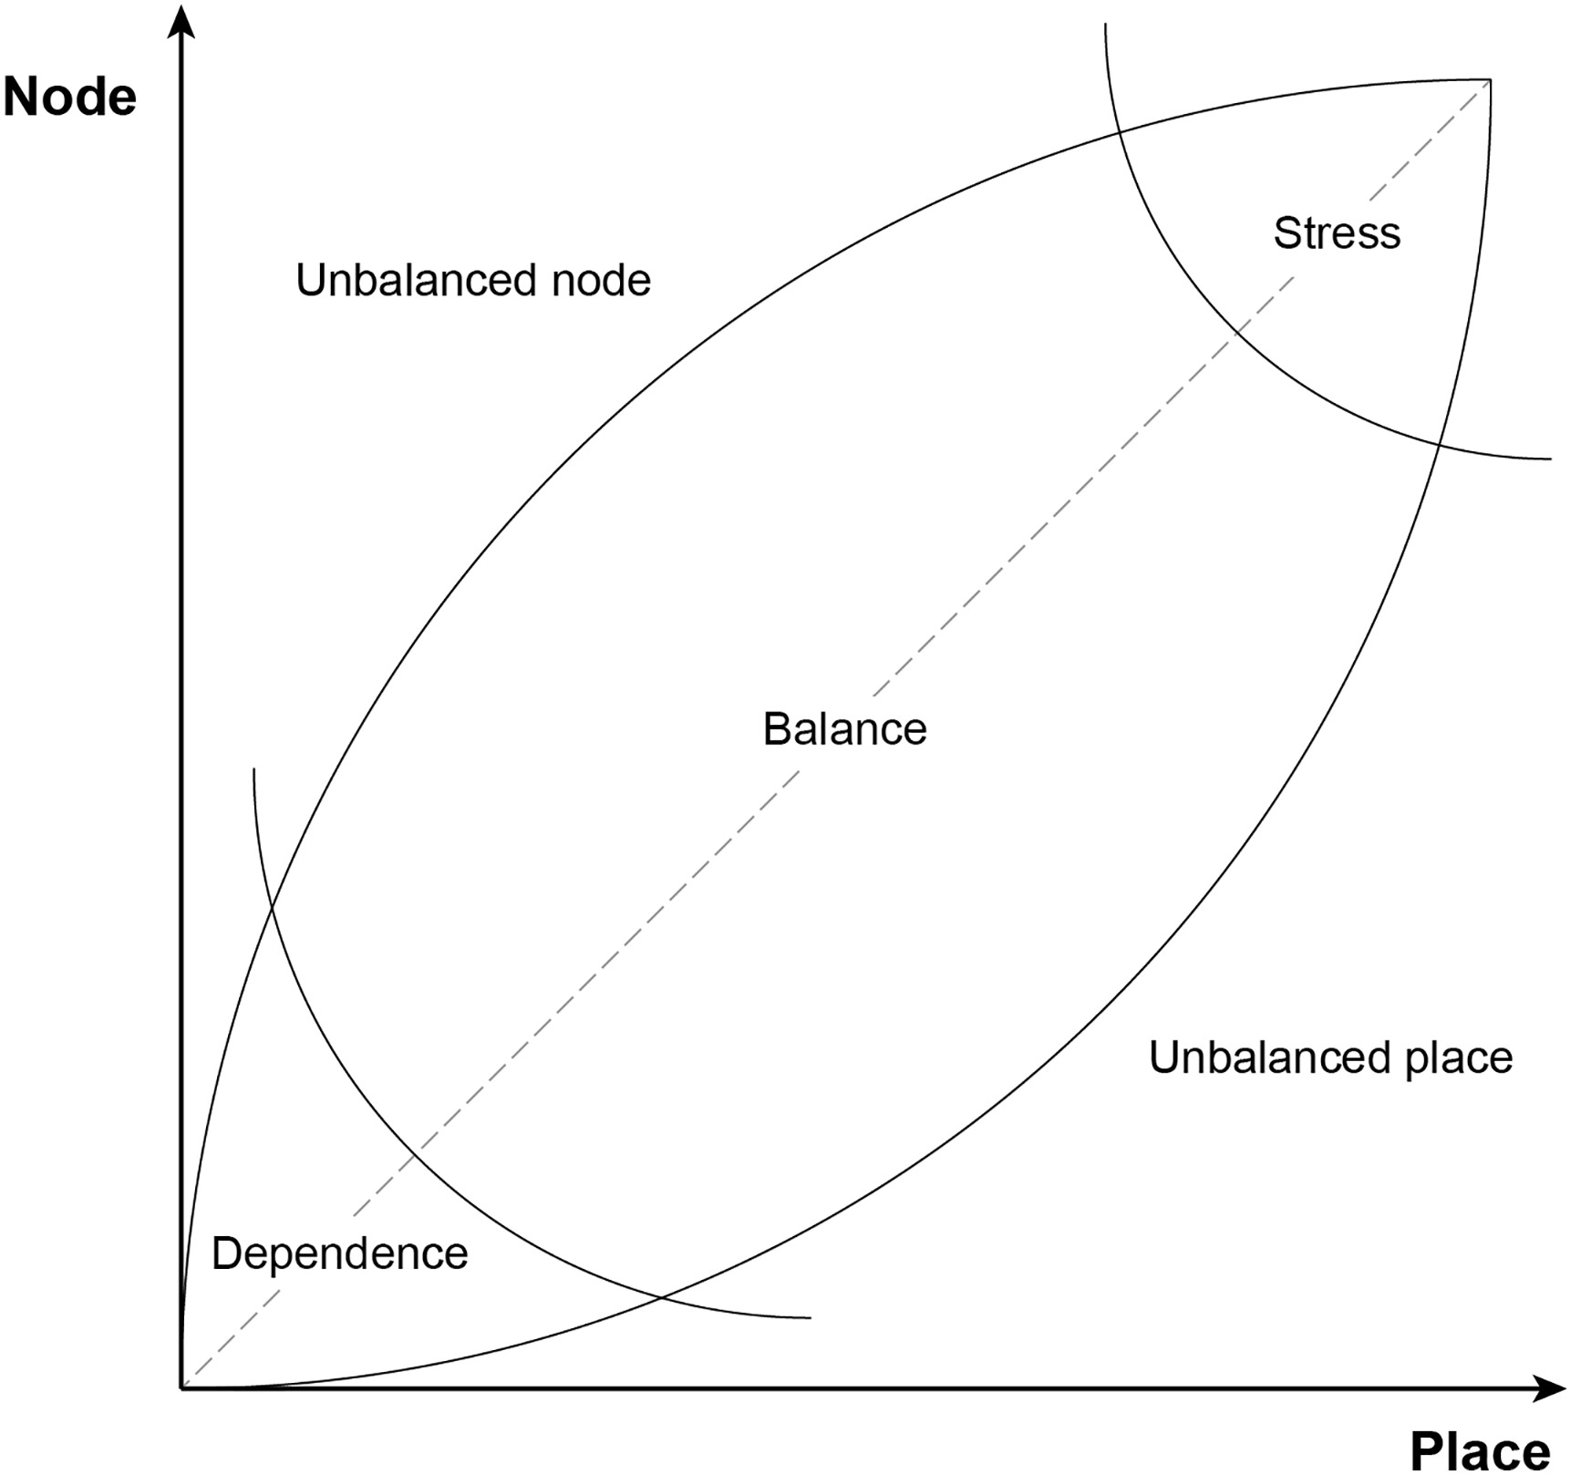

Bertolini (1999) defines the Node-Place model as describes two imbalances and three balance states at different levels (see Figure 1). The three states along the diagonal are the stress zone, the balance zone and the dependency zone, which express a more balanced public transport and land use development for these sites. Conversely, the zones in the top left and bottom right corners are the imbalanced node zone and the imbalanced place zone, respectively, which have less balanced development patterns and are more oriented towards separate functions (nodes or places). The nodes that balance characteristics of Place and Node are considered more successful in the TOD model. The Dependency Zone is considered to be balanced with low levels of development. The Stress Zone indicates that the area is balanced in public transport and land development, but both are very high and maybe overdeveloped. The Imbalanced Node Zone and Imbalanced Place Zone need to be focused on representing their possible development potential.

Based on the theoretical foundations of the Node-Place model, different frameworks based on different lists of indicators have been developed to assess the TOD around nodes based on different cases. The studies cover various cities around the world. At first, the research was mainly conducted in European and North American cities such as Amsterdam (Bertolini, 1999), Tehran (Monajem and Ekram Nosratian, 2015), Brussels (Caset et al., 2019), Flanders (Caset et al., 2020), Lisbon (Vale, 2015; Vale, Viana and Pereira, 2018), London (Zhang, Marshall and Manley, 2019), and Rotterdam (Groenendijk, Rezaei and Correia, 2018). In recent years, Node-Place models have started to gain popularity in studies of Asian regions, such as in Tokyo (Cao, Asakura and Tan, 2020; Chorus and Luca Bertolini, 2011), Shanghai (Chen and Lin, 2015; Gui, Zhang and Wang, 2021; Li et al., 2019), Shenzhen (Su et al., 2021), and Beijing (Gui, Zhang and Wang, 2021; Lyu, Bertolini and Pfeffer, 2016). The vast majority of studies have used clustering analysis to classify a series of nodes into subcategories with different functions and levels of exploitation. In some cases, to facilitate clustering analysis, researchers eliminate insignificant indicators from the index list by principal component analysis (Austin et al., 2010; Zhang, Marshall and Manley, 2019).

While applying the Node-Place model to assess the TOD, researchers have made different improvements to the model, focusing on three main areas: 1. selecting the station boundary; 2. improving the list of indicators; 3. the addition of dimensions.

Firstly, in early studies, a radius of 400-800 meters was frequently used to determine an area of interest around each transport node. However, most of the early studies were conducted on railway stations and more recently, the scope used by researchers has changed based on different types of transport nodes (Bernick and Cervero, 1997; Zhao et al., 2003). For example, in a study in South Korea, researchers suggested that the observation range for metro nodes should be extended to 3 km due to the popularity of bike-sharing, while the observation range for BRT nodes was suggested to be 500 m (Lee, Choi and Leem, 2015). Not only that, when assessing the TOD of the Lisbon urban metro system, Vale et al. suggest an observation range of 500 m by comparing other studies (Jun et al., 2015; Vale, 2015; Vale, Viana and Pereira, 2018).

Secondly, improvements to the list of indicators for the Node-Place Model have also been an important area of research. The original Node-Place Model has 15 normalised indicators, nine of which point to node value and six to place value, with the final node value and place value being their equally weighted mean values, respectively (Bertolini, 1999). The list of indicators has then been abridged or added to in subsequent studies due to data limitations or various other reasons (Chorus and Luca Bertolini, 2011; Monajem and Ekram Nosratian, 2015), such as proximity to city centres and public transport accessibility (PTAL) (Chorus and Luca Bertolini, 2011; Kamruzzaman et al., 2014).

Finally, the current discussion on adding a new dimension is related to 'pedestrian-oriented design', where Node and Place nodes can describe the traffic development and land development in the vicinity of a site but do not represent the 'Oriented Development' TOD well. Development (Lyu, Bertolini and Pfeffer, 2016; Vale, 2015; Vale, Viana and Pereira, 2018). For example, some poorly designed pedestrian paths may reduce people's enthusiasm to get to public transport nodes. The lack of assessment of 'oriented' land development has led researchers to include other indicator series. In the Lisbon metro system study, Vale (2015) proposes a new 'Design' dimension for the value of public transport orientation, looking at the public transport orientation of the area through the Ratio of pedestrian sheds on the street. Similarly, Lyu (2016), in his evaluation of TOD in Beijing, incorporates proximity indicators into a new dimension named 'oriented' to observe the orientation.

Although scientists have improved many aspects of the Node-Place model, the current model still has many shortcomings. Firstly, current research has neglected the connection to new forms of public transport such as bike-sharing. With the development of technology, many cities now have well-established bike-sharing system stations in place, and many studies have found combined travel patterns of bike-sharing and other public transport (Flamm, 2013; Lin et al., 2018; Martin and Shaheen, 2014; Zhang and Zhang, 2018). Therefore, besides observing the connectivity of nodes and buses, we also need to consider the connectivity of nodes and bike-sharing systems.

Furthermore, the current Node-Place model focuses more on estimating the area’s development around each node and neglects to consider the region’s land use and transport planning. In other words, the current Node-Place model ignores the node’s position in the whole public transport system. Researchers have found that many TOD-related initiatives are challenging to promote and implement due to the limitations of administrative boundaries and the competition for development priority between TOD projects near each other that are not part of the same local authority (America, 2007). A successful TOD project needs to go beyond the confines of individual stations and understand the role of each community and station area in a public transport oriented regional network, which is the basis for the concept of some of the more recent projects known as Regional TOD (Anderson, 2011).

The current model assesses the value of a node as a transport node by observing the number and frequency of its connections to other nodes and other public transport systems. This kind of estimation is a local perspective rather than a system perspective, as it does not take the node’s position in the topological network into account. Due to their more central position in the topological network, some stations may have more transit potential despite having fewer connections and should be developed earlier in the system. Several studies have confirmed such a view, but the current Node-Place model cannot be captured (Derrible, 2012; Jayasinghe et al., 2019; Vale, Viana and Pereira, 2018; Wang and Fu, 2017; Zhang, Marshall and Manley, 2019). Therefore, we need to evaluate the node’s value in the entire network in the model.

## Network Analysis in Urban Research

Network centrality has a long history of research, with graph theorists having studied networks since 1735 (Berkeley, 1735). The concept of network centrality has been mentioned in social science research since 1950 (Bavelas, 1948; Leavitt, 1951). However, it was only at the beginning of the 21st century that the concept of network science was taken out of other disciplines and considered a separate discipline and began to be widely applied in various fields (Barabási, 2013). In network science, centrality is an indicator of the importance/influence of nodes in a network (Barabási, 2013). For example, a fundamental task in social network analysis is identifying which individuals in a group are more influential than others, thus helping us understand the role they play in the network (Barabási, 2013).

Network centrality does not have many applications in transport, and some scientists used network analysis to study the relationship between land use and transportation (Curtis, 2011; Derrible, 2012; Zhang, Marshall and Manley, 2019). In these studies, network centrality was used to find key transport nodes and design systems to distribute passenger flows rationally. Scientists have developed many centrality algorithms, such as degree centrality, closeness centrality, betweenness centrality, eigenvector centrality and PageRank (Barabási, 2013; Zhong et al., 2014). Among these, betweenness centrality is significant for transportation research as it represents the importance of a node as a transit node between any other nodes (Derrible, 2012). Such an algorithm that embodies the 'transport' characteristic is well suited to the study of transport systems, particularly to the study of the transport capacity of railway systems.

Although many applications of network centrality in research on public transport systems already exist (Jayasinghe et al., 2019; Vale, Viana and Pereira, 2018; Wang and Fu, 2017; Zhang, Marshall and Manley, 2019; Zhong et al., 2014), among the relevant studies using the Node-Place model for assessment, few studies attempt to incorporate network centrality into the model's assessment framework. Therefore, we introduce the metric of network centrality in this study to enhance the value of the Node-Place model from a systems perspective.

In summary, as a representative analytical framework for assessing transit-oriented development patterns, the Node-Place model still has some shortcomings, even though many studies have been conducted to apply and improve it. The main issues are the ignorance of both the connectivity to bike-sharing systems and the position of nodes in the whole system. Therefore, this study aims to make improvements to Node-Place by focusing on two aspects:

* Introducing indicators for the connectivity of bike-sharing.
* Introducing indicators of network centrality.