

Financial Management For Engineers

EMGT 6305

SPRING 2022

Lingxuan Ye

HW 10

Section 2

## Problem 1

## Problem 2

#### 1

project A

project B

#### 2

project A

project B

#### 3

project A

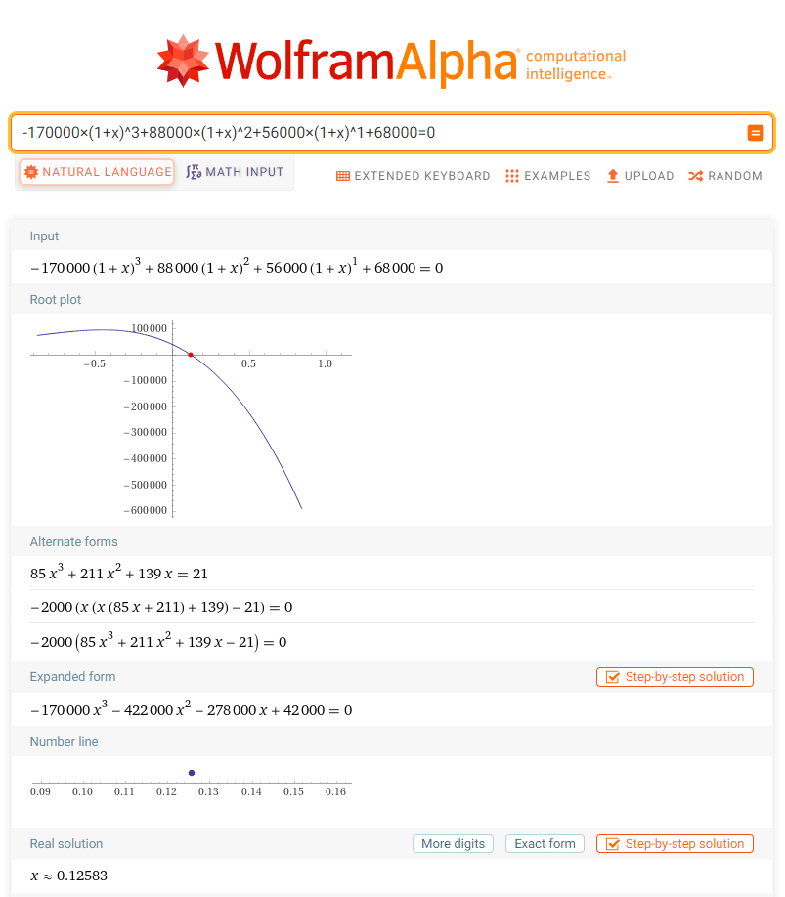

project B

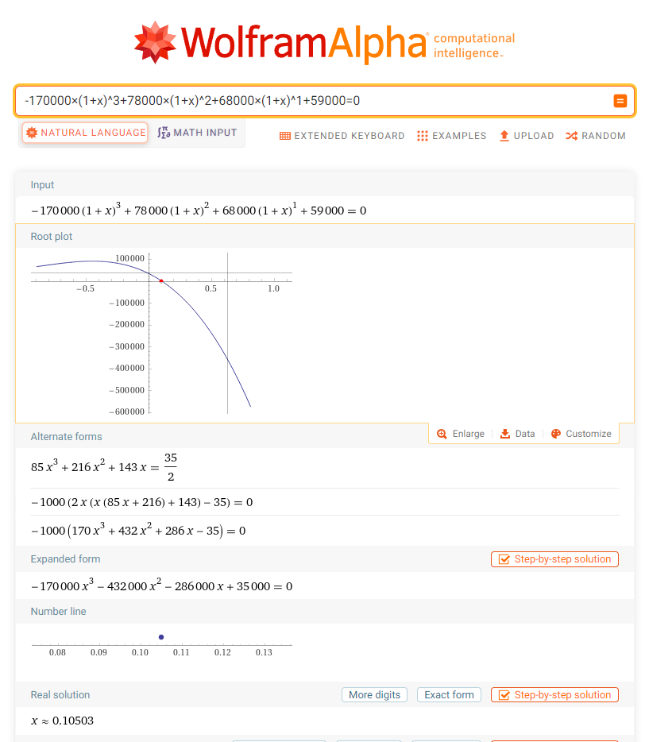

Choose project A for it has a greater IRR.

#### 4

Assume that reinvestment rate is equal to WACC:

project A

project B

Choose project A for it has a greater MIRR.