Problem 59

a
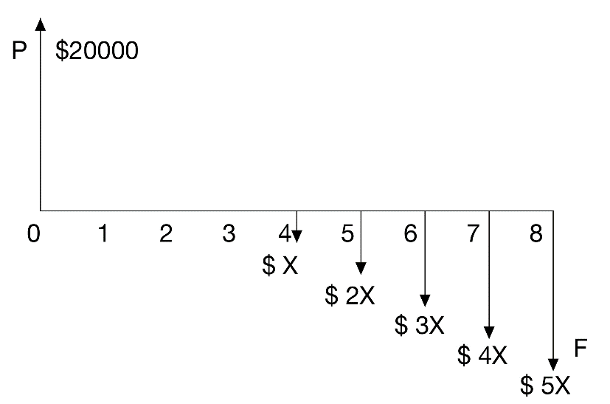

b
Let $F$ denote future value of loan and $F^{'}$ denote future value of payback.
$F_{t=2}={\left(1+i\right)}^{n}P={\left(1+5.5\%\right)}^{2}*20000=22260.5$
$F_{t=2}^{'}=\left(P | G 5.5\%,6\right)X=\frac{1-(1+6*5.5\%)(1+5.5\%)^{-6}}{(5.5\%)^{2}}*X$
$F_{t=2}{=F}_{t=2}^{'}$
Therefore,
$X=1900.97$

c
EOY 4 : $ 1900.97
EOY 5 : $ 3801.94
EOY 6 : $ 5702.91
EOY 7 : $ 7603.88
EOY 8 : $ 9504.85

d
$Amount of Check=\left(1+2+3+4+5\right)X-20000=8514.55$

Problem 71

a
$P=\left(P | A 5\%,10\right)*5000=38608.67$

b
$\left(F | P 5\%,3\right)*P=\left(P | A 5\%,10\right)*5000$
$P=33351.62$

Problem 93
$P=\left(P | A 5\%,5\right)*800+\left(P | G 5\%,5\right)*100$
$P=\frac{{1.05}^{5}-1}{0.05*{1.05}^{5}}*800+\frac{{1-1.25*1.05}^{-5}}{{0.05}^{2}}*100$
$P=4287.27$

Problem 124
Let $A_{k}$ denote investment in $k^{th}$ year and $F_{k,n}$ denote future value of $A_{k}$ in $n^{th}$ year.
For $i=j$:
$A_{k}=A_{1}(1+j)^{k-1}$
$F_{k,n}=(1+i)^{n-k}A_{k}=(1+i)^{n-k}A_{1}(1+j)^{k-1}=A_{1}(1+i)^{n-1}$
$F=\sum_{k=1}^{n}{F_{k,n}}=nA_{1}(1+i)^{n-1}$
Substituted by:
$i=5\%,n=30,A_{1}=7500$
We have:
$F=926130.51$

Problem 147
$No. of cash flow periods=40*12=480$
$F=\left(F | A 0.75\%,480\right)A=2000000$
$A=427.23$
Invest $ 427.23 per month.

Problem 149
$i_{eff}=(1+\frac{r}{m})^{m}-1$
$r=10\%$

a
$m=2$
$i_{eff}=10.25\%$

b
$m=3$
$i_{eff}=10.34\%$

c
$m=4$
$i_{eff}=10.38\%$

d
$m=6$
$i_{eff}=10.43\%$

e
$m=12$
$i_{eff}=10.47\%$

Problem 151
$i=\frac{r}{m}=\frac{6\%}{12}=0.5\%$
$A=\left(A | P 0.5\%,60\right)P=966.64$

