Problem 27
$$r=8\%,m=4 \\ i=\frac{r}{m}=2\% \\ PMT=\left(A | P 2\%,12\right)×P=0.09456×80000=\$ 7564.80 \\ P_{5}=\left(P | A 2\%,12-5\right)×A=6.47199×7564.8=\$ 48959.31 \\ {IPMT}_{6}=P_{5}×2\%=\$ 979.19 \\ {PPMT}_{6}=PMT-{IPMT}_{6}=\$ 6585.61 \\ P_{6}=P_{5}-{PPMT}_{6}=\$ 42373.70$$

All data are retrieved from Table A-a-8, textbook.

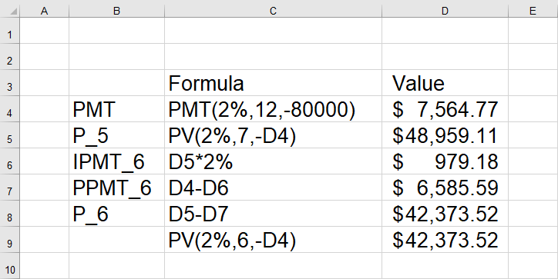

Differences are due to round-off error in the interest tables.

Problem 33
$$F=\left(F | A_{1} i,j,n\right)×A_{1}, where \left[\begin{matrix}A_{1} \\ i \\ j \\ n\end{matrix}\right]=\left[\begin{matrix}1500 \\ 5\% \\ 6\% \\ 36\end{matrix}\right] \\ =\$ 353315.38$$

Problem 41

a.
$$\left(F | A_{1} 6.5\%,8\%,5\right)×1000=\left(F | A 6.5\%,5\right)×X \\ X=\$ 1162.01$$

b.
$$P_{A}=\frac{5}{1+8\%}×1000=\$ 4629.63 \\ P_{B}=\left(P | A 8\%,5\right)×1162.01=\$ 4639.57 \\ P_{A}<P_{B}$$
No, prefer A.

c.
$$P_{A}=\left(P | A_{1} 5\%,8\%,5\right)×1000=\$ 5041.90 \\ P_{B}=\left(P | A 5\%,5\right)×1162.01=\$ 5030.90 \\ P_{A}>P_{B}$$No, prefer B.

Problem 45
$$P_{1}=\left[\left(P | A 12\%, 4\right)×150+\left(P | G 12\%,4\right)×50\right]×\left(1+12\%\right) \\ =\$ 741.40 \\ P_{2}=\left[\left(P | A 12\%,4\right)×35X-\left(P | G 12\%,4\right)×10X\right]×{\left(1+12\%\right)}^{-1}=P_{1} \\ X=12.77$$

Problem 47
$$\left(F | P \frac{8\%}{2},5×2\right)×P_{UL}=7000+\left(F | A 4\%,5×2\right)×7000×3\% \\ P_{UL}=\$ 6432.24$$

She should be willing to purchase for the price under $ 6432.24.

Problem 49
$$F_{min}=\left(F | P 6\%,10\right)×9500-\left(F | A 6\%,10\right)×10000×3.3\% \\ =\$ 12663.39$$

Problem 51
$$i=\frac{12\%}{4}=3\%, r=\frac{6\%}{4}=1.5\%, n=3×4=12 \\ P×\left(F | P i,n\right)=V×r×(F|A i,n)+F \\ P=\$ 8366.62$$

Problem 55
$$1142.38×(F|P 12\%,3)=1200+1200×r×(F|A 12\%,3) \\ r=10\%$$

Problem 59

a.
$$F=4000×(F|P 5\%,3)×(F|P 7\%,3)+2500×(F|P 7\%,3)+5000 \\ =\$ 13735.17$$

b.
$$P=(P|F 5\%,3)×(P|F 7\%,3)×F \\ =\$ 9685.34$$

c.
$$(F|P 7\%,3)×(F|A 5\%,3)×A+(F|A 7\%,3)×A=F \\ A=\$ 1940.86$$

