

Financial Management For Engineers
EMGT 6305
SPRING 2022

Lingxuan Ye

HW 10

Section 2

Problem 1
$$WACC=(Weight of Equity×Cost of Equity) \\ +(Weight of Long‐Term Liabilities×Cost of of Long‐Term Liabilities) \\ ×(1-Average Corporate Tax Rate) \\ =45\%×12\%+(45\%×4\%)×(1-21\%) \\ =6.822\%$$

Problem 2

1
project A
$$170000-88000-56000=\$26000$$
$$\frac{26000}{68000}×12=4.59 months$$
$$payback period=2 years and 4.59 months$$

project B
$$170000-78000-68000=\$24000$$
$$\frac{24000}{59000}×12=4.88 months$$
$$payback period=2 years and 4.88 months$$

2
$$NPV=\sum_{t=0}^{n}{{CF}_{t}×{(1+WACC)}^{-t}}, where n=3$$
project A
$$NPV=\$4451.15$$

project B
$$NPV=-\$1399.11$$

3
$$\sum_{t=0}^{n}{{CF}_{t}×{(1+IRR)}^{-t}}=0, where n=3 \\ \sum_{t=0}^{n}{{CF}_{t}×{(1+IRR)}^{3-t}}=0, where n=3 \\ {CF}_{0}×{(1+IRR)}^{3}+{CF}_{1}×{(1+IRR)}^{2}+{CF}_{2}×{(1+IRR)}^{1}+{CF}_{3}=0$$

project A
$$IRR=12.58\%$$
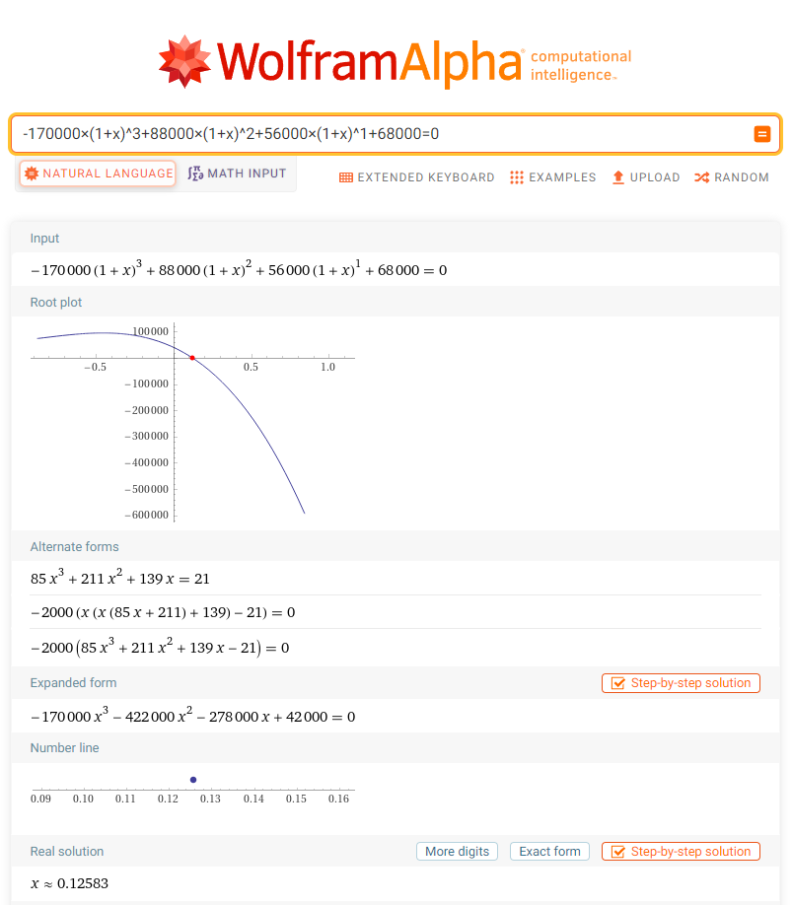

project B
$$IRR=10.50\%$$
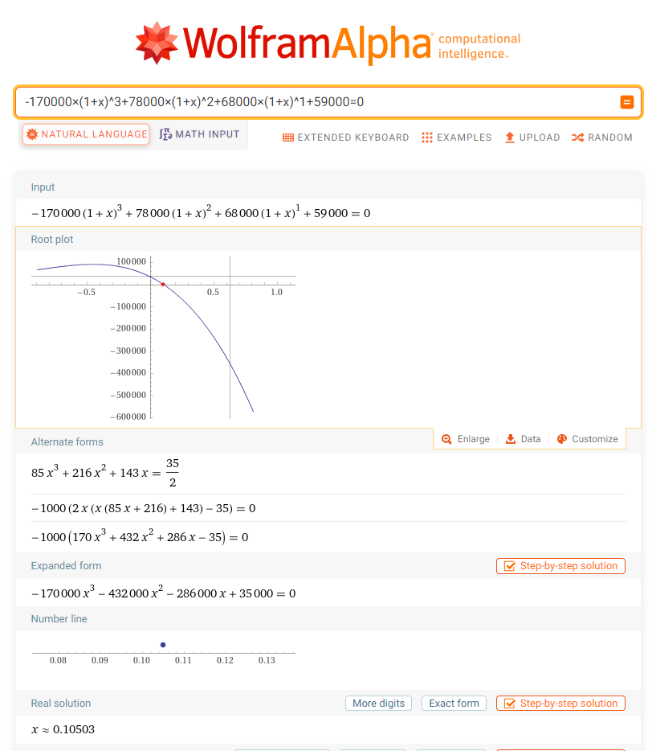

Choose project A for it has a greater IRR.

4
$$\sum_{t=0}^{n}{{PCF}_{t}×{(1+Reinvestment Rate)}^{n-t}} \\ ={(1+MIRR)}^{n}\sum_{t=0}^{n}{{NCF}_{t}×{(1+Financing Cost)}^{-t}}, where n=3$$

Assume that reinvestment rate is equal to WACC:
project A
$$88000×{(1+11\%)}^{2}+56000×{(1+11\%)}^{1}+68000={(1+MIRR)}^{3}×170000 \\ MIRR=11.96\%$$

project B
$$78000×{(1+11\%)}^{2}+68000×{(1+11\%)}^{1}+59000={(1+MIRR)}^{3}×170000 \\ MIRR=10.69\%$$

Choose project A for it has a greater MIRR.

