**Assignment 1: Interactive Environment design and production in Unity**

EEMT21 INTRODUCTION TO XR: APPLICATIONS AND TECHNOLOGIES

Lingyu Gong

23337765

1. **Assignment purpose**

This project aims to demonstrate my proficiency with Unity, encompassing the fundamental operations such as terrain building, component addition, and script integration. My familiarity with the C# programming language plays a crucial role in implementing user interactions and other functionalities. Additionally, this task involves a creative aspect, where I engage in the step-by-step construction of custom scripts and the development of desired scenarios within a structured framework. The project is a fusion of technical skill and creative expression, aiming to create an immersive virtual environment. However, due to constraints in time and resources, some limitations have been encountered. These shortcomings, along with potential improvements, will be thoroughly addressed in the concluding part of the report.

1. **Environment introduction**

The core idea behind my project is to design a mini-game focused on stress relief and healing, inspired by the challenges I face in my professional life. As a specialist, my daily routine often involves working through the night and enduring long hours in a brightly lit lab. Despite these demanding conditions, my colleagues and I remain resilient, drawing strength from one another. During these stressful times, I often find myself daydreaming about being in a vast, beautiful field where I can breathe freely and move without any constraints. This desire for a peaceful escape is what led me to develop this XR-based mini-game as a form of self-expression.

My design features two main scenes to encapsulate contrasting emotions. The first scene is designed to be gloomy and oppressive, evoking feelings of suffocation and dullness, much like the stressful environment of my lab. In contrast, the second scene represents a serene and natural setting, complete with blue skies, green trees, and a gentle spring breeze. This scene is intended to spark imagination and provide a sense of energy and courage to move forward.

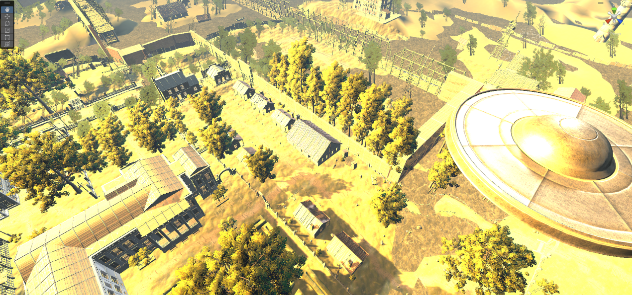

Figure 1 Flood Scene Presentation.

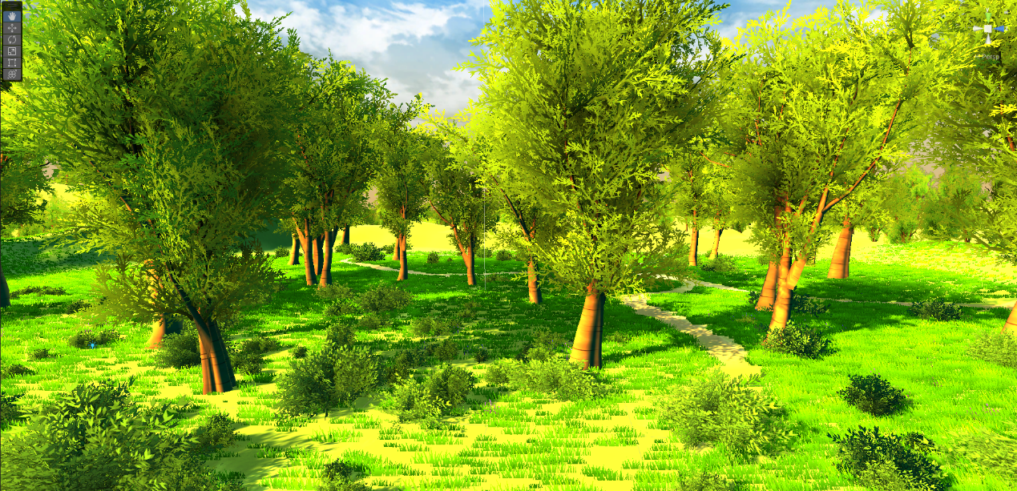

Figure 2 Forest Scene Presentation.

Players can transition between these two scenes via a portal, allowing for a bi-directional journey from the bleak to the blissful. In its current iteration, the game includes a scene of a village submerged in floodwater to depict the oppressive atmosphere, and a scenic mountain landscape to portray tranquillity and beauty.

Although the current scenes used in the game are sourced from pre-built assets and don't completely align with my original vision, they still serve the purpose of providing a stark contrast between stress and relief, and beauty and bleakness. Through this project, I aim to offer players a chance to escape from their stress and immerse themselves in a world of their imagination.

1. **Experience description**

In the current design of my game, the player is introduced to a scene of a flooded world. Upon entering the game, players are immediately immersed in an atmosphere filled with the sounds of rushing water and sober opening sound effects, setting a gloomy tone. The primary objective in this world is exploration. As players navigate through this submerged environment, they encounter remnants of a once-thriving world now in ruins - buildings drowned under water, abandoned cars, and dilapidated sheds. Above, amidst the chaos, strange flying objects can be seen, hinting at the existence of another reality.

The sense of being in an abandoned world is palpable as players search for a portal, their gateway to escape the flood and reach an idyllic world. This portal is strategically located in a pavilion. Upon discovering it, players enter the pavilion and pass through the portal, transitioning from the flooded ruins to a lush, green field.

In this idealistic countryside setting, the overwhelming sounds of the flood are replaced by the soothing rustle of leaves in the wind. The world is awash with vibrant greens, offering a stark contrast to the previous scene and enveloping players in the serene beauty of the fields. For those wishing to revisit the flooded world, the portal remains accessible, allowing players to travel between these two distinct worlds at will.

1. **Detail Explanation**

In the first scene of the game, I've created an atmosphere that embodies desolation and chaos, represented by a flood scenario. The setting is meticulously designed with gloomy lighting and a color palette dominated by greys, enhancing the feeling of despair. The environment is filled with muddy floodwaters, partially destroyed buildings, wrecked bridges, and abandoned vehicles, all contributing to a sense of abandonment and devastation. The audio elements in this scene are carefully chosen to complement the visuals, including the continuous sound of water, the echo of wave splashes, and a dark, ominous ambient soundtrack. Additionally, the rustling of wind through leaves adds a touch of realism to the scene.

The second scene, in contrast, is a serene natural field, vivid with green grass, thriving trees, and blossoming flowers. This scene is divided into two distinct terrains: a dense forest area and an open plain, each offering a unique visual experience. However, I encountered some technical challenges during development. When exporting the project from a Linux to a Windows system, several components were unsupported and resulted in missing elements. Furthermore, there were issues with the collision mechanics involving the trees.

Regarding the audio design for this second scene, the focus is on the soothing sounds of the wind gently swaying the leaves, creating a tranquil and calming environment. Notably, there are no water sounds, emphasizing the contrast with the first scene.

The transition between these two worlds is facilitated by a portal, programmed through scripting. This portal allows the player to seamlessly switch between the chaotic flood scene and the peaceful natural field, symbolizing a journey from turmoil to tranquillity.

1. **Future work**

As I mentioned before, my original intention was a much nicer idyllic scene, at the moment this scene doesn't appear to be as good as it could be, first of all I would add more components such as more brightly coloured bushes and flowers and music to render the ambience, and in itself I would have liked to have added some laughter as the characters move around but it hasn't happened yet, and I would have liked to have added some critter movement to make the whole scene more I would also like to add some small animal movement to make the whole scene more rich. In the other scene, the components are more abundant at the moment, but I would like to find some components with the properties of a dilapidated forest, which I hope will turn the scene into a darker atmosphere and make the contrasts more intense.

In addition to this there are more serious version system incompatibility, I initially built on Linux, and eventually wanted to switch to windows school lab machines, but the lab computers can't install the software on their own, and what was already there was version 2021, which led to a very large number of version incompatibility issues, and my demo was also in the changed incomplete version, so hopefully this will be fixed in the future.

1. **Appendix**

Demo video with explanation: <https://youtu.be/731q0MHzN08>

Demo video without explanation: <https://youtu.be/6dFgh9u_zhI>