**Assignment 2-2: Augmented Reality Interactive Environment design and production**

EEMT21 INTRODUCTION TO XR: APPLICATIONS AND TECHNOLOGIES

Lingyu Gong

23337765

1. **Introduction and Overview**

This project develops an Augmented Reality (AR) application that aims to provide an innovative entertainment tool that brings a new experience to the user by interacting with the real world through augmented reality technology. The app instantly recognises and displays a student's personal details including name, gender and other basic attributes by scanning the student's card. In addition, the app generates a 3D model that matches the student's characteristics, which is not only visually appealing, but also incorporates dynamic elements that make each interaction unique.

As the profile is displayed, the app automatically selects and plays a soundtrack based on the student's personality traits. This personalised music selection aims to enhance the user experience and further showcase the student's personality and style through the combination of music and visuals. For example, a lively and outgoing student might be matched to energetic pop music, while a calm and introverted student might be shown softer, deeper melodies.

The AR app utilises advanced image recognition technology to identify the information on the student's card and uses sophisticated algorithms to extract the relevant data from a database, which is then converted into a visual representation. The whole process is not only fast but also smooth, ensuring easy operation and a pleasant interactive experience for users.

Overall, the development of this app blends the cutting-edge applications of augmented reality technology with the trend of personalised experiences, not only demonstrating the practicality of the technology, but also providing a brand-new way of exploring and expressing personal identity. Through this form of interaction, users can have a relaxing and fun experience in their daily lives, while adding a sense of fun and technology to campus life.

1. **Context and Inspiration**

**2.1 Character selection and character modelling**

Firstly, the inspiration comes from the character selection process in mainstream role-playing games. In these games, players are usually required to select a character before starting the game, a process that not only shows 3D models of each character, but also accompanies detailed character backgrounds, such as personality traits, abilities, and historical stories. This combination of visuals and information not only enhances the immersion of the player, but also makes character selection an engaging part of the game experience. This inspired me to develop an app that recreates this character selection experience in the real world by scanning student cards and using augmented reality to display 3D models of each student and their personal characteristics.

**2.2 Humorous expressions of personal attributes**

The second point of inspiration comes from the fun tradition of my field of study. In the process of learning programming languages and command-line operations (e.g. Turtle), we often humourously call ourselves or our classmates "wangba" (turtle) with certain attributes. This self-deprecation and humour not only increase the fun of learning, but also deepen the communication and friendship among classmates. Therefore, I would like to use the opportunity of this project to transform this humorous and individual expression of campus culture into a visual form by showing the personality and characteristics of each person in a fun way.

1. **Relevance of AR Medium**

AR technology was chosen for this project due to its unique interactivity and immersion. The app scans a student's card to display a personalized 3D model and plays music that matches their personality, enhancing the user experience. This technology adds educational and social value, allowing students to present their identities in a new way and facilitating communication on campus. Overall, choosing AR technology adds a new interactive dimension to campus culture.

1. **User Interaction and Interface Design**

**4.1 Interactivity**

This AR app provides an intuitive and engaging way to interact. Users first initiate the interactive experience by scanning their student card. Once the card is recognised, the application generates a 3D model of the user in real-time and displays relevant personal information such as name, gender and personality traits. In addition, based on the user's personality traits, the app automatically plays background music in the appropriate style. This instant visual and audio feedback not only enhances the user's immersion, but also makes the user feel that his/her personal attributes are fully expressed and respected.

Users can rotate or zoom in to view their 3D models through simple gestures or screen touches, an interaction that provides users with the freedom to explore their own digital representations. The application is also designed with feedback mechanisms, such as direct visual and auditory responses to user actions, making each interaction seem lively and fun.

**4.2 Interface Aesthetics**

In terms of interface design, we focused on clarity and ease of use. The user interface (UI) of the app features a clean layout to ensure that users can navigate and operate it easily. We chose an eye-catching and visually non-fatiguing colour scheme, as well as clear, easy-to-read fonts and icons to ensure that information is accessible and any occlusion is avoided. Together, these design elements ensure that the application is intuitive and efficient.

The graph below shows an example of the user’s interface.

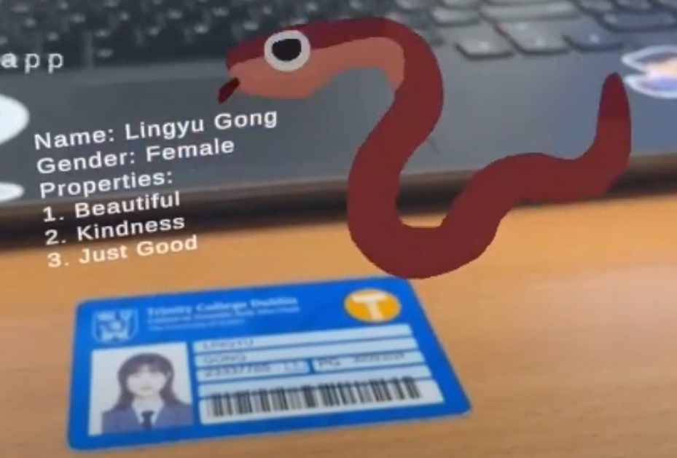

Figure 1 Example of User’s Interface

1. **Audiovisual Integration**

In my AR applications, the use of audio and music is intended to be closely synchronised with visual elements to enhance the user's emotional experience and immersion. By carefully selecting music based on the user's personality traits, the audio design not only reinforces the personalised representation of the character, but also enhances the realism of the environment and the intuitive nature of the interaction through sound effects synchronised with visual actions such as the rotation or scaling of 3D models. This visual and audio consistency ensures that users have a coherent and engaging experience when using the AR app, which significantly improves the overall app's appeal and user satisfaction.

1. **Conclusion and User Expectation**

This AR app creates an experience that is both interactive and educational by combining augmented reality technology with personalised content. Users use this app not only to learn through entertainment, but also to gain insight into the uniqueness of themselves and others, thus enhancing social interactions and the diversity of campus culture. The experience of scanning student cards for personalised 3D models and music not only increases user engagement, but also enhances immersion and satisfaction through the simultaneous use of audio and video.

I expect users to feel the convenience and fun of the technology when using this AR application, and to improve their understanding and connection with their peers through this novel interaction. In addition, the application also demonstrates the potential of AR technology in the educational and social fields, which can be further expanded to other fields in the future, such as distance education and corporate training.

All in all, the app not only demonstrates the power of AR technology, but also provides an innovative platform for users to explore and express their personal identity. It is hoped that in this way, users will become more actively involved in campus life and enjoy a more colourful and interactive experience.

1. **Appendix**

Demo video: <https://youtu.be/sMWGQh34GIw>