**Lab 3 Part 1: FIR Filter Design**

Lingyu Gong

1. **Lab purpose**

Familiar with the design of FIR filters in MATLAB, understand how noise can be removed using a designed filter and examine the effects of quantisation on filter performance.

In this lab, first, go through the filterDesigner tools provided by MATLAB, and then use it into real situation, analyse how different variables can change the result.

1. **Filter Designer**

Filter Designer is a convenient instrument for creating and design filters, type filterDesigner at the command window and a window like the example below will show up.

A brief introduction about the design window.

1. Response Type: There are low-pass, high-pass, band-pass, band-resistance, and other designs.
2. Design Method: There are two categories: IIR and FIR.
3. Filter Order: The order can be set according to your own needs, or you can directly select the minimum order.
4. Frequency Specifications: Set the parameters according to your needs.
5. Magnitude specifications: Define the magnitude attenuation, the unit is dB, decibel, Apass means passband attenuation, and Stop means stopband attenuation.

The example below uses pass frequency as 3.375kHz, stop frequency as 5.625kHz, passband attenuation as 1 dB, and stopband attenuation as 90 dB.

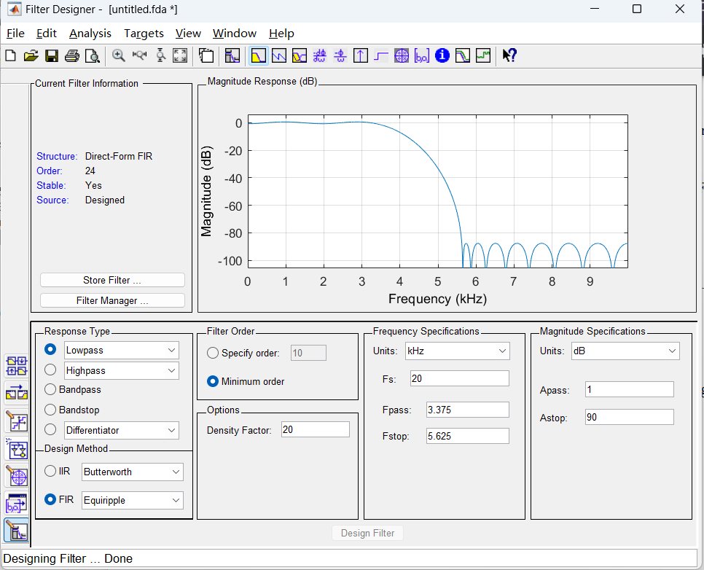

Figure 1 The main window of FilterDesigner in MATLAB

1. **Lab Implement**

Our goal is to eliminate the noise in the audio, so the solution will be like the graphic below. All the code follows this main idea and has comments beside it to help understand. Change domain into frequency and show in the figure1.

Figure 2 The main process of the lab

Pick two main parts to go deeper.

1. When at the process to find the “click”, I use max function, and I try argmax function, but it seems need to be defined by ourself, so I finally choose max function.

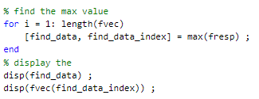

“find_data” is the specific value of amplitude spectrum about the click.

“find_data_index” is the specific frequency of the click, like a positon.

1. When at the process to estimate the noise, I create the filter in filterDesigner tools and export as code.



The part of the filter is as the picture below.

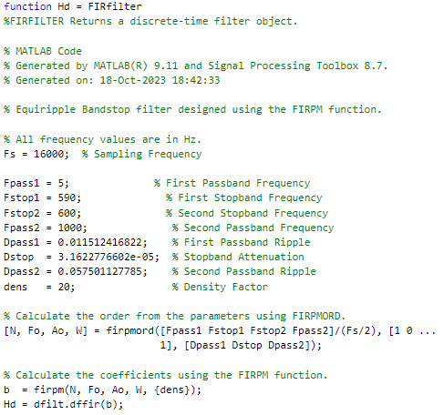

Then I trying to change the value to make my result clearer. Finally, my result is as follow:

Sampling Frequency = 16000 % need to be same as original one.

First Passband Frequency = 5

First Stopband Frequency = 590 % because the click is near 593.7500

Second Stopband Frequency = 600

Second Passband Frequency = 1000

1. **Outcome explanation**

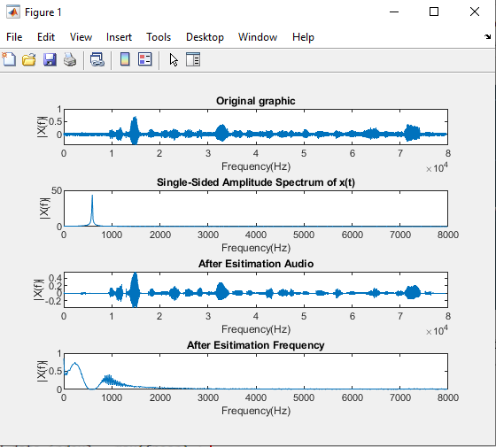

Figure 3 The vitalization result

The key value and the position are shown as above, you can see a big change happened to the click.

Also, you can use: “sound(estimate_audio, Fs);” this line to check the sound when you run the code.

Check the originally: sound(x, Fs) ;

Check after filter: sound(estimate_audio, Fs)

1. **Summary**

The whole lab 3a wants us to get in touch with filter designer in MATLAB, with this tool, we can effortlessly adjust filter values and comprehend the distinctions between them. I have acquired a basic comprehension of the filter design process and aim to explore the different values further in due course.