Summary of issues

1. 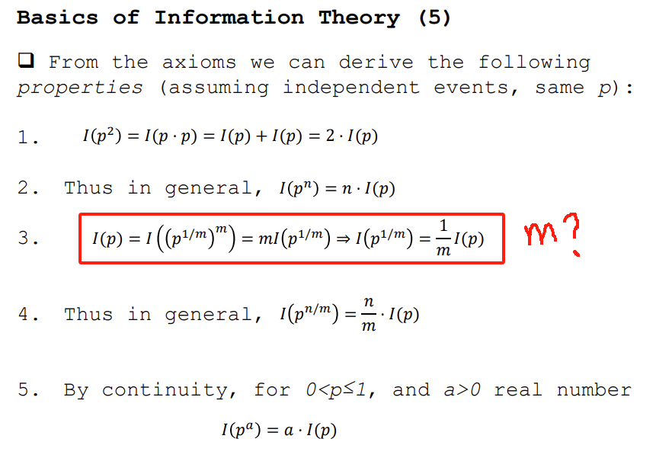**(2.02). What’s “m”?**
2. 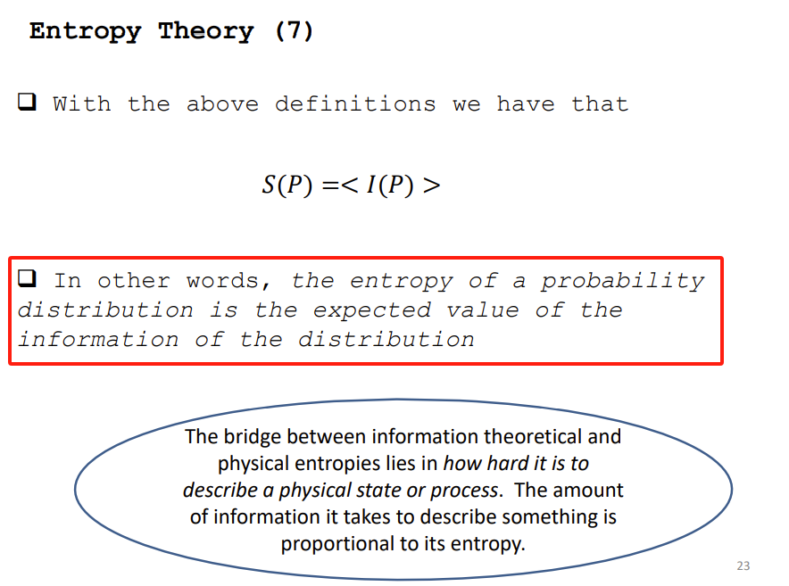**(2.02). How to understand this red mark area? What is the definition of “entropy”?**
3. 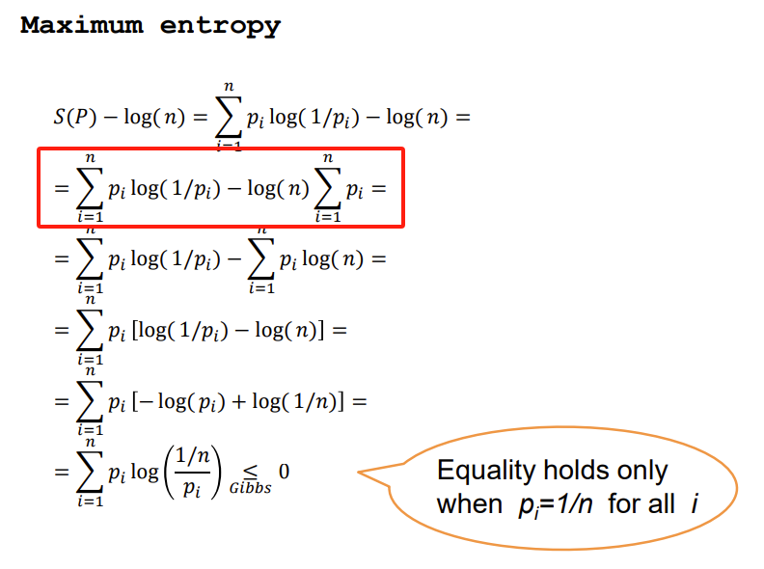**(2.02). Can u help me to clear the prove?**
4. 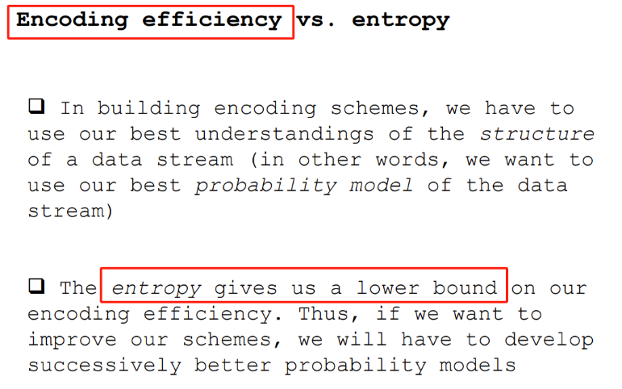**(2.03). Is “compress” means get everything in order, and entropy will be the most messy value?**
5. 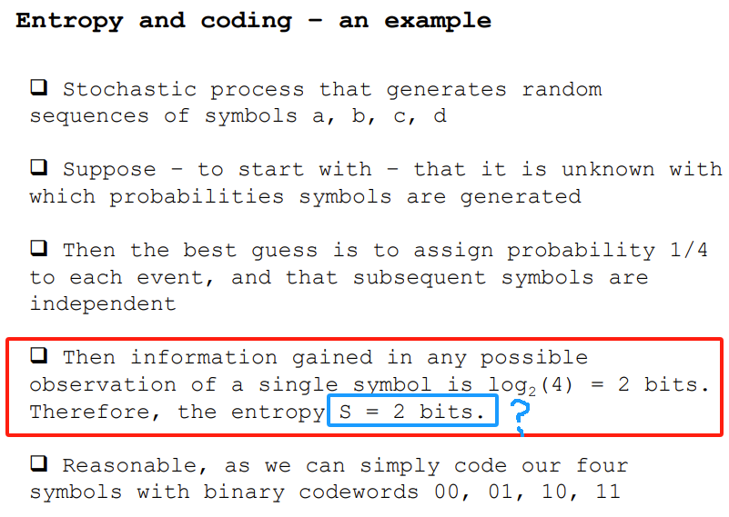**(2.04). Why “S=2 bits” ?**
6. 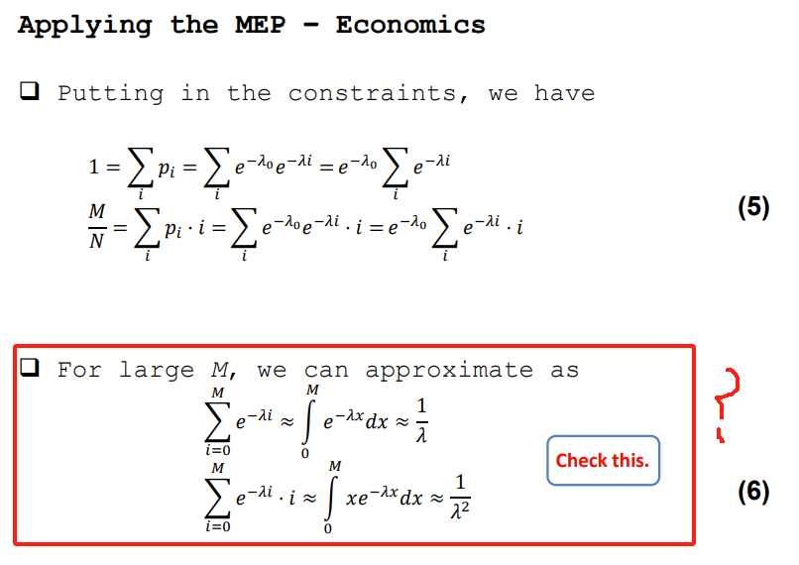**(2.04). Can not prove this, can u help me to go through the prove?**
7. 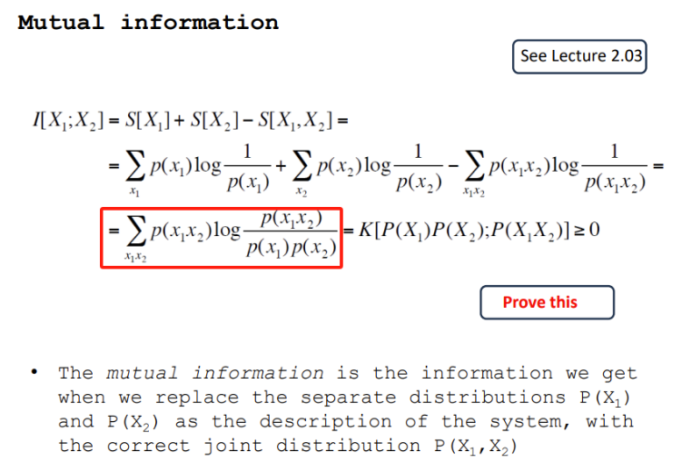 **(2.05). Can not prove this.**
8. 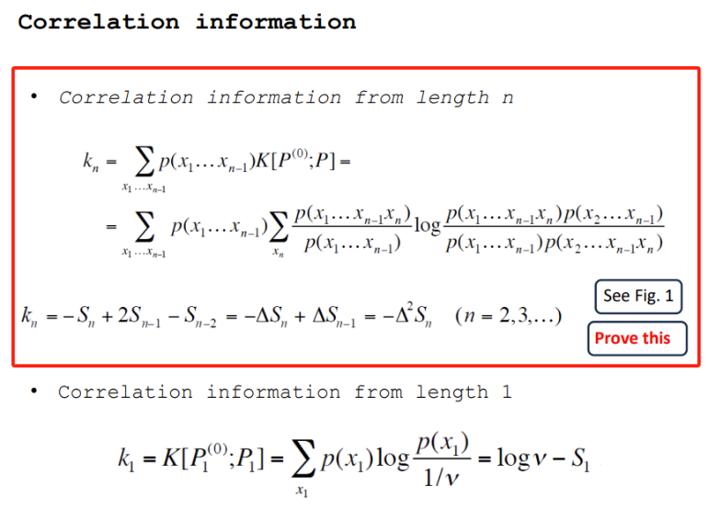 **(2.05). Can not prove this.**
9. 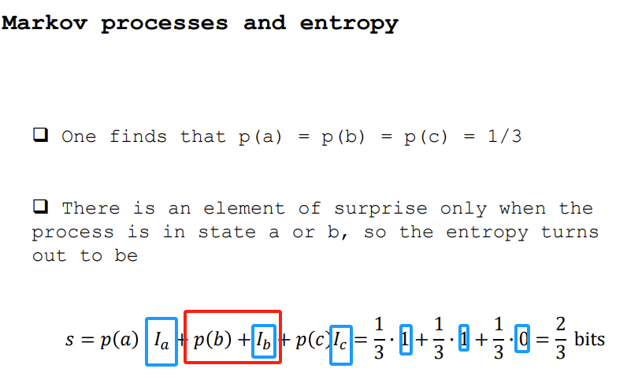**(2.06). How to calculate “I”? Is red area wrong with expression?**
10. 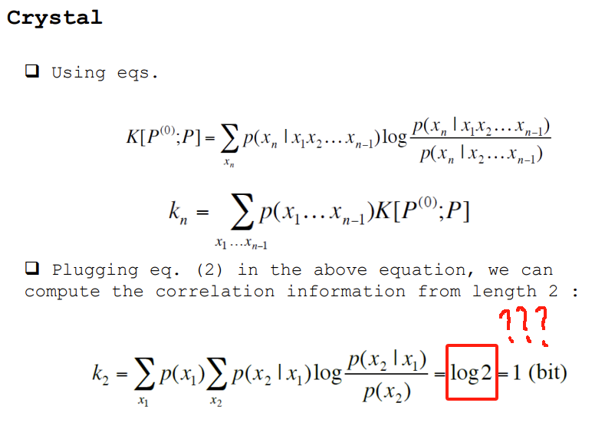**(2.06). Sorry to my poor math calculations, but how did this one get?**
11. 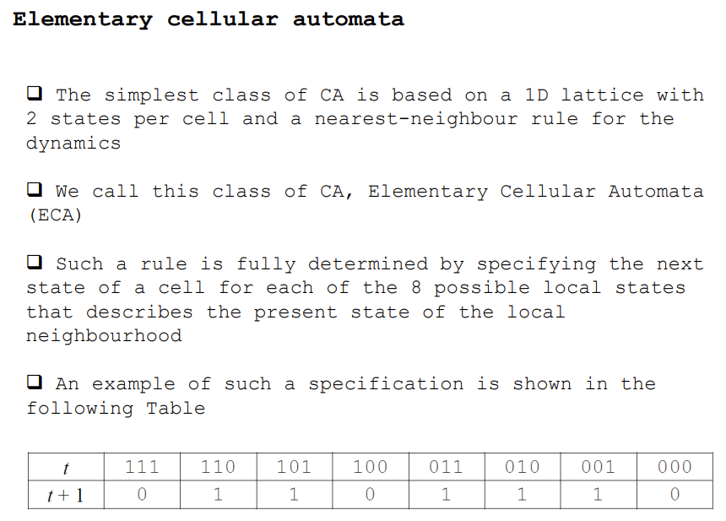**(2.08) How can I get the table below?**
12. **(2.08) For Lecture 2.08 could you remind me about four Class of Rules and what is the main differences between them?**
13. **About the first tutorial, can you help me to clear the logic of question 2? And what the meaning by “m” and “v”?**

My understanding will be: **“m”** is the length of sequence that must occur according to the model (shortest) and for **“v”** is the alphabet that can be generated in this model. I’m not sure is this correct.

1. **(4.01) How to understand “Clustering Coefficient”?**
2. 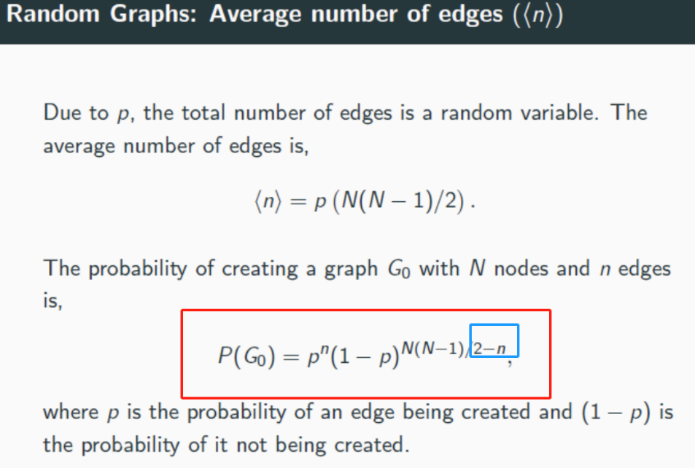**(4.01) As my understanding here should be (N(N-1)/2)-n, is this correct?**