**Lab 1: AM Systems**

EEP55C26 Open Reconfigurable Networks

Lingyu Gong

1. **Lab purpose**

In this experiment, we will attempt to transmit a signal and then receive it. We will observe how the signal transmits information through a wireless channel using AM/FM techniques. We'll also dive deeper into modulation schemes based on time and frequency domains. Finally, we will configure a real-time DSBAM receiver using a Pluto SDR device.

1. **AM Systems**
2. **Observe the AM signal**

In this experiment, we use a device that transmits and receives signals on its own, the first figure shows the architecture of the transmitter side.

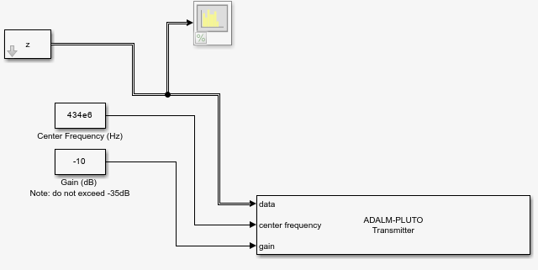

Figure 1 The structure of transmit side.

To establish a connection between the RX and TX on our device, we utilize loopback. As illustrated in Figure 2, the configuration of our receiver side is demonstrated. Upon running the project, we can observe the waveform generated from the receiver side, as demonstrated in Figure 3. Additionally, in Figure 4, I use the label to indicate the corresponding value and peak point.

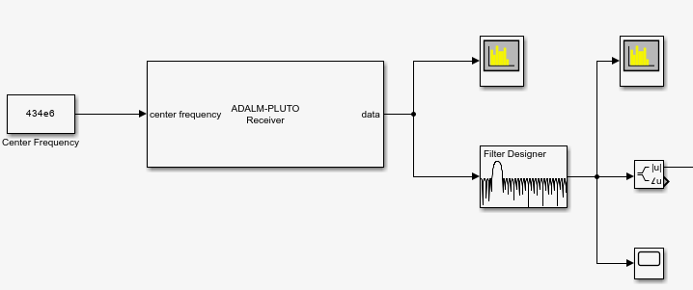

Figure 2 The structure of receiver side.

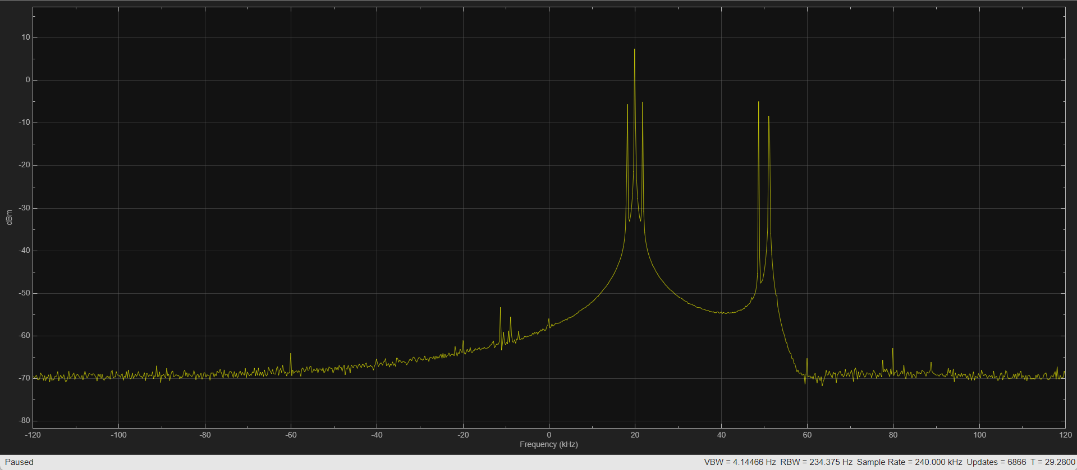

Figure 3 DSBAM and DSB-SC spectrum (Orignal).

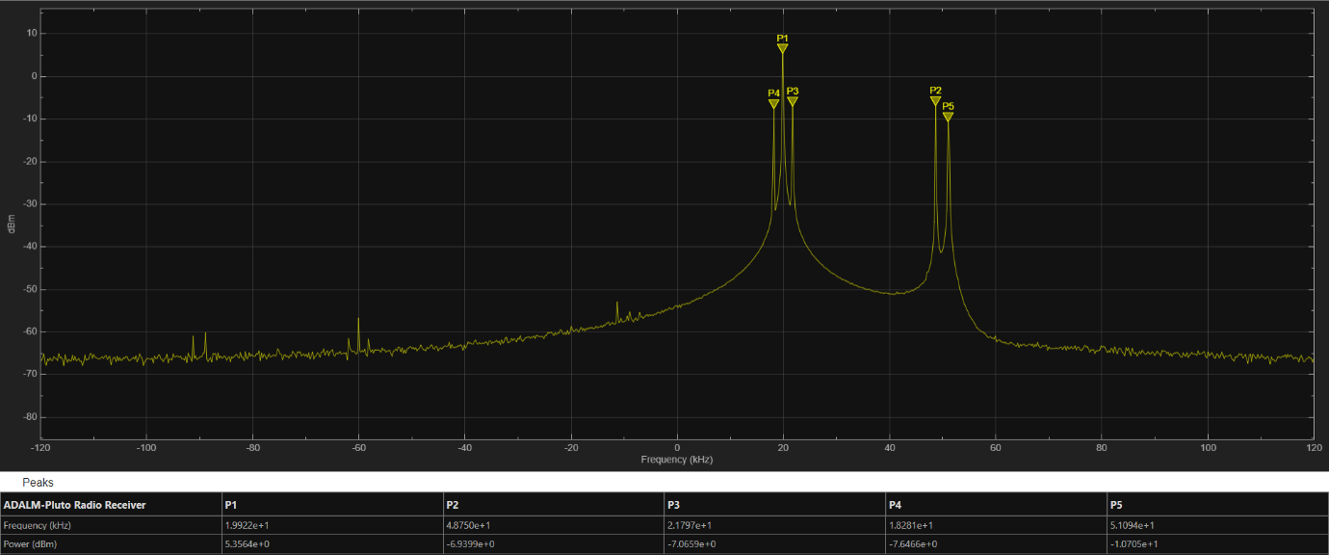

Figure 4 DSBAM and DSB-SC spectrum (with label).

**Question 1.1: On a screenshot of the spectrum analyser, identify the DSBAM, DSB-SC and their sidebands (you may annotate or define them in the text).**

As shown in the appendix, we can learn what the DSBAM and DSB-SC and what are the differences between them, I summarized their characteristics below: Double Sideband Suppressed Carrier (DSB-SC) is a variant of amplitude modulation (AM) where the modulated signal is symmetrically distributed above and below the suppressed carrier frequency. In standard AM, used in applications like AM radio, the amplitude of a carrier wave is varied according to an audio signal. This process results in a signal with the carrier frequency and two mirror-image sidebands, each equal in bandwidth to the modulating signal. However, unlike standard AM, DSB-SC ideally eliminates the carrier level, focusing energy on the sidebands for more efficient transmission.

Based on the information above I can identify the signal on the left will be DSBAM signal and the signal on the right will be DSB-SC. I zoomed in the pictures to make it clear.

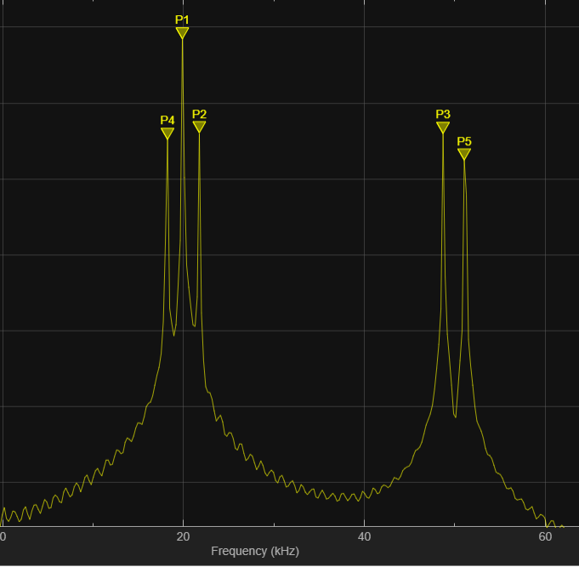

Figure 5 Left spectrum is DSBAM and right spectrum is DSB-SC.

**Question 1.2: Determine the actual carrier frequency of the DSBAM and the DSB-SC passband waveform?**

As shown below in Figure 6, the actual carrier frequency of the DSBAM is 1.9922e+1 kHz, and for DSB-SC, it should be in the middle of P3 and P5 (ideally), so the value will be 4.9922e+1kHz.

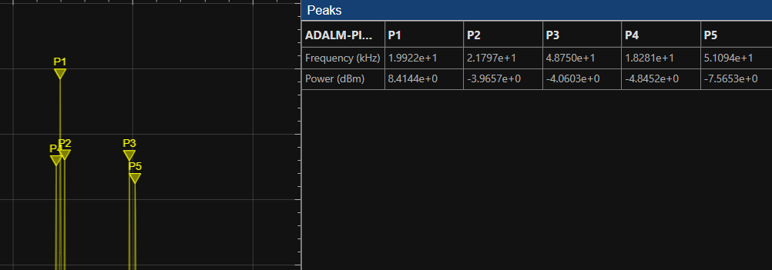

Figure 6 The detail of the information.

**Question 1.3: Can you determine the message frequency of the DSBAM communication signal?**

As shown above, same graphic, the message frequency should equal to P2-P1 (should be same as P1-P4) so the result will be: 1.875e kHz.

1. **Capturing in time-domain**

Figure 7 shows the time-domain waveform observed on the scope. To design my filter, I followed a tutorial and used a 60-order Equiripple band-pass filter.

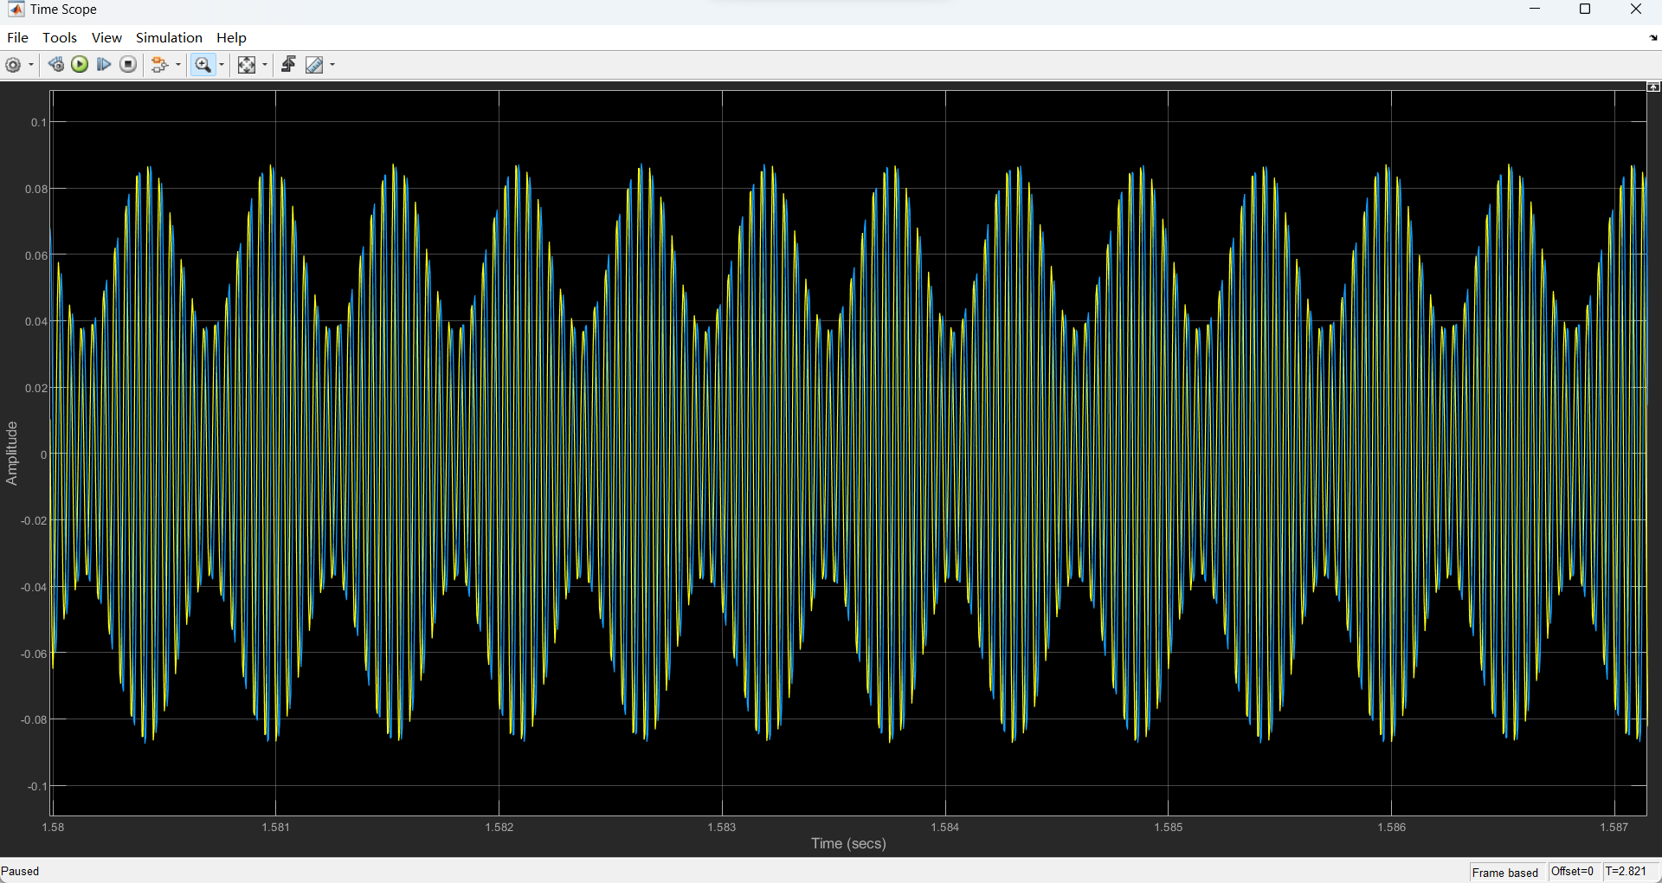

Figure 7 Time-domain signal from the Time Scope

**Question 1.4: Configure the filters appropriately to see both the DSB-SC and DSBAM waveforms. Are you able to identify message frequency from the time-domain plots?**

We can see that initially the mains frequency of the DSBAM was around 20kHz and the mains frequency of the DSB-SC was around 50kHz, so if I were to filter the signal from the DSBAM now I would need to pass around 15-25kHz through and stop the rest, Fig. 9 shows the result after I have filtered the signal using the filter.

To be easier to analyse, I change my design into Figure 8, the first line adding to observe DSBAM, the second line is trying to observe DSB-SC.

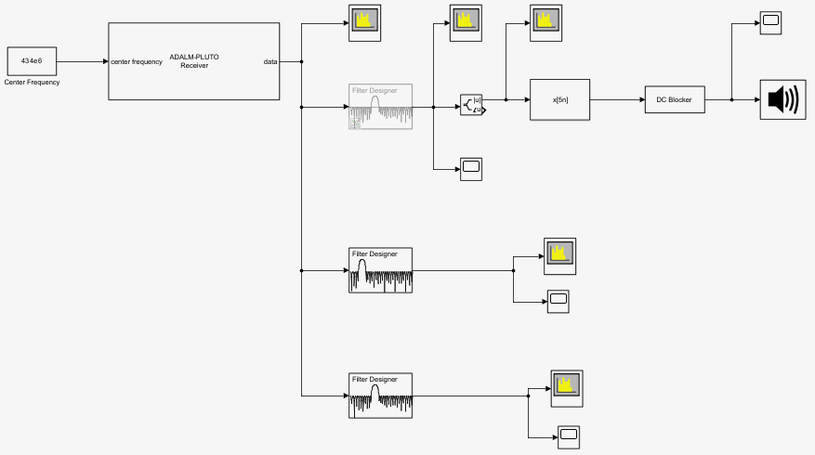

Figure 8 The structure of receiver part after modified.

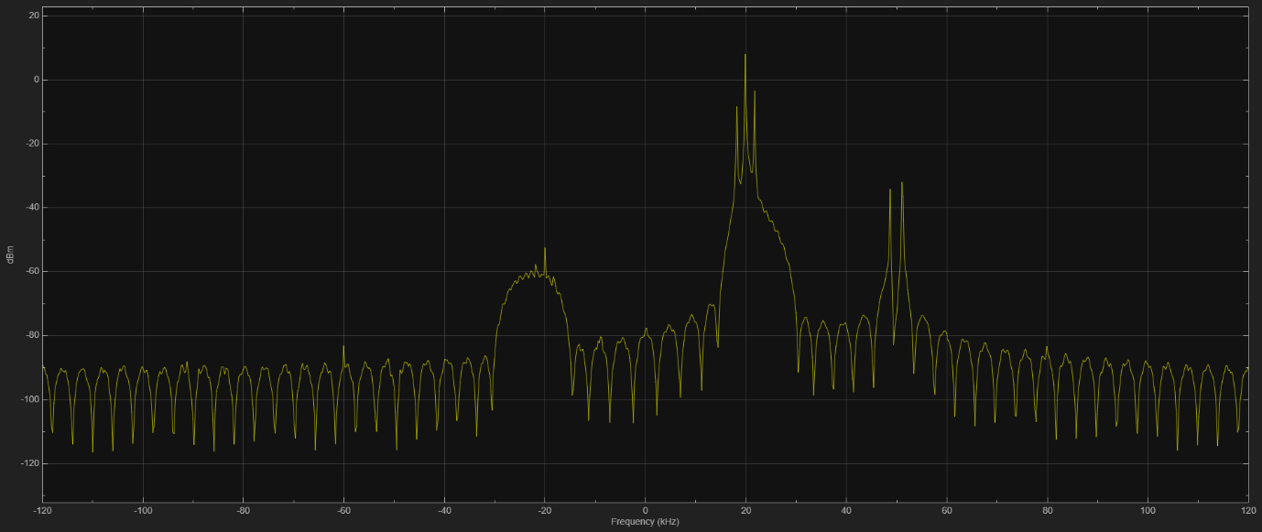

Figure 9 Results after filtering for DSBAM.

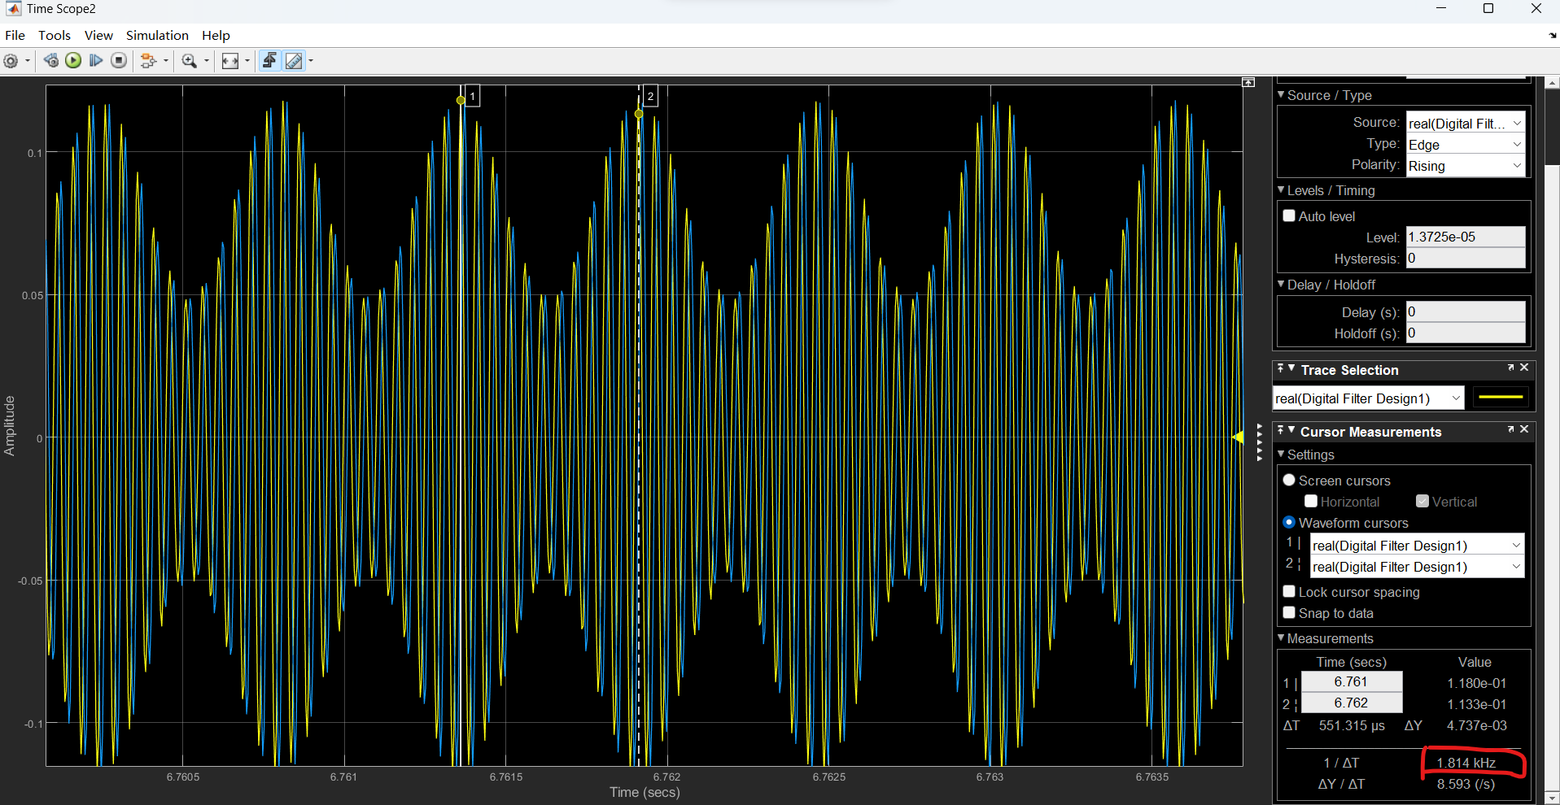

Figure 10 Time domain after filter for DSBAM.

As shown in the Figure 10, I can figure out in the time domain that the message frequency of DSBAM will be around 1.814kHz.

Same as for DSB-SC model, figure 11 is the graph of frequency domain, figure 12 is the time domain, and I can observe that the message frequency will be around 2.436kHz.

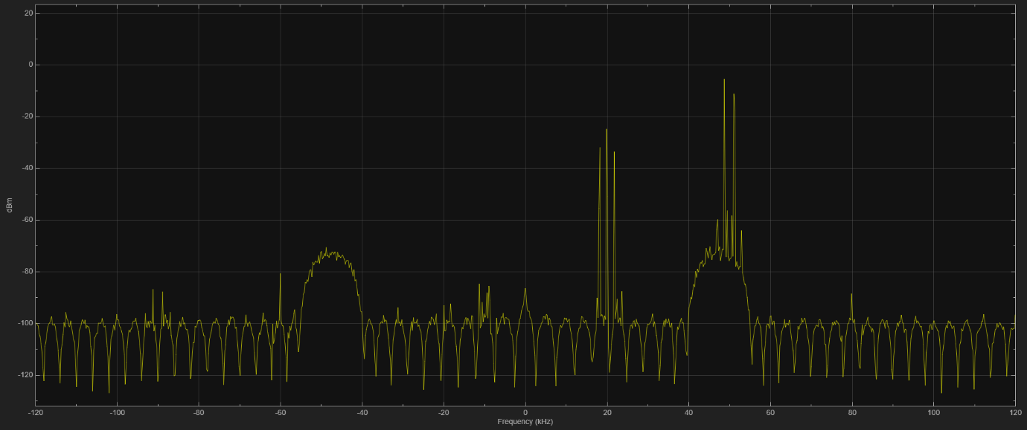

Figure 11 Results after filtering for DSB-SC.

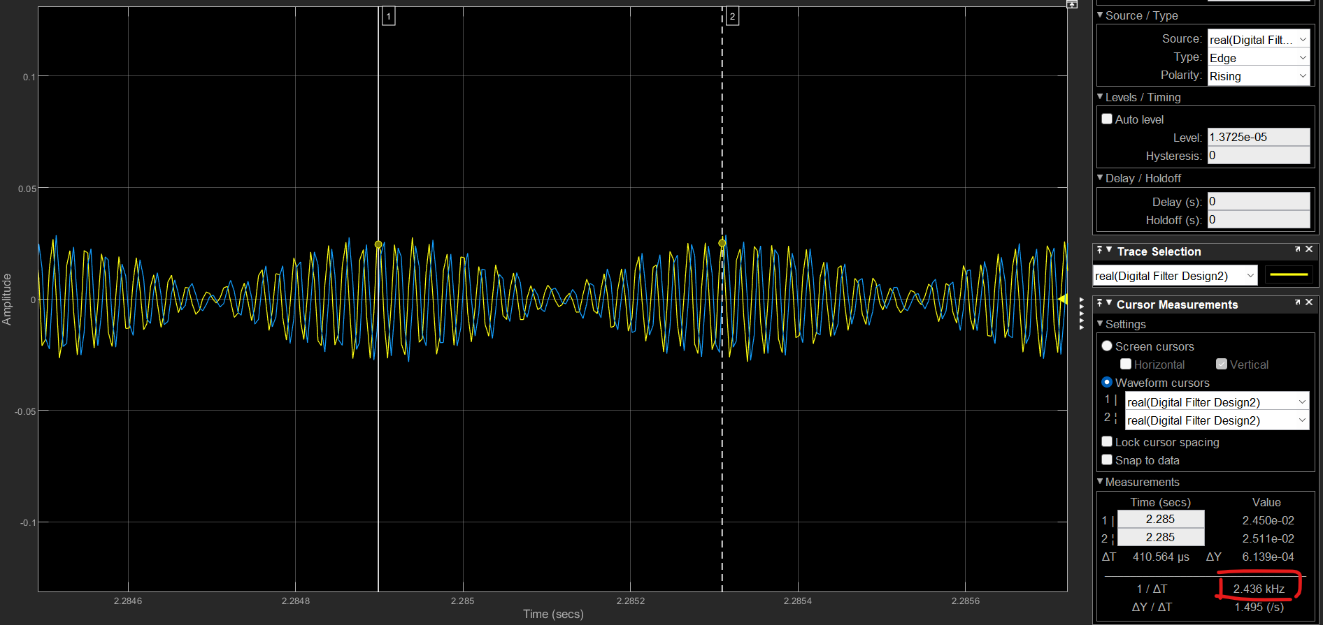

Figure 12 Time domain after filter for DSB-SC.

1. **Complete DSBAM Receiver**

I complete the structure according to the tutorial, adding component Complex to Magnitude-Angle block, FIR Decimation block, DC Blocker block and Audio Device Writer block (shown as figure 13).

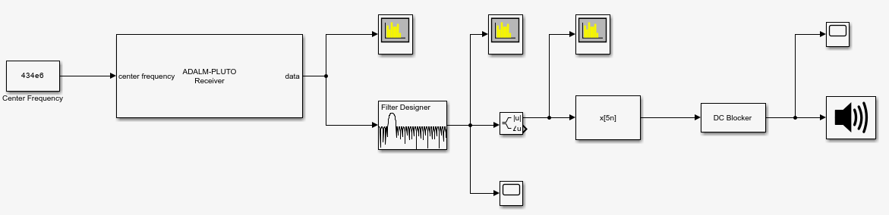

Figure 13 Simulink model for DSBAM receiver.

**Question 1.5: What happens to the recovered audio when you adjust the gain of the SDR receiver block? Summarise your findings.**

To improve the quality of the original audio, I increased the Gain. However, I noticed that as I increased the Gain, the noise also increased. Therefore, I tried different values for Gain, specifically 5, 10, 20, and 30dB. After testing, I found that when I set the Gain to 20dB, the audio had a clear sound without any noise.

|  |  |  |
| --- | --- | --- |
| Gain(dB) | Virtualization Figure | Analyse |
| 5 |  | Very noisy, vocals not clear |
| 10 |  | Reduces some noise, but vocals are small and unclear |
| 20 |  | Almost no noise, vocals are loud and clear |
| 30 |  | Noise is getting louder again; vocal volume is low and unclear |

**Question 1.6: What happens when you remove the Bandpass Filter from the model? [You can do this easily by right-clicking the block and selecting “Comment Through”]. Summarise your findings.**

So, I use commend through to delete the filter and now the whole structure is shown in Figure 14 without a filter. As soon as I ran the code, I noticed that the spectrum changed visibly since there was no filter working. This is shown in Figure 15. Moreover, Figure 16 shows the audio spectrum without a filter, which produced a lot of noise making it difficult to understand what people said in the audio.

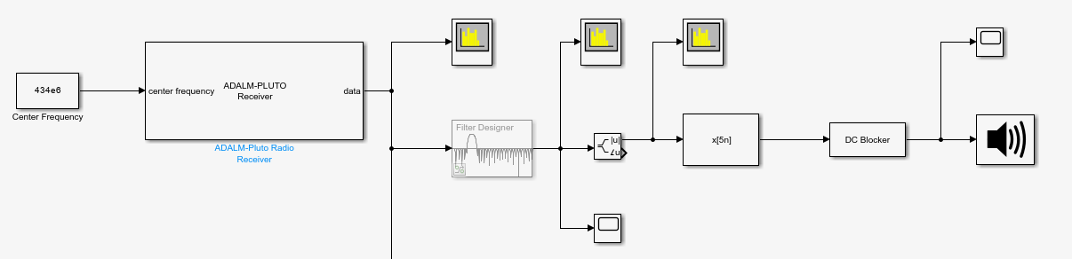

Figure 14 Structure without filter.

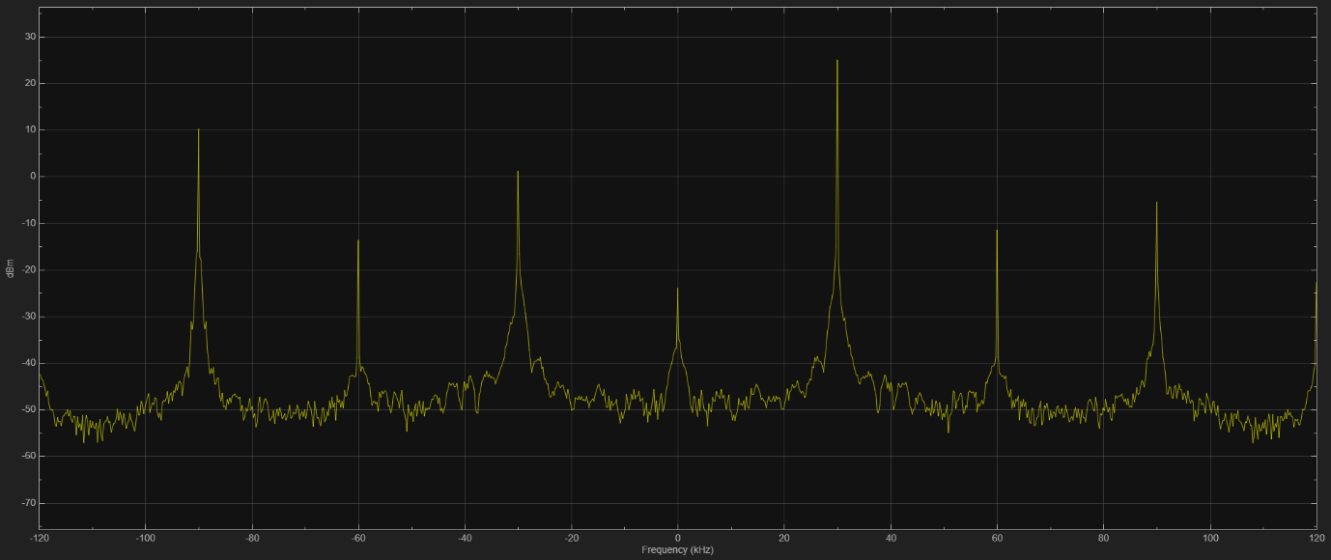

Figure 15 Spectrum after running the code without filter.

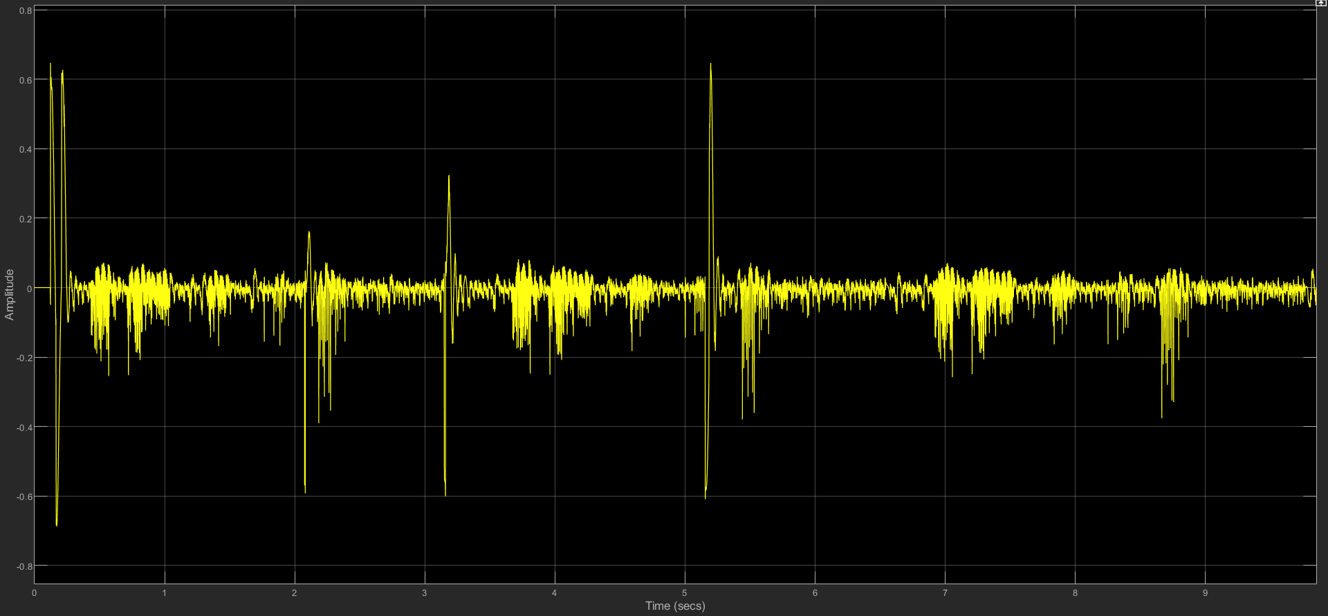

Figure 16 Audio spectrum after running the code without filter.

1. **Summary**

In this experiment, I gained a profound understanding of the signal transmission process and learned to analyse signal characteristics. I familiarized myself with the basic concepts of wireless communication, including sideband and carrier frequencies, and mastered their calculations. Additionally, I skilfully utilized MATLAB’s filter module, adjusted the parameters, and successfully executed filtering.