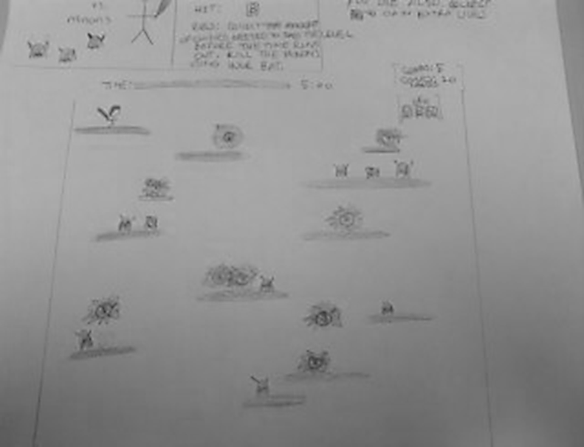Part 1

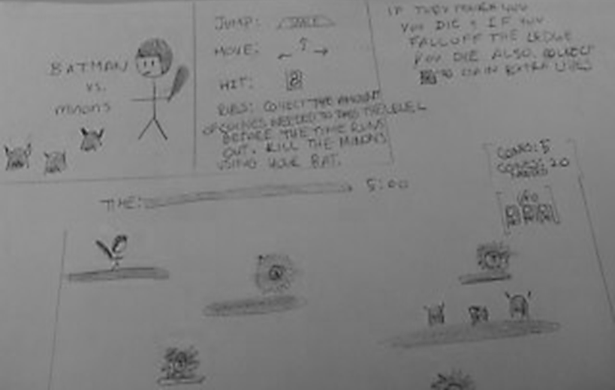

For this class I wish to program a simple game that only requires the user to use the keyboard to control. The goal of my game is that the player must avoid or hit the Little minons with the bat while the amount of coins needed to pass the level. Coins could also be earned by killing the minons. If the player touch the Little minons, then he will lose a life. More lives can be earned by collecting the boxes that have a stickman inside. The player must use the jump key, spacebar, to cross from one ledge to another. The player can die if he misses the ledge as well. Lastly, there would be multiple levels preferably with different themes that have more obsacle, making them harding to pass. In order to program this games I need to how to add sound effects and graphics to my game.

Part 2

Words that I wished to know:

1. Class
2. Calling methods
3. Arrays
4. Exceptions
5. Constructor
6. Using timer
7. Object programming
8. Importing class
9. Converting string
10. Working with array of characters
11. Static and non-static , private classes
12. Using parameters
13. Implement graphics