Câu 1: AppMayTinh

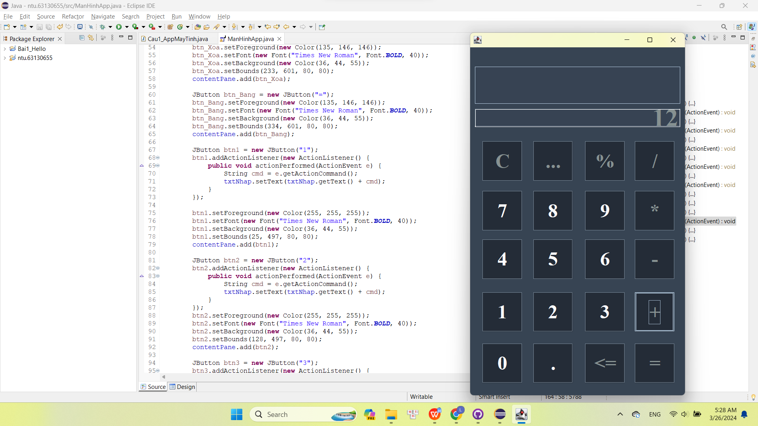

Câu 2:

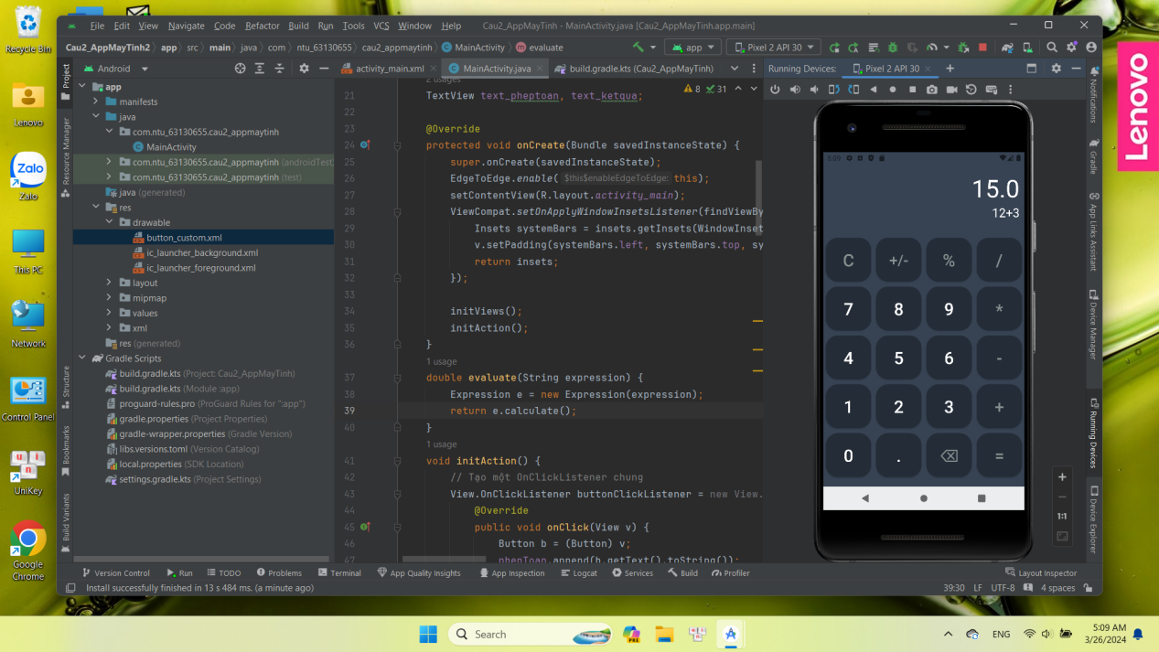

LINK figma: https://www.figma.com/file/KXHboieGiHaoLsORjAiXIq/Untitled?type=design&node-id=0%3A1&mode=design&t=SNFMfObTmpzRhRS6-1