Process Control and Human Machine Interface Development Tool

Hoang Linh An
Mobile Computing
Sheridan College
Oakville, Canada
anho@sheridancollege.ca

Diego Duarte
Mobile Computing
Sheridan College
Oakville, Canada
duartedi@sheridancollege.ca
Ghassem Tofighi
Faculty of Applied Science & Technology
Sheridan College
Oakville, Canada
ghassem.tofighi@sheridancollege.ca

Abstract— A web application service that allows PLC and HMI engineers to automatically build a list of production line devices for use when building production line interfaces.
Keywords—HCI, PLC, HMI, Device, I/O List

Introduction (Heading 1)
An engineer receives an I/O list from the project designer containing all the functions that a production line will perform. The engineer must manually look at this list of functions and create a database of all the devices being used by determining which devices performs that function. For example, TAB_DIS_CV_0001_R is the name tag of a motor called CV_0001. There are several versions of this motor. The “R” describes a reverse functionality. The engineer must identify that a reversible motor is to be used instead of a non-reversible motor. Not only is creating a list of devices slow, it is also prone to errors if any function is overlooked in the I/O list
The software to be built is a web application tool for the development of programmable logic controllers and human machine interfaces. This tool will aid engineers in the target domain to complete a specific step in their project development process more efficiently increasing project completion time.

HCI Principles
Before designing this prototype we took into consideration Usability Engineering. Due to the level at which the software would be operating it is important that users are able to complete the work effectively. To do this we designed a simple but efficient UI that outlines all the activities the software can perform right at the front. Since this software is the first of its kinds, we had to ensure new users would manage to learn the tool as quick and easy as possible. To do this we thought about designing for wayfinding and information seeking. An example of that in the prototype is the navigation bar at the top with the file, save, save as, and log out menus. The side view showing the file tree is also a well-recognized feature used by many studio style tools such as Visual Paradigm, Android Studio, and XCode.

Prototype Design

Requirement Analysis (NeedFinding)
- In the first step of the NeedFinding we consulted a domain expert and ask if there were any current issues they were facing in their work that could be improved by software. At this point the domain expert gave a user story which we than used to outline some requirements for a system.
- The domain expert showed us an example of the work they completed, and we took down some observational notes. We noticed that some of the basic tasks were repetitive and could be automated. For example, comparing values in an excel file to values in a database to determine a category. A software that could automate this process could optimize how the domain expert completes projects.
- Gathering Data
  - Desk Study
    - Doing research online did not yield much information. The proposed system is very specific in the task it will complete and we were unable to find any competitors.
  - Field Study
    - The domain expert had a prototype project that he used to automate his work. We reviewed this software and asked if there was any room for improvement. The domain expert explained that some of the code was hardcoded and had to be changed when different project types were needed. This is something that can be improved upon on our design.
- A well designed product would be a website set up as a subscription based service. On this website companies would be able to create accounts and have their engineers work on it. Engineers would be able to upload their project list into the tool and automatically compare the list with the database of settings. The database would be updated by the company meaning no hardcoded modules would be required. Since this software does not currently exists, being the first to market would give us a great advantage.

Competitive Analysis
Since the tool being developed does not yet exist. We were not able to create the comparison matrix, as well as the competitive analysis

First Initial Prototype Alternatives
My prototype:
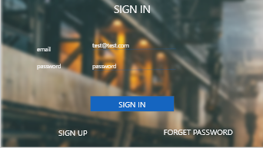
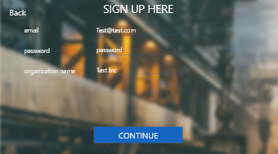
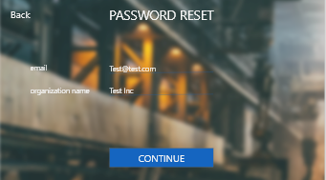
Diego’s Prototype;
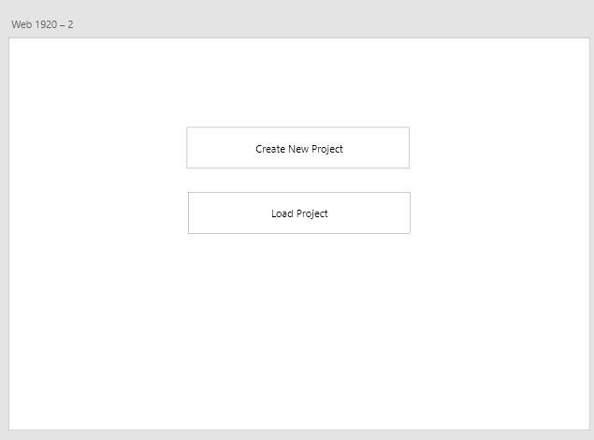
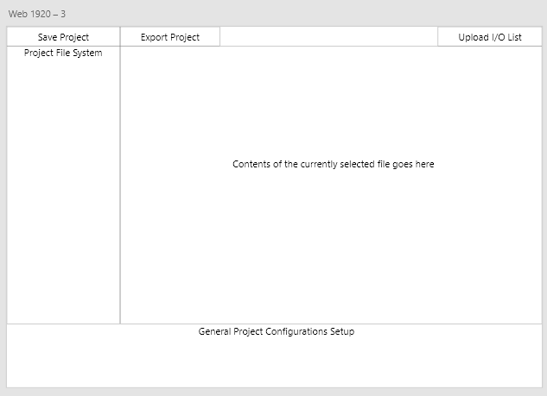
Final:
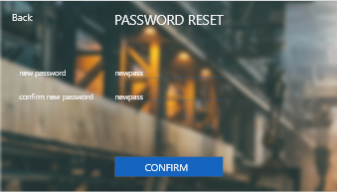
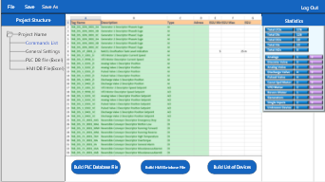
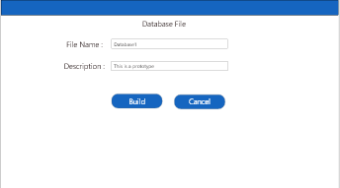
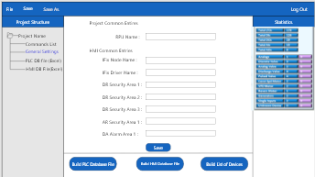
Source: [1]

Prototype evaluation
The scenario I have created for the prototype was engineers use the tool to get the database file by uploading spreadsheets into the tool. They create new accounts, create new projects, upload the spreadsheet files on to the tool and build up database file, either PLC or HMI or list of devices. In addition, they can adjust the settings that suit the project.

Usability Analysis
After the UserTesting users tested my prototype, they said that it was unique and straight forward. One of them suggested that there should be a Contact Page in case they want to ask for help.

Revised Prototype
A contact tab is added on the login screen of the prototype
- login screen before [1]
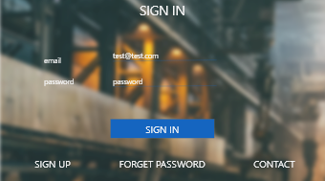
- Login screen after [2]

Future works & Conclusions
In future versions of the system a source control method would be implemented allowing engineers to create team projects with various contributors. The build plc and hmi database features would insert the values into a database that can be access by the engineer instead of having excel files created. More research would be done to determine a better UI layout and improve the professionalism of the system. In summary, this prototype meats enough requirements to be implemented and from the implementation we can learn more about the software architecture.

References

- Final prototype
https://github.com/LinhAn41196/HCIprototype
- Revised prototype
https://github.com/LinhAn41196/RevisedHCIPrototype

We suggest that you use a text box to insert a graphic (which is ideally a 300 dpi TIFF or EPS file, with all fonts embedded) because, in an MSW document, this method is somewhat more stable than directly inserting a picture.
To have non-visible rules on your frame, use the MSWord “Format” pull-down menu, select Text Box > Colors and Lines to choose No Fill and No Line.

