SHUNCOM RULR IoT Platform
Platform architecture, workflow, and API reference document
Document version: 2026-04-12
Audience: Customers, business analysts, project managers, QA teams, implementation teams, and integration stakeholders
Purpose: provide a structured handover-oriented view of how the platform is organized and operated

1. Executive overview
SHUNCOM RULR is a centralized IoT platform designed for smart lighting, gateway control, metering, rule-based automation, alarms, operational dashboards, and project-scoped device management.
The platform is organized around projects and sub-projects. From this hierarchy, dashboards, GIS views, analytics, rules, and operation control all inherit a consistent management context so that visibility and actions remain aligned with access rights.
• The project hierarchy is the primary organizational and operational axis of the platform.
• Type and Group are parallel operational views used to classify and manage devices.
• Device management, the rule engine, dashboards, and realtime events are connected through a unified backend API layer.
• The APIs in this document should be used as a reference inventory; production integration contracts should be confirmed against backend or official OpenAPI sources.
2. Platform architecture
At a high level, SHUNCOM RULR combines a user-facing dashboard layer, a backend API, device management services, a rule engine, a project and GIS layer, and a realtime channel for operational feedback.
Figure 1. Platform architecture
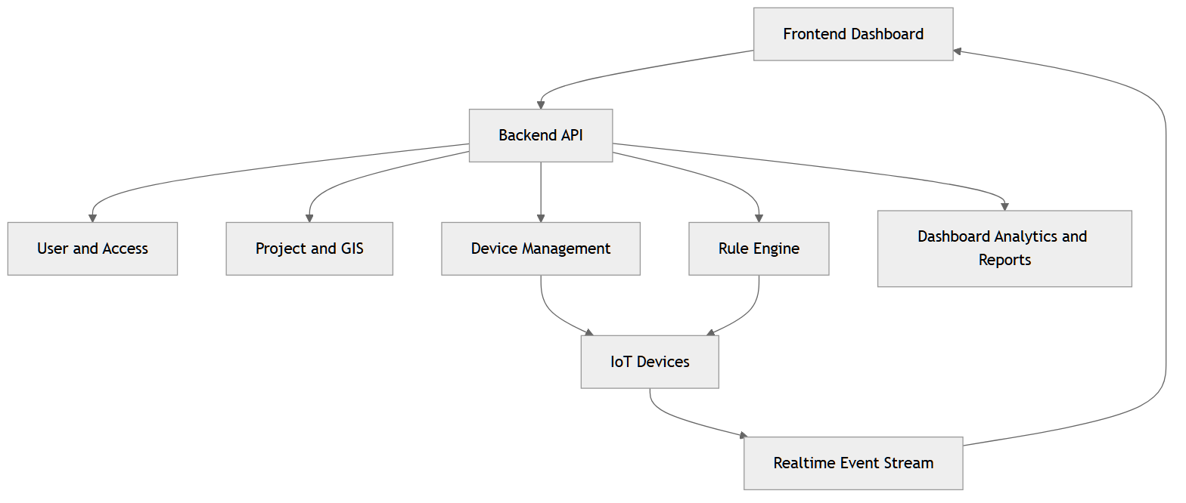
High-level SHUNCOM RULR architecture showing the relationship between the dashboard, API, device management, rules, project scope, and the realtime layer.
The backend API acts as the central integration layer. It coordinates authentication, access control, project hierarchy, device configuration, automation, alarm handling, and dashboard data through one consistent interaction model.
The realtime layer brings device-state changes, alarm events, and rule execution feedback back to the dashboard in near real time so that operations teams can monitor and respond more effectively.
3. Project, sub-project, type, group, and device model
The operating model places the project hierarchy at the center. Type and Group do not replace the project tree; instead, they provide two parallel operating views inside the same project scope.
Figure 2. Project, sub-project, type, group, and device model
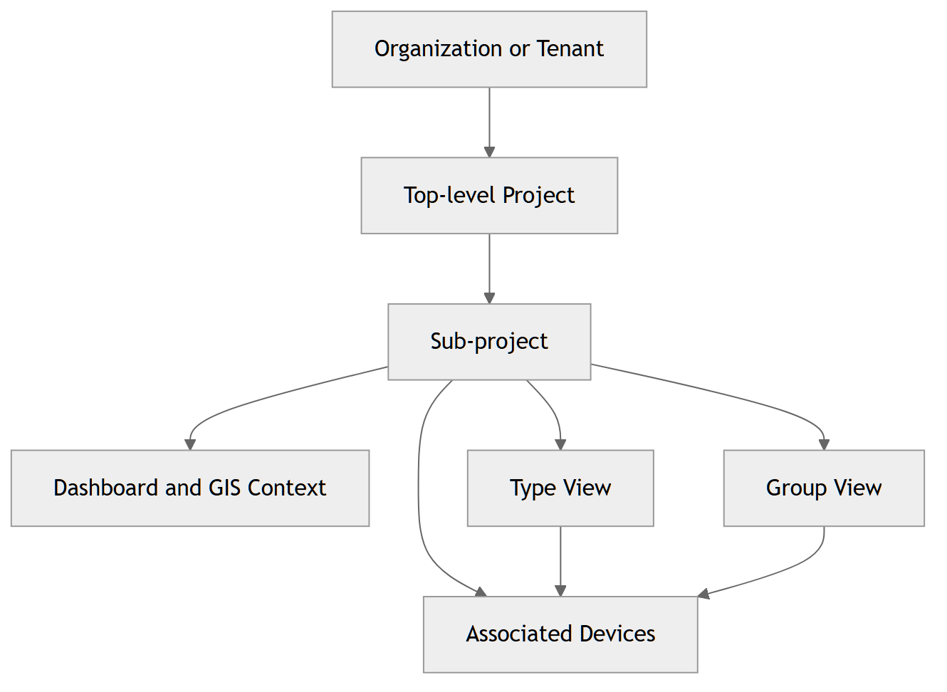
The project hierarchy is the primary operating axis, while Type and Group are parallel operational views used to classify and operate devices.
• The top-level project usually acts as the upper management container for an organization or operating unit.
• A sub-project becomes the main operating scope for dashboards, GIS, analytics, and rules.
• The Type view organizes devices by category or product logic.
• The Group view supports grouped operation, multicast behavior, and business-specific targeting.
• A single device may simultaneously carry project, type, group, and management-scope context.
This model allows the same device to be viewed from multiple operational angles without losing consistency in data visibility and access control.
4. Supported device types
This section explains the device types currently documented in the project's markdown sources. The descriptions are customer-oriented and focus on business role, deployment context, key configuration dependencies, and operational notes.
Gateway
• Purpose: Central communication hub used to connect and manage subordinate field devices.
• Typical deployment: Typically deployed at the field infrastructure layer to anchor controllers, meters, and related collection points.
• Key configuration notes: The configuration form supports product name, device number, project, group, coordinates, altitude, and associations such as distribution box, circuit control, and electricity meter when applicable.
• Operational notes: Operational actions include synchronization, circuit configuration, screen password setup, three-phase ratio settings, and clearing local rules when supported.
Industrial Controller
• Purpose: Industrial control endpoint used for specialized control scenarios within the currently supported ecosystem.
• Typical deployment: Used in deployments that require integration with industrial control points tied to a specific product model.
• Key configuration notes: Its field set depends on the selected product or subtype and should follow the actual device model.
• Operational notes: Operational behavior is model-driven; current documentation describes it as a supported type rather than a dedicated detailed flow.
Smart Light Controller
• Purpose: Lighting control device used for switching, dimming, and smart lighting operations across multiple communication patterns.
• Typical deployment: Used in smart lighting projects and can operate in pass-through, direct communication, or LoRa modes depending on subtype.
• Key configuration notes: Configuration fields change by subtype; some subtypes require a gateway, some require associated luminaires, and some may also need light pole, project, group, and location context.
• Operational notes: Common supported actions include clear, timing calibration, local rule enablement, data reading, device synchronization, and GPS switching when supported by the controller type.
Power Distribution Control (PDC)
• Purpose: Device used to manage and coordinate power distribution at cabinet or power control level.
• Typical deployment: Suitable for deployments that require managed power infrastructure with links to control and metering devices.
• Key configuration notes: Often linked with gateways, circuits, or meters, with exact configuration depending on the chosen deployment architecture.
• Operational notes: Documented primarily as a power infrastructure component, with emphasis on role and associations rather than a separate detailed workflow.
Weather Sensor
• Purpose: Weather telemetry source used for monitoring, dashboard presentation, and environment-related rule scenarios.
• Typical deployment: Used when a project needs weather data as part of operational monitoring or rule triggering context.
• Key configuration notes: Configuration depends on the sensor model and telemetry requirements and may depend on project, group, and installation location.
• Operational notes: Its primary role is environmental telemetry delivery; current documentation covers it at supported device type level.
Environmental Sensor
• Purpose: Environmental sensing device used to capture field data for monitoring and analysis.
• Typical deployment: Suitable for use cases that require environmental measurements within a project or operational area.
• Key configuration notes: Configuration follows the selected sensor model and telemetry scope, while project, group, and location remain important operating context.
• Operational notes: Used as a data source for dashboards, analytics, or rule conditions depending on the business scenario.
Smart Electric Meter
• Purpose: Energy metering device used to capture power consumption data and feed project-level energy analytics.
• Typical deployment: Typically used in deployments that require energy tracking, consumption KPIs, and dashboard-based reporting.
• Key configuration notes: The form typically supports an associated gateway, meter-related fields, project, group, and location; some technical fields depend on the meter model.
• Operational notes: Meter data acts as a key source for energy overview screens, reporting, and operations-related energy analysis.
Lighting Pole
• Purpose: Physical infrastructure record used to anchor devices to a lighting pole or real-world installation point.
• Typical deployment: Useful in deployments that need to map devices to real field infrastructure for asset organization and location context.
• Key configuration notes: The form follows common device fields and supports project and group assignments to preserve operational context.
• Operational notes: Acts as an infrastructure container and anchor point for related devices within the same deployment area.
Lighting Fixture
• Purpose: Lighting asset used in smart lighting scenarios, especially where a controller must be associated with a specific lighting load.
• Typical deployment: Used in lighting deployments where controllers and luminaires must be explicitly linked for control and presentation purposes.
• Key configuration notes: Some controller flows require associated luminaires; without the correct association, the controller may not target the intended lighting asset.
• Operational notes: It is a critical part of the lighting asset model, supporting precise control and maintaining controller-to-fixture integrity.
Smart Water Meter
• Purpose: Smart water metering device included in the platform's currently supported device set.
• Typical deployment: Suitable for deployments that extend from electrical metering into water metering within the same telemetry and asset management environment.
• Key configuration notes: Current documentation describes it at supported type level; detailed schema and associations should follow the actual deployed model.
• Operational notes: Its primary role is to provide metering data within the same monitoring and operations platform.
Leakage Monitoring
• Purpose: Leakage monitoring device used for alarm-oriented and safety-oriented field scenarios.
• Typical deployment: Deployed where the project needs early detection of leakage-related abnormalities and alarm-based response.
• Key configuration notes: Detailed configuration depends on the sensor model and business thresholds and is usually tied to project-level telemetry and alarm logic.
• Operational notes: This device is suited for safety monitoring use cases and supplies input signals for alarm generation.
Indoor Light Controller
• Purpose: Indoor lighting control device maintained as an explicit supported device type in the current documentation set.
• Typical deployment: Suitable for indoor spaces that require lighting control within the same centralized project operations model.
• Key configuration notes: It may have its own subtype patterns; exact configuration should follow the deployed product model.
• Operational notes: Its operational role centers on indoor lighting control and linkage to dashboard or group-based operating context when needed.
Scene Panel
• Purpose: Scene-based interaction device that supports contextual control within the current device ecosystem.
• Typical deployment: Used where rapid scene activation or user-facing interaction is required for grouped operational control.
• Key configuration notes: Current documentation describes it as a supported type at high level; detailed configuration depends on the actual panel model.
• Operational notes: Its main role is to support scene-based or interaction-driven operational flows within a project.
Accessory Device
• Purpose: Supporting accessory device used to complete the device ecosystem within the same management platform.
• Typical deployment: Suitable for deployments that require accessory components as part of the overall project asset landscape.
• Key configuration notes: Current documentation normalizes the naming but does not provide a dedicated flow; configuration should follow the specific accessory model.
• Operational notes: Treated as a supporting device type with a complementary role in the overall deployment scenario.
5. Core workflows
The workflows below describe how the main SHUNCOM RULR modules work together during platform operation and configuration.
Figure 3. End-to-end operating flow
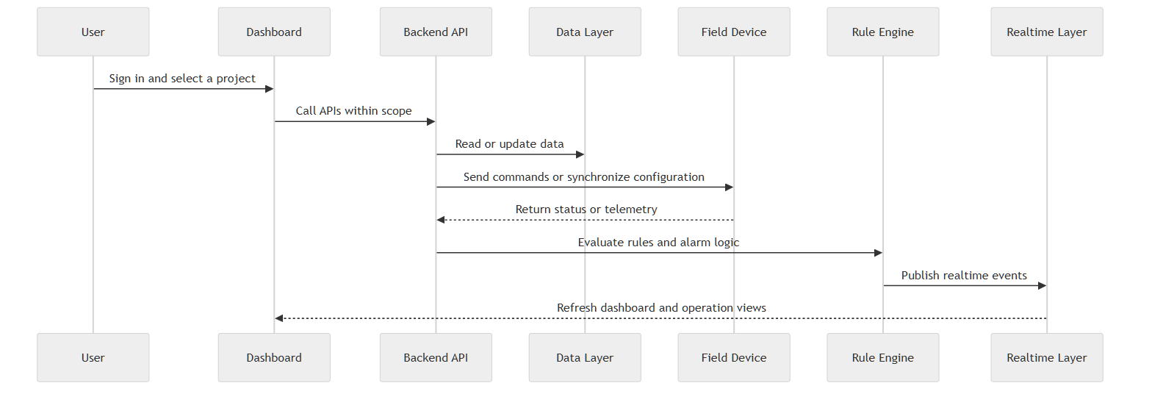
Typical operating flow from the end user through the dashboard, backend API, database, field devices, rule engine, and realtime updates.
Sign-in and session initialization
Objective: Authenticate the user and load roles, permissions, and management scope before entering the platform.
1. The user opens the login page and submits valid credentials.
2. The platform authenticates the account and checks that the user is active.
3. After successful sign-in, the system loads the user profile, permissions, and management scope.
4. The dashboard and navigation are then rendered according to the approved access scope.
Related APIs:
• POST /auth/login
• POST /auth/refresh
• GET /auth/me
• POST /auth/logout
Create users, roles, and management scope
Objective: Define who can see which data and which project, group, and product-category scope each user can operate within.
1. An administrator creates a new user or updates an existing one.
2. Roles are created or assigned based on business responsibilities.
3. Permissions and management scope are applied to the target user or role.
4. From that point onward, dashboards, device lists, and operations are filtered by the saved scope.
Related APIs:
• POST /users
• PUT /users/{id}/roles
• PUT /users/{id}/scope
• POST /roles
• GET /roles/permissions
Create projects and sub-project hierarchy
Objective: Establish the primary operating context for dashboards, GIS, rules, analytics, and device visibility.
1. The user creates a new project from the project tree with name, manager, address, and coordinates.
2. The root project or sub-project is stored in the platform hierarchy.
3. The sub-project becomes the primary operating scope for device distribution, dashboards, and GIS.
4. Display settings, operating schedules, and power consumption plans can then be assigned to that project.
Related APIs:
• GET /projects
• POST /projects
• GET /projects/tree
• GET /projects/{id}/children
Associate devices with projects and groups
Objective: Place devices into the correct operating context for dashboards, rules, GIS, and centralized operations.
1. The user selects the target project or group inside device management.
2. The device is searched, selected, and confirmed for association.
3. The platform stores the project-level or group-level association.
4. The device then appears in the correct dashboard, analytics, and operation-control context.
Related APIs:
• GET /projects/{id}/devices
• POST /device-groups/{id}/devices
• DELETE /device-groups/{id}/devices
• PATCH /devices/{id}
Onboard devices by type
Objective: Create device records through dynamic forms driven by category, product, and subtype.
1. The user opens the Type view and selects the device type to create.
2. The form presents Device Information, Product Information, and Asset Info based on the selected model.
3. The user enters project, group, location, and required technical fields.
4. The platform validates the data by device type before storing the new record.
Related APIs:
• GET /device-types
• GET /device-types/{code}
• POST /devices
• PUT /devices/{id}
Configure project-level dashboard presentation
Objective: Configure display information, lighting schedules, and the electricity consumption plan for each project.
1. The user opens a project and enters the Display Information area.
2. Styles, titles, visible modules, and usage scenario are configured for the project.
3. Lighting schedules and the electricity consumption plan are then set within the same project context.
4. The homepage dashboard updates to reflect the saved presentation settings.
Related APIs:
• GET /projects/{id}
• PUT /projects/{id}
• GET /dashboard/statistics
• GET /dashboard/map-data
GIS distribution and map-based management
Objective: Place devices onto the project map to support visualization, location management, and field operations.
1. The user selects a project with the appropriate GIS context.
2. Devices with coordinates are placed individually or distributed along a route in batch.
3. Locations can be fine-tuned to reflect the real field condition.
4. The dashboard map and operation control then consume this location dataset.
Related APIs:
• GET /projects/{id}
• GET /dashboard/map-data
• PATCH /devices/{id}
• PUT /devices/{id}
Create platform rules
Objective: Configure centralized platform-side automation for trigger conditions and operational actions.
1. The user creates a platform rule with metadata, effective period, and remarks.
2. Trigger conditions and execution actions are configured for the required use case.
3. Target devices, groups, or categories are selected according to business scope.
4. The rule can then be enabled, disabled, or manually executed where supported.
Related APIs:
• GET /rules/platform
• POST /rules/platform
• POST /rules/platform/{id}/enable
• POST /rules/platform/{id}/execute
Create local rules and synchronize them to devices
Objective: Push lightweight automation down to gateways or devices to reduce dependency on real-time network connectivity.
1. The user creates a local rule with the required trigger and action pattern for the target device type.
2. The rule is stored on the platform as a configuration awaiting synchronization.
3. A sync command is sent to the target gateway or device.
4. Per-device synchronization results are returned for validation and troubleshooting.
Related APIs:
• GET /rules/local
• POST /rules/local
• POST /rules/local/{id}/sync
• DELETE /rules/local/gateway/{gatewayId}
Create alarm rules and handle alerts
Objective: Detect abnormal conditions, send alerts, and support operations teams in handling them by severity and processing status.
1. The user creates a receiving group and an alarm rule for the required condition set.
2. The platform monitors data and events and generates alarms when conditions are met.
3. Alarms appear in the operations and maintenance area for operator review.
4. Operators can acknowledge, resolve, or process alarms in batch according to the operating procedure.
Related APIs:
• POST /rules/alarm
• GET /alarms
• POST /alarms/{id}/acknowledge
• POST /alarms/{id}/resolve
Operation control, device detail, and analytics
Objective: Enable immediate operations, device-level status review, and historical analysis within the same project context.
1. The user enters operation control through the map view or device list.
2. A device or group of devices is selected for the required quick action.
3. The device detail page presents overview data, alarms, operation records, rules, and historical information.
4. Statistical analysis and reporting are then used to review trends, KPIs, and exports when required.
Related APIs:
• POST /devices/{id}/actions/power-on
• POST /devices/{id}/actions/dim
• GET /devices/{id}/metrics/history
• GET /reports/operations
6. API reference inventory
The following list should be used as a reference inventory for solution review, traceability, and integration preparation. Before it is used as a production contract, endpoint names, payloads, permission keys, and realtime behavior should be validated against the backend implementation or official OpenAPI source.
• Reference REST base URL: https://rulr-aiot.com/api/v1
• Reference realtime base URL: wss://rulr-aiot.com/ws/v1
• Authentication model: Bearer token for protected resources
• Scope model: role + management scope + project/group/device visibility
Authentication APIs
POST /auth/login — Authenticate the user and create a session.
POST /auth/refresh — Refresh an access token.
POST /auth/logout — Terminate the current session.
GET /auth/me — Get the current user profile.
POST /auth/password/change — Change the user password.
POST /auth/password/reset-request — Request a password reset.
POST /auth/password/reset — Reset the password by token.
POST /auth/mfa/enable — Enable multi-factor authentication.
POST /auth/mfa/disable — Disable multi-factor authentication.
POST /auth/mfa/verify — Verify an MFA code.
User, organization, and role APIs
GET /users — List and filter users.
POST /users — Create a new user.
PUT /users/{id} — Update a user profile.
PATCH /users/{id}/status — Enable or disable a user.
PUT /users/{id}/roles — Assign roles to a user.
PUT /users/{id}/scope — Update management scope.
GET /organizations — List organizations.
POST /organizations — Create an organization.
GET /organizations/{id}/projects — List projects under an organization.
GET /roles — List roles.
POST /roles — Create a new role.
GET /roles/permissions — List available permissions.
Project APIs
GET /projects — List the project hierarchy.
GET /projects/{id} — Get project details.
POST /projects — Create a project.
PUT /projects/{id} — Update a project and related settings.
DELETE /projects/{id} — Delete a project subject to business rules.
GET /projects/{id}/devices — List devices under a project.
GET /projects/{id}/children — List child projects.
GET /projects/tree — Get the full project tree.
Device APIs
GET /devices — List and filter devices.
GET /devices/{id} — Get device details.
POST /devices — Create a new device record.
PUT /devices/{id} — Update a device configuration fully.
PATCH /devices/{id} — Partially update a device.
DELETE /devices/{id} — Execute recycle or delete behavior according to platform policy.
GET /device-types — List supported device types.
GET /device-types/{code} — Get device-type details.
GET /device-types/{code}/template — Get a template for import or configuration.
Device action and lifecycle APIs
POST /devices/{id}/actions/power-on — Power on a supported device target.
POST /devices/{id}/actions/power-off — Power off a supported device target.
POST /devices/{id}/actions/dim — Set a dimming level.
POST /devices/{id}/actions/sync — Synchronize device data or configuration.
POST /devices/{id}/actions/reboot — Reboot the device when supported.
POST /devices/{id}/actions/read-data — Read current data from the device.
POST /devices/{deviceId}/control — Send a generic control command.
POST /devices/batch — Create devices in batch.
POST /devices/batch/import — Import devices from a file.
GET /devices/batch/import/{jobId} — Track import job status.
GET /devices/batch/export — Export devices.
DELETE /devices/batch — Delete devices in batch.
POST /devices/actions/bulk — Execute a bulk action.
Device group APIs
GET /device-groups — List device groups.
GET /device-groups/{id} — Get device group details.
POST /device-groups — Create a device group.
PUT /device-groups/{id} — Update a device group.
DELETE /device-groups/{id} — Delete a device group subject to business rules.
POST /device-groups/{id}/devices — Add devices to a group.
DELETE /device-groups/{id}/devices — Remove devices from a group.
POST /device-groups/{id}/sync — Synchronize group or multicast configuration.
POST /device-groups/{id}/actions/{action} — Execute a group-level action.
Rule and alarm APIs
GET /rules/platform — List platform rules.
POST /rules/platform — Create a platform rule.
POST /rules/platform/{id}/enable — Enable a rule.
POST /rules/platform/{id}/disable — Disable a rule.
POST /rules/platform/{id}/execute — Execute a rule manually.
GET /rules/platform/{id}/executions — Get rule execution history.
GET /rules/local — List local rules.
POST /rules/local — Create a local rule.
POST /rules/local/{id}/sync — Synchronize a local rule to the device layer.
DELETE /rules/local/gateway/{gatewayId} — Clear local rules at gateway level when required.
GET /rules/alarm — List alarm rules.
POST /rules/alarm — Create an alarm rule.
GET /alarms — List alarms or filtered alarm views.
POST /alarms/{id}/acknowledge — Acknowledge an alarm.
POST /alarms/{id}/resolve — Resolve an alarm.
GET /alarms/statistics — Get alarm statistics.
Dashboard, reporting, and audit APIs
GET /dashboard/statistics — Get dashboard KPIs by project scope.
GET /dashboard/energy — Get energy overview data.
GET /analytics/energy — Get energy analytics data.
GET /dashboard/alarms/summary — Get alarm summary information for the dashboard.
GET /dashboard/devices/status — Get device status distribution.
GET /dashboard/map-data — Get GIS map display data.
GET /recycle-bin — List records currently in recycle bin.
POST /recycle-bin/{id}/restore — Restore an item from recycle bin.
DELETE /recycle-bin/{id} — Permanently delete a recycle-bin item.
DELETE /recycle-bin/clear — Clear the entire recycle bin.
GET /settings/system — Get system settings.
PUT /settings/system — Update system settings.
GET /settings/timezone — Get timezone settings.
PUT /settings/timezone — Update timezone settings.
GET /settings/notifications — Get notification settings.
PUT /settings/notifications — Update notification settings.
GET /reports/energy — Read or generate energy reports.
GET /reports/device-status — Get a device-status report.
GET /reports/alarms — Get an alarm report.
GET /reports/operations — Get an operations report.
POST /reports/generate — Generate a custom report.
GET /reports/{id}/download — Download a generated report.
GET /audit/logs — Get audit logs.
GET /audit/logs/{id} — Get audit log details.
GET /audit/user/{userId} — Get activity history for a user.
7. Realtime, alarms, and operational feedback
In addition to data-oriented APIs, SHUNCOM RULR relies on a realtime channel to deliver device status, alarm events, rule execution feedback, and dashboard refresh updates to operations users.
Figure 4. Realtime, alarm, and operational feedback flow
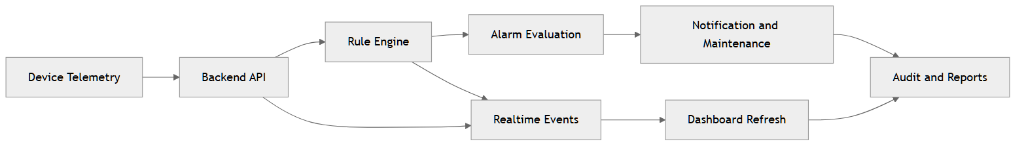
Devices, the rule engine, alarm handling, and the dashboard all participate in the platform's near real-time response cycle.
The current documentation refers to message groups such as device status updates, per-device metrics, alarm notifications, rule execution feedback, and dashboard statistics updates.
• device.status or device.status.update
• devices.{id}.metrics
• alarms, alarm.triggered, alarms.new
• rules, rule.executed, rules.execution
• dashboard.statistics
8. Business constraints and document notes
• Most APIs outside authentication require the appropriate role, permission, and management scope.
• Device validation depends on the selected device type, product, and subtype.
• Timezone directly affects time-based rules and operating schedules.
• Coordinate data is important for GIS distribution and sunrise/sunset-based use cases.
• Current documentation describes batch import support at up to 5,000 records per batch.
• Delete and recycle flows must be considered together with dependency bindings and related historical data.
This document has been prepared as a customer-facing handover and explanation package. Some technical details in the API section are still reference-oriented and should be validated before they are treated as production integration commitments.

