Study

1.a. Boolean is a type of variable which just has two results : “ True or false”

1.b. 3 differents expression :

+) >>> 5 == (3 + 2)

True

+) >>> 5 == 6

False

+) >>> j = "hel"

>>> j + "lo" == "hello"

True

2.

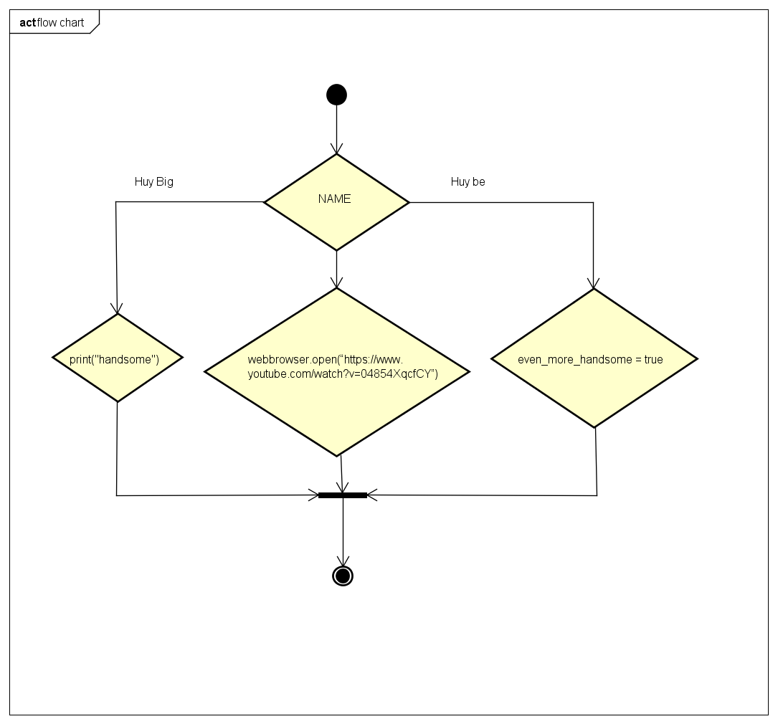

3.a. Nested conditionals are in a conditional have another conditional.

3.b. age = int(input(“Enter your age”))

If age < 10:

Print(“you are child”)

Else :

If age < 18:

Print(“you are teenager”)

Else :

Print(“you are adult”)