

**CENTER OF SOFTWARE ENGINEERING**

**PROPOSAL DOCUMENT**

***Plagiarism Check***

Version: 1.0

Date: Feb 15th, 2017

**Project Information**

|  |  |  |  |
| --- | --- | --- | --- |
| **Project Acronym** | PCP | | |
| **Project Title** | Plagiarism Check Project | | |
| **Start Date** | Feb 15th, 2017 | End Date |  |
| **Lead Institution** | Duy Tan University | | |
| **Project Manager & Contact Details** | Huy Nguyen Dang Quang, Msc  Email:  Phone: | | |
| **Partner Organization** |  | | |
| **Project Web URL** |  | | |
|  | Name | Email | Phone |
| **Team member’s** | Trung Le Duc | [lductrung92@gmail.com](mailto:lductrung92@gmail.com) |  |
| Linh Nguyen Phan Hoang | [linh.nguyenphanhoang@gmail.com](mailto:linh.nguyenphanhoang@gmail.com) | 0905777594 |

**Proposal Document**

|  |  |  |  |
| --- | --- | --- | --- |
| **Document Title** | Proposal |  |  |
| **Reporting Period** |  |  |  |
| **Author(s) & project** | Huy Nguyen Dang Quang | Project Manager & Scrum master |  |
| **Role** | Trung Le Duc | Team member |  |
| Linh Nguyen Phan Hoang | Team member |  |
| **Date** | Feb 15th, 2017 | Filename | Proposal_v1.0 |
| **URL** |  | | |
| **Access** | CSE | |  |

|  |  |  |
| --- | --- | --- |
| **Document History** | | |
| **Version** | **Date** | **Comments** |
| **V1.0** | Feb 15th, 2017 | Draft for comment |

|  |  |  |
| --- | --- | --- |
| **Document Approval** | | |
| MSc. Huy Nguyen Dang Quang  *Product owner & Scrumaster* |  | Date : |
| Trung Le Duc  *Team Member* |  | Date : |
| Linh Nguyen Phan Hoang  *Team Member* |  | Date : |

Contents

I. INTRODUCTION 6

1.1 Purpose 6

1.2 Scope 6

**II. PROJECT OVERVIEW** 7

2.1 Project definition 7

2.2 Business Need 7

2.5 Project Goal 8

2.6 System overview 9

2.6.1 System Context 9

2.6.2 System context description 9

2.7 Technical constrains 9

III. MASTER PLAN 10

3.1 Scrum Process 10

3.2 Master Plan 11

3.3 Organization Management 12

3.3.1 Human Resource 12

3.3.2 Cost Estimation 12

# I. INTRODUCTION

## 1.1 Purpose

The purpose of the proposal is to:

* Provides an overview of the project includes the purpose and scope of project.
* Define the business need and problem in detail.
* Provide solutions for business needs and show the overview of system architecture.
* Provide overview about resources, schedule, solution and budget for the project.

## 1.2 Scope

* This document provides an overview of project will be developed. It includes the description of business need, the proposed solution, financial forecast and some constraints that involved in the project.
* The document provides a comprehensive master plan for each phase of software development based on the processes that have been selected.
* Proposal includes the introduction of solutions, determine the best way to develop software that we make, the total estimated costs, payback period, break-even volume for the project.

**1.3 References**

|  |  |  |
| --- | --- | --- |
| No. | References | Document Information |
| 1 | **Scrum process** | <https://www.scrum.org/> |

***Table 1.3.1: Reference***

**1.4 Summary**

* Project: Plagiarism Check Project
* Team member: 2 members.
* Development process: Scrum.
* Time: 3,5 months.

**II. PROJECT OVERVIEW**

## 2.1 Project definition

To build a website to check assignment of student when they upload file to website. Single – sign – on this project to E-learning.

## 2.2 Business Need

**Issue description**

Plagiarism is known as a serious concern in academic environment. Beside strict policy applied to plagiarist, there could be some kind of tools to help both educators and students prevent it. There are commercial products produced to detect plagiarism. However, these products are too expensive to educators in Vietnam and they have not given any proof whether these products work well in Vietnamese. Moreover, there are some detection methods available that could be a good choice to work in Vietnamese academic environment. However, these products have their own detection methods and these methods could not be changed. In addition, scalability is also an important feature for a plagiarism detection system because the number of documents in database is very large and increases rapidly. In this paper, we present a plagiarism detection system to detect plagiarism that have three above features: working on one’s own database, flexibility, and scalability.

**2.3 Prior Art**

**2.4 Proposed Solution**

* We recommends building a website can be checking plagiarism any documents that are uploaded. It can find and point out how many percent duplication of document uploaded by compare with internal database and the Internet.
* That site can be SSO to the E-learning system easy for manage assignment submit of student.

## 2.5 Project Goal

* Collected documents(remix): Expressing a different way from many sources and make the content fit seamlessly.
* Duplication: Submission of others. Its all the same root word for word of article but no qouted.

## 

## 2.6 System overview

### 2.6.1 System Context

***Figure 2.6.1: System context overview***

### 2.6.2 System context description

## 2.7 Technical constrains

* **Technical to develop**
  + Laravel PHP Framework
  + MySql
* **Environment**

**Windows, Mac**

**Web browser**: Chrome, IE, Firefox.

**Other Constraints:**

* Resource: 4 people.
* Budget: Limited.
* Time: The project must be completed within 2 months frame.
* Technology: SQL server, ASP.NET
* Environment: Internet.

# III. MASTER PLAN

## 3.1 Scrum Process

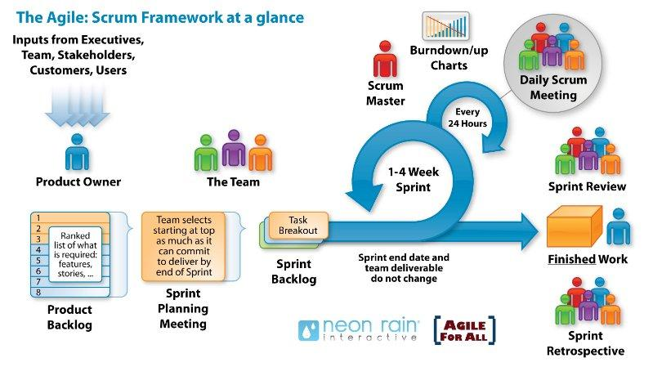

***Figure3.1.1: General SCRUM Process***

* Scrum is an iterative and incremental agile software development framework for managing software projects and product or application development.
* Scrum focuses on project management institutions where it is difficult to plan ahead.
* Mechanisms of empirical process control, where feedback loops that constitute the core management technique are used as opposed to traditional command-and-control management.
* Its approach to planning and managing projects is by bringing decision-making authority to the level of operation properties and certainties.
* Benefit of the methodology:
* Project can respond easily to change.
* Problems are identified early.
* Customer gets most beneficial work first.
* Work done will better meet the customer’s needs.
* Improved productivity.
* Ability to maintain a predictable schedule for delivery.

## 3.2 Master Plan

## 3.3 Organization Management

### 3.3.1 Human Resource

* **Team’s Information**

|  |  |  |  |
| --- | --- | --- | --- |
| **Full Name** | **Phone** | **Email** | **Position** |
| Huy Nguyen Dang Quang |  |  | Product Owner |
| Huy Nguyen Dang Quang |  |  | Scrum master |
| Trung Le Duc |  |  | Team member |
| Linh Nguyen Phan Hoang | 0905777594 | [linh.nguyenphanhoang@gmail.com](mailto:linh.nguyenphanhoang@gmail.com) | Team member |
|  |  |  |  |

### 3.3.2 Cost Estimation

The following outlines the cost to complete all the identified components for the project.

|  |  |  |  |
| --- | --- | --- | --- |
| No. | Phase | Milestone | Cost( 2 hours/day)  USD |
| 1. | Start-up | STU | $100 |
| 2. | Development | SPR 0 | $200 |
| SPR1 | $200 |
| SPR2 | $200 |
| SPR3 | $200 |
| 3. | Other costs | OTH | $250 |
| 4. | Project’s Meeting | PM | $100 |
| 5. | Final Release | FR | $50 |
| 6. | **Total** | | **$1.300** |