# Lab

1. The Basic HTTP GET/response interaction
2. Question 1 :

The verion of HTTP my brower’s running is 1.1

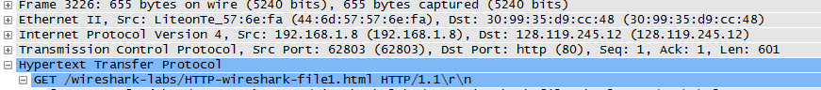

The version ofHTTP the server running is 1.1

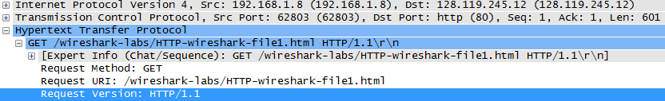

1. Question 2 :

The accept language : 

1. Question 3 :

My computer IP address and the gaia.cs.unmass.edu server

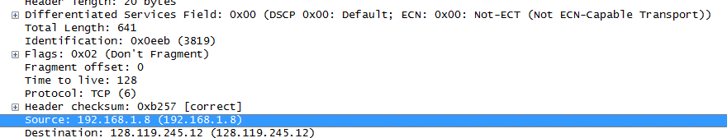

1. Question 4 :

The status return



1. Question 5 :
2. Question 6 :
3. Question 7 :
4. The HTTP CONDITIONAL GET/response interaction
5. Question 8 : I see 
6. Question 9.

The server didn’t explicitly the contents of the file

1. Question 10.

Yes : the information include date time last accessed web.



1. Question 11.



The server did’t not return the contents.

3. Retrieving Long Documents

1. Question 12.

This a message 

1. Question 13.

The number is 8725.



1. Question 14.

The status code and phrase is 200 OK.



1. Question 15.



4. HTML Documents with Embedded Objects

1. Question 16.

The first ID get message requests is : 128.119.245.12

The seconds ID is 192.168.1.8

The third ID is 1223.119.245

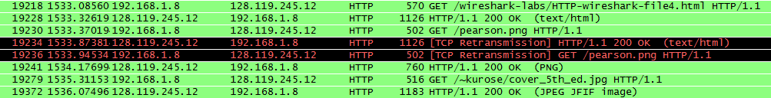

1. Question 17.

Images were download in serially

s