**Travel Advisor Project Report**

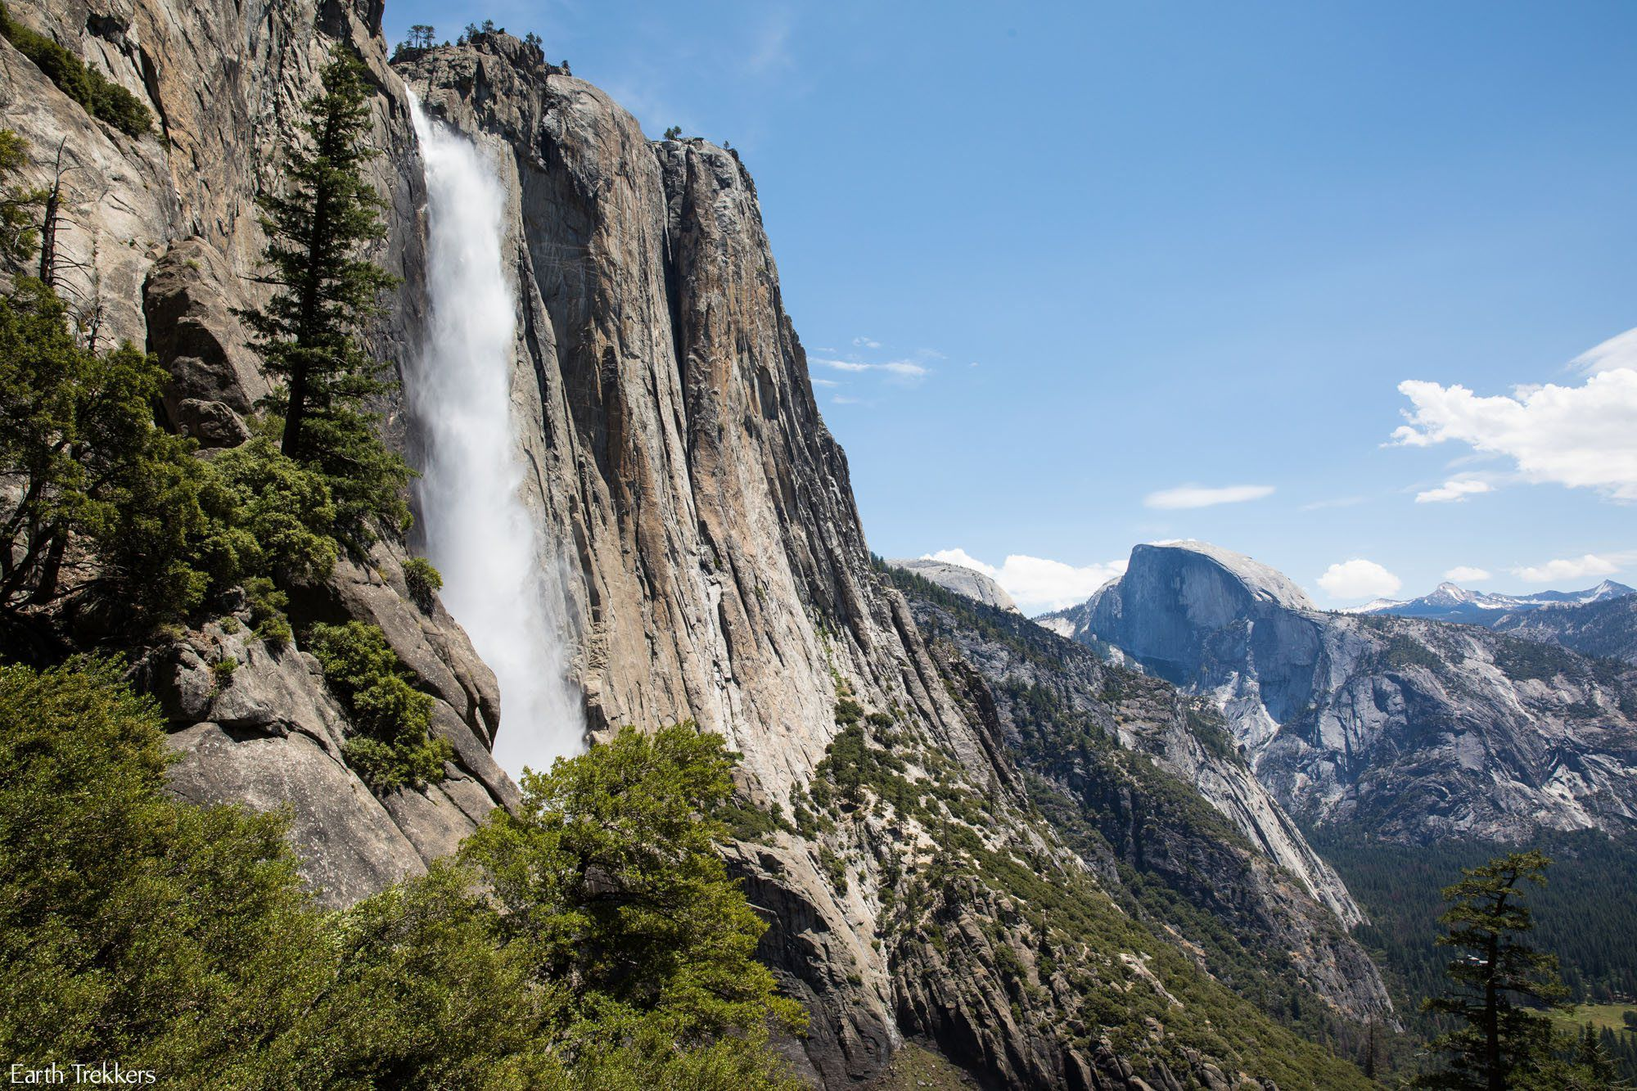

**Prepared by**

**Hongcheng Wu, Spancer Guo, Jiajie Lin, Zachary Flebbe**

**for use in CS 440**

**at the**

**University of Illinois Chicago**

**February 2020**

# **Project Description**

## **Project Overview**

## Travel advisor is a mobile application that provides users satisfaction when traveling nation park, this application aims to become the fully functional travel guide application. It included a schedule of different parks, rating, weather notification, history, and photo gallery, and it has a navigation system that helps you to find the direction you are looking for. The application makes you never get lost in the national parks, and there is an emergency call button that could send your location to the rescue team when there is an emergency case happening.

## **The Purpose of the Project**

### **The User Business or Background of the Project Effort**

### Our application is designed for the business investors and park owners to advertise the park and keeps the park safe. The idea would be for visitors in national parks, especially the first time visitors to know information about the park, or something they can use as a guide in their journey. By using this application, users can improve their experience in the park, so they will be more likely to come back again or recommend the park to others. Also, it would be useful for people who are interested in coming to the park, by using this application it will attract them to come.

### Since we are making this application as a mobile application, our primary user will be smartphone owners who are traveling in the park or have a potential to do so. Users will be able to use this application to obtain information anywhere at any time as long as they have access to a smartphone.

### The biggest challenges in travel are travel planning and orienting yourself in a place, and this application will solve both of the problems for the user. So, the effort of this project will go towards creating a great user experience by keeping it simple and easy, but nonetheless, providing authoritative and comprehensive information. We want the national park visitors to have a safe and relaxing journey in the park, but in the meantime they don’t miss the beautiful scenery and fun activities.

### Solving those problems would help the visitors to enjoy their time of travel. On the other hand, it would prevent risks from happening by providing the user information in the area including weather, vegetation, animals, ect. Also, it would ensure the user gets help in timely matters if they are endangered.

### **Goals of the Project**

### The goal of this project is to increase the overall quality of the user’s journey in national parks. As said before, making travel planning and orienting itself in the national park earlier so that people are more likely to choose national park as the destination of their vacation. The visitors should see the effect immediately after using our product, and the park should see an increase in visitor volume in 6 months.

### **Measurement**

### Since seasons and time of the year can have a huge impact on the visitor volume, the idea of measuring if the park’s visitor volume has increased after using our product would be comparing the visitor volume in the same season or same time of the year with one using our product and another don’t.

### To measure if the the overall quality of the user’s journey has been increased, there could be some surveys sent out anonymously through the application. There could also be some kind of place where people can rate the application or leave comments about the application.

## **The Scope of the Work**

The production statificity all visitors require during their traveling in National Park. When visitors travel across the National park, most of them are self-driving tours, and amateur hikers. There are a whole bunch of common sense of safe traveling they should know, and it costs a lot for tutoring every visitor, they may only visit once National park for their entire life. Well, this mobile application will be able to handle all complicated situations while you are traveling.

### **The Current Situation**

Since portability and practicability are important in the modern world, the product only requires installation on a client smartphone. When clients finish their tour, they could just uninstall the application or they could keep it for further use. This application is also very practical, such as offline road map, weather Advisor, emergency rescue, etc.

There are countless travel guide applications existing in the world, why would our clients use this application? The reason is the most travel guide applications are too broad and not specific. The common travel guide application would not be able to do certain things that clients require when clients are traveling National Park. But this particular application is aiming for a certain group of clients, such as hiker, researcher, ecologist, or geographer.

The main design of this application is to help clients having a better experience while they are using this application. This application would not be so useful for common daily use. But it turns out to be very useful when clients use it in Nation Park. This application gives all what clients need, if there is no signal, this application provides an offline road map. Anything emergency happened, the application has all contact and rescue methods.

### **The Context of the Work**

Travel Advisor application including online GPS navigation system, and offline road map, and database relate species living in National park, also weather advisor is constantly updating the weather data and precaution for future days, beside that, clients can share their experience, new founds, photos and suggestion on the build-in web community. Any unexpected or emergency happened, the application provides instruction and 24 hours dial-service support. Well Travel Advisor is aiming to do certain things , it is not a general app that is used for common travel and daily use.

The Navigation System is a very basic road map with all necessary areas in national parks. Clients could use other navigation systems to lead their road, but the main part of this navigation system also includes trail maps, campground and service area. This function would be very useful for all travelers. Scenic Spots Guide requires a database that contains a large number of species which inhabit its lands, it requires connection to a server so that client could access the data of species. Weather advisor does not just display general weather information, it has a lot of details that could be used for certain studies. Emergency rescue is using the minimum resource to get connected rescue teams and display what users should do now and the closest service area. This part of information should build-in this application, because we can not guarantee that wifi or cell phone signal cover all areas. This part of function compulsive because the main idea of this application is satisfying users while traveling to certain areas.

The requirement efforts are modifiable, both database on the server or application itself should all be modifiable. For the navigation system, it also could be used on emergency rescue, since we can not guarantee the signal will be stable, so the deviation should be within 100 meter.

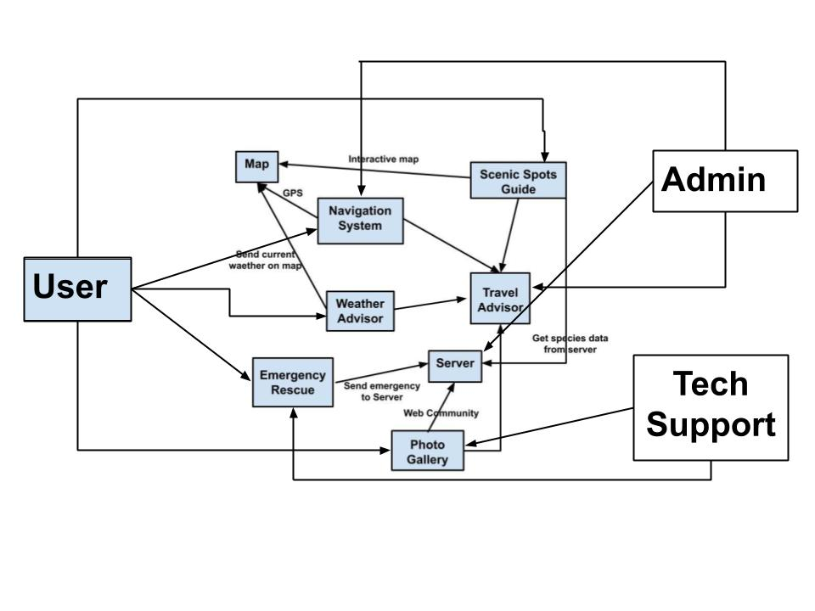

### **Work Partitioning**

**Business Event List**

**Event Name Input and Output Summary**

|  |  |  |
| --- | --- | --- |
| 1. Analysing weather data | Local weather station and general area weather station readings in | Analysing and combining both general area weather data and local weather data. Because some species’ activities are based on weather and time. |
| 2. Navigation system | Input could be the final destination or incidentally location that users want passing by. Output is direction and good view spot or species around the road. | Planning the way to the final destination, and showing all view spots and species haunt spots. |
| 3. Interactive map | User pressing spot on the map | Listing of scenic spots and animals which are contained within the selected area. |
| 4. Emergency rescue | User pressing emergency button | While visitors travel in the national park, they may have concerns about what happened in their life, what they should do, etc. When user pressed this emergency rescue |
| 5. Server connection | Automatically connect | For security reasons, the application will upload the last user location, if the user is missing, the rescue team could track by user last location. |
| 6. Upload photos and stories to Photo Gallery | Server connection and user standard input, may need album permission | Users can share their great photos and scenic advise on Photo Gallery |

### **Competing Products**

Travel Advisor application distributes general travel advice application by aiming to certain users and do certain things. First of all, not all applications have 24 hours dial-service support. Any unexpected or emergency happened, the application provides instruction and connects the rescue team immediately. Secondly, not all applications are gathering local weather data and analysing with general area weather data, since some species are very rare and strict on weather and time, this would be very helpful if users want to observe certain species.

## **The Scope of the Product**

This product is to be used by both workers and visitors of the National Parks system: this includes the visitor, the admin and emergency services if necessary. All parties will have access to the navigation system, scenic spots guide, weather advisory, photo gallery, and emergency rescue system. This product is meant to augment visitor’s experiences in the national park system by offering users the ability to navigate the parks via their smartphone; this navigation will highlight scenic spots and a photo gallery of notable spots. To promote safety, the user will be identified of any inclement weather and offer the ability to call for emergency rescue if necessary. The admin will have access to all facets of the system and emergency services will have access to the rescue system.

### **Scenario Diagram(s)**

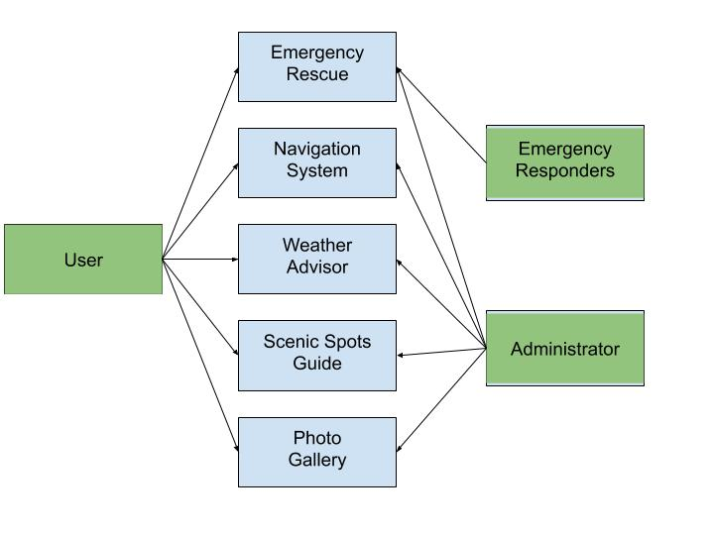

### **Product Scenario List**

|  |  |  |
| --- | --- | --- |
| Number | Scenario | Actor Involved |
| 1 | User selecting spot for navigation | User |
| 2 | User checking weather reports for the day | User |
| 3 | User checking the photo gallery for a specified area | User |
| 4 | Admin updating photo gallery with new user submitted photos | Admin |
| 5 | User using emergency rescue feature; pings emergency services | User |
| 6 | Emergency services finding a user’s location after emergency rescue signal is sent out | Emergency Services |

### **Individual Product Scenarios**

Upon opening the application, the user (whether a visitor, administrator or emergency services) will be connected to the server via a secure connection. At this point a visitor would have many options; suppose the visitor elects to check the photo album to see where they would like to visit first. Once a location is determined, the user would open the interactive map and click on the location that they would like to visit. This would activate the navigation system, showing the visitor a route to their intended destination along with any scenic destinations along the way. The visitor would then have the ability to check the weather advisor to ensure that conditions would be ideal for the planned visit. After arriving at the destination, suppose the visitor gets lost, injured or stuck in extreme weather; this would send a notification to emergency services that a rescue is required. The emergency services would open the application and select emergency rescue; this would show the last known location of the distress signal and spring into action.

## **Stakeholders**

### **The Client**

### The clients are for business investors and park owners. The business investors want tourists to have a better tourist experience, and the park owner may want their parks to have better safety.

### **The Customer**

The tourists and park managers have to install the app and get a better tourist experience and management. The clients would update the newest announcements and tourists will get the newest information of the parks. Also, they would be required to maintain and update monthly.

### **Hands-On Users of the Product**

The hand on users are going to be tourists and parks managers. The primary users will be tourists, and they would be able to use this application to help them to get useful information with their park visit. When they have the application installed and they would allow them to get the information of the park they are visiting.

### **Maintenance Users and Service Technicians**

The application will be posted on the app store, so users can install it by themselves. The application will be maintained monthly and if there are any bugs that appear have been reported by the user will fix it as soon as possible.

### **Other Stakeholders**

The other stakeholder that would benefit those shops in the parks which will increase their business performance.

Quality Assurance: The product will be a success depending on the user experience ratings and feedback. For our application, we have a big amount of users which also are our application’s tester. They will see any of the problems that the application would have missed or mistakes. We also have a professional tester team and they will receive those feedback from the user. They will have a good understanding of the software on test cases, and be able to confirm that reported by the users was exciting. Then, they can communicate with the software developing teams to fix the problems.

Technology experts: Technology experts will be responsible to provide customers with the best technology that they have. They have to understand what the customers demand and what the developers need to build, and in order to supply them with the most efficient way.

Software Developer: Software Developers will be in charge of the software architecture. All the application functionalities are depending on the software developers, they have to work on all the UI, back-end, and maintain of the software.

Legal: A legal representation of the company is going to be required to ensure all the data safety for all customers. The legal must obey all the fundamental ethical rules, and regulatory boundaries. They also have to protect data and in order to prevent any of those mishaps information privacy.

### **User Participation**

The user would be expected to share the data with the development group, which will help them to analy which feature that the users use the most. The user would be allowed to write their feedback directly in the application.

### **Priorities Assigned to Users**

The priorities will be set by the level of the user (people who use the application more frequently). The Users would be responsible to give feedback and report bugs that occur, and the development team could be taking care of the issues as soon as possible.

## **Mandated Constraints**

### **Solution Constraints**

Description: The product shall have offline map

Rationale: Using map for some place without signal

Fit criterion: Not like the interactive map, an offline map should exceltly as a physical map, with high resolution, shall not be able to interact but be able to zoom in and out.

Description: The product shall have 24 hours emergency dial-service

Rationale: There are many accidents happened in mountain or somewhere far from city, and this application will send rescue signal to the outside rescue team by using all radio frequency, include satellite and personal intercom channel

Fit criterion: 24 hours immediately response

Description: The product shall be able to be installed on a smartphone device.

Rationale: The product is to be marketed to travelers, hikers and mountain climbers. Smartphones are easy to carry and interactive.

Fit criterion: The product shall be able to use low power mode. When a user is trying to use an emergency rescue function, this product needs to make sure the remaining battery is able to constantly send rescue signal for over 30 minutes, and there shall be no external power source.

### **Implementation Environment of the Current System**

First of all the physical environment is a general modern smartphone, this application can be used both in the city and outside of the city area. Secondly, there are at least two servers. The main server contains the species database that needs to be inquired from an interactive map from a user device. The main server and backup server both are taking immediate response to the emergency request with the user's last location. There should also be customer service, response and repair of the bugs and issues that customers provide to the debug center. For communication systems, it will use general mobile community strategies such as wifi, signal and GPS.

After this application connect internet, if user location has update or user have not update their location for a while, For security reasons application will automatically upload user last location to server, if the user is missing, the rescue team could track by user last location.

### **Partner or Collaborative Applications**

The Scenic Spots Guide outputs the user interesting species and scenic, this part will require developer import data from national park research database or library and upload data to the main server. So that when a user is inactive with a map, specie and scenic will be sent to the user device.

There is another function that needs to collaborate with the national park security system and rescue team. The Emergency Rescue function will immediately contact the rescue team and upload a report to the security system.

### **Off-the-Shelf Software**

In order to implement this software, a framework that allows for dual platform (ios/android) should be used in development.

### **Anticipated Workplace Environment**

The primary users would be using it outside, we have displays that are visible in sunlight. And we have to make sure that the users can access the network to make the product working properly.

### **Schedule Constraints**

There are no schedule constraints for this product, but the product should take about 6 months to compete. The majority of the work of the product is going to be the back-end of the application.

### **Budget Constraints**

The budget constraint would be around 50K, and most of the budget will speed on the software development parts. Server maintenance routine, customer service.

## **Naming Conventions and Definitions**

### **Definitions of Key Terms**

Navigation System: The Application comes with a navigation system and a map of each location, seven day weather forecasts, sunset/sunrise times, facilities available at the park and links to trail maps, campground maps and more.

Weather Advisor: The system will display the forecaster weather in the map with different areas in the park, like fog in the north of the park, or rain in the south of the park.

Photo Gallery: It is not just a photo gallery but more like a web community where pros and fans can share their photos and stories with others. This feature helps to find your own kind and developing network.

Emergency Rescue: The emergency rescue feature would consist of a very minimal UI with a button. When the button is pressed, the devices’ current GPS coordinates are recorded and immediately relayed to rescue teams. There is a high likelihood the device could run out of battery so this must be instantaneous.

Scenic Spots Guide: The scenic spots guide is a map that has a list of scenic spots and animals which are contained within the selected park marked on it. Users can select each of the scenic spots or animals to know more information about them.

### **UML and Other Notation Used in This Document**

Any UML or Notation will be explained in more detail later in the report.

### **Data Dictionary for Any Included Models**

Under the interactive map there is statistical analysis system, this particular system gathers weather data and species activities including: activity time, sleeping time, suckling period and favorite food, etc. The statistical and analysis system finds out the weather and time in relation to species. This helps both visitors and researchers observe any species within the national park.

Species databases are grouped by their type i.e. fish, birds and mammals; this could be divided even further into subsets like Mammal ->Carnivore/Herbivore.

Scenic spots are grouped by the amount of time needed to be spent there( >30 mins, 30 mins - 1hr, >1hr). When users are using the navigation system to their final destination, scenic spots will also display around route, grouped by time, so that user could make a little detour, but viewing a great scenic spot.

## **Relevant Facts and Assumptions**

### **Facts**

### The factual information would be gathered from each national park. It would be the number of people viewed the information or rating and number of comments of the specific park. The data would be obtained daily or monthly depending on the volume.

### This app will always be useful for national parks. This app would not only bring them more visitors but also help keep the visitors happy and safe.

### This app is only for national parks and the visitors traveling in the park use only. It would require the application installed on a smartphone.

### Any misuse from the users might lead to some mishaps for this app, please keep in touch with the customer so we can prevent it from happening or timely solve the problem.

### People can learn the knowledge from this app including vegetation, animals or even the park itself.

### **Assumptions**

### We are assuming the visitors who are using this app have basic knowledge of using a smartphone, and can read English. Also, we assume all the national parks operate within the same guidelines. Adjustment could be made upon the request of the customers.