#include <stdio.h>

int main() {/*

1) //Q2

a) pow(b,2)-4*a*c

b) (-b+sqrt(d))/ (2*a)

c) (-b-sqrt(d))/ (2*a)

2)

a) log(1-x)/log(1.0/2)

b) 12.26*n

*/}

void split_name(char* name, char* fname, char* ffname, char* gender){

char *m, null;

sscanf(name, "%s %s &c %s", m, fname, &null, ffname);

if(m[2] == '.')

*gender = 'm';

*gender = 'f';

}

char* format_name(char* fname, char* mname, char* ffname, char gender){

char* result = NULL;

if(gender == 'm'){

result = (char*)malloc(sizeof(char)*(strlen(fname)+strnlen(ffname)+7));

sprintf(result, "%s %s %c. %s", "Mr.", fname, mname[0], ffname );

}else{

result = (char*)malloc(sizeof(char)*(strlen(fname)+strnlen(ffname)+8));

sprintf(result, "%s %s %c. %s", "Mrs.", fname, mname[0], ffname );

}

return result;

}

PS C:\Users\Dell> cd "c:\Users\Dell\OneDrive\Documents\Lbs C\lab 3\" ; if ($?) { gcc test.c -o test } ; if ($?) { .\test }

#include <stdio.h>

int main() {

//1

// int (*pMyFunc)(int);

//2

//int(*ptr[t])();

//an array namred ptr of 5 fun of pointers each returns int

// void(*f)(); f=(void(*)())&f1; f=(void(*)())&f2;

    return 0;

 }

PS C:\Users\Dell> cd "c:\Users\Dell\OneDrive\Documents\Lbs C\lab 3\" ; if ($?) { gcc test.c -o test } ; if ($?) { .\test }

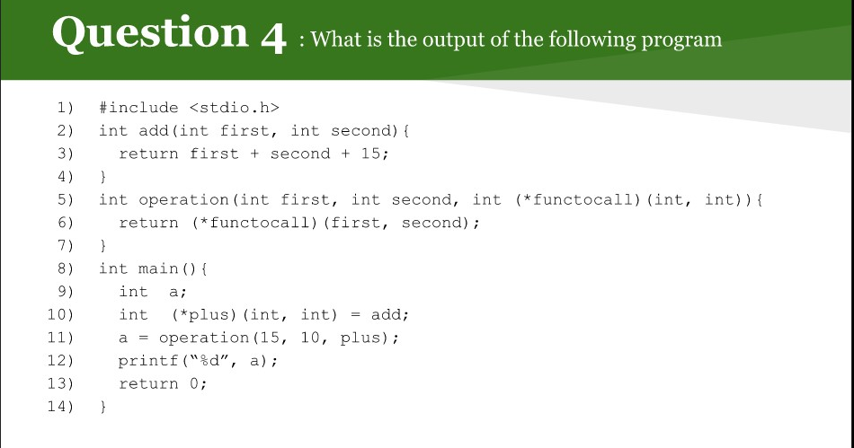

The output will be 40

Link: <https://github.com/Link20222/CSC_215_KSU_44_C-language/tree/main/HWs/3> (I will upload my codes in GitHub later)