02/02/2024 – Created a simple level with a simple player controller

03/02/2024 15:43 – Attempting to create a interaction mechanism for moving objects around, opening doors and whenever the player needs to interact with the environment. Currently not working as the ray is casting from the player and not the camera.

03/02/2024 15:46 – moved interaction script to the camera and now the ray is casting from the camera. Now I need to program something which can handle interactions and make it obvious the object can be interacted with.

03/02/2024 16:02 – Player can see if an object is interactable. Errors are from when Raycast hit is null. I’m not sure how to check if Raycast hit has a value or not so those errors are staying for now.

03/02/2024 16:10 – found a fix for above issue. A bool can be used to store if the raycast had hit anything. I can use the bool to check is the raycast has value and only execute further code if there is value so the errors are gone now.

04/02/2024 – Started creating the reaction part of an interaction, the play can see if an object is interactable but cant actually interact with it. I need objects that can be moved around for things like setting up a stage, have an animation for things like doors opening and to be able to be put in an inventory for things like storing keys.

04/02/2024 15:19 – im using a rough system here to implement the interaction system I want. The player can move objects around but they can also move them out of bounds.

07/02/2024 10:12 – with interactions, im thinking I wont be able to consolidate everything into a few number of scripts.

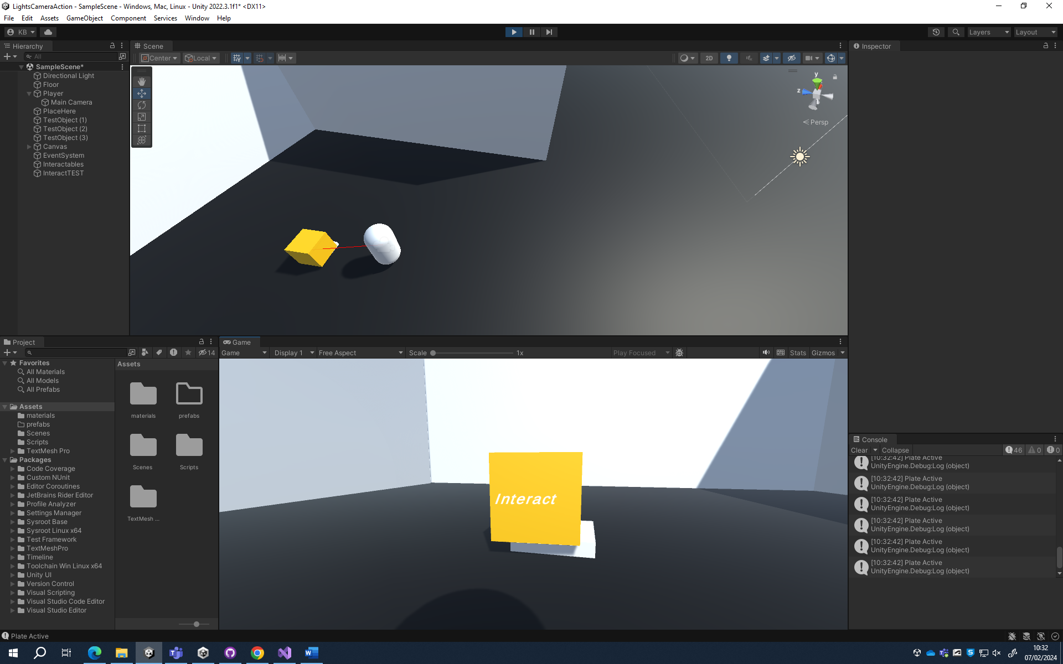

07/02/2024 10:33 – made a pressure plate, this will be used to check if the player has placed an object and will activate things later

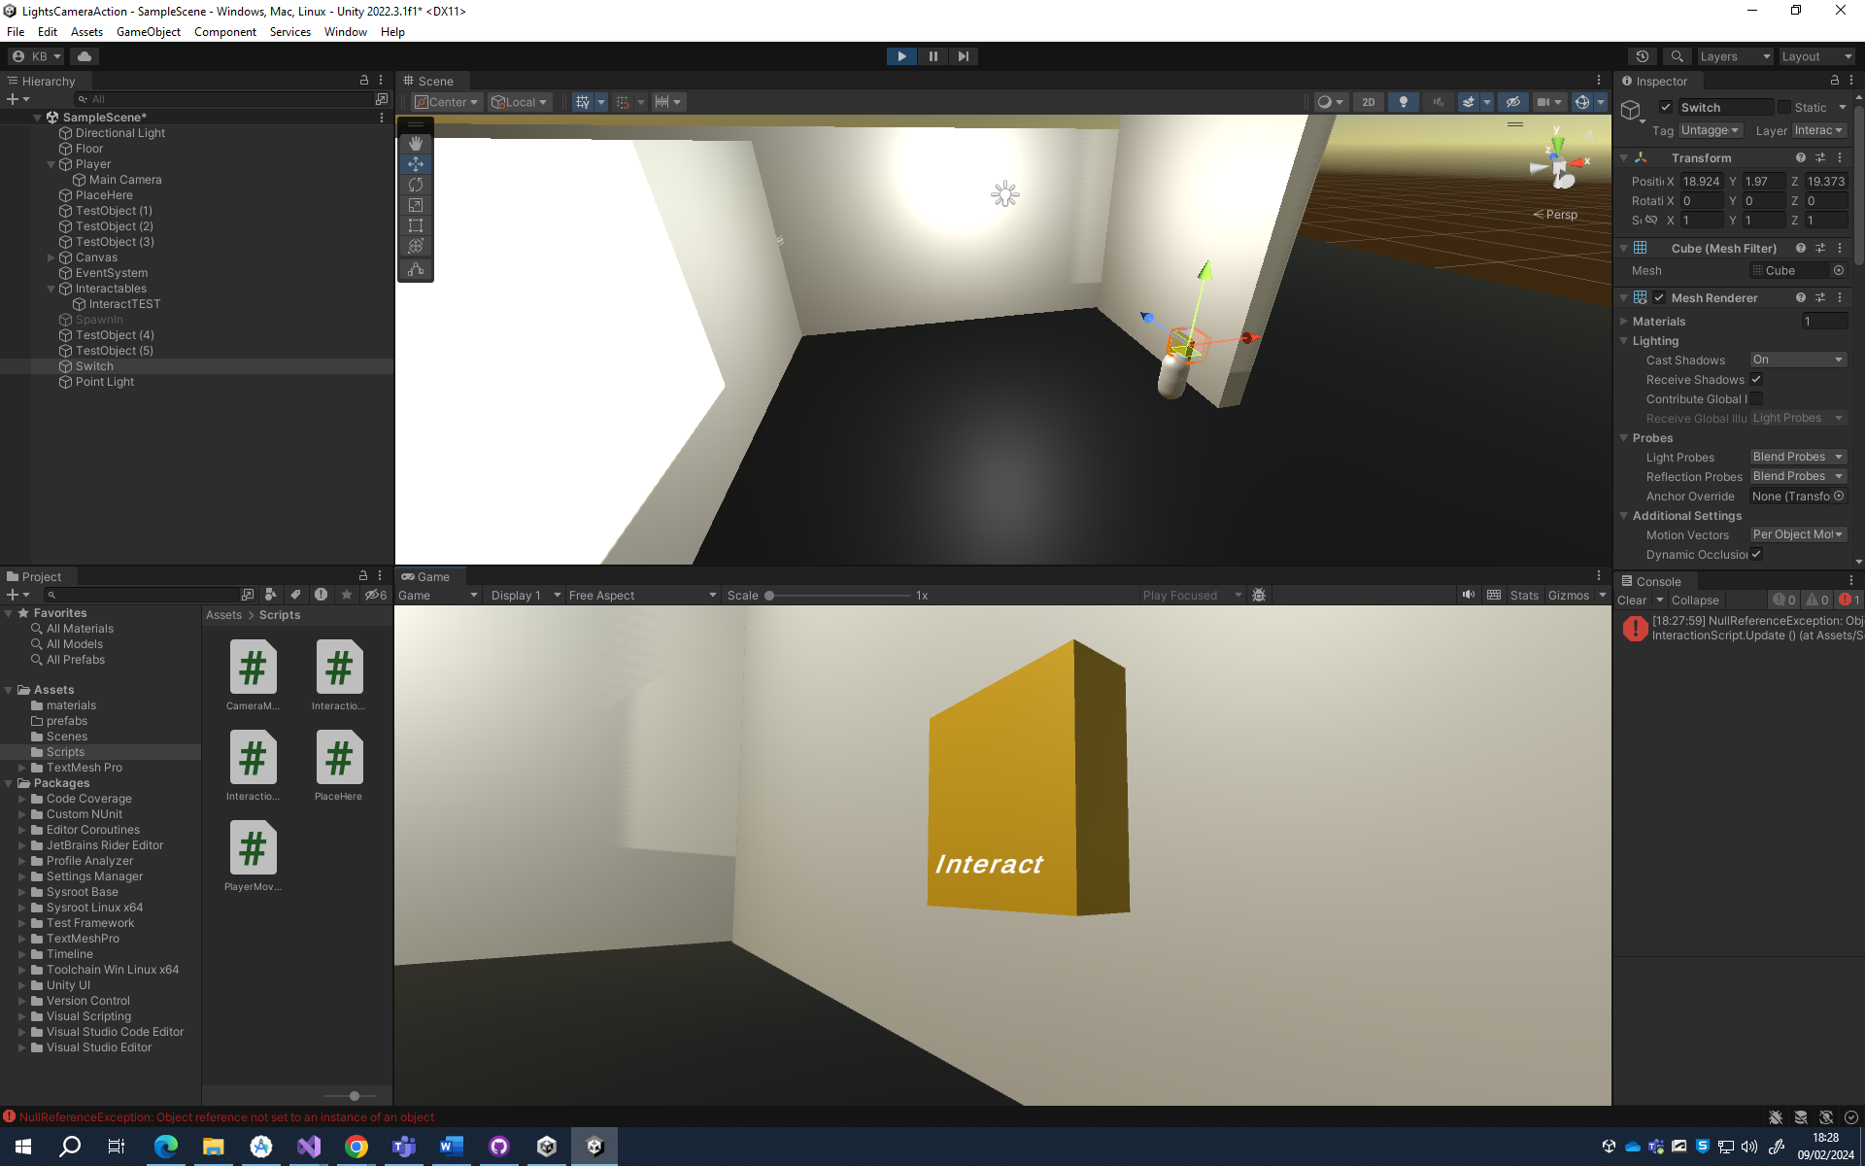

09/02/2024 18:30 – made a light switch, it can be used to switch power on in the main level

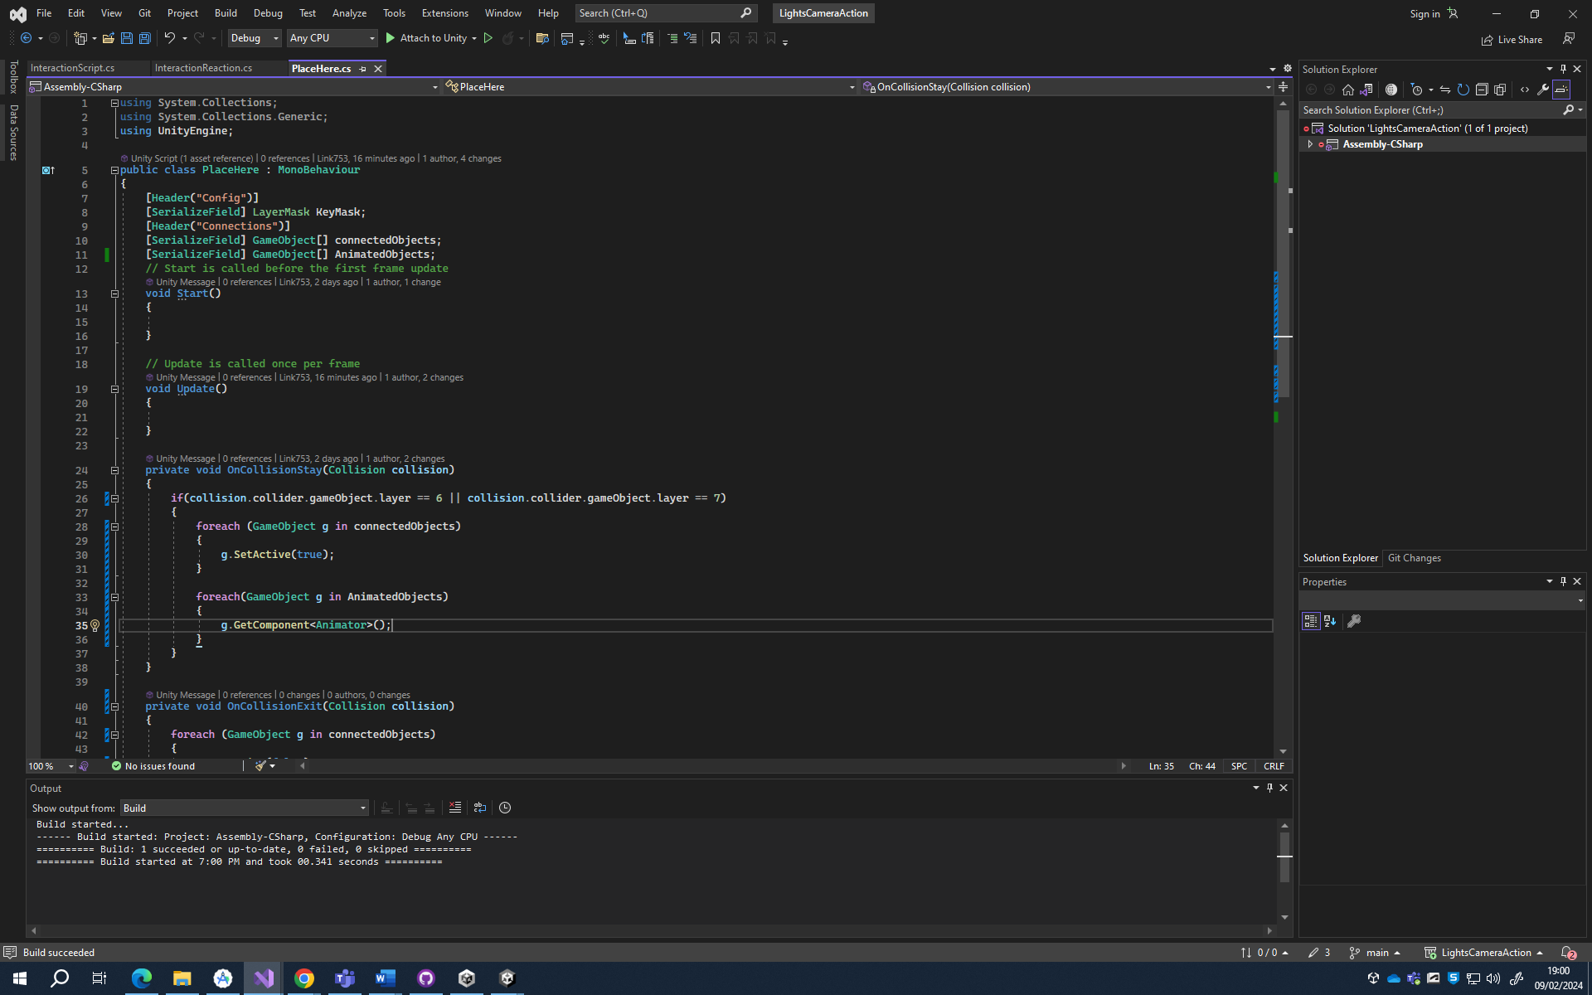

09/02/2024 19:01 – lines 33 to 36 will be for animated objects, eg an entity looking at you or something moving.

10/02/2024 16:49 - I made a pressure plate for the player

21/02/2024 10:06 – added synoptic report

14/02/2024 – began creating a basic camera model in blender

06/03/2024 09:47 – realised I left the blender model on my home pc and didn’t commit changes to github. Started to create a portable camera that the player takes with them. The idea is they are documenting crime scenes left behind by a serial killer and they decide to document previous crime scenes on their own. Idea is that while documenting, something stalks them and may mess with them.

08/03/2024 - Created an imported a camera model from blender!

