跨境商品组 / 户外家具选款资料

C01 Extra Wide High Back Camping Chair
加宽高背轻量露营椅
KC2218 / KC2228
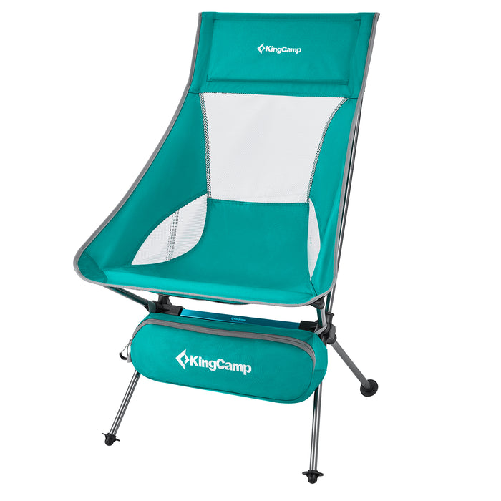 | Seat fabric: 600D Oxford  Frame: Aluminum  Open size: 66 x 65 x 44/92 cm  Packed product size: 52 x 13 x 17 cm  Product weight: 1.5 kg / 3.3 lb  Weight capacity: 150 kg / 330 lb
Mesh back and padded headrest; aluminum frame; carry bag and a large mesh storage pocket.

C02 WILLOW C20 Lounge Chair with Side Table
WILLOW C20 带边桌折叠躺椅
KC2455 / KC2465
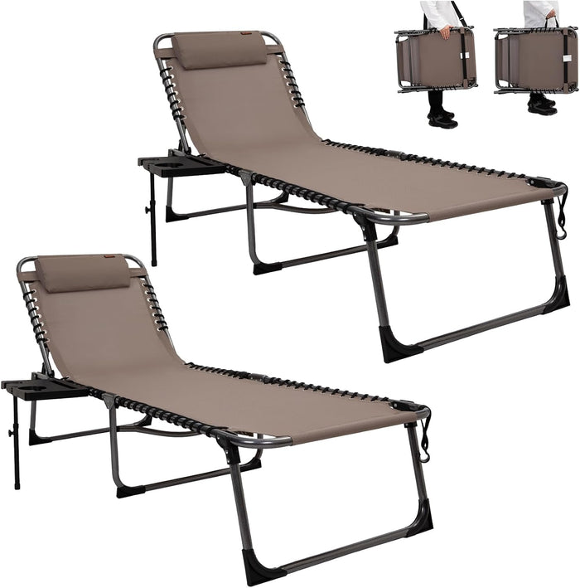 | Fabric: Textilene  Frame: Spray-coated steel, 22 x 1.0 mm tube  Open size: 190 x 59 x 34/37 cm  Packed product size: 76 x 15 x 60 cm  Product weight: 6.6 kg / 14.5 lb  Maximum load: 120 kg / 264 lb  Supplied with each chair: Pillow, side bag and outer bag
Five backrest positions: 120, 140, 155, 170 and 180 degrees. Side table, adjustable pillow, side pockets and carrying straps.

C03 Oversized Director Chair with Side Table
加大折叠导演椅（伸缩边桌）
KC2644 / KC2684
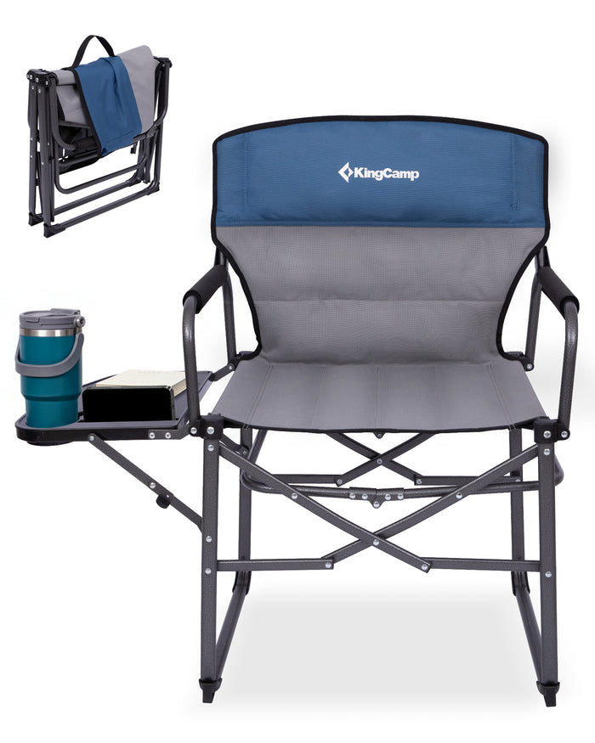 | Seat fabric: 100% polyester 600 x 300D PVC  Frame: Steel  Open size: 50 x 55 x 48/92 cm  Folded size: 52 x 15 x 50 cm  Product weight: 5.7 kg / 12.6 lb  Rated static load: 200 kg / 440 lb  Front edge static load: 180 kg / 396 lb
Padded seat and foam armrests; retractable side table with cup holder; press-to-open folding design.

C04 MAGNOLIA B40 Padded Lounge Chair
MAGNOLIA B40 全垫折叠躺椅
KC2641
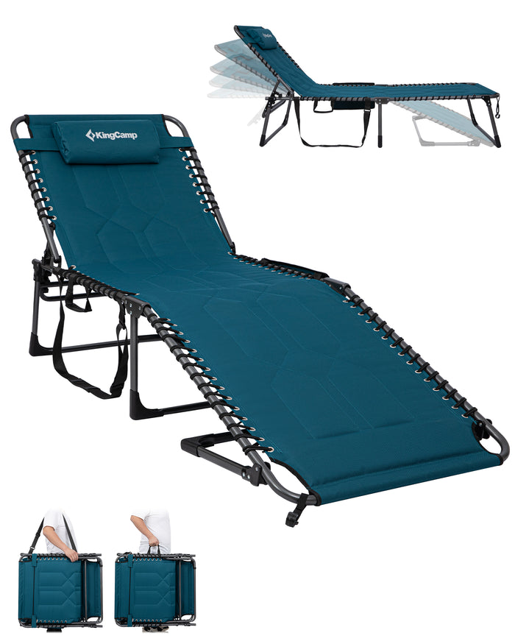 | Seat fabric: 600D Oxford with PVC coating  Cushion: PU foam  Frame: Powder-coated steel  Open size: 200 x 68 x 34/38 cm  Folded size: 80 x 15 x 72.5 cm  Product weight: 8.8 kg / 19.4 lb  Maximum static load: 200 kg / 440.9 lb  Seat edge load: 150 kg / 330.6 lb  Included: One chair, adjustable pillow, detachable storage pocket
Five reclining positions including flat; full-length PU foam padding; adjustable pillow and detachable side storage pocket.

C05 ORCHID C20 Hammock Chair with Footrest
ORCHID C20 网背吊床椅（可拆脚托）
KC2517
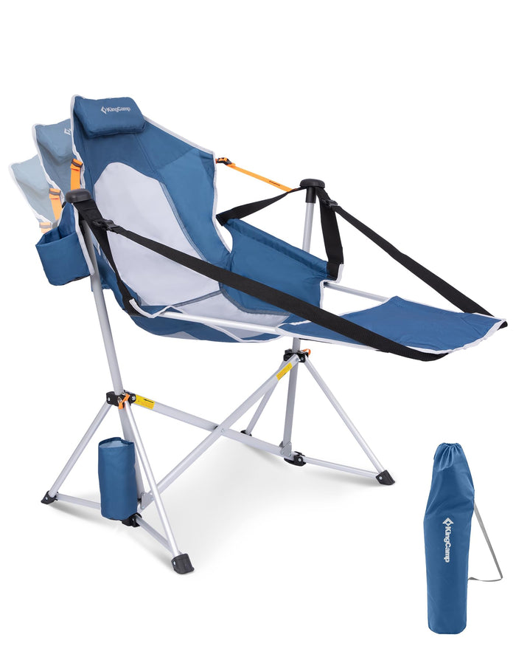 | Fabric: 600D Oxford polyester and nylon mesh  Frame: 6063 aluminum alloy and Q195 steel  Open size: 96 x 69 x 58/120 cm  Folded size: 19.5 x 18.5 x 93.5 cm  Net weight: 5.1 kg / 11.2 lb  Rated static load: 250 kg / 551 lb  Seat front-edge static load: 180 kg / 396 lb
Detachable footrest, adjustable backrest, mesh back, padded headrest, cup pockets and shoulder bag.

C06 Mesh Folding Director Chair
网面折叠导演椅
KC3824 / KC2010
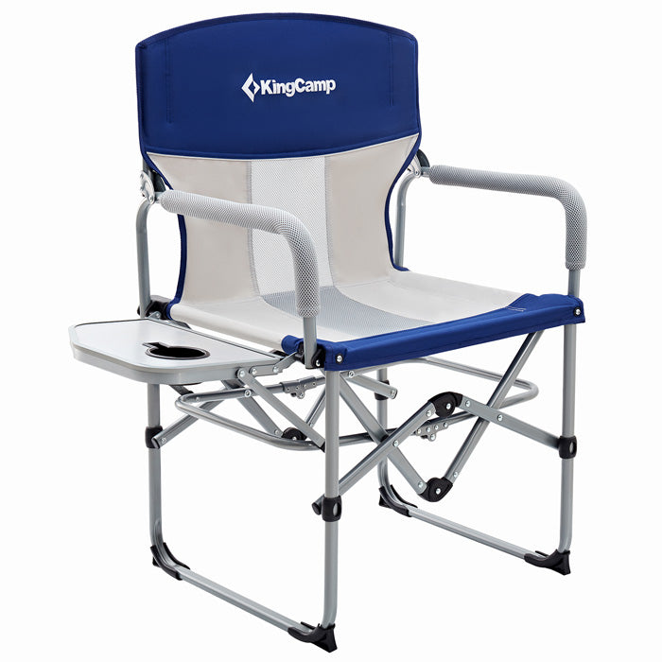 | Seat material: 600D Oxford  Frame: Steel tube  Packed product size: 50 x 48 x 15 cm  Product weight: 5.4 kg / 11.9 lb  Weight capacity: 136 kg / 300 lb
Breathable mesh seat surface, padded seat/back/armrests, folding side table and built-in cup holder.

C07 LEMON C20 Double Butterfly Chair
LEMON C20 双人蝴蝶椅
KC2424
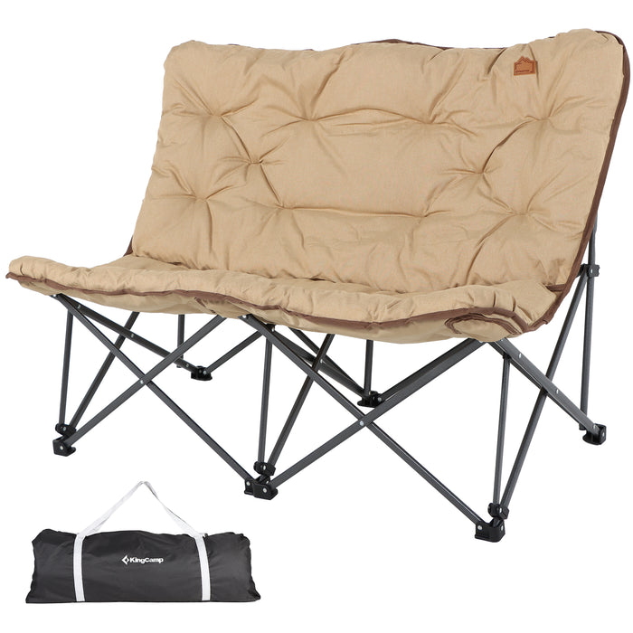 | Seat fabric: 600D Cationic Oxford  Frame: Q195 steel tubing  Width x depth x height: 132 x 81 x 94 cm  Packed product size: 32 x 25 x 95 cm  Product weight: 8.5 kg / 18.7 lb  Included: One frame, one double seat cover, one carry bag, two compression straps
A continuous double seat for two people; detachable padded seat cover; one folding frame, carry bag and two compression straps.

C08 Lightweight Folding Camp Chair
轻量折叠露营椅（杯托款）
KC2216 / KC2256
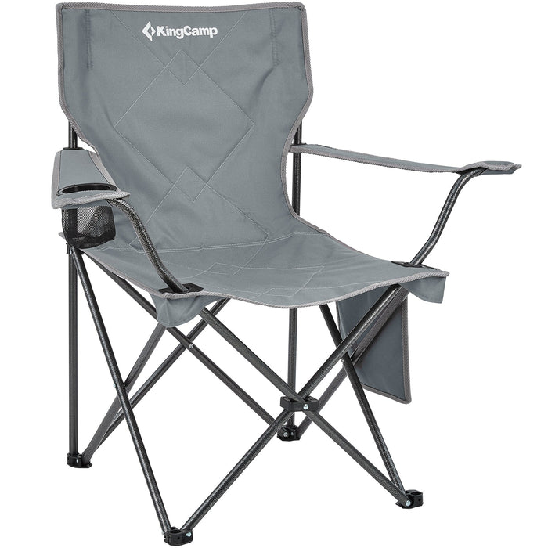 | Seat material: 600D Oxford  Frame: Steel tube  Open size: 19.68 x 19.68 x 32.3 in  Packed product size: 6.3 x 6.3 x 32.6 in  Product weight: 5.3 lb  Maximum static load: 120 kg / 265 lb  Maximum impact load: 100 kg / 220 lb
Adjustable armrests, mesh cup holder, steel frame and shoulder carry bag.

C09 Reclined Mesh-Back Camping Chair
高靠背网面露营椅（侧袋款）
KC3825
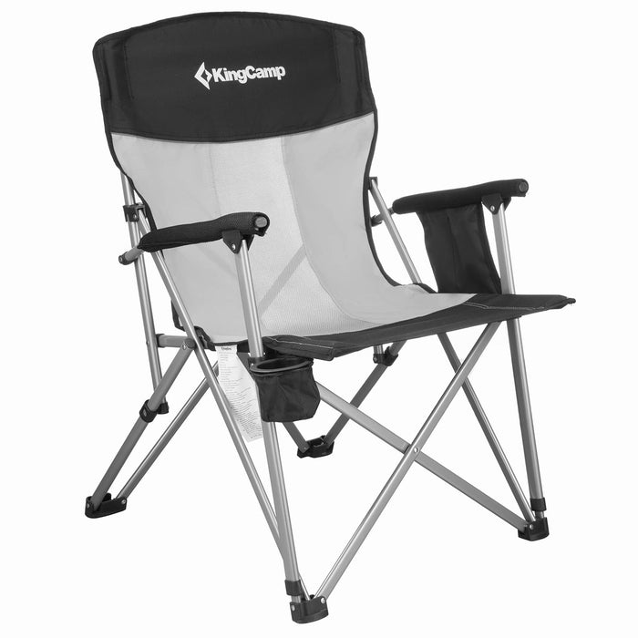 | Seat material: 600D Oxford  Frame: Steel tube  Packed product size: 97 x 18 x 17 cm  Product weight: 4.3 kg / 9.4 lb  Weight capacity: 136 kg / 300 lb
Reclined mesh back; padded seat and back; cup holder, side pocket and quick folding frame.

C10 Low Sling Folding Beach Chair
低座折叠沙滩椅
KC2105 / KC2104
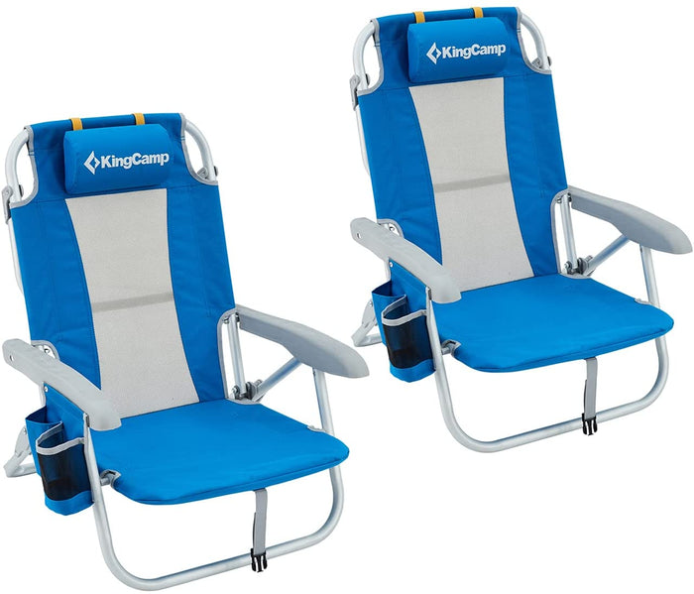 | Seat material: 600D Oxford  Frame: Aluminum alloy  Weight capacity: 136 kg / 300 lb  Recline: Three positions, including lay-flat
Three seating positions including lay-flat; foam pillow, mesh back, storage pouch and rear towel bar.

