**Unstop Problem**

Backend Logic in file

Src->controller->unstopProblem.controller.js

DB schema in file

Src->models->unstopProblem.model.js

Frontend Logic In file

Src->pages->unstopProblem.js

Working of code and cases are explained below in this doc file With output screenshots ----------------------------------------------------------------------------------------------------------------🡪>>>>>>>>>>>>>>>>>>>>>>>>>>>>>>>>>>>>>>>>>>>>>

If user tries to book more than 7 tickets

Booking All Row Tickets

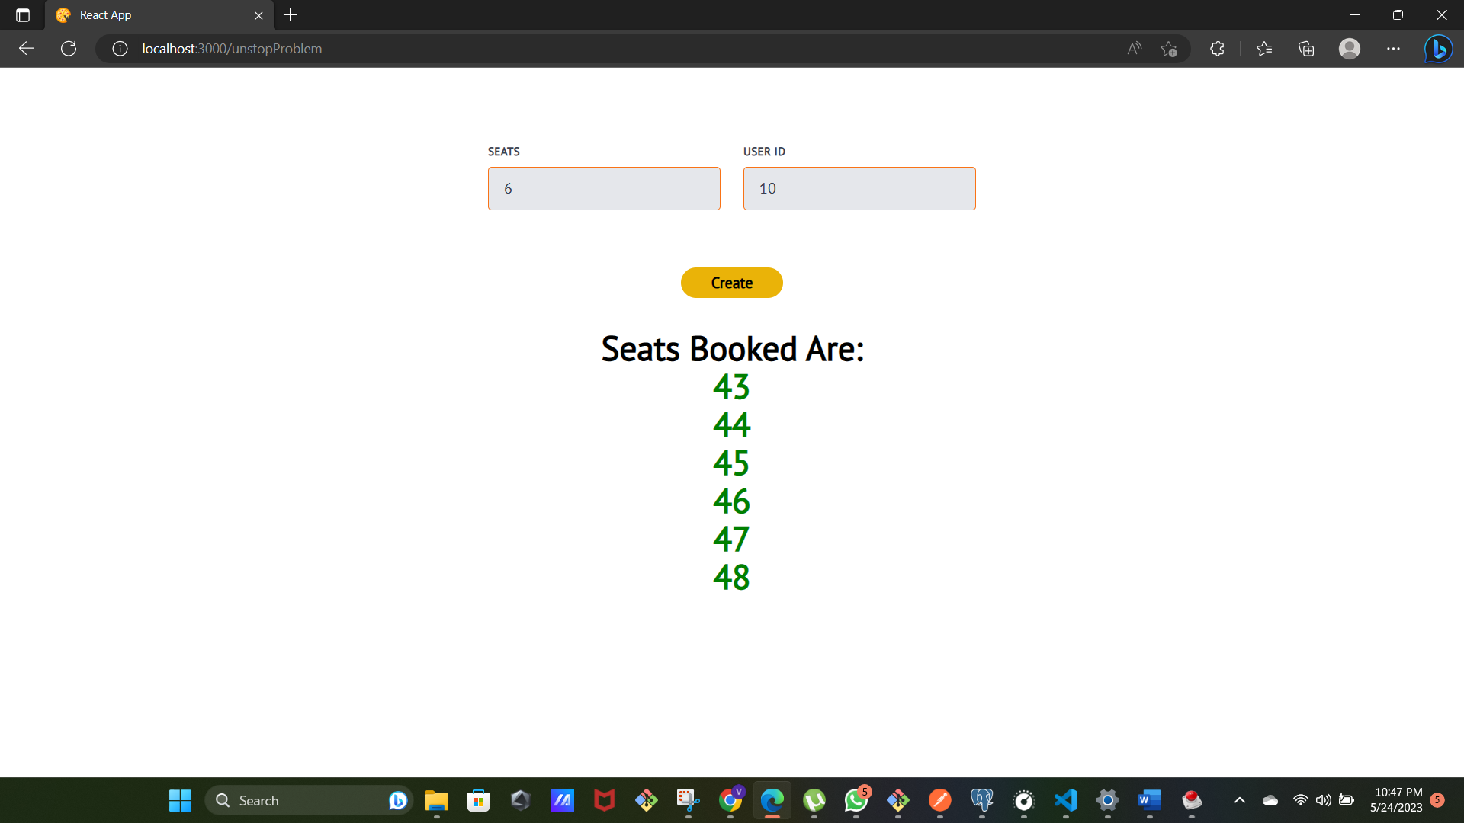

If seats are available in a row but with other seats(as 26 27 28 were left, as 3 seats were available here in this row so these 3 seats are booked.)

Now if 6 seats are not available in a row closest seats are booked

If seats value that is entered are not available

