**LinkedIn**

**System Requirements Document**

**Index**

1. **Introduction** ………………………………………………………………………………………………………………... 3
   1. **Objectives** ……………………………………………………………………………………………….…. 3
   2. **System Overview** ……………………………………………………………….………….……….…. 4
2. **User roles** ………………………………………………………………………………………………………………....... 5
3. **Functional Requirements** ……………………………………………………………………………………………. 6
4. **Workflow Charts** …………………………………………………………………………………………………………. 8
5. **Interface Design** ………………………………………………………………………………………………………… 11
6. **Rules** …………………………………………………………………………………………………………………….….… 12
7. **Project Programming Language and Technologies**…………………………………………………….. 12
8. **Project Upload Requirements**…………………………………………………………………………….….….. 12
9. **Project Evaluation**………………………...…………………………………………………………………….…….. 13
10. **Deadline**………………………...…………………………………………………………………….………………….… 13

**1. Introduction**

**1.1 Objectives**

Many people find it difficult to find job advertisements for the location of available places for employment. It is also difficult for company owners to find highly qualified employees easily.

This document contains the following sections:

* User roles.
* Workflow diagrams.
* Functional requirements.

**1.2 System Overview**

The system is an integrated program developed for employment in companies. It is a dynamic and responsive system. Which provides an easy way for the company to hire candidates and also provides the facility for candidates to apply for different jobs.

The system consists of the following main parts:

* Create a travel and tourism system procedure.
* Additional services.
* Reports and Statistics.

**2. User Roles**

**2.1. User**

Is a who searches for a job and tracks whether there is a company that has vacancies, as well as determines his educational level and expresses his opinion on the site.

**2.2. Admin**

Is a user who tracks the site and finds out the number of registered companies and the number of job applicants and gets a report on it.

**2.3. Employers**

Registers companies, know the applicants for the company and approve or reject the candidates.

**2.4. Guest User**

Is a user who visits the website and can give his opinion about the website in general.

**3. Functional Requirements**

**3.1. User:**

* Users can see the latest job posted on the home page.
* Can view total listed jobs.
* Register on the Website.
* View his applied (Today’s applied jobs, Yesterday applied for jobs, Last seven days applied jobs and total applied jobs).
* Fill in his education details.
* Looking at the jobs available to him according to the educational level, he applies for the job and uploads his CV (as a document).
* Search between two dates for applied jobs.
* Search for jobs according to job titles.
* Change his information.

**Notes**: If the candidate is accepted for the job, a message will be received from the company.

**3.2. Admin:**

* View detail of the registered company.
* View user registration details.
* Search between two dates for registered companies and job applicants.
* Obtain a report displaying the number of companies that were registered in a certain period, as well as displaying the number of vacancies listed by a particular company in certain periods.
* Manage pages (Home, about us, contact us).

**3.3. Employers:**

* Registration new company.
* Sign in like a company.
* Add and manage vacancies in the company (CRUD).
* The company can see the number of applicants for a job in the company.
* Accepting or rejecting job applicants and sending a message to them.
* Search between two dates for job applicants.
* Obtaining a monthly and annual report showing the number of job applicants, the number of those accepted, and the number of those rejected.

**3.4. Guest Users**

* Can view home, about us, and contact us pages.
* Can view listed jobs.
* Can register himself.

**4.** **Workflow Chart**

**4.1. Home:**

**Footer**

**Contact Form**

**Nav bar**

**Header**

**Background / Slider**

**Templates**

**4.2. Use Case Diagram**

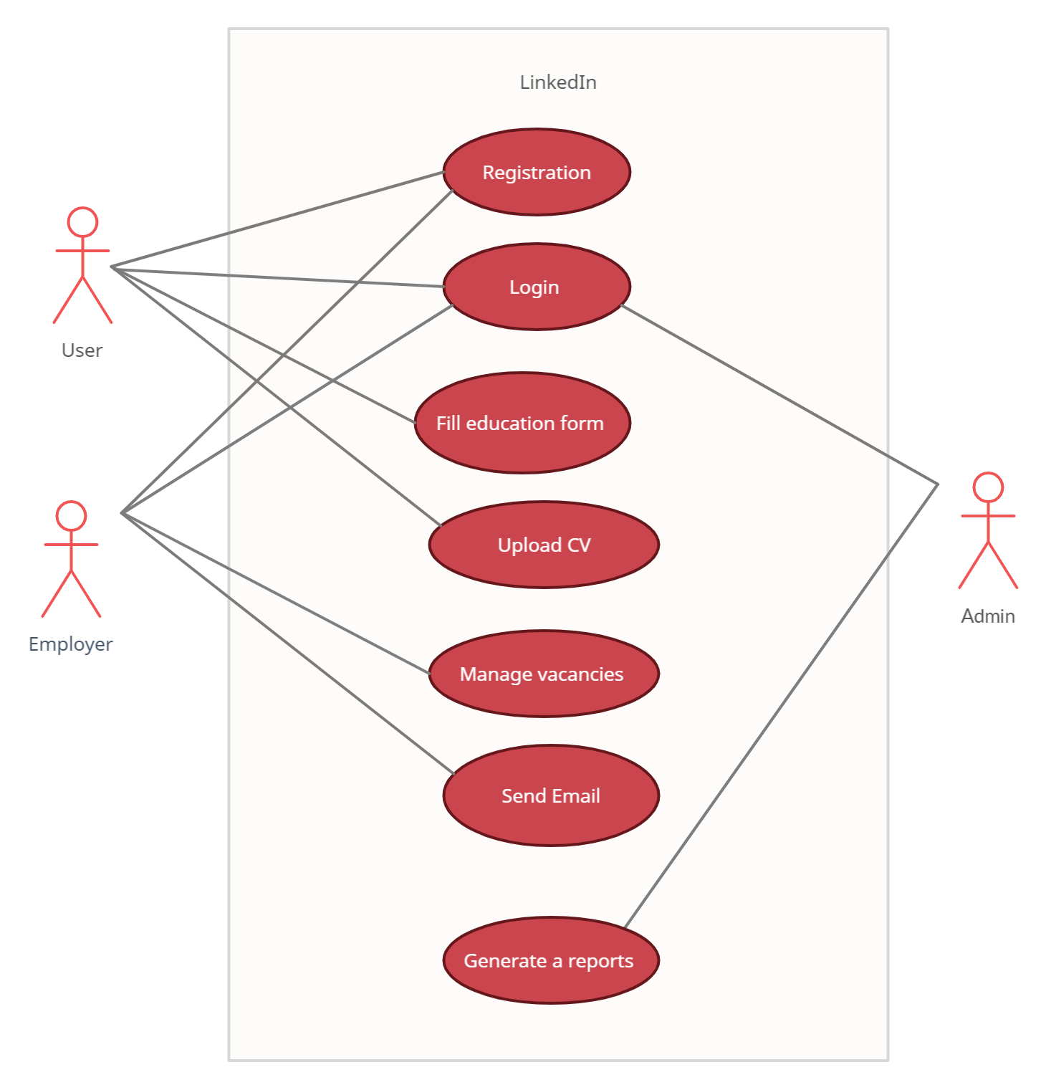

**4.3. Project Plan**

**5. Interface Design**

* Use the Bootstrap template to prepare the home page.
* Use the recognized colors in the design.
* Don’t forget to Search by package, name, and interval.
* The report displays on the website and document.
* The report must be containing charts.
* Use a dashboard template for different users.
* Users’ sessions must be designed.
* Home Page must contain reviews, testimonials, about us, contact us, header, footer, and background or slider.
* Each part in the home must change dynamically using Database.

**6. Rules**

* Keep the rules of the clean code.
* Keep the rules of the business.
* Don't forget to design the logout button.
* Keep the project name.

**7.** **Project Programming Language and Technologies**

* Use Visual Studio 2019.
* Oracle Server.
* Use SQL Developer.
* Use ASP.NET Core Web API.
* Use Angular.

**8. Project Upload Requirements**

* Upload your project code.
* Upload Project Presentation (Advertising presentation (.
* Upload Project Video.

**9. Project Evaluation**

* 15% Project video and presentation.
* 35% Interfaces Design.
* 50% Code Functionality.

**10. Deadline**

**27/01/2022 – 10/04/2022**

The project is submitted on the portal: 10/04/2022.