Synthetic exterior point-cloud benchmark for rockpile fragmentation: fragment generation, rockpile construction, EdgeConv learning, and size-distribution proxy evaluation
  - N. Ha1
1 Department of Energy and Resources Engineering, National Korea Maritime and Ocean University, Busan, Republic of Korea; ORCID: 0009-0007-4918-6239
Corresponding author: N. Ha, noah.ha.au@gmail.com

Abstract
Post-blast rockpile fragmentation controls loading, hauling, and crushing performance, but field point clouds rarely provide fragment-level labels or independent size references. This study presents a synthetic benchmark for exterior rockpile point clouds in which individual rock-like fragments are generated first, assembled into labelled piles, filtered to retain only visible exterior points, and then used to compare fragment clustering methods. A graph EdgeConv model predicts whether neighbouring exterior points belong to the same fragment, and thresholded edge affinities are converted into connected components and visible-surface particle-size proxies. The same 100 scenes, each containing 150 fragments, were used for all methods with a 60:20:20 train, validation, and test split. The latest held-out comparison showed that a calibrated graph-threshold rule gave the lowest mean absolute eighty per cent passing-size error, 14.37 per cent, while EdgeConv with post-splitting gave 19.04 per cent and retained stronger learned local affinity information than the shallow multilayer perceptron. The results show that synthetic exterior piles can separate two questions that are often conflated in rockpile monitoring: whether visible fragments are cleanly segmented, and whether the resulting surface clusters recover a useful size-distribution proxy. The benchmark is intended as a reproducible pre-field testbed rather than a replacement for mine-site calibration.
Keywords: fragmentation monitoring; rockpile; point cloud segmentation; synthetic benchmark; EdgeConv; mine-to-mill

Introduction
Blast fragmentation affects digging, loading, hauling, crushing, and comminution. A reliable estimate of the coarse end of the fragment-size distribution can help engineers detect oversize material, adjust blast designs, and stabilise crusher feed. Two-dimensional image-analysis systems remain attractive because they are practical, but they must infer scale, overlap, and hidden fragment boundaries from a projected view. Three-dimensional photogrammetry and laser scanning preserve richer surface geometry, yet a scan still observes only the outside of the muckpile. Buried contacts and hidden backs of fragments remain unknown.
This study therefore treats surface estimates as visible-surface size-distribution proxies. The word proxy is important. The benchmark does not claim that an exterior point cloud directly measures the whole-pile particle size distribution. Instead, it asks how much reference size information can be recovered when the algorithm is given only the kind of exterior points that a camera or scanner could plausibly see.
The contribution is a reproducible synthetic pre-field workflow. Rock-like fragments are generated with known identities and volumes; piles are constructed from those fragments; full synthetic geometry is converted into exterior-only point clouds; and an edge-affinity model is compared with graph, density, region-growing, and shallow learning baselines. The manuscript emphasises the construction of the labelled piles and exterior learning target because these steps determine whether a method is being tested on a realistic scan proxy or on unobservable interior geometry.
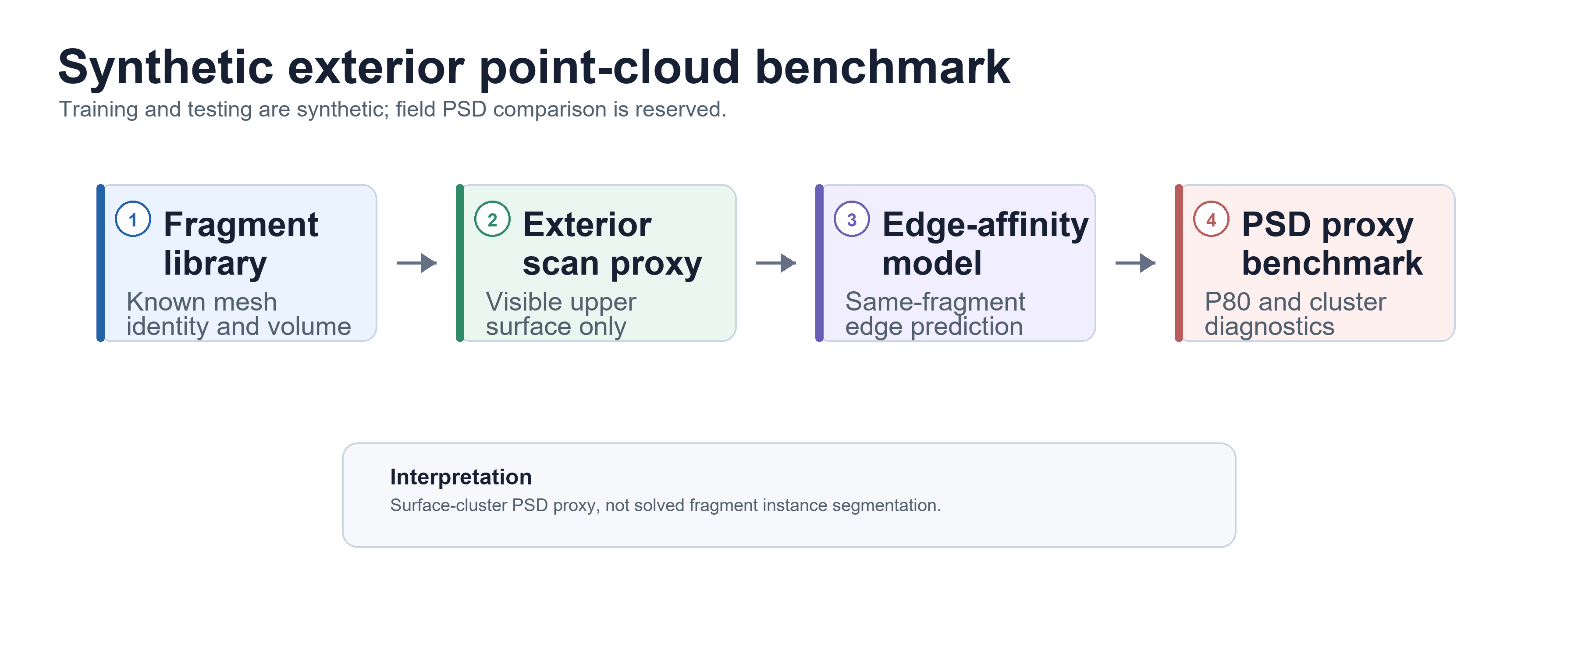
Figure 1. Benchmark workflow from synthetic fragment generation to exterior-only learning and size-distribution proxy evaluation

Related work and benchmark positioning
Fragmentation models and monitoring systems have a long history in blasting and mine-to-mill optimisation (Cunningham, 1983; Ouchterlony, 2005). Commercial and research image-analysis systems such as WipFrag made fragmentation measurement operationally accessible, but their two-dimensional measurements remain sensitive to occlusion, scale, fines, and manual editing (Palangio et al., 1995; Siddiqui et al., 2009). Structure-from-motion and laser scanning provide point clouds that are more suitable for surface-shape reasoning, and have been applied in geoscience and mining contexts (Westoby et al., 2012; Eltner et al., 2016; Engin et al., 2020).
Point-cloud neural networks including PointNet, PointNet++, and dynamic graph convolutional neural networks show that local geometric relationships can be learned directly from irregular samples (Qi et al., 2017a; Qi et al., 2017b; Wang et al., 2019). For rockpiles, however, a direct fragment-ID classifier is poorly posed because fragment labels are arbitrary from one scene to another. Edge affinity is a more transferable target: neighbouring points are classified as same-fragment or different-fragment, after which connected components form candidate visible fragments.

Materials and methods

Synthetic fragment mesh library
The benchmark begins with a library of synthetic rock-like fragment meshes. Each mesh carries a fixed fragment identity, volume, equivalent spherical diameter, and local surface samples. Fragment generation is kept separate from rockpile construction so that the size reference is known before any pile placement, exterior filtering, or machine-learning step is applied. This prevents the downstream segmentation algorithm from defining its own reference size distribution.
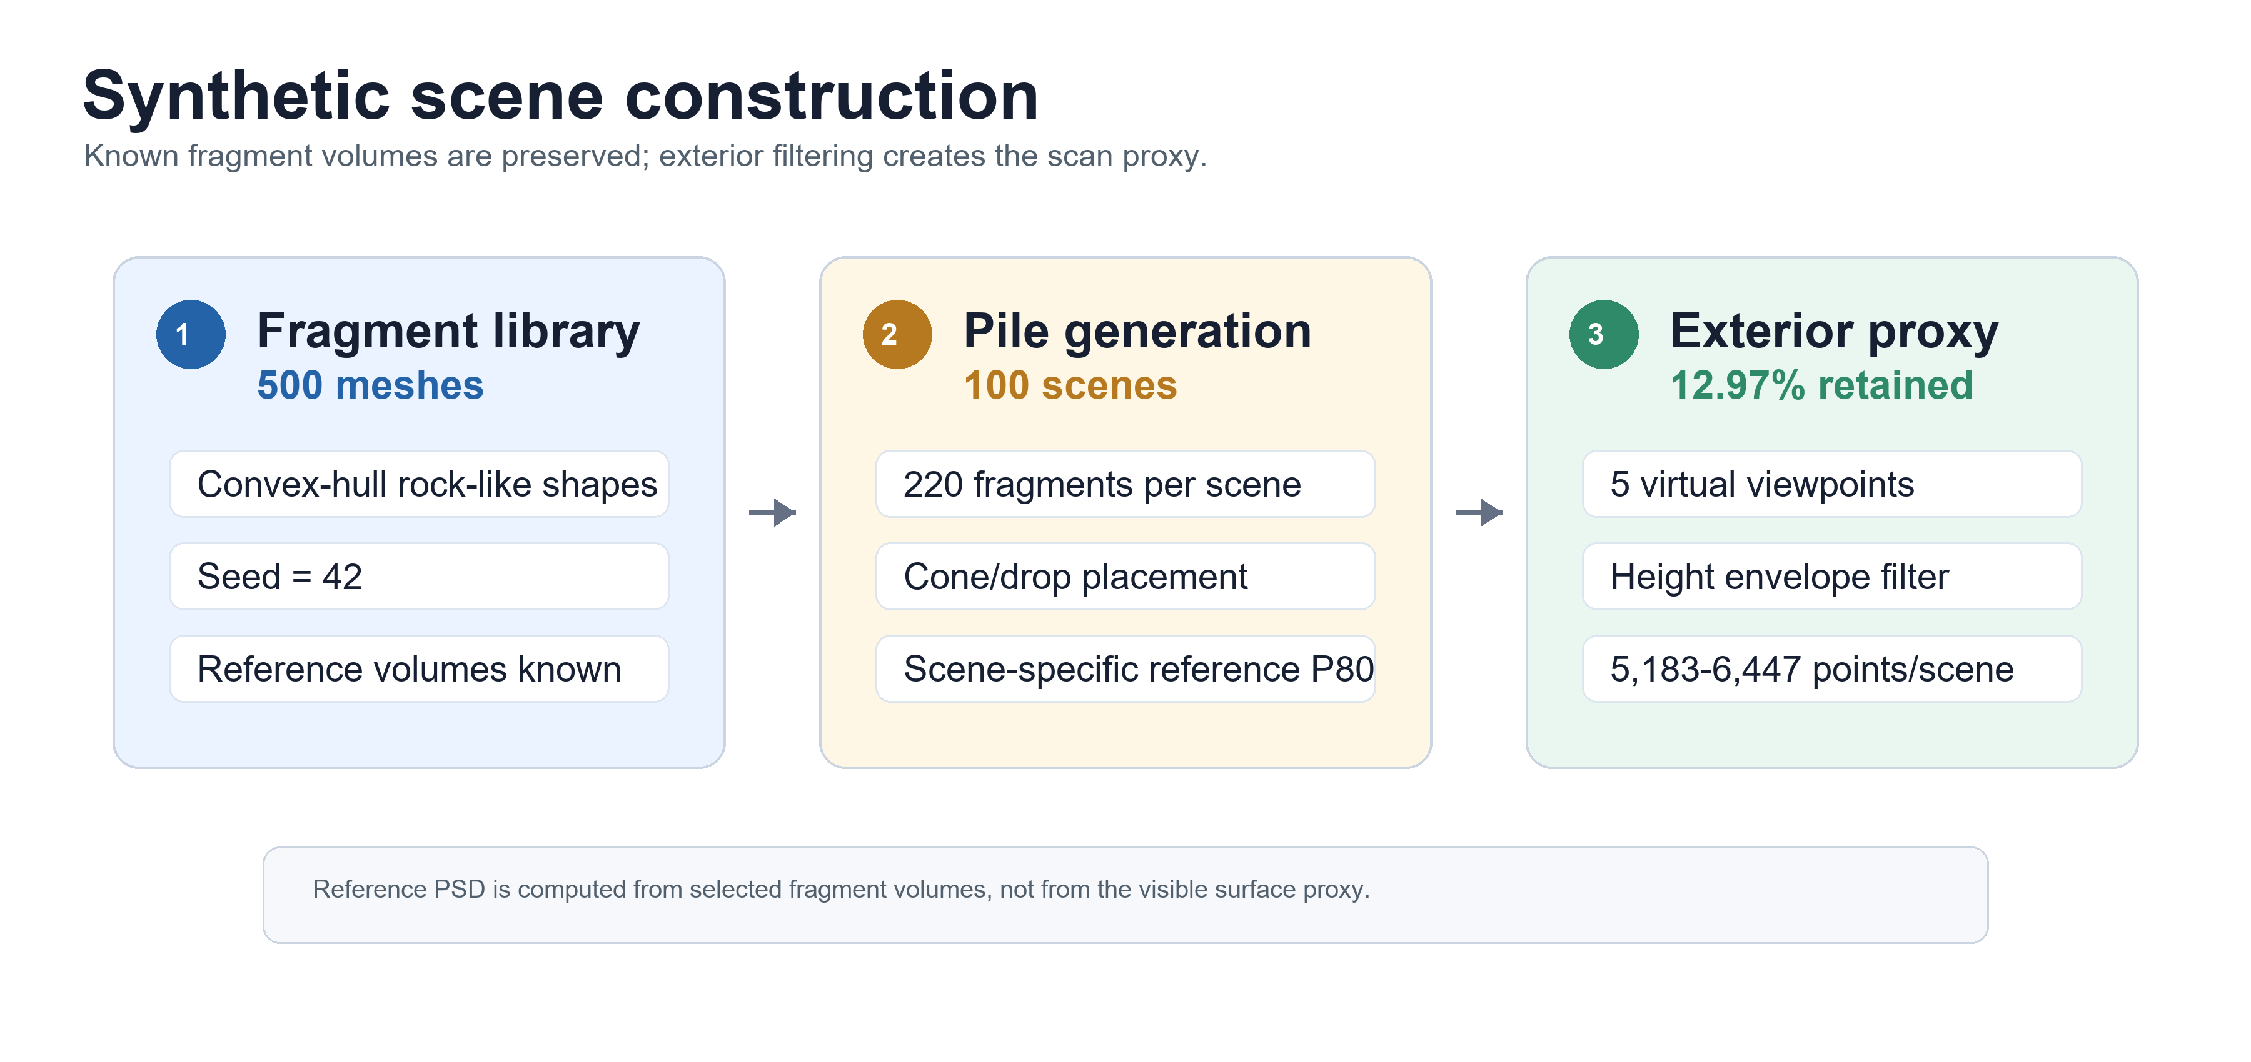
Figure 2. Synthetic fragment and rockpile generation sequence with label-preserving mesh placement and exterior sampling

Rockpile construction backend
The production dataset used the no-boundary envelope-relax and axis-clump backend developed after earlier sequential-drop and Chrono trials. Those trials were useful for diagnosing contact explosions, excessive lateral dispersion, and boundary-box artefacts, but the final reported 100-scene dataset was produced by a deterministic CPU-parallel placement workflow that preserved individual fragment meshes and stored the scene centres and orientations required for reconstruction.
Table 1. Production rockpile generation settings used for the 100-scene dataset
Item | Value
Number of scenes | 100
Fragments per scene | 150
Scene split | 60 training, 20 validation, 20 test scenes
Pile backend | No-boundary envelope-relax placement with axis-clump contact approximation
Boundary condition | Open floor; no confinement box in the final production run
Placement objective | Compact mound-like pile with overlap rejection and radial containment penalty
Stored outputs | Per-fragment centre, orientation, mesh identity, labels, and exterior point-cloud samples

Material and contact interpretation
The material parameters were selected to represent dense hard rock rather than lightweight artificial particles. Because the production backend is a geometry-preserving placement and relaxation model rather than a full field calibration of breakage mechanics, the parameters should be read as physically informed contact settings used to stabilise pile morphology and prevent unrealistically elastic scattering.
Table 2. Material and contact parameters used to guide the hard-rock pile-generation trials
Parameter | Value
Density | 2670 kg/m3
Young's modulus | 5.0e10 Pa
Poisson ratio | 0.25
Coefficient of restitution | 0.20
Static friction coefficient | 0.85
Sliding friction coefficient | 0.65
Rolling friction coefficient | 0.15
Spinning friction coefficient | 0.03

Mesh placement and exterior point-cloud sampling
After placement, source fragment meshes were reconstructed at their stored scene centres and orientations. This mesh-level reconstruction was used for visual audit and for confirming that fragment identity had not been lost during scene construction. The learning data were not sampled from arbitrary internal surfaces. Instead, the full mesh scene was converted into an exterior scan proxy using viewpoint-based visibility followed by a plan-view height-envelope filter.
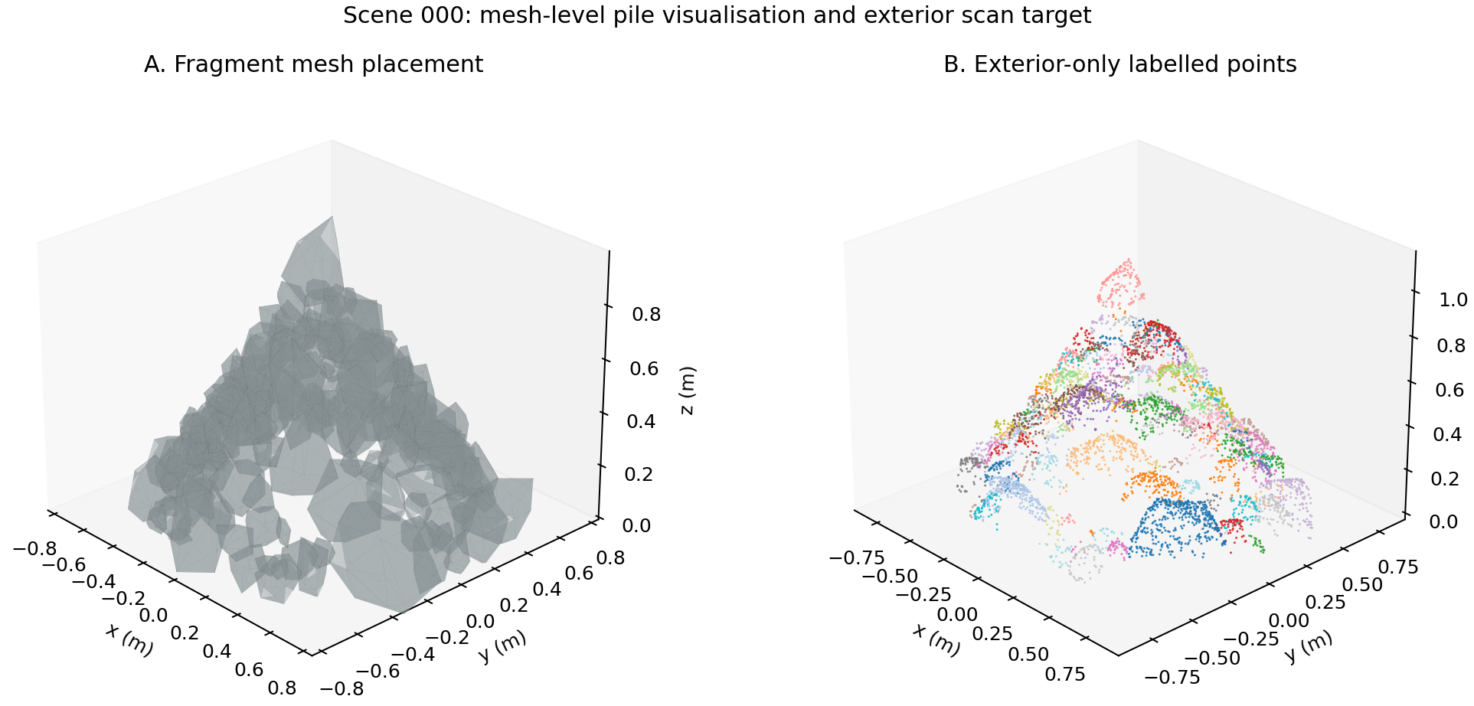
Figure 3. Scene 000 mesh-level pile visualisation and exterior-only point-cloud target with retained fragment labels
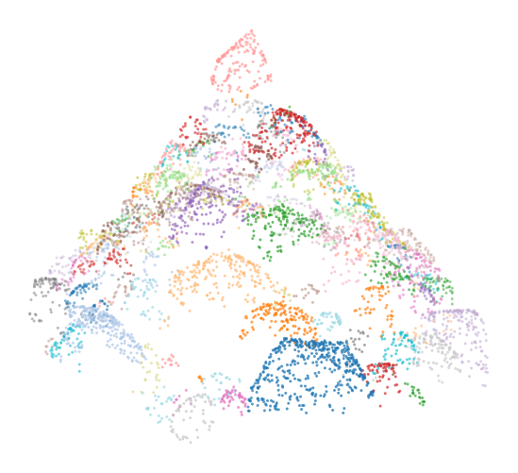
Figure 4. Representative exterior point cloud from the no-boundary 150-fragment dataset

Exterior-only scan construction
Table 3. Exterior scan and graph construction settings used for the learning target
Stage | Setting
Surface visibility | Multi-view nearest-surface retention
Envelope filtering | Plan-view height filter retaining the upper exterior envelope
Label transfer | Each retained point stores the source fragment identity
Graph construction | Local point graph built from exterior samples only
Learning target | Binary same-fragment edge affinity
Post-processing | Thresholded affinities converted to connected components and size proxies

The exterior filter is deliberately conservative. A full synthetic pile includes contact patches and interior faces that cannot be observed from a field scan. Training on those points would make the benchmark easier but less relevant. The exterior-only construction therefore sacrifices some label completeness to preserve the visibility constraint.

Edge-affinity learning and baseline methods

Why EdgeConv was used
EdgeConv was selected because the task is local and relational. Rockpile segmentation depends on whether adjacent surface patches belong to the same fragment, and this decision is influenced by relative position, local surface shape, and neighbourhood context. A scene-level fragment-ID classifier would not transfer across piles because fragment numbers are arbitrary. A purely global network would also discard the local contact information that separates neighbouring stones. EdgeConv instead forms local graph features and updates point representations from neighbouring relationships, matching the edge-affinity formulation of the benchmark.
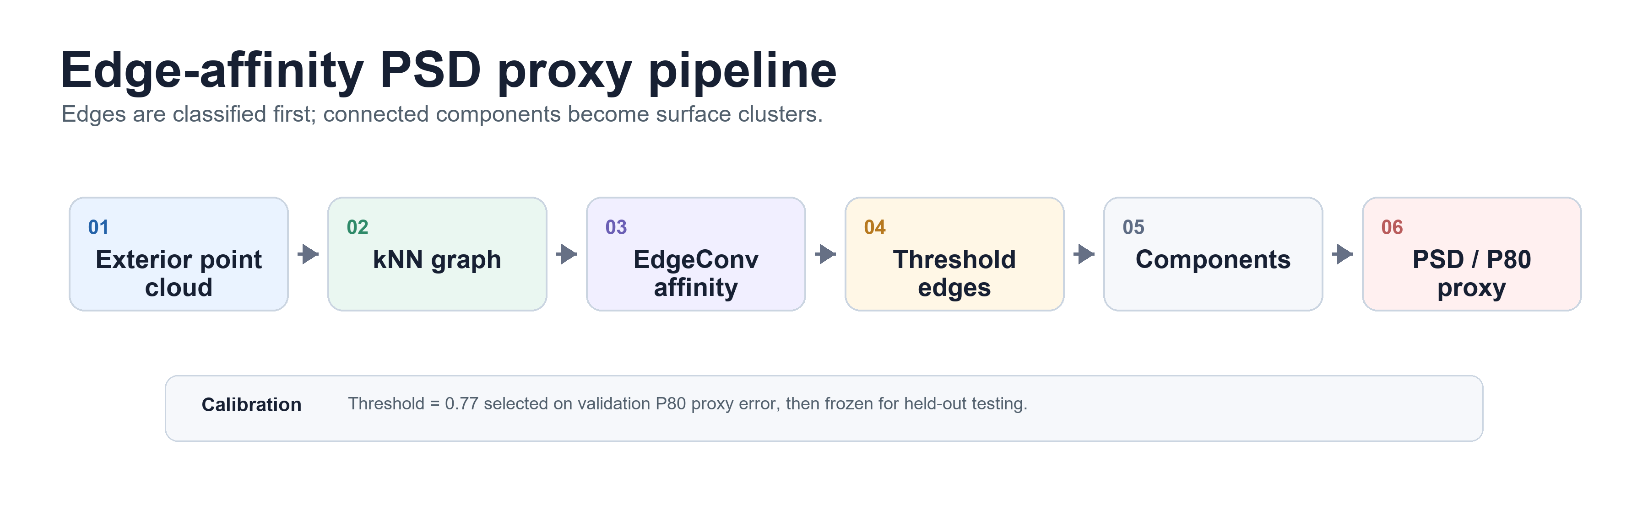
Figure 5. Edge-affinity formulation from exterior points to graph edges, thresholded components, and size-distribution proxies
Table 4. EdgeConv model and training configuration for the 150-fragment, 100-scene run
Component | Configuration
Input | Exterior point coordinates and local graph edges
Target | Balanced positive and negative same-fragment edge labels
Backbone | Dynamic graph EdgeConv-style local feature aggregation
Training scenes | 60
Validation scenes | 20
Held-out test scenes | 20
Epochs | 24
Validation selection | Threshold selected on validation scenes before test evaluation
Post-processing variants | Plain thresholding, absorb/merge rules, and post-splitting variants

Baseline methods
All baseline methods were evaluated on the same 150-fragment scenes and the same 60:20:20 split. The non-learning baselines used validation-selected hyperparameters. The multilayer perceptron baseline used the same edge-affinity target but without EdgeConv neighbourhood feature aggregation, which isolates the value of graph-based local feature learning.

Size-distribution proxy evaluation
Predicted connected components were converted to a visible-surface particle-size proxy using a principal-component span diameter and an equivalent-volume proxy. The eighty per cent passing size was then interpolated from the volume-weighted cumulative curve. The same conversion was used for every method so that differences in reported error come from the predicted components rather than from method-specific size calibration.
Instance metrics and size metrics were both reported. Normalised mutual information and adjusted Rand index measure how well the point partition matches fragment labels. Mean absolute passing-size error measures whether the resulting components recover the coarse size proxy. These two outcomes are related but not identical: a method can produce imperfect fragment instances while still giving a useful size proxy, or can over-merge and produce a poor coarse-size estimate despite superficially coherent clusters.

Results
The 24-epoch EdgeConv run showed improving training loss and high validation average precision, confirming that the model learned informative same-fragment edge affinities. The remaining difficulty was calibration of the affinity threshold and post-processing for realistic exterior piles, where overly strict thresholds split visible fragments into too many components.
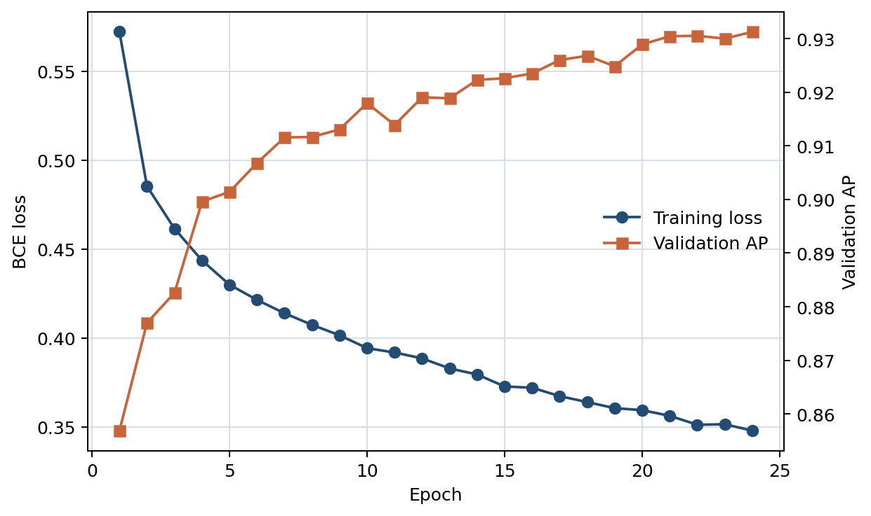
Figure 6. Training loss and validation average precision for the 24-epoch EdgeConv edge-affinity run
Table 5. Held-out EdgeConv post-processing comparison for the 20 test scenes
Variant | Threshold | Mean absolute P80 error (%) | Median absolute P80 error (%) | Mean NMI | Mean ARI | Noise
edgeconv post split | 0.997 | 19.04 | 18.36 | 0.492 | 0.032 | 0.603
edgeconv | 0.997 | 20.82 | 19.42 | 0.492 | 0.034 | 0.603
edgeconv absorb post split | 0.997 | 21.84 | 21.40 | 0.597 | 0.070 | 0.506
edgeconv absorb | 0.997 | 23.45 | 21.40 | 0.597 | 0.073 | 0.506

Table 6. Latest 150-fragment held-out test comparison after retraining or recalibrating all baseline methods on the same scene split
Method | Selected setting | Mean absolute P80 error (%) | Median absolute P80 error (%) | Mean NMI | Mean ARI | Noise
Graph threshold | d=0.070,z=0.040,c=0.050,thr=0.85 | 14.37 | 12.74 | 0.379 | 0.005 | 0.694
MLP affinity | threshold=0.999 | 16.15 | 14.64 | 0.123 | -0.006 | 0.908
DBSCAN | eps=0.025,min=6,zw=1.00 | 18.99 | 15.31 | 0.586 | 0.039 | 0.423
EdgeConv post split | threshold=0.997 | 19.04 | 18.36 | 0.492 | 0.032 | 0.603
Region growing | r=0.035,a=0.100,c=0.035,z=0.035 | 116.01 | 105.13 | 0.751 | 0.325 | 0.195

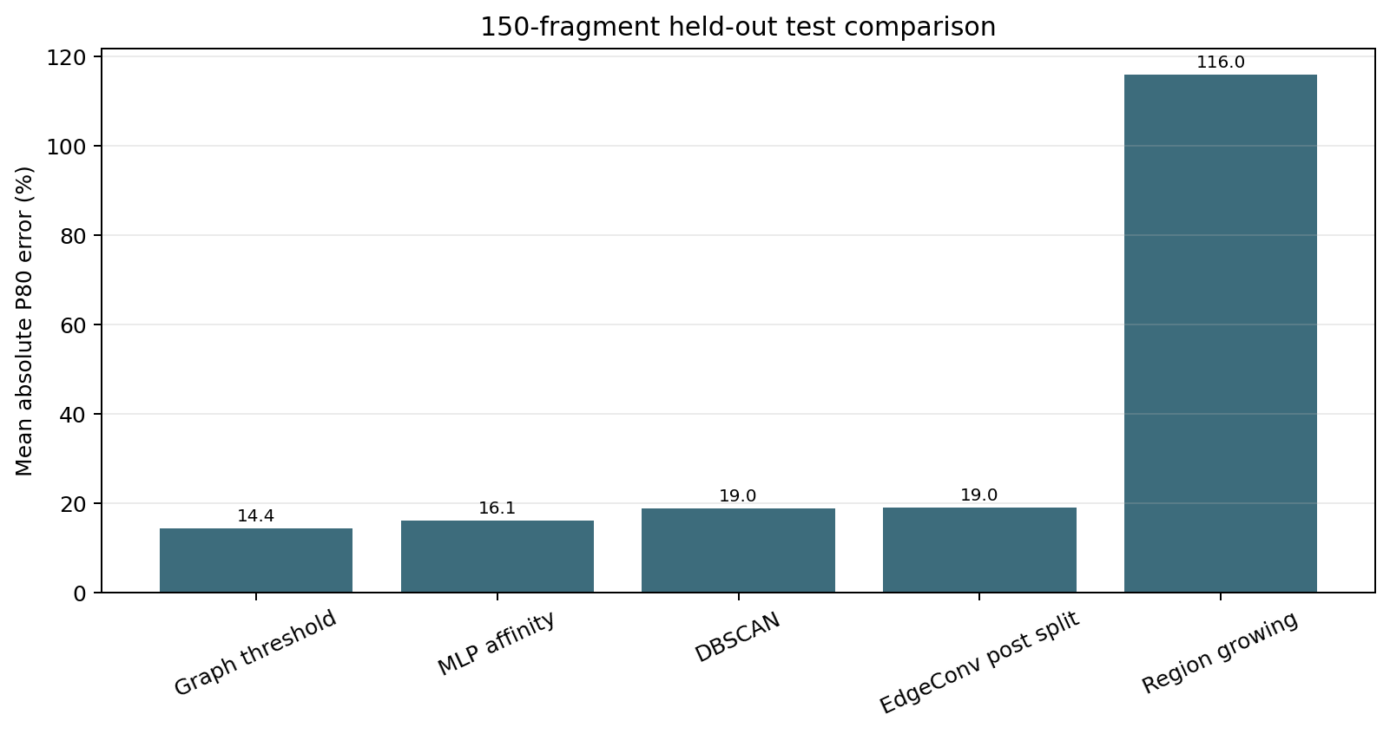
Figure 7. Held-out test mean absolute P80 error for the latest 150-fragment comparison
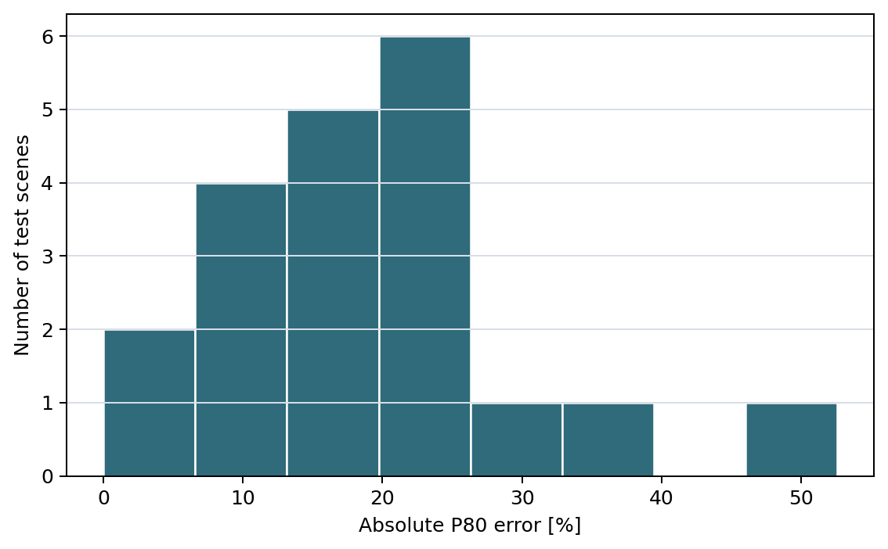
Figure 8. Held-out test distribution of absolute P80 error for the validation-selected EdgeConv post-split setting

Discussion
The results suggest that the benchmark is diagnosing two separate behaviours. EdgeConv learns useful edge affinity, as indicated by the training curve and validation average precision, but the final size proxy is sensitive to the probability threshold and component rules. In the latest realistic-pile setting, very high thresholds tend to cut components into many small pieces, raising the noise fraction and damaging the coarse size estimate. This explains why a calibrated graph-threshold rule can outperform the neural model on P80 error even though the neural model has learned a meaningful local affinity function.
This finding is operationally important. A segmentation model should not be judged only by edge average precision or only by a final P80 value. If the objective is muckpile monitoring, the post-processing stage must be calibrated for the probability distribution produced by the model and for the exterior morphology of the pile. The current benchmark makes that calibration visible by reporting threshold behaviour, noise fraction, instance scores, and size-proxy error together.
The baseline comparison also shows why the graph formulation remains useful. Density clustering and simple region growing can capture some surface continuity, but they are brittle when point density, local slopes, and fragment spacing vary. The multilayer perceptron edge-affinity baseline lacks dynamic neighbourhood feature aggregation. EdgeConv is therefore retained as the main learning model because it is the most direct learned analogue of the local graph decision required by the problem, even though its threshold and merge rules still need improvement.

Limitations and field validation
The benchmark is synthetic and exterior-only. It does not replace field calibration against sieve analysis, belt scanner measurements, excavated fragment surveys, or other independent references. The pile generator preserves fragment meshes and labels but is not a full validation of blast breakage, rebound, weathering, fines generation, or operational digging disturbance. The reported numbers should therefore be interpreted as controlled pre-field performance rather than mine-site accuracy.
Future work should include field point clouds with independent size references, better threshold calibration, noise-penalised validation objectives, component-merge rules, and contact models that move from axis-clump approximations toward multi-sphere or polyhedral fragment contact where computation permits.

Conclusions
A labelled synthetic exterior point-cloud benchmark was developed for rockpile fragmentation monitoring. The workflow generates individual fragment meshes, constructs 150-fragment rockpile scenes, filters the full geometry to exterior-only scan proxies, and evaluates same-fragment edge-affinity learning against multiple baselines. The latest 100-scene comparison showed that the graph-threshold baseline achieved the lowest held-out mean absolute passing-size error, while EdgeConv learned strong local affinity but remained sensitive to threshold and post-processing calibration. The benchmark therefore provides a useful pre-field environment for separating model learning, component formation, and visible-surface size-proxy estimation.

Acknowledgements
No external funding was received for this study. OpenAI Codex was used as an assistance tool for code refactoring, document formatting, and drafting support. The author reviewed the scientific content, analysis, and final text.

CRediT author statement
N. Ha: Conceptualization, Methodology, Software, Investigation, Validation, Formal analysis, Data curation, Writing - original draft, Writing - review and editing, Visualization.

Data and code availability
The code, synthetic scene metadata, tables, and manuscript assets are available in the project repository: https://github.com/Linkgyu/rockpile-edgeconv-arxiv. The field validation stage has not yet been completed.

Declaration of competing interest
The author declares no known competing financial interests or personal relationships that could have appeared to influence the work reported in this paper.

References
Cunningham, C.V.B. 1983. The Kuz-Ram model for prediction of fragmentation from blasting. Proceedings of the 1st International Symposium on Rock Fragmentation by Blasting, Lulea, Sweden.
Eltner, A., Kaiser, A., Castillo, C., Rock, G., Neugirg, F., and Abellan, A. 2016. Image-based surface reconstruction in geomorphometry: merits, limits and developments. Earth Surface Dynamics, vol. 4, pp. 359-389.
Engin, I.C., Maerz, N.H., Boyko, K.J., and Reals, R. 2020. Practical measurement of size distribution of blasted rocks using LiDAR scan data. Rock Mechanics and Rock Engineering, vol. 53, pp. 4653-4671.
Ester, M., Kriegel, H.-P., Sander, J., and Xu, X. 1996. A density-based algorithm for discovering clusters in large spatial databases with noise. Proceedings of KDD.
Hubert, L. and Arabie, P. 1985. Comparing partitions. Journal of Classification, vol. 2, pp. 193-218.
Ouchterlony, F. 2005. The Swebrec function: linking fragmentation by blasting and crushing. Mining Technology, vol. 114, pp. 29-44.
Palangio, T.C., Franklin, J.A., and Maerz, N.H. 1995. WIPFRAG: a breakthrough in fragmentation measurement. Proceedings of the 21st Annual Conference on Explosives and Blasting Technique.
Paszke, A., Gross, S., Massa, F., Lerer, A., Bradbury, J., Chanan, G., Killeen, T., Lin, Z., Gimelshein, N., Antiga, L., et al. 2019. PyTorch: an imperative style, high-performance deep learning library. Advances in Neural Information Processing Systems.
Pedregosa, F., Varoquaux, G., Gramfort, A., Michel, V., Thirion, B., Grisel, O., Blondel, M., Prettenhofer, P., Weiss, R., Dubourg, V., et al. 2011. Scikit-learn: machine learning in Python. Journal of Machine Learning Research, vol. 12, pp. 2825-2830.
Qi, C.R., Su, H., Mo, K., and Guibas, L.J. 2017a. PointNet: deep learning on point sets for 3D classification and segmentation. Proceedings of CVPR.
Qi, C.R., Yi, L., Su, H., and Guibas, L.J. 2017b. PointNet++: deep hierarchical feature learning on point sets in a metric space. Advances in Neural Information Processing Systems.
Siddiqui, F.I., Shah, S.M.A., and Behan, M.Y. 2009. Measurement of size distribution of blasted rock using digital image processing. Journal of King Abdulaziz University: Engineering Sciences, vol. 20, pp. 81-93.
Vinh, N.X., Epps, J., and Bailey, J. 2010. Information theoretic measures for clusterings comparison: variants, properties, normalisation and correction for chance. Journal of Machine Learning Research, vol. 11, pp. 2837-2854.
Wang, Y., Sun, Y., Liu, Z., Sarma, S.E., Bronstein, M.M., and Solomon, J.M. 2019. Dynamic graph CNN for learning on point clouds. ACM Transactions on Graphics, vol. 38, article 146.
Westoby, M.J., Brasington, J., Glasser, N.F., Hambrey, M.J., and Reynolds, J.M. 2012. Structure-from-Motion photogrammetry: a low-cost, effective tool for geoscience applications. Geomorphology, vol. 179, pp. 300-314.

