<?xml version="1.0" encoding="utf-8"?>  
<LinearLayout xmlns:android="http://schemas.android.com/apk/res/android"  
 xmlns:app="http://schemas.android.com/apk/res-auto"  
 xmlns:tools="http://schemas.android.com/tools"  
 android:layout_width="match_parent"  
 android:layout_height="match_parent"  
 tools:context=".MainActivity"  
 android:orientation="vertical"  
 >  
<TextView  
 android:id="@+id/text"  
 android:layout_width="match_parent"  
 android:layout_height="wrap_content"  
 android:text="..."  
 android:background="#ffa"  
 android:textSize="40sp"  
 android:gravity="center"/>  
 <Button  
 android:id="@+id/btn_nfc"  
 android:layout_width="wrap_content"  
 android:layout_height="wrap_content"  
 android:text="点我开启NFC"  
 android:textSize="25sp"  
 android:gravity="center"  
 android:layout_gravity="center"/>  
  
</LinearLayout>

package com.example.myapplication0320;  
  
import androidx.annotation.NonNull;  
import androidx.appcompat.app.AppCompatActivity;  
import androidx.recyclerview.widget.LinearLayoutManager;  
import androidx.recyclerview.widget.RecyclerView;  
import androidx.recyclerview.widget.StaggeredGridLayoutManager;  
  
import android.annotation.SuppressLint;  
import android.content.Intent;  
import android.graphics.Rect;  
import android.nfc.NfcAdapter;  
import android.os.Bundle;  
import android.os.Handler;  
import android.provider.ContactsContract;  
import android.provider.Settings;  
import android.view.View;  
import android.view.ViewGroup;  
import android.widget.Button;  
import android.widget.ImageView;  
import android.widget.TextView;  
import android.widget.Toast;  
  
import java.util.zip.Inflater;  
  
public class MainActivity extends AppCompatActivity {  
  
private TextView mText;  
private NfcAdapter mNfcAdapter;  
private Button btnnfc;  
  
 @Override  
 protected void onCreate(Bundle savedInstanceState) {  
 super.onCreate(savedInstanceState);  
 setContentView(R.layout.*activity_main*);  
 mText = findViewById(R.id.*text*);  
 btnnfc = findViewById(R.id.*btn_nfc*);  
 initNfc();  
  
  
 }  
  
 private void initNfc(){  
 mNfcAdapter = NfcAdapter.*getDefaultAdapter*(this);  
 if (mNfcAdapter==null){  
 mText.setText("当前手机不支持NFC");  
 return;  
 }  
 if(!mNfcAdapter.isEnabled()){  
 mText.setText("请先在系统中开启NFC");  
// Toast.makeText(this,"请开启NFC！",Toast.LENGTH_LONG).show();  
 btnnfc.setOnClickListener(new View.OnClickListener() {  
 @Override  
 public void onClick(View view) {  
 Intent intent = new Intent(Settings.*ACTION_WIRELESS_SETTINGS*);  
 startActivity(intent);  
 }  
 });  
 return;  
  
 }  
 if (mNfcAdapter.isEnabled()){  
 mText.setText("NFC功能已开启");  
 return;  
 }  
 }  
 }

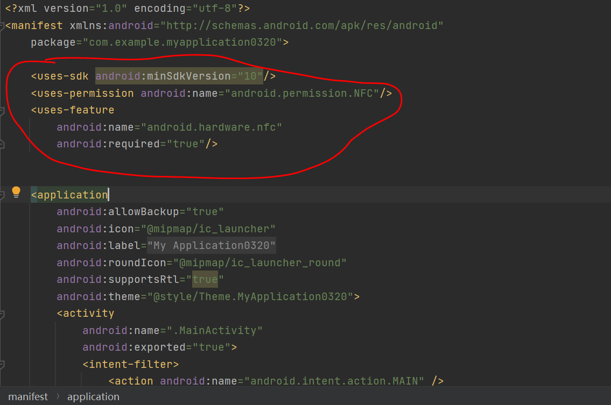

<uses-sdk android:minSdkVersion="10"/>  
<uses-permission android:name="android.permission.NFC"/>  
<uses-feature  
 android:name="android.hardware.nfc"  
 android:required="true"/>