1. **首先我们先进行程序运行后的设计，即主程序（MainActivity.java）和主程序页面(activity_main.xml)**

**Activity_main.xml的代码如下：**  
<?xml version="1.0" encoding="utf-8"?>

<LinearLayout xmlns:android="http://schemas.android.com/apk/res/android"

xmlns:app="http://schemas.android.com/apk/res-auto"

xmlns:tools="http://schemas.android.com/tools"

android:layout_width="match_parent"

android:layout_height="match_parent"

tools:context=".MainActivity"

android:orientation="vertical">

<LinearLayout

android:layout_width="match_parent"

android:layout_height="wrap_content"

android:orientation="horizontal">

<TextView

android:layout_width="0dp"

android:layout_height="wrap_content"

android:layout_weight="1"

android:gravity="center"

android:text="我喜欢"

android:textSize="35dp"/>

</LinearLayout>

<LinearLayout

android:layout_width="match_parent"

android:layout_height="wrap_content"

android:orientation="horizontal">

<TextView

android:id="@+id/menu1"

android:layout_width="0dp"

android:layout_height="wrap_content"

android:layout_weight="1"

android:gravity="center"

android:text="歌曲"

android:textSize="25dp"

/>

<TextView

android:id="@+id/menu2"

android:layout_width="0dp"

android:layout_height="wrap_content"

android:layout_weight="1"

android:gravity="center"

android:text="专辑"

android:textSize="25dp"

/>

</LinearLayout>

<FrameLayout

android:id="@+id/content"

android:layout_width="match_parent"

android:layout_height="0dp"

android:layout_weight="9">

</FrameLayout>

</LinearLayout>

**页面如下**

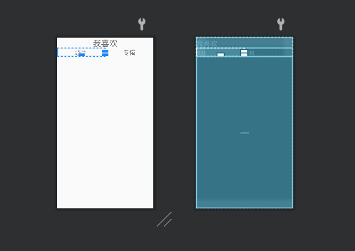

***其中我喜欢和专辑代表的是两个fragment，分别对应着frag1和frag2，点击“我喜欢”显示音乐列表，点击“专辑”显示专辑列表，程序运行后默认显示音乐列表***

**MainActivity.java的代码如下：**

package com.example.myapplication;

import androidx.annotation.NonNull;

import androidx.appcompat.app.AppCompatActivity;

import androidx.fragment.app.FragmentManager;

import androidx.fragment.app.FragmentTransaction;

import androidx.recyclerview.widget.LinearLayoutManager;

import androidx.recyclerview.widget.RecyclerView;

import androidx.recyclerview.widget.StaggeredGridLayoutManager;

import android.annotation.SuppressLint;

import android.content.Intent;

import android.graphics.Rect;

import android.nfc.NfcAdapter;

import android.os.Bundle;

import android.os.Handler;

import android.provider.ContactsContract;

import android.provider.Settings;

import android.view.View;

import android.view.ViewGroup;

import android.widget.Button;

import android.widget.ImageView;

import android.widget.TextView;

import android.widget.Toast;

import java.util.zip.Inflater;

public class MainActivity extends AppCompatActivity implements View.OnClickListener {

private TextView tv1,tv2;

private FragmentManager fm;

private FragmentTransaction ft;

@Override

protected void onCreate(Bundle savedInstanceState) {

super.onCreate(savedInstanceState);

setContentView(R.layout.activity_main);

//绑定控件

tv1=findViewById(R.id.menu1);

tv2=findViewById(R.id.menu2);

//设置监听器

tv1.setOnClickListener(this);

tv2.setOnClickListener(this);

//fm为Fragment的管理者，ft为其改变者

fm=getSupportFragmentManager();

//默认显示frag1

ft= fm.beginTransaction();

ft.replace(R.id.content,new frag1());

ft.commit();

}

@Override

public void onClick(View view) {

ft= fm.beginTransaction();

//切换

switch(view.getId()){

case R.id.menu1:

ft.replace(R.id.content,new frag1());

break;

case R.id.menu2:

ft.replace(R.id.content,new frag2());

break;

default:

break;

}

ft.commit();

}

}

1. **接下来我们进行frag1的设计，frag1显示音乐列表，并设置点击事件，点击歌曲后跳转到MusicActivity中播放该歌曲，与frag1对应的布局文件有music_list和item_layout, music_list获取音乐列表并让音乐垂直排列，item_layout让每首歌曲以图片、曲名的方式排列**

**music_list.xml的代码及页面如下：**

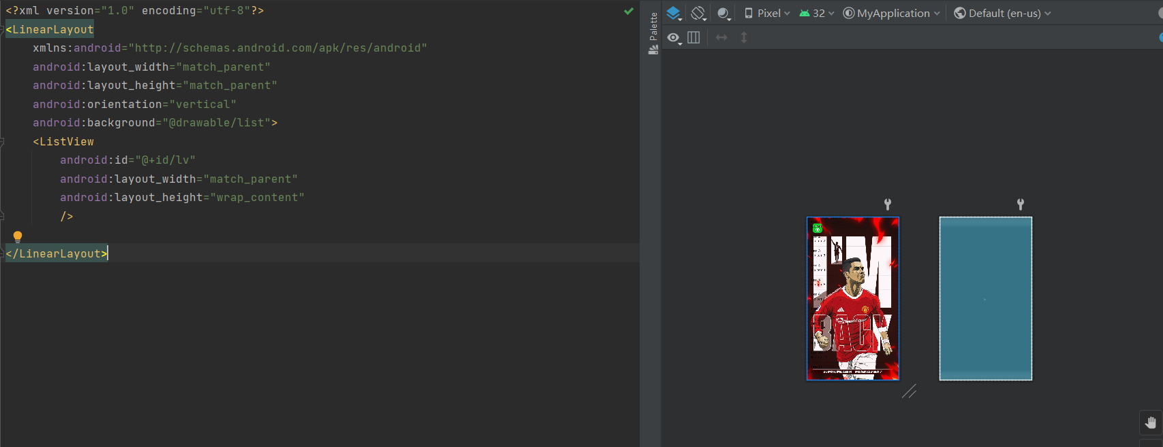

**item_layout.xml的代码及页面如下：**

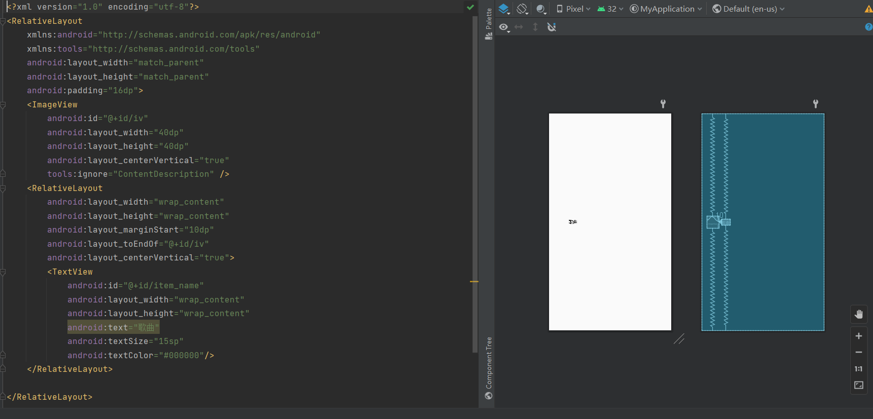

**Frag1.java的代码如下：**

package com.example.myapplication;

import android.annotation.SuppressLint;

import android.content.Intent;

import android.os.Bundle;

import android.view.LayoutInflater;

import android.view.View;

import android.view.ViewGroup;

import android.widget.AdapterView;

import android.widget.BaseAdapter;

import android.widget.ImageView;

import android.widget.ListView;

import android.widget.TextView;

import androidx.fragment.app.Fragment;

public class frag1 extends Fragment {

private View view;

//创建歌曲的String数组和歌手图片的int数组

public String[] name={"Two Steps From Hell _ Thomas Bergersen - Victory","Wiz Khalifa _ Charlie Puth - See You Again (feat_ Charlie Puth)","鹿先森乐队 - 春风十里"};

public static int[] icons={R.drawable.music0,R.drawable.music1,R.drawable.music2};

@Override

public View onCreateView(final LayoutInflater inflater,ViewGroup container,Bundle savedInstanceState){

//绑定布局

view= inflater.inflate(R.layout.music_list,null);

//创建listView列表并且绑定控件

ListView listView = view.findViewById(R.id.lv);

//实例化一个适配器

MyBaseAdapter adapter = new MyBaseAdapter();

listView.setAdapter(adapter);

//列表元素的点击监听器

listView.setOnItemClickListener(new AdapterView.OnItemClickListener() {

@Override

public void onItemClick(AdapterView<?> adapterView, View view, int position, long id) {

//创建Intent对象，参数从frag1跳转到MusicActivity

Intent intent = new Intent(frag1.this.getContext(),MusicActivity.class);

//将歌曲名和歌曲的下标存入Intent对象

intent.putExtra("name",name[position]);

intent.putExtra("position",String.valueOf(position));

//开始跳转

startActivity(intent);

}

});

return view;

}

//创建自定义适配器

class MyBaseAdapter extends BaseAdapter{

@Override

public int getCount() {

return name.length;

}

@Override

public Object getItem(int i) {

return name[i];

}

@Override

public long getItemId(int i) {

return i;

}

@Override

public View getView(int i, View convertView, ViewGroup parent) {

//绑定好VIew，然后绑定控件

@SuppressLint("ViewHolder") View view = View.inflate(frag1.this.getContext(),R.layout.item_layout,null);

TextView tv_name = view.findViewById(R.id.item_name);

ImageView iv=view.findViewById(R.id.iv);

tv_name.setText(name[i]);

iv.setImageResource(icons[i]);

return view;

}

}

}

1. **然后进行frag2的设计，与frag2对应的布局文件为frag2_layout.xml，里面放置专辑图片，也可以放置歌手信息等，可自由拓展**

**frag2_layout.xml的代码及页面如下：**

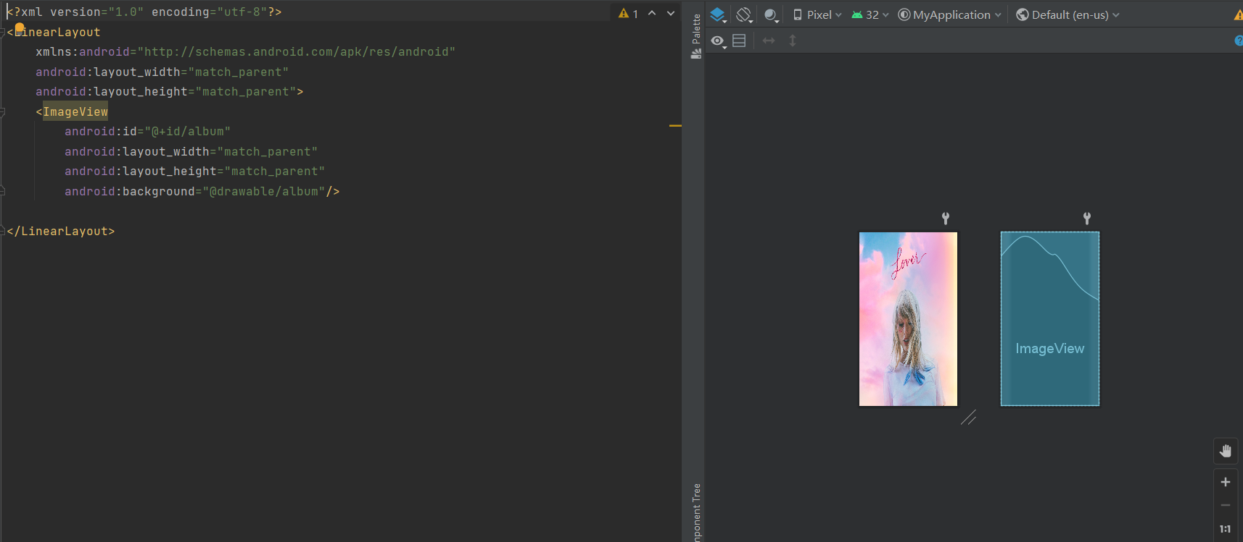

**Frag2.java的代码如下：**

ackage com.example.myapplication;

import android.os.Bundle;

import android.view.LayoutInflater;

import android.view.View;

import android.view.ViewGroup;

import androidx.core.app.BundleCompat;

import androidx.fragment.app.Fragment;

public class frag2 extends Fragment {

//创建一个View

private View album;

//显示布局

public View onCreateView(final LayoutInflater inflater, ViewGroup container, Bundle savedInstanceState){

album=inflater.inflate(R.layout.frag2_layout,null);

return album;

}

}

4 、**最后进行播放服务(MusicService.java)、播放页面（activity_music.xml）、播放程序（MusicActivity.java）的设计**

***播放页面含有背景图片、转动光盘、歌名、进度条、当前播放时长、总时长、上一首、暂停、播放、下一首、返回***

**activity_music.xml的代码如下：**

<?xml version="1.0" encoding="utf-8"?>

<LinearLayout

xmlns:android="http://schemas.android.com/apk/res/android"

xmlns:app="http://schemas.android.com/apk/res-auto"

xmlns:tools="http://schemas.android.com/tools"

android:layout_width="match_parent"

android:layout_height="match_parent"

android:background="@drawable/background"

tools:context=".MusicActivity"

android:gravity="center"

android:orientation="vertical">

<ImageView

android:id="@+id/iv_music"

android:layout_width="240dp"

android:layout_height="240dp"

android:layout_gravity="center_horizontal"

android:layout_margin="15dp"

android:src="@drawable/music0"/>

<TextView

android:id="@+id/song_name"

android:layout_width="wrap_content"

android:layout_height="wrap_content"

android:text="歌曲名"

android:textSize="20sp"

/>

<SeekBar

android:id="@+id/sb"

android:layout_width="match_parent"

android:layout_height="wrap_content"/>

<RelativeLayout

android:layout_width="match_parent"

android:layout_height="wrap_content"

android:paddingLeft="8dp"

android:paddingRight="8dp">

<TextView

android:id="@+id/tv_progress"

android:layout_width="wrap_content"

android:layout_height="wrap_content"

android:text="00:00" />

<TextView

android:id="@+id/tv_total"

android:layout_width="wrap_content"

android:layout_height="wrap_content"

android:layout_alignParentRight="true"

android:text="00:00" />

</RelativeLayout>

<RelativeLayout

android:layout_width="match_parent"

android:layout_height="wrap_content">

<Button

android:id="@+id/btn_continue_play"

android:layout_width="80dp"

android:layout_height="80dp"

android:layout_centerHorizontal="true"

android:background="@drawable/play"/>

<Button

android:id="@+id/btn_pause"

android:layout_width="80dp"

android:layout_height="80dp"

android:layout_centerHorizontal="true"

android:background="@drawable/pause" />

<Button

android:id="@+id/btn_play"

android:layout_width="80dp"

android:layout_height="80dp"

android:layout_centerHorizontal="true"

android:background="@drawable/play"/>

<Button

android:id="@+id/btn_last"

android:layout_width="60dp"

android:layout_height="60dp"

android:layout_centerVertical="true"

android:layout_marginRight="10dp"

android:layout_toLeftOf="@id/btn_play"

android:background="@drawable/last"/>

<Button

android:id="@+id/btn_next"

android:layout_width="60dp"

android:layout_height="60dp"

android:background="@drawable/next"

android:layout_centerVertical="true"

android:layout_marginLeft="10dp"

android:layout_toRightOf="@id/btn_play"

/>

<Button

android:id="@+id/btn_exit"

android:layout_width="60dp"

android:layout_height="60dp"

android:background="@drawable/exit"

android:layout_centerVertical="true"

android:layout_marginLeft="30dp"

android:layout_toRightOf="@id/btn_next"/>

</RelativeLayout>

</LinearLayout>

**页面如下：**

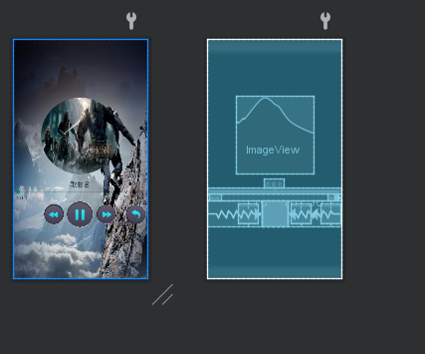

***播放服务中设置计时器、MusicControl***

**MusicService.java的代码如下：**

package com.example.myapplication;

import android.app.Service;

import android.content.Intent;

import android.media.MediaPlayer;

import android.net.Uri;

import android.os.Binder;

import android.os.Bundle;

import android.os.IBinder;

import android.os.Message;

import java.util.Timer;

import java.util.TimerTask;

public class MusicService extends Service {

//声明一个MediaPlayer引用

private MediaPlayer player;

//声明一个计时器

private Timer timer;

public MusicService() {

}

@Override

public IBinder onBind(Intent intent) {

// TODO: Return the communication channel to the service.

return new MusicControl();

}

@Override

public void onCreate(){

super.onCreate();

//创建音乐播放器对象

player=new MediaPlayer();

}

//添加计时器用于设置音乐播放器中的播放进度条

public void addTimer(){

//如果计时器不存在，也就是没有引用实例

if (timer==null){

//创建计时器对象

timer=new Timer();

TimerTask task=new TimerTask() {

@Override

public void run() {

if (player==null)

return;

else {

//获取歌曲总时长

int duration = player.getDuration();

//获取歌曲当前播放时长

int currentPosition = player.getCurrentPosition();

//创建消息对象

Message message = MusicActivity.handler.obtainMessage();

//将音乐总时长和播放进度封装至bundle中

Bundle bundle = new Bundle();

bundle.putInt("duration",duration);

bundle.putInt("currentPosition",currentPosition);

//再将bundle封装到message消息对象中

message.setData(bundle);

MusicActivity.handler.sendMessage(message);

}

}

};

//开始即使任务后的5毫秒，第一次执行task任务，以后1000毫秒（1s）执行一次

timer.schedule(task,5,1000);

}

}

//创建一个内部类MusicControl，功能是让主程序控制service里面的多媒体对象。IBinder 是Binder的子类，因此要返回MusicControl给IBinder。

class MusicControl extends Binder{

public void play(int i){

//下面这步有点奇怪

Uri uri =Uri.parse("android.resource://"+getPackageName()+"/raw/"+"music"+i);

try {

//重置音乐播放器

player.reset();

//加载多媒体文件

player=MediaPlayer.create(getApplicationContext(),uri);

//播放音乐

player.start();

//添加计时器

addTimer();

}catch (Exception exception){

exception.printStackTrace();

}

}

//暂停播放音乐

public void pausePlay(){

player.pause();

}

//继续播放音乐

public void continuePlay(){

player.start();

}

//设置音乐播放位置

public void seekTo(int progress){

player.seekTo(progress);

}

}

//停止播放并销毁

@Override

public void onDestroy(){

super.onDestroy();

if (player==null){

return;

}

if (player.isPlaying()){

player.stop();//停止播放音乐

}

player.release();//释放占用资源

player=null;

try {

timer.cancel();//计时器归零

}catch (Exception exception){

exception.printStackTrace();

}

}

}

***播放程序中设置按钮点击事件、光盘转动事件、进度条监听事件和服务连接事件***

**MusicActivity.java的代码如下：**

package com.example.myapplication;

import static java.lang.Integer.min;

import static java.lang.Integer.parseInt;

import androidx.annotation.NonNull;

import androidx.annotation.RequiresApi;

import androidx.appcompat.app.AppCompatActivity;

import android.animation.ObjectAnimator;

import android.content.ComponentName;

import android.content.Intent;

import android.content.ServiceConnection;

import android.os.Build;

import android.os.Bundle;

import android.os.Handler;

import android.os.IBinder;

import android.os.Looper;

import android.os.Message;

import android.view.View;

import android.view.animation.LinearInterpolator;

import android.widget.Button;

import android.widget.ImageView;

import android.widget.SeekBar;

import android.widget.TextView;

@RequiresApi(api = Build.VERSION_CODES.KITKAT)

public class MusicActivity extends AppCompatActivity implements View.OnClickListener{

//定义歌名名称的数组

public String[] musicName={"Two Steps From Hell _ Thomas Bergersen - Victory","Wiz Khalifa _ Charlie Puth - See You Again (feat_ Charlie Puth)",

"鹿先森乐队 - 春风十里"};

private static SeekBar sb;//定义进度条

//定义开始和总时长，歌名

private static TextView tv_progress,tv_total,name_song;

//定义旋转的动画

private ObjectAnimator animator;

//声明MusicService中的音乐控制器

private MusicService.MusicControl musicControl;

//定义各个按钮

private Button play;

private Button pause;

private Button continue_play;

private Button last;

private Button next;

private Button exit;

private ImageView iv_music;//定义歌曲图片框

Intent intent1,intent2;//定义两个意图

MyServiceConn myServiceConn;

private boolean isUnbind = false;//记录服务器是否被解绑

public int change = 0;//记录下标的变化值，便于之后的上一首下一首操作

@Override

protected void onCreate(Bundle savedInstanceState) {

super.onCreate(savedInstanceState);

setContentView(R.layout.activity_music);

//获得意图

intent1 = getIntent();

//初始化控件

init();

}

private void init(){

//依次绑定控件

tv_progress=findViewById(R.id.tv_progress);

tv_total=findViewById(R.id.tv_total);

sb=findViewById(R.id.sb);

name_song=findViewById(R.id.song_name);

iv_music=findViewById(R.id.iv_music);

play=findViewById(R.id.btn_play);

pause=findViewById(R.id.btn_pause);

continue_play=findViewById(R.id.btn_continue_play);

last=findViewById(R.id.btn_last);

next=findViewById(R.id.btn_next);

exit=findViewById(R.id.btn_exit);

//设置监听事件

play.setOnClickListener(this);

pause.setOnClickListener(this);

continue_play.setOnClickListener(this);

last.setOnClickListener(this);

next.setOnClickListener(this);

exit.setOnClickListener(this);

//创建意图对象

intent2=new Intent(this,MusicService.class);

myServiceConn=new MyServiceConn();//创建服务连接对象

bindService(intent2,myServiceConn,BIND_AUTO_CREATE);//绑定服务

//从歌曲列表传过来的歌曲名

String name = intent1.getStringExtra("name");

//设置歌曲显示

name_song.setText(name);

//定义歌曲列表传过来的下标position

String position = intent1.getStringExtra("position");

//将字符串转化为整形i

int i =parseInt(position);

//图像框设置为frag1里面的图标数组，下标为i

iv_music.setImageResource(frag1.icons[i]);

//为滑动条设置监听事件

sb.setOnSeekBarChangeListener(new SeekBar.OnSeekBarChangeListener() {

@RequiresApi(api = Build.VERSION_CODES.KITKAT)

@Override

public void onProgressChanged(SeekBar seekBar, int progress, boolean fromUser) {

//当滑动条滑到末端时，自动播放下一首

if(progress==seekBar.getMax()){

change++;//自动下一首，下标加一

String position = intent1.getStringExtra("position");

int nowPosition = (parseInt(position)+change)% musicName.length;//当前歌曲下标

iv_music.setImageResource(frag1.icons[nowPosition]);//切换到nowPosition这首歌的封面

name_song.setText(musicName[nowPosition]);//切换到nowPosition这首歌的歌名

musicControl.play(nowPosition);//播放nowPosition这首歌

musicControl.seekTo(0);//重置播放进度

//pause.setVisibility(View.VISIBLE);

}

}

@Override

public void onStartTrackingTouch(SeekBar seekBar) {//滑动条开始滑动时调用

musicControl.pausePlay();

animator.pause();

}

@Override

public void onStopTrackingTouch(SeekBar seekBar) {//滑动条停止滑动时调用

//根据滑动条的进度改变音乐播放进度

int progress = seekBar.getProgress();

//切换到当前播放进度

musicControl.seekTo(progress);

musicControl.continuePlay();

animator.resume();

}

});

//执行动画的对象是iv_music，// 动画效果是0-360°旋转（用的是浮点数，所以加个f）。

animator=ObjectAnimator.ofFloat(iv_music,"rotation",0.0f,360.0f);

animator.setDuration(10000);//动画旋转一周的时间为10000毫秒

animator.setInterpolator(new LinearInterpolator());//匀速转动

animator.setRepeatCount(-1);//无限循环

}

//Handler主要用于异步消息的处理，在这里是处理子线程MusicService传来的消息

public static Handler handler = new Handler(Looper.getMainLooper()){

//从主线程中处理从子进程发送过来的消息

@Override

public void handleMessage(@NonNull Message message){

//获取从子线程中发送过来的音乐播放进度

Bundle bundle = message.getData();

int duration = bundle.getInt("duration");

int currentPosition = bundle.getInt("currentPosition");

sb.setMax(duration);

sb.setProgress(currentPosition);

//歌曲总时长，单位为毫秒

int minute=duration/1000/60;

int second=duration/1000%60;

String strMinute=null;

String strSecond=null;

if (minute<10){

strMinute="0"+minute;

}

else {

strMinute=minute+"";

}

if (second<10){

strSecond="0"+second;

}

else {

strSecond=second+"";

}

tv_total.setText(strMinute+":"+strSecond);

//歌曲当前播放时长

minute = currentPosition / 1000 /60;

second = currentPosition / 1000 % 60;

if (minute<10){

strMinute="0"+minute;

}

else {

strMinute=minute+"";

}

if (second<10){

strSecond="0"+second;

}

else {

strSecond=second+"";

}

tv_progress.setText(strMinute+":"+strSecond);

}

};

//设置点击事件

@RequiresApi(api = Build.VERSION_CODES.KITKAT)//迷惑

@Override

public void onClick(View view) {

String position = intent1.getStringExtra("position");

//将字符串转为整数

int i=parseInt(position);

switch(view.getId()){

case R.id.btn_play:

play.setVisibility(View.INVISIBLE);

pause.setVisibility(View.VISIBLE);

continue_play.setVisibility(View.INVISIBLE);

musicControl.play(i);

animator.start();

break;

case R.id.btn_last:

if ((i+change)<1){

change= musicName.length-1-i;

musicControl.play(i+change);

iv_music.setImageResource(frag1.icons[i+change]);

name_song.setText(musicName[i+change]);

play.setVisibility(View.INVISIBLE);

pause.setVisibility(View.VISIBLE);

continue_play.setVisibility(View.INVISIBLE);

animator.start();

break;

}

else{

change--;

musicControl.play(i+change);

iv_music.setImageResource(frag1.icons[i+change]);

name_song.setText(musicName[i+change]);

play.setVisibility(View.INVISIBLE);

pause.setVisibility(View.VISIBLE);

continue_play.setVisibility(View.INVISIBLE);

animator.start();

break;

}

case R.id.btn_next:

if ((i+change)== musicName.length-1){

change=-i;

musicControl.play(i+change);

iv_music.setImageResource(frag1.icons[i+change]);

name_song.setText(musicName[i+change]);

play.setVisibility(View.INVISIBLE);

pause.setVisibility(View.VISIBLE);

continue_play.setVisibility(View.INVISIBLE);

animator.start();

break;

}

else{

change++;

iv_music.setImageResource(frag1.icons[i+change]);

name_song.setText(musicName[i+change]);

musicControl.play(i+change);

play.setVisibility(View.INVISIBLE);

pause.setVisibility(View.VISIBLE);

continue_play.setVisibility(View.INVISIBLE);

animator.start();

break;

}

case R.id.btn_pause:

pause.setVisibility(View.INVISIBLE);

continue_play.setVisibility(View.VISIBLE);

play.setVisibility(View.INVISIBLE);

musicControl.pausePlay();

animator.pause();

break;

case R.id.btn_continue_play:

play.setVisibility(View.INVISIBLE);

continue_play.setVisibility(View.INVISIBLE);

pause.setVisibility(View.VISIBLE);

musicControl.continuePlay();

animator.resume();

break;

case R.id.btn_exit:

unbind(isUnbind);

isUnbind=true;

finish();

break;

}

}

//用于实现连接服务

class MyServiceConn implements ServiceConnection{

@Override

public void onServiceConnected(ComponentName componentName, IBinder service) {

musicControl=(MusicService.MusicControl) service;

}

@Override

public void onServiceDisconnected(ComponentName componentName) {

}

}

//未解绑则解绑

private void unbind(boolean isUnbind){

if (!isUnbind){

musicControl.pausePlay();

unbindService(myServiceConn);//解绑服务

}

}

@Override

protected void onDestroy(){

super.onDestroy();

unbind(isUnbind);//解绑服务

}

}

运行结果将会在录制的视频中呈现，视频为下一个附件