**CS673S16 Software Engineering** 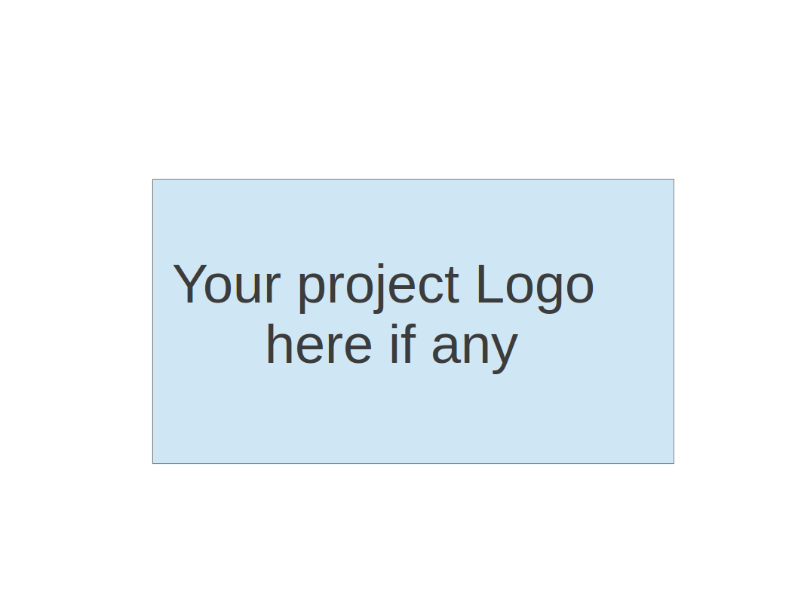

**Team 1 - Project Name**

**Tests Report**

|  |  |  |  |
| --- | --- | --- | --- |
| Team Member | Role(s) | Signature | Date |
| Baoxiang Yang | Team Leader | *Baoxiang YANG* | 12/01/2017 |
| Haotian Wu | Requirement Leader | *Haotian Wu* | 12/01/2017 |
| Shuhan Liu | QA Leader | *Shuhan Liu* | 12/01/2017 |
| Lei Yang | Implementation Leader | *Lei Yang* | 12/01/2017 |
| Qiwei Zheng | Environment and Integration Leader | *QZ* | 12/01/2017 |
| Linlan Chen | Configuration Leader | *Linlan Chen* | 12/01/2017 |
|  |  |  |  |
|  |  |  |  |

**Revision history**

|  |  |  |  |
| --- | --- | --- | --- |
| **Version** | **Author** | **Date** | **Change** |
| **1.0** | **Linlan** |  | **draft** |
| **2.0** | **Linlan** | **2017.12.08** | **Add test report table** |

Introduction

Test Summary

Tests Reports

Testing Metrics

References

Glossary

# Introduction

The reports will introduce the testing part of our project in three aspects: test summary, test reports and testing metrics. Test summary briefly talks about the tests we applied to make sure our game work correctly and reasonably based on each test type. Tests reports shows the detailed description of each test case performed and the result. Test metrics includes the metrics we used for evaluation.

# Test Summary

In this section, you will summarize what was tested and what happened, based on each test type.

**Unit Tests**

We have four main scripts for logic control and we employ TDD to complete these scripts, the following are the unit tests and we have passed all of them.

* Shell explosion
  + CalculateDistanceTest:

This unit test is to make sure the system can calculate the distance between any two objects correctly, such as between two tanks or between the center of an explosion and the tank being attacked.

* DestroyTest:

To make sure the shell will be destroyed once hit something or achieved its max lifetime.

* CalculateDamageTest:

This unit test is to make sure the system can calculate the damage caused by the shell correctly.

* Tank Shooting
  + FiredTest:

To make sure we present the fire status correctly.

* + CalculateLauchForceTest：

This unit test is to make sure the user can charge force to the shell correctly corresponding to the button pressing duration.

* Tank Health
  + TakeDamageTest:

This unit test is to make sure the the health point of a tank respond correctly to shells.

* + TankDeathTest

This unit test is to make sure the tank shows it status correctly for the system to manage the game.

* Tank Movement
  + MoveForwardTest:

To make sure the position is calculated correctly when we move the tank forward. The position is presented by a 3D vector.

* MoveBackwardTest:

To make sure the position is calculated correctly when we move the tank backward. The position is presented by a 3D vector.

* CombineMoveTest:

To make sure the tank can combine moving forward and backward correctly.

* TurnLeftTest:

To make sure the tank can turn to left side successfully. We use quaternion to present the direction of the tank.

* TurnRightTest:

To make sure the tank can turn to right side successfully. We use quaternion to present the direction of the tank.

* CombineTurnTest:

To make sure the tank can combine turn to every directions correctly.

* CombinedMovementTest:

To make sure the combination of the movements above works well.

**Results:**Current version has passed all the 14 unit tests.

**System Tests**

Tests of functional requirements:

1. Start game with another player on the same screen.
2. Each player can pause, restart or quit the game during the game.
3. The two players can choose one map out of three.
4. Both of the players can make the tank move left, right, up or down.
5. Let the tank shoot shell and if a shell hits a tank, tank will lose HP.
6. Tank has HP and game will be over if one tank loses all HP.
7. Tank will have areas(mountains, etc) where cannot move through.
8. Can destroy some objects(walls, hills, etc) on the map by shooting shell.
9. The explosion of map destruction deals damage to tank.

Tests of non-functional requirements:

1. There should be a easy understand menu for users with no more than 5 buttons.
2. The tank should be able to turn around in 6 seconds to make give the user a smooth game experience.
3. To make sure map size is reasonable, the tank should be able to move across the tank within 20 seconds.
4. Detailed game instructions.

**Results**: According to our beta testing, our game passed all the system tests.

**Acceptance Tests**

1. Given the shell is fired out of a tank, when its max lifetime but still not hit anything, it should explode automatically.
2. Given the user is charge force of the shell, when the user release the "fire" button, the longer he pressed the fire button, the stronger the force will be, unless it reaches the maximum force.
3. Given a tank is inside a shell's explosion radius, when the shell explodes, the closer it's to the shell, the more damage it will suffer.
4. Given a tank is death, when the other tank want to deal damage to it, there will be no more hp loss.
5. Given a shell is fired, when it hits something, it should explode immediately.
6. Given a player is controlling a tank, when he press and release the "fire" button, a shell should be fired.
7. Given the tank is moving on the map, when it meets terrain, it should not be able to move through.
8. Given the tank has go through continuous collisions, when it meets collider again, it will not move through the collider.
9. Given tank A is firing tank B, when A's shell hits B or B is within the shell's explosion radius, there should be a hp loss of B.
10. Given tank B is attacked by two shells, when they explode together, the closer shell should cause more damage.
11. Given tank A is being attacked, when its health point is down to 0, then it loses current round.
12. Given a player is controlling a tank, when the tank fire, then the shell will not explode inside its own collider.
13. Given the first round, two tanks are initiated at two separate point.
14. Given an ended round, when the new round restart, two tanks will be reset to the same point as the first round no matter where the tanks are in the last ended round.
15. Given a new round, the text will becomes "Round <number>" and will disappear in seconds.
16. Given an ended round, the text will becomes "Win" or "Lose" or "Draw" depends on the results and disappear in seconds.
17. Given an ended game, the text will becomes "Win the game" or "Lose the game" depends on the results and disappear in seconds.
18. Given an round, when one player lose a round, current round ends, a new round will start and tanks will be reset.
19. Given a game, when player A win more rounds than player B, game ends. Message will show player A win the game.
20. Given a round, player A and player B uses different keys to control the tanks.
21. Given a round, player A and player B will know which tank is whose.
22. Given the player is moving the tank, when he wants to move the tank out of our designed border, the tank will stop.
23. Given the player is moving the tank, when he wants to turn the tank which can cause the tank body out of our designed border, the tank will stop.
24. Given the tanks' current health point is not full, when the tank picks up the hp package on floor, its health point increases.
25. When loaded into the game, it shows a map-selection menu.
26. When clicked on one of the maps on the menu, it successfully logged into the exact map.
27. Given the tanks' current health point is not full, when the tank picks up the hp package on floor, its health point increases.
28. Given a player is playing the game, he can see his own health point on an up corner of the window and can see his enemy's at the another up corner.
29. Given two players are playing the game, when the health point presents, two sliders should in different color.
30. Given there is a health point slider to show the tank's status, when the tank is being attacked, the slider should change according to the health point change.
31. Given the current health point of a tank goes down to 0, the tank can be destroyed.
32. Given the player is using the forest map, he should be able to move around.
33. Given the player is using the forest map, when he want to move through the restricted areas or across borders, the tank should be stopped.
34. Given the player is using the forest map, when he want to attack another tank, he should be able to deal damage to another tank and suffer the damage from others.
35. Given player A is controlling tank 1 and player B is controlling tank 2, when B press "fire" button, tank 2 should be able to fire a shell.
36. Given two players are playing the game, when the health point of two tanks changes, the health point should not be shown in rectangle.
37. Given the player is using the city view map, he should be able to move around.
38. Given the player is using the city view map, when he want to move through the restricted areas or across borders, the tank should be stopped.
39. Given the player is using the city view map, when he want to attack another tank, he should be able to deal damage to another tank and suffer the damage from others.
40. When I killed an enemy tank, my score increased by 1.
41. When I was killed by an enemy tank, enemy's score increased by 1.
42. When user pause the game and click the quit button, the game should go back to the menu.
43. When user quit the game and start the game again, everything should be reset, such the score, HP, etc.
44. Given two players are playing the tank game, when one player press/click the pause button, both of them will not be able to control their tank any more.
45. Given a current running game round, 2 players with different scores, say one with 2 points and another with 3 points. When one of the player pause the game and click restart game button. Then the game starts again and both players should have 0 points.
46. Given a current running game round, 2 tanks have different HP, say one with 60 HP out of 100 and another with 50 HP out of 100. When one of the player pause the game and click restart game button. Then the game starts again and both tank should have 100 HP.
47. Given a pause menu, there will be 3 buttons including "Resume", "Restart" and "Quit". When player click resume, both players will be able to control the tank again and the menu will disappear. When player click restart, the health and score of each player will be reset. When player click quit, the game will go back to the main menu.
48. Given a current running game round, a map with some small objects that can be destroyed, 2 tanks. When tank fires shell towards one of the objects, then the object will disappear (be destroyed).
49. Given a current running game round, the objects that has been destroyed in previous round will not show up in current round.

**Results:** Current version has passed all the acceptance tests.

# Tests Reports

In this section, you will give a detailed description of each test case performed and the result. You shall list what are existing tests developed in the previous semester and what are new tests developed currently.

For each test case, you can use the following template (or something based on the following template)

* Test case ID, name
* New or old:
* Test items: (what do you test )
* Test priority (high/medium/low)
* Dependencies (to other test case/requirement if any):
* Preconditions: (if any)
* input data:
* Test steps:
* Postconditions:
* Expected output:
* Actual output:
* Pass or Fail:
* Bug id/link: (this should link to your github issue id)
* Additional notes:

(You can use an additional table or document for this section)

The link of the additional table:

<https://docs.google.com/spreadsheets/d/1GOkRaM5rHdsXUsMfPd0lxiCOS2TxOYCXHYhtnN-FgHI/edit#gid=0>

# Testing Metrics

In this section, you shall report the any metrics used for the evaluation, e.g. coverage, defects rate, etc.

**Coverage:**

|  |  |
| --- | --- |
| Instruction Coverage | 93.8% |
| Branch Coverage | 100% |
| Line Coverage | 93% |

**Test Pass Rate:**

|  |  |
| --- | --- |
| Unit test | 100% |
| System test | 100% |
| Acceptance test | 100% |

**Defects rate:**

In 35 test cases listed, 7 of them failed at first. The defects rate is around 20%. But now all the bugs have been fixed.

# References

# Glossary