# ****About Crucible****

Atlassian Crucible is the on-premises code review solution for enterprise teams. It allows your development teams to catch major defects, improve code architecture, and discuss desired improvements, without the need for meetings.

## **1.1 Role**

Crucible is a flexible application that caters for a wide range of team sizes and work styles. You will need to know about the basic roles used in Crucible:

* [Authors](https://confluence.atlassian.com/crucible045/authors-in-crucible-947848643.html): Usually the creator of the code; the person who will act on the review's outcome.
* [Reviewer](https://confluence.atlassian.com/crucible045/reviewer-947848656.html): A participant that will comment on the source files in the review, raising points and discussion on the work that was done.
* [Moderator](https://confluence.atlassian.com/crucible045/moderator-947848648.html): Usually the person who starts the review and is responsible for deciding the outcomes and closing it. The moderator is disabled for the "agile" permission scheme to simplify workflow.

## **1.2 Crucible Workflow**

There are a number of different ways in which you can use Crucible for code reviews. The following diagram shows the basic workflow that applies to most Crucible code reviews.

#### Lightweight code commenting with Crucible (individual)

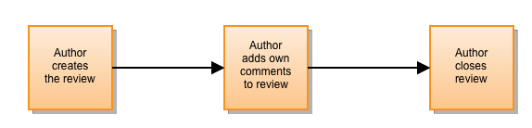

#### One-to-many reviews without a moderator (Agile team)

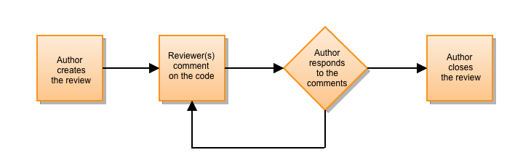

#### Formal group reviews (CMM team)

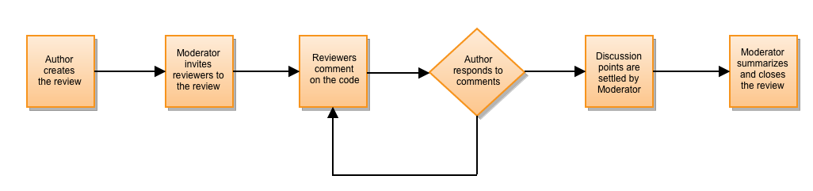

# ****2. Use Jira and Crucible for code review (*****One-to-many reviews without a moderator*****)****

## **2.1 Create review, code review and close review**

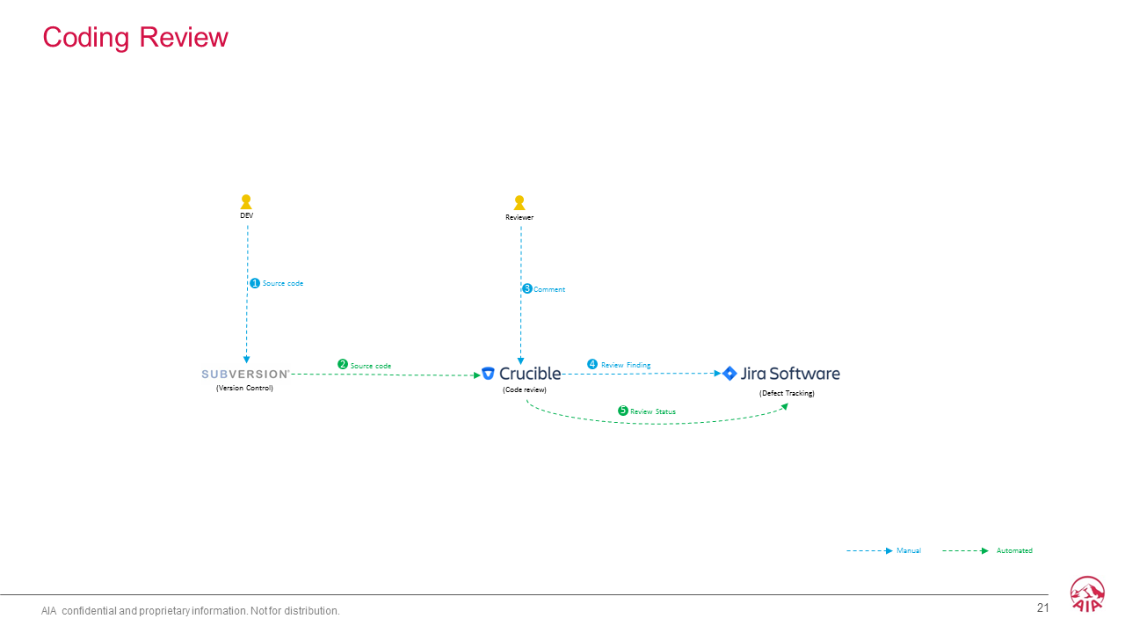

### **2.1.1 Commit code with Jira number**

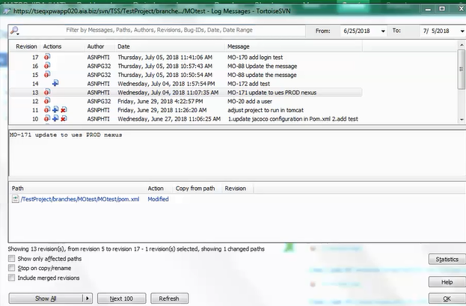

### **2.1.2 Change issue status to review, then create crucible review from Jira**

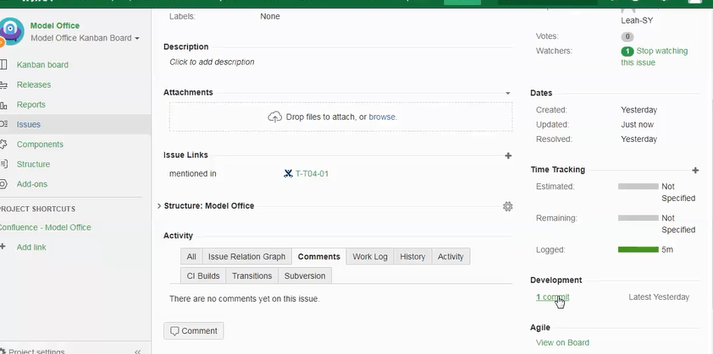

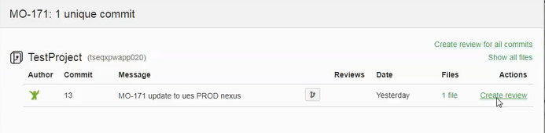

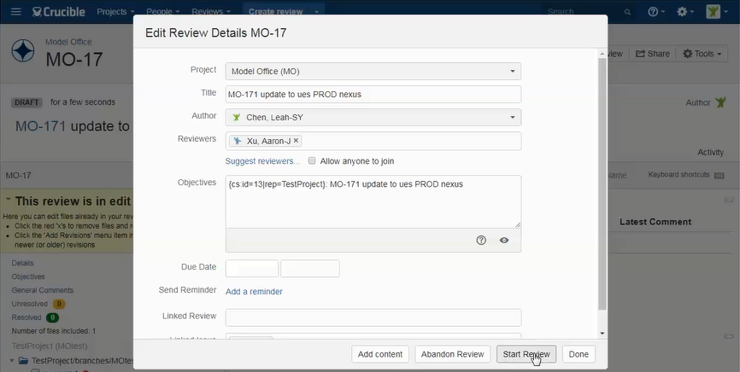

### **Create Jira issue from Crucible**

#### Add comments as a defect

**Hook the Defect check box 🡪 select Ranking and Classification 🡪 click the comment button to finish create issue**

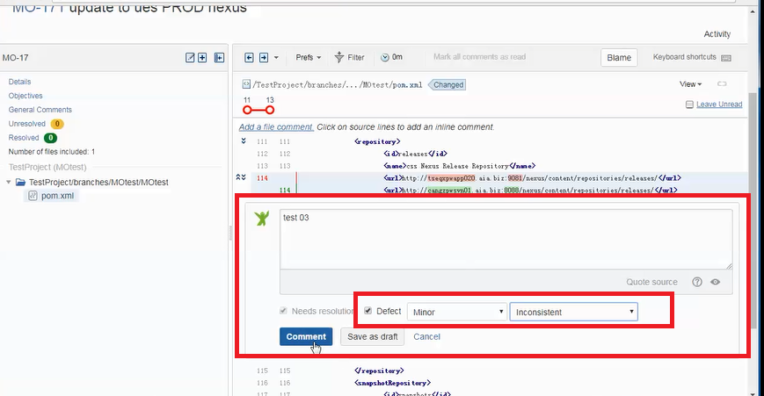

#### Create Jira issues from the review

**Inline issue creation allows:**

Tracking of the status of the comment

A faster way to pull out incidental suggestions raised in reviews as Jira Software issues

A quick link back to the comment from the Jira Software issue, using Remote Issue Links.

**You might find this useful when:**

1. Tracking the status of a review:

a. The 'Issues Raised from Comments' section in the review shows the open/closed status of related issues.

b. Raising related issues enforces dealing with subtasks before the review can be closed.

2. Closing off a review:

a. You can create Jira Software issues, unrelated to the current review, to track matters to be dealt with later.

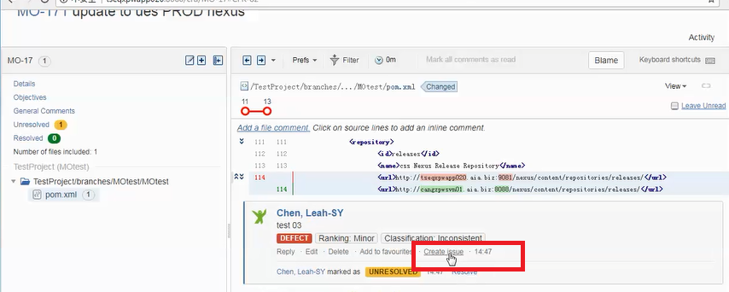

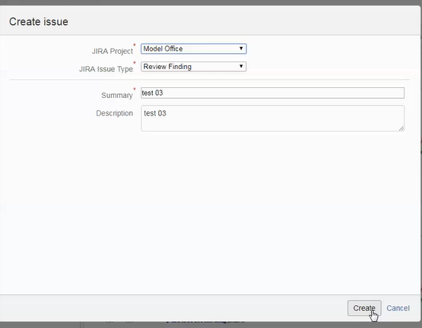

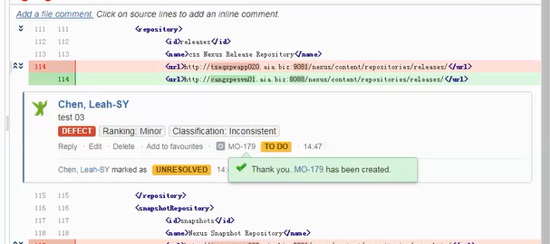

#### **You can also add a general comments and create issue**

Steps: Click on the Details link to the right, and like the steps above, after click the Comment button, you can create issue.

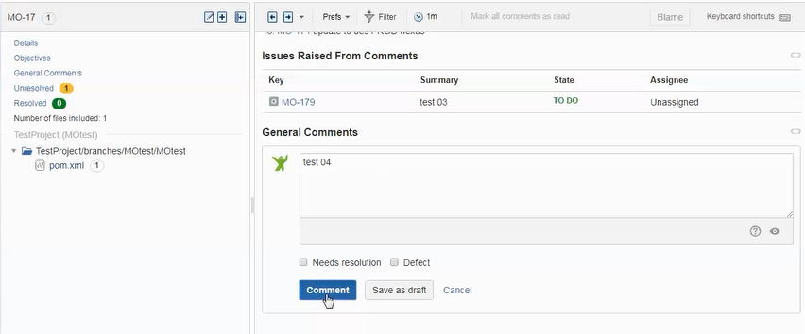

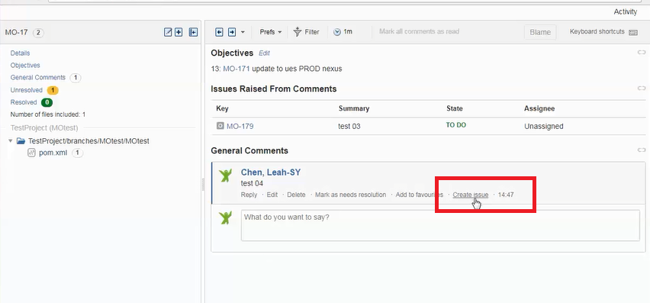

### **2.1.4 Change the defect comment to resolve when finished**

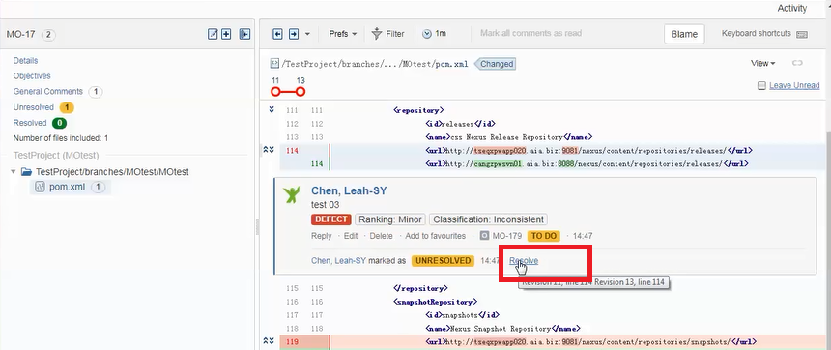

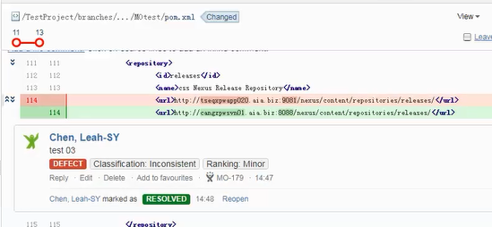

### **2.1.5 Close the review and update Jira issue status**

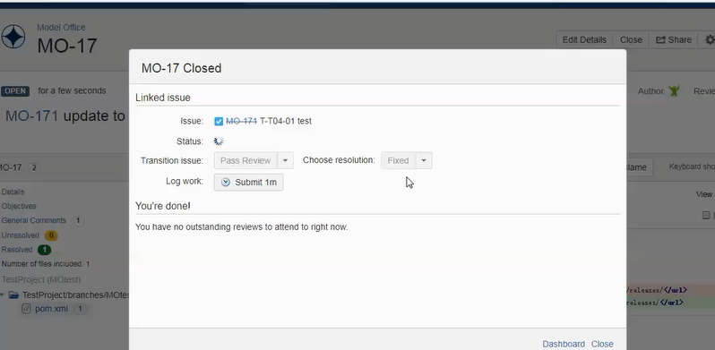

Issue status has been updated to DONE

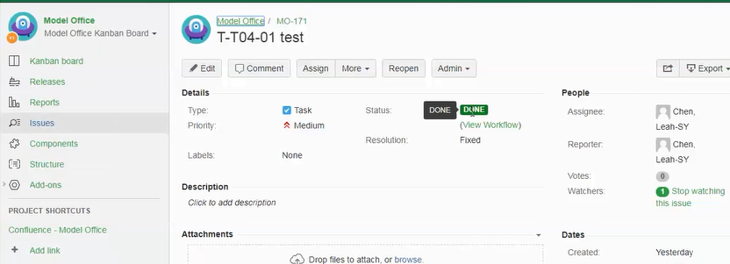

## 2.2 Trace review finding

### **2.2.1 Create review after code commit**

Steps: In issue page, click commit, then create review and choose reviewer

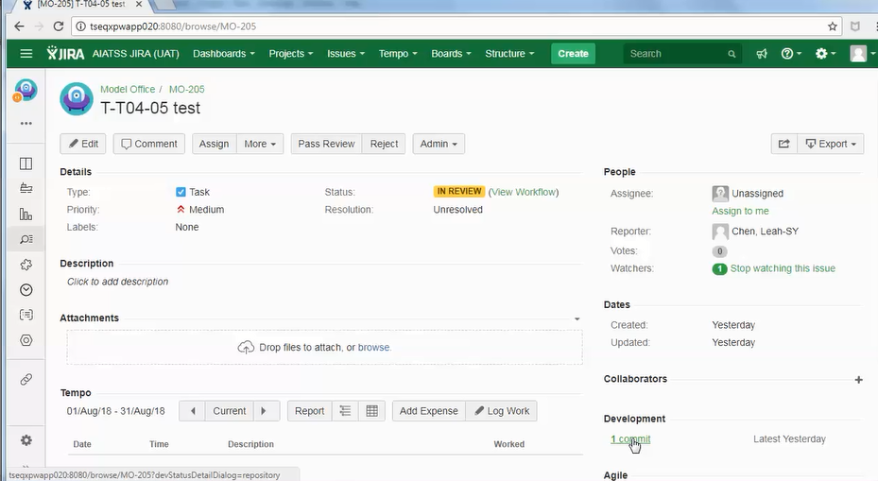

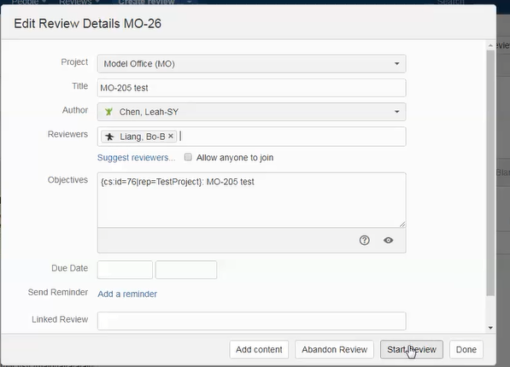

### **2.2.2 Create new Jira issue as defect when review and find defect**

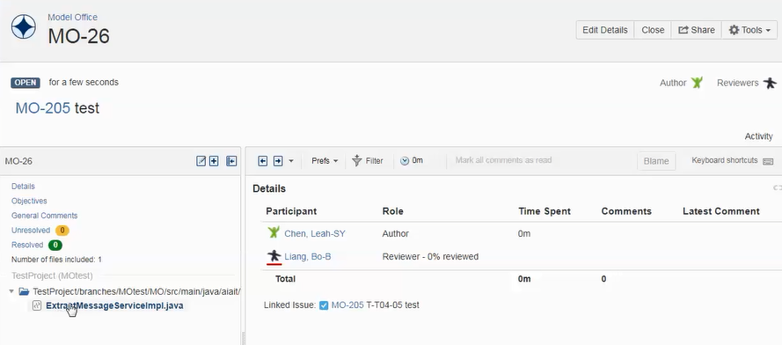

**Hook the Defect check box 🡪 select Ranking and Classification 🡪 click the comment button to finish create issue**

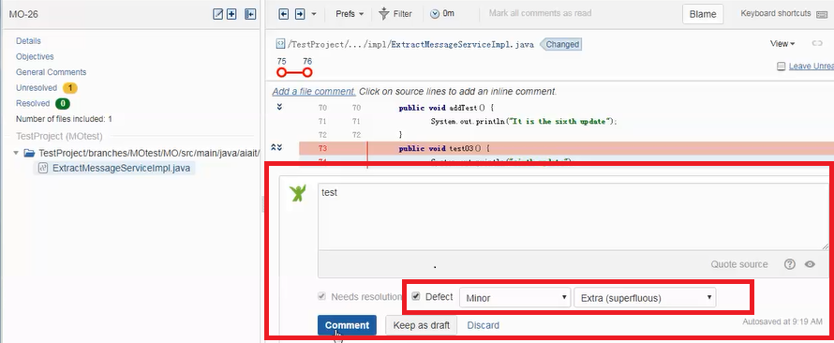

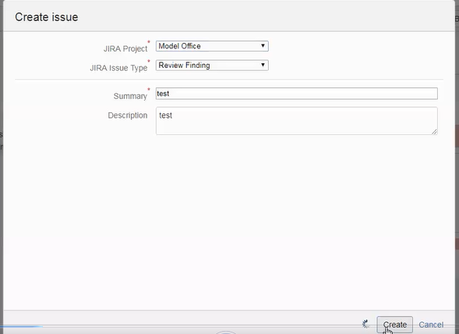

A new Jira issue has been created success when you see page like below

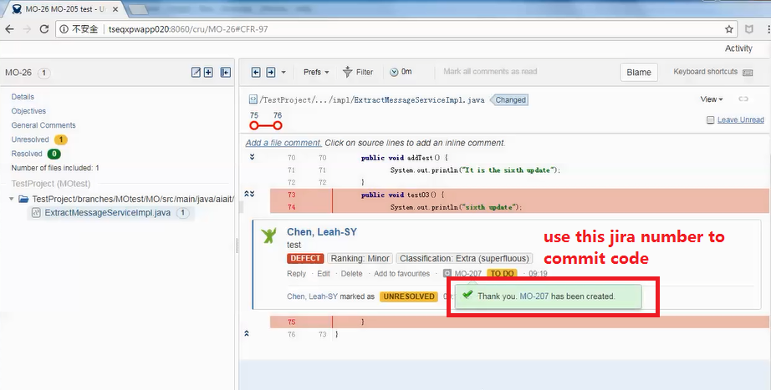

### **2.2.3 Commit code with Jira number of defect**

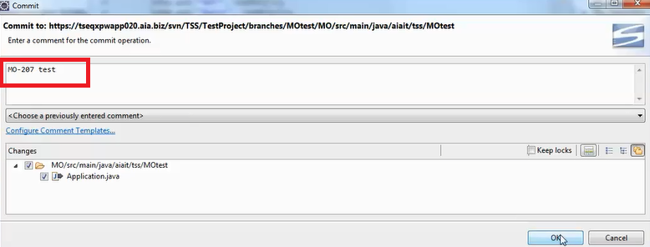

### **2.2.4 Add review content by filter of the Jira number**

Click the add icon

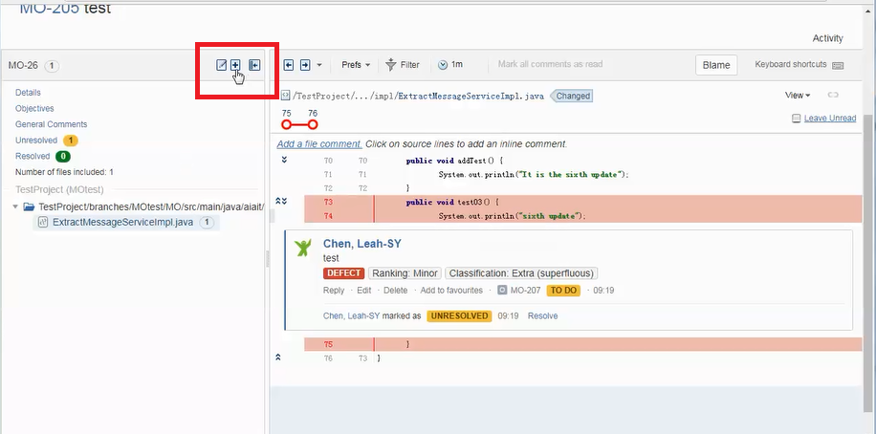

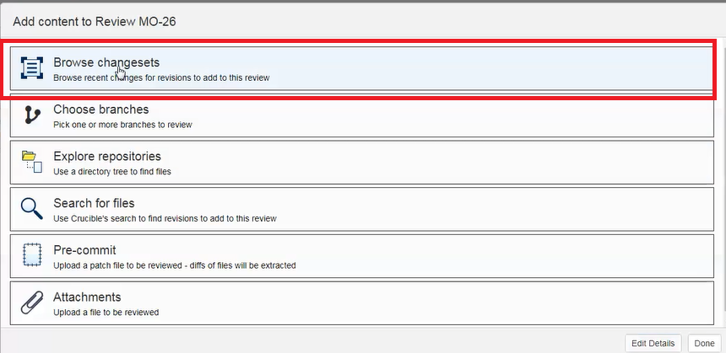

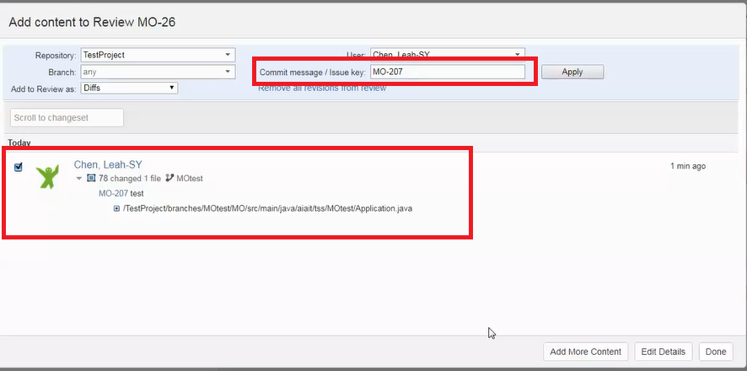

### **2.2.5 From Jira issue link to review**

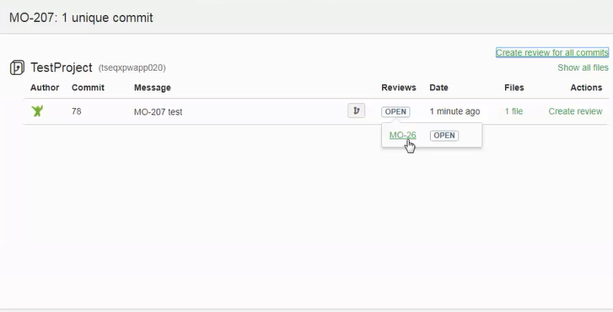

# 3. Detail demo video link

Please refer to [http://tseqxpwapp040:8090/display/SSIC#ModelOffice-CodeReview](http://tseqxpwapp040:8090/display/SSIC%23ModelOffice-CodeReview%20)