Advanced Aquatic Ecology

University of Wyoming

ZP Course 5620

Post-Doc Instructors: Bella Oleksy, Carol Barbosa, Matt Dunkle, Ben Tumolo

11-14 April 2023

**General Course Links:**

* Reading Materials and Supplementary Resourcves
  + <https://docs.google.com/document/d/1v7tHKSFxVOkwxROz1_vVzSPWp8l2ETRL9mCa4jumNZo/edit#heading=h.6lsss7nwls0z>
* Course Overview
  + <https://docs.google.com/document/d/1phyqjSzYnt6YqRoB_BDkfwmjXiwyoRNDC-my6MMOJQU/edit>
* Jam Board link
  + <https://jamboard.google.com/d/1z9uuYR48SfabCsr88zmWqhxgVDEQCenV0xiMlcPgpd8/viewer?f=0>

**Project Inspired by Oleksy et al (2022)**

[**https://github.com/bellaoleksy/rocky-mtn-color**](https://github.com/bellaoleksy/rocky-mtn-color)

**Publication:** [**https://iopscience.iop.org/article/10.1088/1748-9326/ac939c/pdf**](https://iopscience.iop.org/article/10.1088/1748-9326/ac939c/pdf) **Project GitHub: LakeColor_SpatTem**

[**https://github.com/LinneaRock/LakeColor_SpatTem**](https://github.com/LinneaRock/LakeColor_SpatTem)

**Notes for Group Presentation**

**14 April 2023**

**Workflow**

1. Discussed what data was available that we thought was feasible to collect and analyze
   1. Inspired by *Oleksy et al (2022)*
2. Determined that we were interested in two questions looking at lakes less than 10 ha
   1. Temporal question – how lakes change color
   2. Spatial color – how changing through space
3. Data sources – significant amount of time cleaning and organizing the data
   1. LAGOS locus
   2. LAGOS geo
   3. Lakecolor – from Bella and colleagues (NOT PUBLISHED)
   4. Wrote scrips to create pull the data and create the data frames
4. Worked on a communal GitHub

**Questions**

1. How are small (<10 ha) lakes changing in color from 1984-2021?
   1. **Temporal Analyses (Linnea, Ashleigh, Sean)**
      1. **Trend Analysis**
         1. We built a dataset that included only lakes less than 10 hectares and had a minimum of 3 points per lake for a total of 7249 lakes
         2. We filtered the data to include only data from June 1 through September 15 by Julian date
         3. We then averaged the dominate wave length across that time period to produce one value per year per lake
         4. We calculated the non-parametric TheilSen’s slope for each lake time series of median summer color using the trend package *per Oleksy et al (2022)*
         5. We used the Mann-Kendallz-score and compared the p-value from that z-score to α = 0.05 *per Oleksy et al (2022)*
         6. Classified trend categories based on Oleksy et al (2022)
            1. **No trend** when the p-value of the Sen’s slope was greater than 0.05. All other categories had p-values of <0.05
            2. **Blue->Greener,** for lakes that started blue during the first half of the record (median DWL 530 nm) and had a positive slope;
            3. **Intensifying Green/brown** for lakes that started green prior to 2005 (median DWL >530 nm) and had a positive slope;
            4. **Green->Bluer** for lakes that started green (median DWL >530 nm between 1984 and 2005) and had a negative slope; and
            5. **Intensifying Blue** for lakes that started blue prior to 2005 (DWL <530 nm) and had a negative slope.
            6. 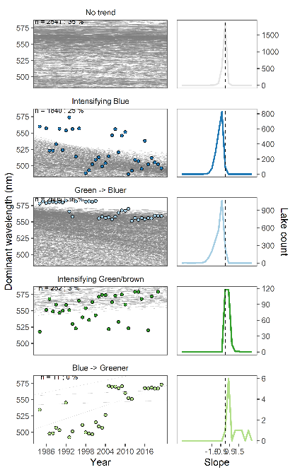
      2. **Ecologically significant**
         1. We defined ecologically significant trends as those that had a change in dominant wavelength of greater than 5 nm over 37 years (our study period)
         2. Results – Figure
            1. 5 nm is somewhat arbitrary (but = 5% change)

Using this cutoff in another study (Oleksy wildfire) – may actually be able to detect

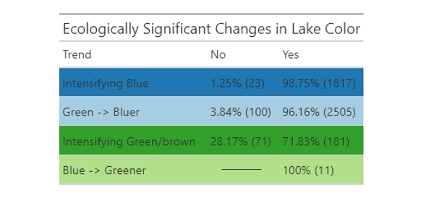

* + 1. **Next steps**
       1. We would like to back-calculate the dominant wavelength value to chlorophyll levels to determine what difference in nm would correlate to a
  1. **CART**
     1. We divided the population of lakes into three categories: bluing or greening or no trend *per Oleksy et al (2022)*
     2. To address our first research objective, we attempted a classification and regression tree (CART; Therneau and Atkinson 1997) to determine which environmental characteristics explained variation in lake color across *per Oleksy et al (2022)*
     3. Variables – lake water area, connectivity class, total perimeter, elevation, watershed area and the residence time (watershed area to lake area)
     4. Training dataset = started with 80/20 then final = 60/40% but results were similar
  2. **Results** –
     + 1. CART model indicated that elevation was the biggest predictor for bluing and no trend lakes, but did not show any results for greening lakes
       2. 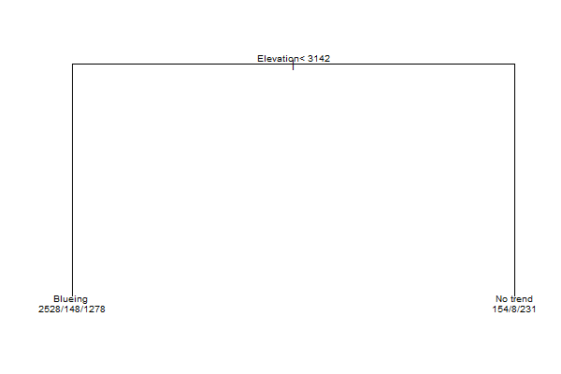
  3. **Additional Temporal analyses**
     1. Based on cart model results, we looked at elevations across the three categories
        1. No significant results, but found that in general, the greening lakes were at a lower elevation compared to the bluing and no trend lakes
        2. 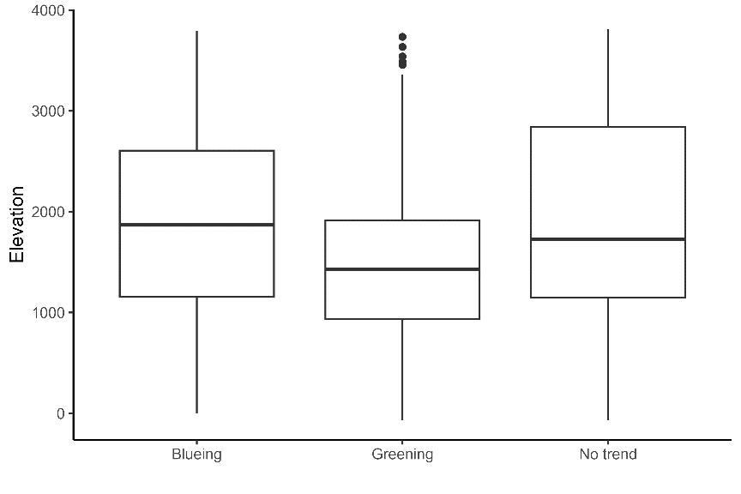
     2. Density plots
        1. Drainage type
           1. Negative slope = trending towards blueing
           2. Positive slope = trending towards green
           3. Results – in the headwater systems, there was more greening compared to the other systems – very interesting finding
        2. WANT TO EXPLORE THIS MORE!!  
           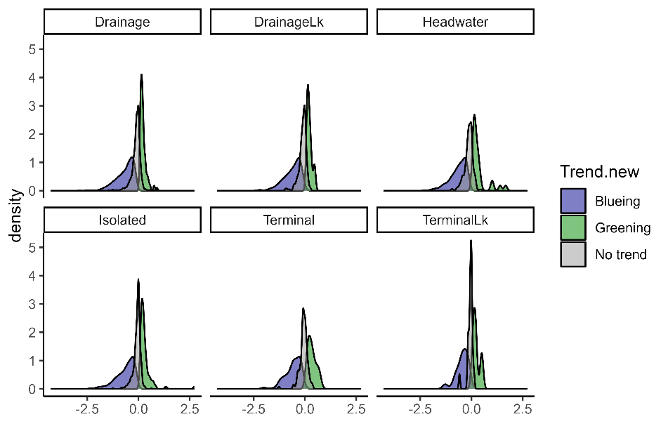
        3. Not discussed – trend by state
        4. 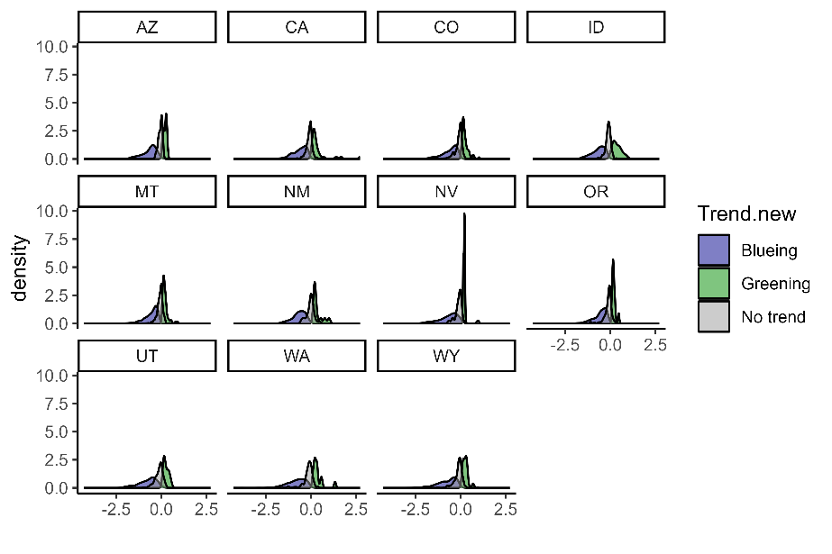

1. **Does proximity control how similar lakes are in color?**
   1. Spatial Analyses (Jordy, Spencer, Jordan)
      1. How changes through time addressed above
      2. Wanted to understand if lakes closer together more close in color, and if lakes that are farther away more different in the spectrum
      3. We used pairwise comparison to understand across space if there were differences
      4. Started with Wyoming
         1. NO! We did not see any difference in trends in color across the state
         2. Repeated for California
            1. No trend!
            2. Perhaps we are not going far enough apart?

Saw No trend!!

* + 1. What if we break up categories within the Intermountain west –
       1. Similar = within 10 nm
       2. Different = >50 nm between lakes
    2. If we look at the connectivity, are we seeing lakes closer in color vs if comparing drainage vs headwater
       1. NO TREND!
    3. Last Approach – looked at elevation
       1. Calculated difference in elevation between lakes and difference in color
       2. (black box plot with green line!!)
       3. Result – as difference in elevation lakes, we saw there was a different in dominant wave length
          1. This supports the results that high ele vs low elev are different in wave length (temporal temp found headwater = greening, but found elevation is important for those lakes that are bluing (CART model results))
          2. 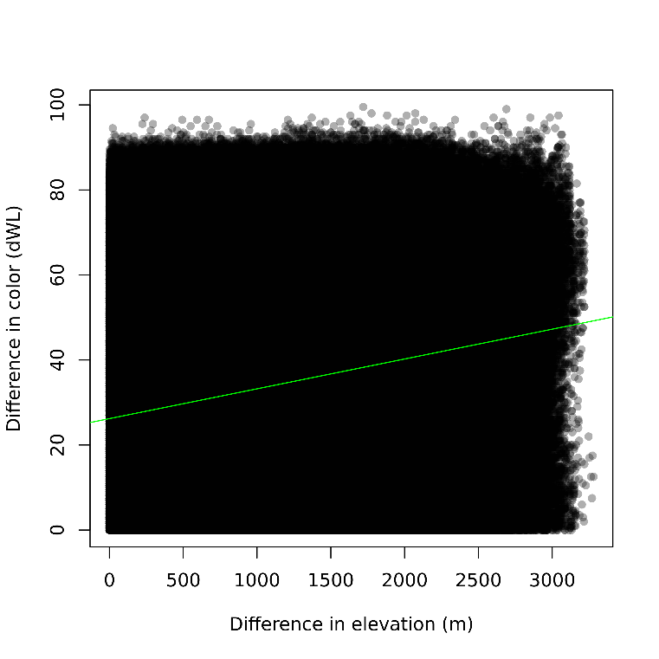
    4. Visualize the difference in lake color across space (SPENCER)
       1. Plotted the results
       2. 1991 to 2021
          1. Saw a bluing of lakes visually across time – perhaps this is a function of different sampling? Bella says no! Only lakes with 30 year record or greater is included here
          2. Would like to explore this further  
               
             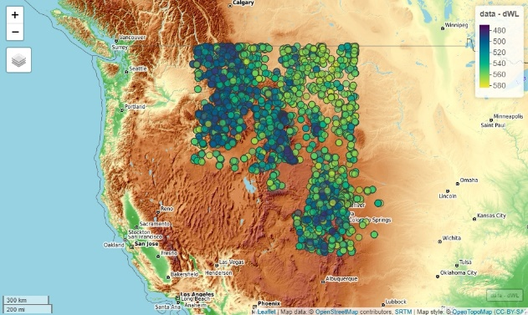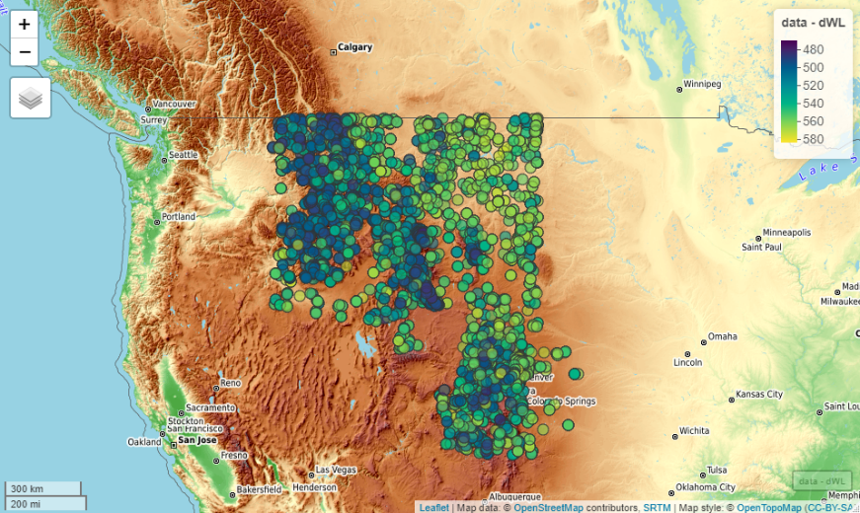
          3. Interactive Maps for ID, MY, WY, CO

1991 =

2021 =

* + - * 1. Interactive Map for all states – See SPENCER’S CODE!!!!
  1. Conclusions
     1. **Elevation is an important variable for bluing lakes**
        1. **Many small high-elevation lakes are bluing**
     2. Saw more lakes bluing
     3. We hypothesized that we would see more greening in the low elevation small lakes
        1. This dataset may also include more lakes at high elevation because many high elevation lakes are small
     4. Small lakes are underrepresented in general so interesting to analyze smaller lakes
     5. What if this dataset was available prior to 1960s?
        1. Perhaps could be influenced by CWA?
     6. Questions – can we get lake depth
        1. Some LAGOS data does include depth
        2. Predicting lake depth is very challenging – models are not reliable
        3. In Western US, lake depth is very dynamic (not static!!)
           1. Depends on time of year, season, water management
     7. Question – how does increase of aquatic invasive species change lake color
        1. In the Midwest, where dreissenids are invading, it is likely that lake color will become bluer
        2. Would be cool to use Bellas fire pipeline with the
     8. Question - How does color relate to opacity
        1. Generally, a higher value correlates with less clear lakes
        2. Hard to pin down ecological significance if were to consider the turbidity
           1. However, we can tell the cause of turbidity (i.e. glacial till = very blue, vs algae vs sediment)
  2. What did we learn?
     1. Spencer – GitHub!!
     2. Jordy – growing arching of ideas and pruning, repeated
     3. Sean – learning better workflow practices in GitHub and R
     4. Linnea – agree, agree; really enjoyed working on team and how to collaborate (with Github, push pull, etc)
        1. Different than working remotely with a team
     5. Ashleigh – learning source files to build data
     6. Bella – amazed how quickly we picked this up and collated the datasets then created workflows
     7. Carol – watched team complement one another, great access to super computer and that was very helpful