# Introduction

Enrichment of nitrogen (N) and phosphorus (P) are mainly responsible for eutrophication (Wetzel, 2001), one of the biggest, often anthropogenically-caused threats to freshwaters (Smith & Schindler, 2009) and biodiversity (Reid et al., 2019) across the globe. Eutrophication can have detrimental consequences on aquatic ecosystem health including decreased oxygen, formation of toxins, and changes in organismal communities (Camargo & Alonso, 2006). Many freshwaters across the United States (U.S.) are already plagued by eutrophication or are at risk of shifting into eutrophic states (Dodds et al., 2008). In the U.S., an estimated $2.2 billion in annual losses because of eutrophication is likely an underestimate of the actual amount (Dodds et al., 2008).

There is an ongoing debate about whether N or P is more important in causing eutrophication or which is the main limiting nutrient. Many studies focus solely on P or argue that P should be the top management priority (Carpenter, 2008; Ngatia & Taylor, 2019). Reasons supporting the P paradigm include factors like N-fixing bacteria that can increase N availability (Schindler et al., 2008), accumulation of P in soils and freshwater sediments (Bennett et al., 2001), potential for internal loading (Sun et al., 2022), past successful P reduction efforts (Foy, 2005), and geographic extent, e.g., focus on the northeast and Midwest (Liang et al., 2020). Additionally, there is belief that P is primarily the limiting nutrient in freshwaters, while N is limiting in oceans (Correll, 1999), and that N-limitation in freshwaters is merely a result of P enrichment in eutrophic waters (Havens, 1995).

Despite the longstanding P-limitation paradigm, the importance of N in regulating primary productivity is widely recognized. In fact, there is evidence that northern-hemisphere (Bergström & Jansson, 2006), high latitude, high altitude (Hogan et al., 2014), and alpine (Oleksy et al., 2020) lakes were N-limited prior to an influx of N-deposition resulting in eutrophication and a shift toward P-limitation. Focusing on eutrophication management, P reduction alone is no longer an adequate solution. Rather, there is increased need for research on nutrient amounts, ratios, and N’s impact on eutrophication (Yao et al., 2018). Reductions in P pollution in large lakes may lead to accumulation of N (Finlay et al., 2013), negating the attempt to mitigate nutrient pollution. In the Western US, N-deposition can significantly alter ecosystems (Fenn et al., 2003). And projected precipitation patterns under a changing climate will only likely increase N loading into freshwaters worldwide (Sinha et al., 2017).

Experiments have demonstrated how both nutrients together have an impact on productivity significantly more than additions of a single nutrient and how stoichiometrically imbalanced resources can have detrimental impacts (Elser et al., 2011; Redoglio et al., 2022). Despite the mounting evidence, the conversation has remained on whether P or N has more impact rather than considering the potential for co-nutrient limitation or limitation that vacillates between N and P. Because their cycles are coupled in the environment (Oviedo-Vargas et al., 2013), studying N and P in together terms of relative abundances may unfold large-scale patterns that would otherwise be unseen. We believe this idea can be applied to the concept of nutrient limitation by distancing ourselves from the binary N vs. P focus and address the potential for lakes to shift between limitation or be limited by both nutrients. Nutrient limitation can be defined using Liebig’s law of minimum, which states that organismal growth is limited by the resource or nutrient in lowest supply. And the relative abundance of these nutrients indicate the balance of the supply (Sterner & Elser, 2002). Nutrient ratios have been extensively used to determine limitation (Downing & McCauley, 1992; Guildford & Hecky, 2000; Hellström, 1996; Ptacnik et al., 2010; Redfield, 1958; Rhee & Gotham, 1980). DIN:TP may be more indicative of the bioavailable nutrient forms than TN:TP and may serve as a better indicator of nutrient limitation in lakes (Bergström, 2010).

In this study we challenged the single nutrient viewpoint and evaluated how both N and P contribute to eutrophication and limitation at a continental scale using U.S. Environmental Protection Agency (USEPA) National Lakes Assessment (NLA) data. NLA surveys include empirical data from thousands of lakes across the U.S., which allows researchers to gain the first comprehensive assessment of lake water quality and ecosystem health across a range of climates and environmental contexts. We used both nutrient concentrations and ratios to assess limitation since limitation is likely a function of both relative and absolute abundance (Guildford & Hecky, 2000). Using these broad scale survey data, we aim to examine the following questions:

1. Which nutrient correlates best with chlorophyll-a, an indicator of eutrophication, in lakes across ecoregions of the US?
2. How does nutrient limitation vary by U.S. ecoregion and do the data indicate any widespread shifts in nutrient limitation between 2007 and 2017?
3. How does nutrient limitation relate to trophic state?
4. Do conclusions drawn from NLA surveys vary depending on if you focus only on lakes sampled in multiple surveys vs using all surveyed lakes?

# Methods

## NLA lakes and methods

NLA data from survey years 2007 and 2017 were used in the analyses (USEPA, 2010, 2022a). The 2012 data were excluded because we were interested in evaluating the long-term, decadal shifts rather than the shorter-term changes. In 2007, 1156 lakes were surveyed nationwide; 95 were sampled twice in the same year, and 124 were considered reference lakes. References lakes were hand-selected to represent the least-disturbed conditions in each ecoregion. Parameters assessed for reference lakes were total P, total N, chloride, sulfate, turbidity, lakeshore physical parameters, and anthropogenic disturbances like agriculture, residences, and industry. The reference lakes were determined to be in least disturbed conditions for all the assessed parameters (USEPA, 2022b). In 2017, 1112 lakes were sampled nationwide; 97 were sampled twice in the same year, and 108 were considered reference lakes. Between the two survey years, 282 lakes were resampled. In 2007, lakes greater than 4 ha were sampled. This changed in the later survey and lakes with surface area > 1 ha and 1-m deep were included.

The USEPA used a Generalized Random Tessellation Stratified survey design to randomly choose sampling sites (USEPA, 2022b). Stratification was based on Omernik level-3 aggregated ecoregions, state, and lake size. Discretizing the dataset into Omernik’s nine aggregated ecoregions provides a qualitative understanding of spatial patterns and regional homogeneities (Omernik, 1987). Each lake is assigned a weight to indicate the number of lakes it represents with error. The NLA data are specifically designed to assess lakes across the US, rather than the individual lakes sampled, by using population weight estimates (USEPA, 2022b).

### Sampling and laboratory methods

Lakes were sampled between May-September of each survey year. In 2007 there were nine sampling events in October and in 2017, there were four sampling events in October. The USEPA used standardize sampling protocols in each survey year. Water was collected using an integrated sampler within the euphotic zone or up to 2m depth. Chlorophyll samples were stored in a dark 2L bottle and stored on ice until filtration with a 0.4 µm pore size polycarbonate filters. Nutrient samples were stored in 250 mL bottles on ice and sulfuric acid was added to stabilize samples at pH <2. More on these standardize sampling procedures can be found in the NLA field operations manuals (USEPA, 2007a, 2017a).

Samples were shipped overnight to approved laboratories and processed within 24 hours of receipt. Samples are analyzed for chlorophyll-a via extraction in 90% acetone followed by fluorometry. Total nutrients are analyzed via persulfate digestion then automated colorimetric analysis. Laboratory processing procedures must maintain quality assurance/control outlined by the EPA. More information about these processes and quality assurance can be found in the NLA laboratory operations manuals (USEPA, 2007b, 2017b).

### Trophic state determination

The NLA uses chlorophyll-a concentration as a proxy for trophic state, while acknowledging that trophic state is actually determined by a variety of characteristics including nutrients, climate, morphometry, etc. Oligotrophic lakes have chlorophyll-a concentrations ≤ 2 µg L-1. Mesotrophic lakes have concentrations greater > 2 µg L-1 and ≤ 7 µg L-1. Eutrophic lakes have concentrations > 7 µg L-1 and ≤ 30 µg L-1. And hypereutrophic lakes have concentrations > 30 µg L-1 (USEPA, 2022b).

## Data analyses

### Limitation calculation

Nutrient limitation for lakes can fall into three categories: P-limitation, N-limitation, or co-nutrient limitation. We used a nutrient concentration threshold and a molar nutrient ratio specific to each ecoregion and survey year to determine the potential for P-, N-, or co-nutrient limitation. To determine nutrient concentration thresholds, we calculated the median dissolved inorganic N (DIN) or total phosphorus (TP) concentration between the 25th percentile of all surveyed lakes and the 75th percentile of reference lakes in each ecoregion and year. We used the median between these two methods because we have both a small set of reference lakes and a larger set of all surveyed lakes to assess and this provided reasonable values for nutrient criteria (USEPA et al., 2000). Next, we calculated the mean of log-transformed DIN:TP molar ratios in each ecoregion and year. We categorized a lake as potentially N-limited if the TP value exceeded the concentration threshold and log DIN:TP ratio was below the ratio threshold. A lake was potentially P-limited if the DIN value was greater than the DIN concentration threshold and log DIN:TP was above the ratio threshold. Lakes that did not meet any of these criteria were considered likely co-limited. There were 71 individual lakes in 2017 that did not include DIN data that were dropped from the analyses on nutrient limitation. There were no reference lakes in the Northern Plains in 2007, so concentration thresholds were determined solely by the 25th percentile of all surveyed lakes in the Northern Plains ecoregion in 2007.

### Statistical analyses

All data analyses were performed in the R programming language (R Core Team, 2022) with heavy reliance on the tidyverse package suite for data wrangling and visualization (Wickham et al., 2019) and the sf package for creating maps (Pebesma, 2018). To assess whether N or P was a better explanatory variable of trophic state, chlorophyll-a was used as a proxy for trophic state as the response variable. We used TN rather than DIN for these analyses because TN’s relationship with chlorophyll-a is more comparable to TP and DIN was an overall poor predictor of chlorophyll-a. Both the response and predictor variables were logged, and we performed linear models. The R2 and AIC values were compared to determine which nutrient had the best explanatory power of chlorophyll-a.

To assess shifts in limitation and trophic status, we used the change_analysis function in the spsurvey package (Dumelle et al., 2022). The change_analysis function incorporates the lake weights to measure the difference in the proportion of categories between two surveys (USEPA, 2022b). Reference lakes and observations from any second visits were not included. These shifts were analyzed using all surveyed lakes representing lakes across the conterminous U.S. (n = 1953) in addition to only examining shifts in lakes that were sampled in both 2007 and 2017 (n = 464). Shifts were considered not statistically significant when the error bars crossed zero. The cat_analysis function from the survey package was used to generate weighted percentages of lakes in each limitation category across the two survey years. Reference lakes and observations from second visits were not included (n = 1953).

# Results

### Nutrient stoichiometry

Between 2007 and 2017, DIN:TP stoichiometry showed a significant decrease across the full dataset (p <0.001). DIN:TP molar ratios were highest among P-limited lakes and lowest among N-limited lakes (p < 0.001). Grouped within limitation category, DIN:TP ratio decreases with increasing trophic state and ratios vary significantly between trophic states (all p < 0.01) with the following exceptions. In P-limited lakes, DIN:TP ratios do not differ between hypereutrophic and eutrophic lakes (p >0.05). In N-limited lakes, DIN:TP ratios do not differ between oligotrophic and mesotrophic lakes (p >0.05).

### Nutrient availability to predict trophic status

Both TN and TP were important in different ecoregions of the US, in fact, there was a clear divide in the data (Figure 1). In the western US, consisting of the Northern Plains, Southern Plains, Xeric, and Western Mountains ecoregions, the linear models using TN as a predictor of trophic state (chlorophyll-a as a proxy) were better based on the models’ higher R2 and lower AIC values. This was contrasted by the eastern US, consisting of Northern Appalachians, Southern Appalachians, Coastal Plains, Temperate Plains, and Upper Midwest ecoregions. In the eastern US, the linear models using TP as a predictor produced higher r2 and lower AIC values (Figure 2).

### Limitation and trophic state

There were 718 observations of P-limited lakes, 1034 N-limited lakes, and 649 co-nutrient limited lakes across the entire dataset based on the criteria used (Table 1, Figure 3). The 75th percentile nutrient concentrations from the total assessed lakes dataset were not statistically different from the 25th percentile nutrient concentrations from the reference lakes (p = 0.135 and p = 0.159, for TP and DIN, respectively). The proportion of lakes in each limitation status varies across ecoregions and survey years (Figure 4). Across the conterminous US, in 2007, 21% of lakes were co-limited by both N and P, and that number increased to 32.3% in 2017. N-limited lakes decreased from 49.3% in 2007 to 45.9% in 2017. And in 2007, 29.7% of lakes were P-limited and that number decreased to 21.8% in 2017.

Using chlorophyll *a* as a proxy for trophic state, the survey data indicate that there were 368 oligotrophic lakes (Oligo.), 737 mesotrophic lakes (Meso.), 753 eutrophic lakes (Eutro.), and 513 hypereutrophic lakes (Hyper.). Across the conterminous U.S., oligotrophic lakes decreased from 12.8% in 2007 to 9.2% in 2017. Mesotrophic lakes also decreased from 36.6% in 2007 to 22.7% in 2017. Eutrophic and hypereutrophic lakes both showed an increase between 2007-2017 of 30.3%-43.8% and 20.3%-24.3%. These patterns varied across ecoregions (Figure 5).

### Shifts in nutrient limitation

#### Lakes sampled in both 2007 and 2017

At the national scale among lakes sampled in both surveys (dotted lines in Figure 6a), there was a significant increase in co-nutrient limited lakes (17.3%) and a significant decrease in N-limited lakes (-18.4%). At the National scale, there was no net change in the percentage of P-limited lakes, but substantial changes within the nine aggregated ecoregions (Figure 6b). In the Northern Appalachians, lakes shifted from co-nutrient and N-limitation (-13.4% and -20.8%, respectively) toward P-limitation (34.1%). Lakes in the Temperate Plains shifted from N-limited (-35.9%) toward both co-limited (14%) and P-limited (21.9%). The Upper Midwest lakes shifted from being N-limited (-41%) and P-limited (-24.3%) toward co-nutrient limitation (65.3%). In the Northern Plains, lakes became more co-nutrient limited (42%) and less P-limited (-28%), with little change in N-limited lakes. The Southern Plains showed the opposite pattern with a decrease in co-nutrient limitation (-16.8%), increase in N-limitation (11.1%), and non-significant increase in P-limited lakes. Western Mountains lakes shifted from P-limited (-19.5%) to co-nutrient limited (9.3%) with an insignificant increase in N-limited lakes. In the Southern Appalachians, Coastal Plains, and Xeric ecoregions, no shifts were significant.

#### Full population of lakes

When extrapolated to the entire population of lakes across the U.S. (solid lines in Figure 6a), co-nutrient limited lakes also increased (11.3%), but P-limited lakes decreased (-7.9%). Using the entire population of lakes, there was no net change in N-limited lakes, which contrasts the results of the resampled population. The trends of the resampled lakes were generally representative of the full population in the ecoregions, though magnitudes differed and there were a few stark differences (solid lines in Figure 6b). For example, there was a change in the direction of the shift in co-nutrient limited lakes in the Northern Appalachians such that among the full population assessment, there was a 16% increase compared to a X% decrease in the resampled lakes. The percentage of N-limited lakes in the Southern Appalachians and Western Mountains changed signs in the full population assessment compared to the resampled lakes assessment, but the shifts remained insignificant. There were no shifts in the percentage of P-limited lakes in the Northern Appalachians, Temperate Plains, Northern Plains, and Western Mountains in the full population assessment, but the resampled population indicated the shifts were positive (X%), positive (X%), negative (X%), and negative (X%), respectively. Finally, in the Xeric ecoregion, N-limited lakes increased by 16.5% in the full population assessment but showed no net change in the resampled lakes.

### Shifts in trophic status at the national scale

#### Lakes sampled in both 2007 and 2017

At the national scale, resampled lakes became less hypereutrophic (-8.3%) and more mesotrophic (9%), with no net change in oligotrophic and eutrophic lakes. However, at the national scale, changes in trophic state varied by nutrient limitation category (Figure 7). Co-nutrient limited lakes followed the overall national pattern, with these lakes becoming less hypereutrophic (-10.4%) and more mesotrophic (14%) with marginal changes in the percentage of oligotrophic or eutrophic co-limited lakes. The only substantial shift in trophic state of N-limited lakes only occurred with an increase in hypereutrophic systems (13.7%). P-limited lakes showed the most widespread changes in trophic state. Specifically, the percentage of oligotrophic and hypereutrophic lakes decreased (-12.9% and -23.9% respectively), while the percentage of eutrophic lakes increased by 35%.

#### Full population of lakes

The resampled lakes results differed significantly from the full population estimate (Figure 7). When considering all the lakes in the NLA survey years 2007 and 2017, lakes became less oligotrophic (-3.7%) and mesotrophic (-13.9%) and more eutrophic (13.5%) and hypereutrophic (4%). Co-nutrient limited lakes shifted from mesotrophic (-13.2%) and hypereutrophic (-4%) toward eutrophic (21%) status with no significant change in oligotrophic status. N-limited lakes followed the national pattern, becoming less oligotrophic (-3.8%) and mesotrophic (-19.6%) and more eutrophic (7.9%) and hypereutrophic (15.6%). P-limited lakes showed a significant decrease in oligotrophic lakes (-5.8%) and a significant increase in eutrophic lakes (14.6%) with no significant changes in mesotrophic or hypereutrophic status lakes.

# Discussion

1. This study intended to answer questions of nutrient limitation and water quality in U.S. lakes and through that to support efforts related to nutrient management strategies.
   1. We found important regional differences in the drivers of trophic state. In the Western US, TN was the stronger driver of eutrophication compared to in the Easter U.S. where TP was the more influential driver (Figures 1, 2).
      1. Regional scale processes can influence nutrient composition in lakes, including N-deposition (Burns, 2004) and vegetation characteristics (Kopáček et al., 2000).
      2. Potential explanations for the difference in trophic state predictor include the differences between the Eastern and Western US. The ecoregions of the eastern U.S. are generally characterized by greater forest and agricultural land cover, whereas the Western U.S. is characterized by greater grasslands and pasture land cover.
      3. Additionally, N-deposition has demonstrated its potential detrimental impacts on Western ecosystems (Fenn et al., 2003) while legacy accumulation of P is much higher in the Eastern U.S. (Sabo et al., 2021).
      4. Understanding these different regional drivers may assist in eutrophication management and mitigation.
2. Assessing shifts only in the lakes re-sampled in multiple NLA surveys can help provide general trends but may not adequately estimate the changes in the full population of lakes.
   1. Therefore, this discussion uses the shift estimates from the full population, but note that there is significant error around both these population estimates as well as the resampled lake shift estimates (solid bars in Figure 6, 7).
   2. We should note that in this study, we are assuming limitation for whole lake ecosystems and using total and dissolved nutrient pools rather than understanding specifics about the real species communities and their nutrient requirements.
      1. We acknowledge that limitation and trophic status likely depend on a lot of criteria, and here we are using the readily available nutrient and chlorophyll-a concentrations as proxy measurements.
         1. Rather than relying on experimental data, which requires extensive time and money, we hope this may serve as a method to estimate limitation and water quality using the resources available.
3. Across the conterminous US, co-nutrient limited lakes increased between 2007 and 2017, while single nutrient limitation decreased. However, N-limited lakes were still the most prevalent.
   1. Within the nine aggregated ecoregions, we see N-limitation increasing in the Southern Plains and Xeric regions, and co-nutrient limitation increasing in the Northern Appalachians, Temperate Plains, Upper Midwest, Northern Plains, and Western Mountains. P-limitation did not increase in any of the ecoregions.
      1. These shifts toward co-nutrient limitation in addition to the shift toward greater eutrophication across the U.S. in all limitation categories may be indicative of the extent of nutrient excess plaguing our freshwaters (Dodds et al., 2008, 2011) and the potential for these lakes to swing back and forth between limitation statuses as some of these co-nutrient limited lakes occur in high nutrient conditions (Figure 3).
4. Nutrient limitation and trophic state shifts in U.S. lakes may help identify key nutrients to focus on in induvial management plans.
   1. Hypereutrophic lakes across the U.S. increased in N-limited lakes only, while oligotrophic lakes decreased in single-nutrient limited lakes.
      1. Understanding which nutrient is more impactful via its limitation status can serve as a starting point for determining strategies toward improved water quality and may require a balanced approach.
         1. For example, reductions in P pollution lead to the accumulation of N in large lakes across the world (Finlay et al., 2013).
         2. Additionally, balancing nutrient stoichiometry may be one way to remediate eutrophic lakes, while also controlling the input of excess nutrients (Stutter et al., 2018).
   2. Across the two surveys, DIN:TP stoichiometry was highest in P-limited lakes and lowest in N-limited lakes with the ratio decreasing with increasing trophic status as well, consistent with previous studies (e.g., Downing & McCauley, 1992).
      1. In N-limited lakes, however, there was no difference in nutrient stoichiometry between oligotrophic and mesotrophic lakes; compared to in P-limited lakes where there was no stoichiometric difference between eutrophic and hypereutrophic lakes. These variations from the overall trend may be a result of the extents of excess and lack of nutrients.
5. There is complexity in nutrient management strategies related to nutrient proportions and forms, and managing only N or P can lead to unintended ecological consequences caused by availability of the other nutrient (Glibert, 2017).
   1. Changing climate and other human-induced stressors will likely exacerbate eutrophication and the need for management. Assuming a single nutrient is limiting can lead export of other nutrients and increased productivity problems downstream (Wurtsbaugh et al., 2019).
   2. Connectivity of freshwaters across the landscape necessitates the need for stoichiometrically balanced nutrient management since along the continuum of freshwaters to the ocean, limitation may shift. Management strategies that focus on a sole nutrient could increase availability of the other limiting nutrient in subsequent waters, thus intensifying eutrophication downstream (Conley et al., 2009).
6. You may not have enough space in the document, but if you do want to end with something broad you can have a conclusion paragraph that summarizes that both N and P matter, that nutrient limitation varies both through space and time, and that future work should look at identifying why some of these shifts through time appear to be so large (and whether management interventions can help prevent large changes toward eutrophic/hypereutrophic systems in the future).

# Figures and Tables

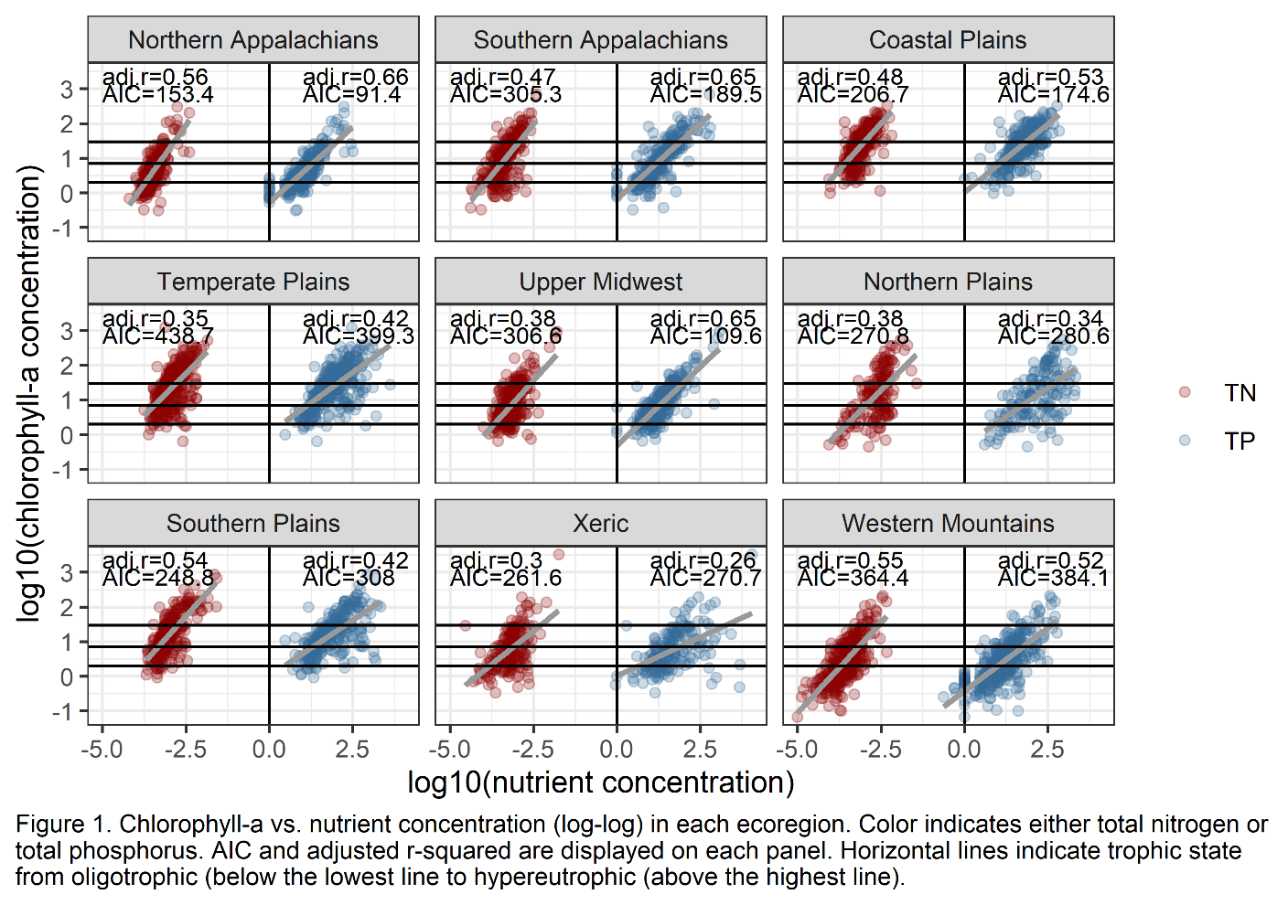

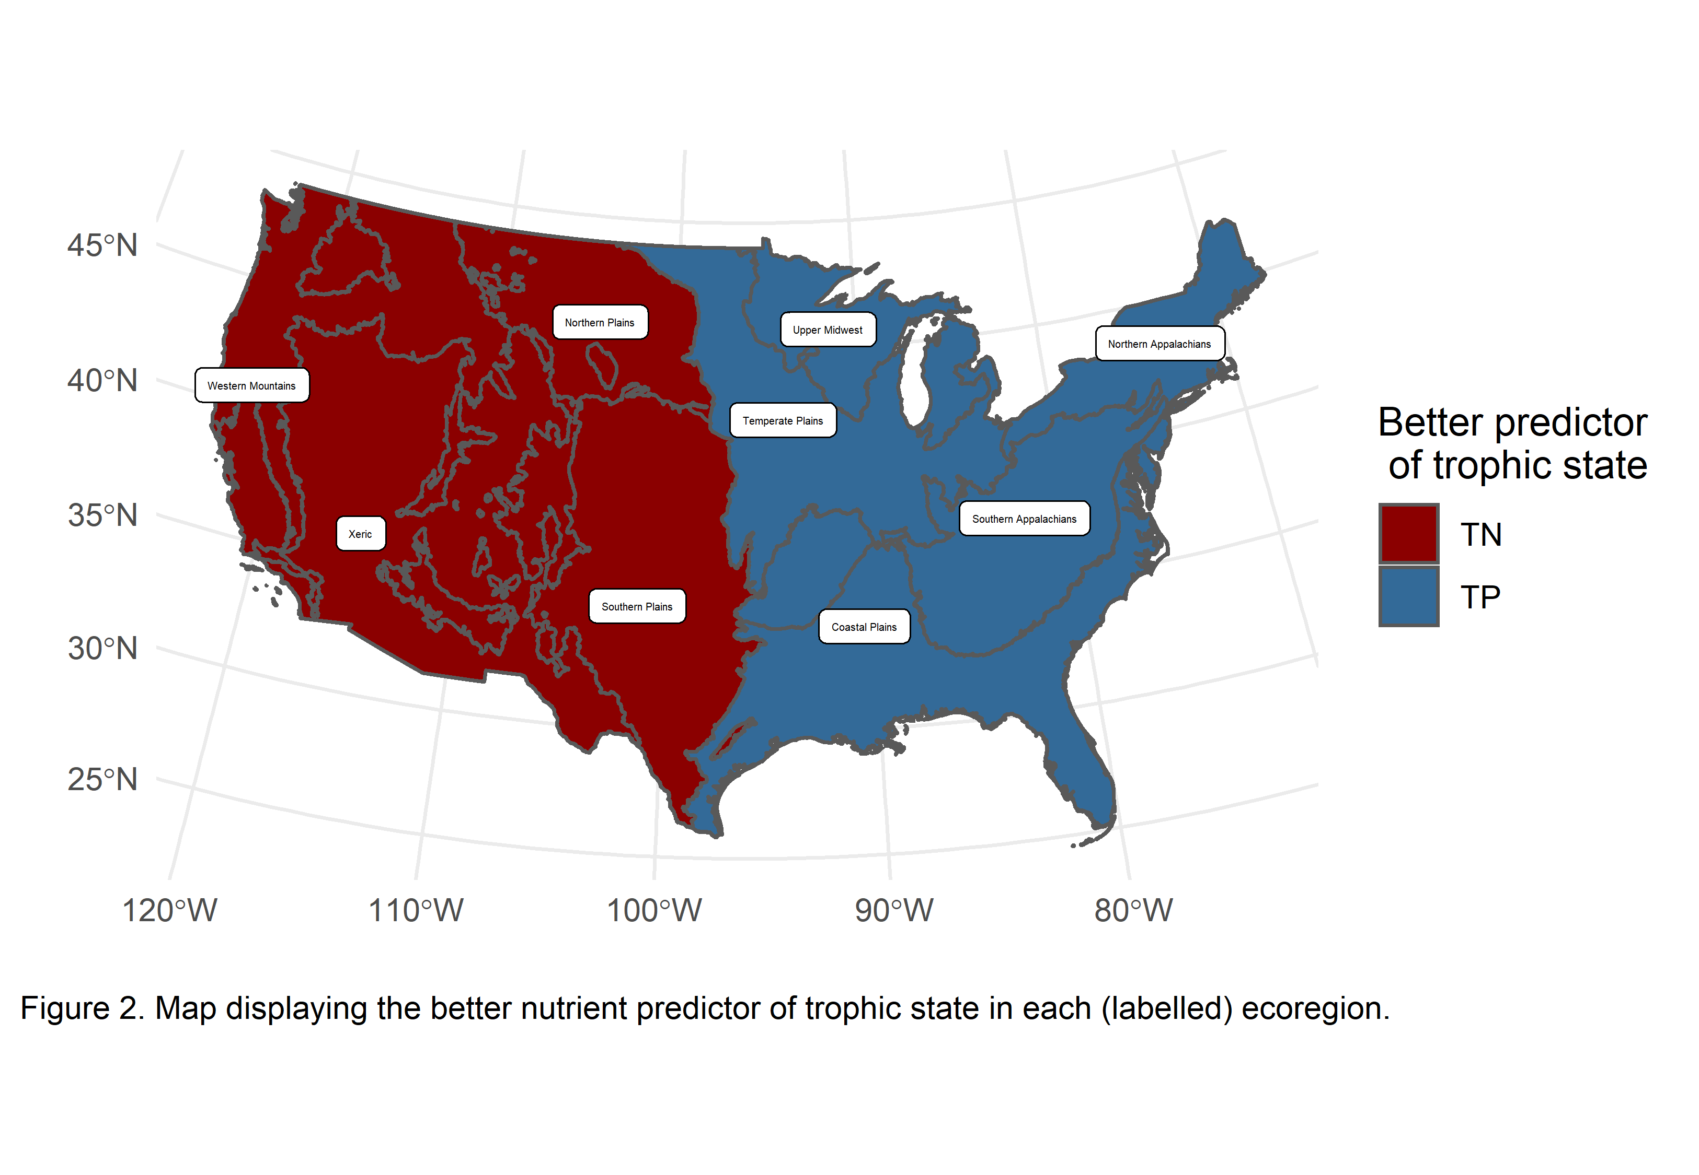

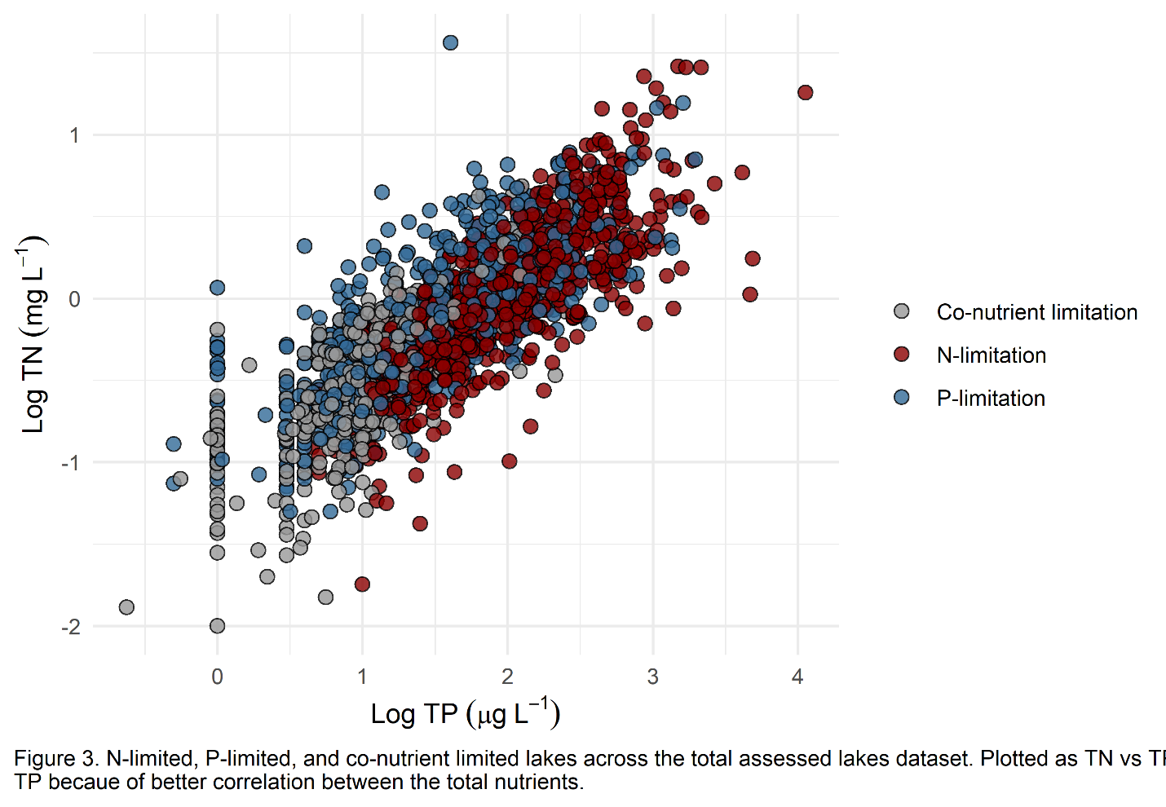

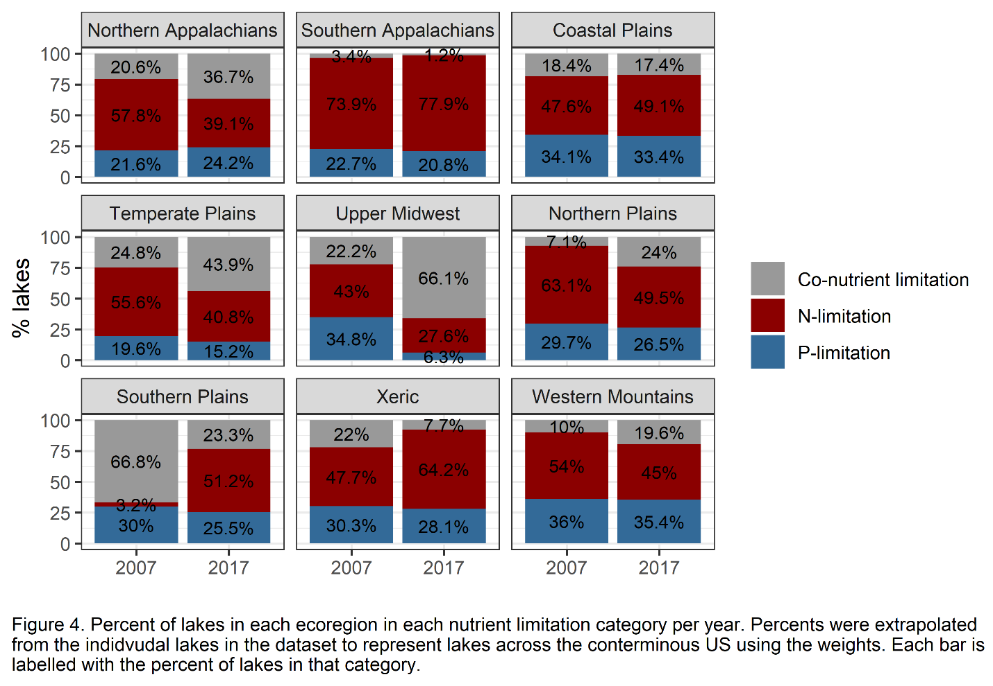

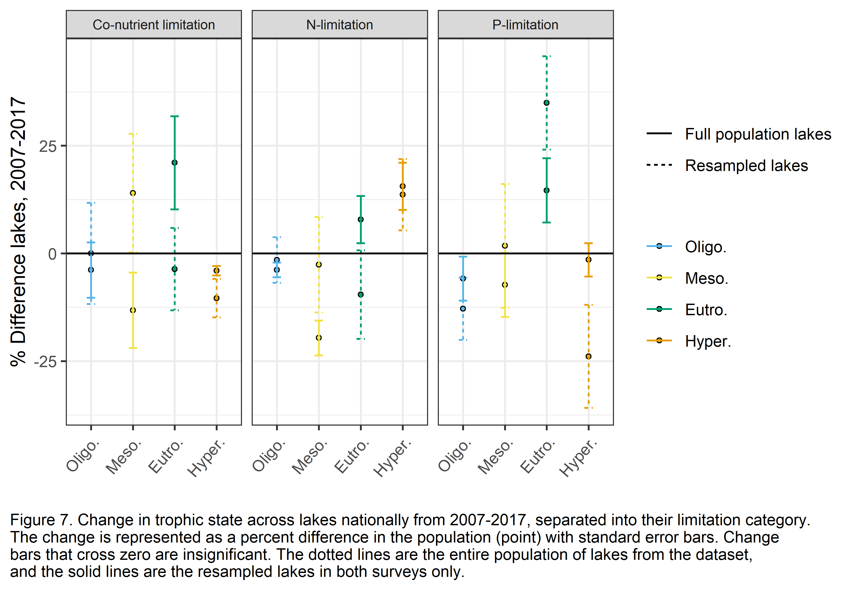

Table 1. Nutrient molar ratios and concentration thresholds used in limitation calculations.

|  |  |  |  |  |  |  |  |  |  |  |  |  |  |  |  |  |
| --- | --- | --- | --- | --- | --- | --- | --- | --- | --- | --- | --- | --- | --- | --- | --- | --- |
|  | **Average DIN:TP molar ratio** | | **Average TN:TP molar ratio** | | **25th Percentile DIN mg L-1 from all lakes** | | **75th Percentile DIN mg L-1 from reference lakes** | | **DIN mg L-1 concentration threshold** | | **25th Percentile TP µg L-1 from all lakes** | | **75th Percentile TP µg L-1 from reference lakes** | | **TP µg L-1 concentration threshold** | |
|  | **2007** | **2017** | **2007** | **2017** | **2007** | **2017** | **2007** | **2017** | **2007** | **2017** | **2007** | **2017** | **2007** | **2017** | **2007** | **2017** |
| **Northern Appalachians** | 21.54 | 3.99 | 108.49 | 62.62 | 0.01 | 0.01 | 0.02 | 0.01 | 0.02 | 0.01 | 4.75 | 8.16 | 11.00 | 13.66 | 7.88 | 10.91 |
| **Southern Appalachians** | 38.07 | 14.14 | 96.36 | 61.84 | 0.01 | 0.01 | 0.02 | 0.01 | 0.02 | 0.01 | 7.38 | 9.94 | 10.00 | 16.37 | 8.69 | 13.15 |
| **Coastal Plains** | 4.42 | 5.90 | 43.78 | 46.17 | 0.02 | 0.01 | 0.02 | 0.01 | 0.02 | 0.01 | 28.25 | 24.61 | 36.00 | 24.73 | 32.13 | 24.67 |
| **Temperate Plains** | 6.34 | 6.67 | 46.14 | 46.36 | 0.02 | 0.02 | 0.14 | 0.03 | 0.08 | 0.02 | 33.75 | 35.15 | 80.50 | 49.75 | 57.13 | 42.45 |
| **Upper Midwest** | 17.81 | 13.83 | 132.50 | 88.94 | 0.02 | 0.01 | 0.04 | 0.64 | 0.03 | 0.32 | 8.00 | 13.37 | 9.50 | 33.35 | 8.75 | 23.36 |
| **Northern Plains** | 4.43 | 23.89 | 48.86 | 67.02 | 0.04 | 0.02 | NA | 0.04 | 0.04 | 0.03 | 61.00 | 48.22 | NA | 275.62 | 61.00 | 161.92 |
| **Southern Plains** | 3.61 | 1.99 | 41.37 | 37.89 | 0.02 | 0.01 | 0.06 | 0.06 | 0.04 | 0.04 | 24.00 | 25.89 | 533.75 | 55.12 | 278.88 | 40.50 |
| **Xeric** | 29.05 | 6.45 | 78.38 | 43.61 | 0.02 | 0.01 | 0.02 | 0.02 | 0.02 | 0.01 | 15.00 | 19.10 | 48.25 | 21.51 | 31.63 | 20.30 |
| **Western Mountains** | 15.16 | 4.38 | 71.70 | 44.22 | 0.01 | 0.01 | 0.01 | 0.02 | 0.01 | 0.01 | 4.00 | 9.60 | 4.00 | 14.07 | 4.00 | 11.83 |

# References

Bergström, A. K. (2010). The use of TN:TP and DIN:TP ratios as indicators for phytoplankton nutrient limitation in oligotrophic lakes affected by N deposition. *Aquatic Sciences*, *72*(3), 277–281. https://doi.org/10.1007/S00027-010-0132-0/FIGURES/1

Bergström, A. K., & Jansson, M. (2006). Atmospheric nitrogen deposition has caused nitrogen enrichment and eutrophication of lakes in the northern hemisphere. *Global Change Biology*, *12*(4), 635–643. https://doi.org/10.1111/j.1365-2486.2006.01129.x

Burns, D. A. (2004). The effects of atmospheric nitrogen deposition in the Rocky Mountains of Colorado and southern Wyoming, USA-a critical review. *Environmental Pollution (Barking, Essex : 1987)*, *127*(2), 257–269. https://doi.org/10.1016/S0269-7491(03)00264-1

Camargo, J. A., & Alonso, Á. (2006). Ecological and toxicological effects of inorganic nitrogen pollution in aquatic ecosystems: A global assessment. *Environment International*, *32*(6), 831–849. https://doi.org/10.1016/J.ENVINT.2006.05.002

Conley, D. J., Paerl, H. W., Howarth, R. W., Boesch, D. F., Seitzinger, S. P., Havens, K. E., Lancelot, C., & Likens, G. E. (2009). Controlling Eutrophication: Nitrogen and Phosphorus. *Science*, *323*(5917), 1014–1015. https://doi.org/10.1126/science.1167755

Correll, D. (1999). Phosphorus: A rate limiting nutrient in surface waters. *Poultry Science*, *78*(5), 674–682. https://doi.org/10.1093/ps/78.5.674

Dodds, W. K., Bouska, W. W., Eitzmann, J. L., Pilger, T. J., Pitts, K. L., Riley, A. J., Schloesser, J. T., & Thornbrugh, D. J. (2008). Eutrophication of U.S. Freshwaters: Analysis of Potential Economic Damages. *Environmental Science and Technology*, *43*(1), 12–19. https://doi.org/10.1021/ES801217Q

Dodds, W. K., Smith, V. H., & Lohman, K. (2011). Nitrogen and phosphorus relationships to benthic algal biomass in temperate streams. *Https://Doi.Org/10.1139/F02-063*, *59*(5), 865–874. https://doi.org/10.1139/F02-063

Downing, J. A., & McCauley, E. (1992). The nitrogen: Phosphorus relationship in lakes. *Limnology and Oceanography*, *37*(5), 936–945. https://doi.org/10.4319/LO.1992.37.5.0936

Dumelle, M., Kincaid, T. M., Olsen, A. R., & Weber, M. H. (2022). *spsurvey: Spatial Sampling Design and Analysis*.

Elser, J. J., Marzolf, E. R., Goldrnan, C. R., Marnoif, E. R., & Goldman, C. 8. (2011). Phosphorus and Nitrogen Limitation of Phytoplankton Growth in the Freshwaters of North America: A Review and Critique of Experimental Enrichments. *Https://Doi.Org/10.1139/F90-165*, *47*(7), 1468–1477. https://doi.org/10.1139/F90-165

Fenn, M. E., Baron, J. S., Allen, E. B., Rueth, H. M., Nydick, K. R., Geiser, L., Bowman, W. D., Sickman, J. O., Meixner, T., Johnson, D. W., & Neitlich, P. (2003). Ecological Effects of Nitrogen Deposition in the Western United States. *BioScience*, *53*(4), 404–420. https://doi.org/10.1641/0006-3568(2003)053[0404:EEONDI]2.0.CO;2

Finlay, J. C., Small, G. E., & Sterner, R. W. (2013). Human influences on nitrogen removal in lakes. *Science*, *342*(6155), 247–250. https://doi.org/10.1126/SCIENCE.1242575

Glibert, P. M. (2017). Eutrophication, harmful algae and biodiversity—Challenging paradigms in a world of complex nutrient changes. *Marine Pollution Bulletin*, *124*(2), 591–606. https://doi.org/10.1016/j.marpolbul.2017.04.027

Guildford, S. J., & Hecky, R. E. (2000). Total nitrogen, total phosphorus, and nutrient limitation in lakes and oceans: Is there a common relationship? *Limnology and Oceanography*, *45*(6), 1213–1223. https://doi.org/10.4319/lo.2000.45.6.1213

Havens, K. E. (1995). Secondary nitrogen limitation in a subtropical lake impacted by non-point source agricultural pollution. *Environmental Pollution*, *89*(3), 241–246. https://doi.org/10.1016/0269-7491(94)00076-P

Hellström, T. (1996). An empirical study of nitrogen dynamics in lakes. *Water Environment Research*, *68*(1), 55–65. https://doi.org/10.2175/106143096X127208

Hogan, E. J., McGowan, S., & Anderson, N. J. (2014). Nutrient limitation of periphyton growth in arctic lakes in south-west Greenland. *Polar Biology*, *37*(9), 1331–1342. https://doi.org/10.1007/s00300-014-1524-8

Kopáček, J., Stuchlík, E., Straškrabová, V., & Pšenáková, P. (2000). Factors governing nutrient status of mountain lakes in the Tatra Mountains. *Freshwater Biology*, *43*(3), 369–383. https://doi.org/10.1046/J.1365-2427.2000.00569.X

Oleksy, I. A., Baron, J. S., Leavitt, P. R., & Spaulding, S. A. (2020). Nutrients and warming interact to force mountain lakes into unprecedented ecological states. *Proceedings of the Royal Society B*, *287*(1930), 20200304–20200304. https://doi.org/10.1098/RSPB.2020.0304

Omernik, J. M. (1987). Ecoregions of the Conterminous United States. *Annals of the Association of American Geographers*, *77*(1), 118–125. https://doi.org/10.1111/J.1467-8306.1987.TB00149.X

Oviedo-Vargas, D., Royer, T. V., & Johnson, L. T. (2013). Dissolved organic carbon manipulation reveals coupled cycling of carbon, nitrogen, and phosphorus in a nitrogen-rich stream. *Limnology and Oceanography*, *58*(4), 1196–1206. https://doi.org/10.4319/LO.2013.58.4.1196

Pebesma, E. (2018). Simple Features for R: Standardized Support for Spatial Vector Data. *The R Journal*, *10*(1), 439–446. https://doi.org/10.32614/RJ-2018-009

Ptacnik, R., Andersen, T., & Tamminen, T. (2010). Performance of the Redfield Ratio and a Family of Nutrient Limitation Indicators as Thresholds for Phytoplankton N vs. P Limitation. *Ecosystems*, *13*(8), 1201–1214. https://doi.org/10.1007/S10021-010-9380-Z/FIGURES/5

R Core Team. (2022). *R: A Language and Environment for Statistical Computing*. https://www.R-project.org/

Redfield, A. C. (1958). THE BIOLOGICAL CONTROL OF CHEMICAL FACTORS IN THE ENVIRONMENT. *American Scientist*, *46*(3), 230A – 221.

Redoglio, A., Radtke, K., & Sperfeld, E. (2022). How nitrogen and phosphorus supply to nutrient-limited autotroph communities affects herbivore growth: Testing stoichiometric and co-limitation theory across trophic levels. *Oikos*, *2022*(9), e09052. https://doi.org/10.1111/oik.09052

Reid, A. J., Carlson, A. K., Creed, I. F., Eliason, E. J., Gell, P. A., Johnson, P. T. J., Kidd, K. A., MacCormack, T. J., Olden, J. D., Ormerod, S. J., Smol, J. P., Taylor, W. W., Tockner, K., Vermaire, J. C., Dudgeon, D., & Cooke, S. J. (2019). Emerging threats and persistent conservation challenges for freshwater biodiversity. *Biological Reviews*, *94*(3), 849–873. https://doi.org/10.1111/brv.12480

Rhee, G. ‐Y, & Gotham, I. J. (1980). OPTIMUM N:P RATIOS AND COEXISTENCE OF PLANKTONIC ALGAE1. *Journal of Phycology*, *16*(4), 486–489. https://doi.org/10.1111/J.1529-8817.1980.TB03065.X

Sabo, R. D., Clark, C. M., Gibbs, D. A., Metson, G. S., Todd, M. J., LeDuc, S. D., Greiner, D., Fry, M. M., Polinsky, R., Yang, Q., Tian, H., & Compton, J. E. (2021). Phosphorus Inventory for the Conterminous United States (2002–2012). *Journal of Geophysical Research: Biogeosciences*, *126*(4), e2020JG005684. https://doi.org/10.1029/2020JG005684

Sinha, E., Michalak, A. M., & Balaji, V. (2017). Eutrophication will increase during the 21st century as a result of precipitation changes. *Science*, *357*(6349), 405–408. https://doi.org/10.1126/science.aan2409

Smith, V. H., & Schindler, D. W. (2009). Eutrophication science: Where do we go from here? *Trends in Ecology & Evolution*, *24*(4), 201–207. https://doi.org/10.1016/J.TREE.2008.11.009

Sterner, R. Warner., & Elser, J. J. (2002). *Ecological stoichiometry: The biology of elements from molecules to the biosphere*.

Stutter, M. I., Graeber, D., Evans, C. D., Wade, A. J., & Withers, P. J. A. (2018). Balancing macronutrient stoichiometry to alleviate eutrophication. *Science of The Total Environment*, *634*, 439–447. https://doi.org/10.1016/J.SCITOTENV.2018.03.298

USEPA. (2007a). Survey of the Nation’s Lakes. Field Operations Manual. EPA 841-B-07- 004. *U.S. Environmental Protection Agency, Washington, DC*. https://www.epa.gov/national-aquatic-resource-surveys/national-lakes-assessment-2007-field-operations-manual

USEPA. (2007b). Survey of the Nation’s Lakes: Integrated Quality Assurance Project Plan. EPA/841-B-07-003. *U.S. Environmental Protection Agency, Office of Water and Office of Research and Development, Washington, DC*. https://www.epa.gov/national-aquatic-resource-surveys/national-lakes-assessment-2007-quality-assurance-project-plan

USEPA. (2010). *National Aquatic Resource Surveys. National Lakes Assessment 2007 (data and metadata files)*. Available from U.S. EPA website: http://www.epa.gov/national-aquatic-resource-surveys/data-national-aquatic-resource-surveys

USEPA. (2017a). National Lakes Assessment 2017. Field Operations Manual. EPA 841-B-16-002. *U.S. Environmental Protection Agency, Washington, DC*. https://www.epa.gov/national-aquatic-resource-surveys/national-lakes-assessment-2017-field-operations-manual

USEPA. (2017b). National Lakes Assessment 2017. Laboratory Operations Manual. V.1.1. EPA 841‐B‐16‐ 004. *U.S. Environmental Protection Agency, Washington, DC*. https://www.epa.gov/national-aquatic-resource-surveys/national-lakes-assessment-2017-laboratory-operations-manual

USEPA. (2022a). *National Aquatic Resource Surveys. National Lakes Assessment 2017 (data and metadata files)*. Available from U.S. EPA website: http://www.epa.gov/national-aquatic-resource-surveys/data-national-aquatic-resource-surveys

USEPA. (2022b). National Lakes Assessment 2017: Technical Support Document. EPA 841‐R‐22‐001. *U.S. Environmental Protection Agency, Office of Water and Office of Research and Development*. https://www.epa.gov/national-aquatic-resource-surveys/national-lakes-assessment-2017-technical-support-document

USEPA, Gibson, G., Carlson, R., Simpson, J., Smeltzer, E., Gerritson, J., Chapra, S., Heiskary, S., Jones, J., & Kennedy, R. (2000). *Nutrient Criteria Technical Guidance Manual Lakes and Reservoirs. EPA-822-B00-001.* 232.

Wetzel, R. G. (2001). *Limnology*. Academic Press.

Wickham, H., Averick, M., Bryan, J., Chang, W., McGowan, L. D., François, R., Grolemund, G., Hayes, A., Henry, L., Hester, J., Kuhn, M., Pedersen, T. L., Miller, E., Bache, S. M., Müller, K., Ooms, J., Robinson, D., Seidel, D. P., Spinu, V., … Yutani, H. (2019). Welcome to the tidyverse. *Journal of Open Source Software*, *4*(43), 1686. https://doi.org/10.21105/joss.01686

Wurtsbaugh, W. A., Paerl, H. W., & Dodds, W. K. (2019). Nutrients, eutrophication and harmful algal blooms along the freshwater to marine continuum. *WIREs Water*, *6*(5), e1373. https://doi.org/10.1002/wat2.1373

Yao, X., Zhang, Y., Zhang, L., & Zhou, Y. (2018). A bibliometric review of nitrogen research in eutrophic lakes and reservoirs. *Journal of Environmental Sciences*, *66*, 274–285. https://doi.org/10.1016/j.jes.2016.10.022