# Introduction

Enrichment of nitrogen (N) and phosphorus (P) are mainly responsible for eutrophication (Wetzel, 2001), one of the biggest, often anthropogenically-caused threats to freshwaters (Smith & Schindler, 2009) and biodiversity (Reid et al., 2019) across the globe. Eutrophication can have detrimental consequences on aquatic ecosystem health including decreased oxygen, formation of toxins, and changes in organismal communities (Camargo & Alonso, 2006). Many freshwaters across the United States (U.S.) are already plagued by eutrophication or are at risk of shifting into eutrophic states (Dodds et al., 2008). In the U.S., an estimated $2.2 billion in annual losses because of eutrophication is likely an underestimate of the actual amount (Dodds et al., 2008).

There is an ongoing debate about whether N or P is more important in causing eutrophication or which is the main limiting nutrient. Many studies focus solely on P or argue that P should be the top management priority (Carpenter, 2008; Ngatia & Taylor, 2019). Reasons supporting the P paradigm include factors like N-fixing bacteria that can increase N availability (Schindler et al., 2008), accumulation of P in soils and freshwater sediments (Bennett et al., 2001), potential for internal loading (Sun et al., 2022), past successful P reduction efforts (Foy, 2005), and geographic extent, e.g., focus on the northeast and Midwest (Liang et al., 2020). Additionally, there is belief that P is primarily the limiting nutrient in freshwaters, while N is limiting in oceans (Correll, 1999), and that N-limitation in freshwaters is merely a result of P enrichment in eutrophic waters (Havens, 1995).

Despite the longstanding P-limitation paradigm, the importance of N in regulating primary productivity is widely recognized. In fact, there is evidence that northern-hemisphere (Bergström & Jansson, 2006), high latitude, high altitude (Hogan et al., 2014), and alpine (Oleksy et al., 2020) lakes were N-limited prior to an influx of N-deposition resulting in eutrophication and a shift toward P-limitation. Focusing on eutrophication management, P reduction alone is no longer an adequate solution. Rather, there is increased need for research on nutrient amounts, ratios, and N’s impact on eutrophication (Yao et al., 2018). Reductions in P pollution in large lakes may lead to accumulation of N (Finlay et al., 2013), negating the attempt to mitigate nutrient pollution. In the Western US, N-deposition can significantly alter ecosystems (Fenn et al., 2003). And projected precipitation patterns under a changing climate will only likely increase N loading into freshwaters worldwide (Sinha et al., 2017).

Experiments have demonstrated how both nutrients together have an impact on productivity significantly more than additions of a single nutrient and how stoichiometrically imbalanced resources can have detrimental impacts (Elser et al., 2011; Redoglio et al., 2022). Despite the mounting evidence, the conversation has remained on whether P or N has more impact rather than considering the potential for co-nutrient limitation or limitation that vacillates between N and P. Because their cycles are coupled in the environment (Oviedo-Vargas et al., 2013), studying N and P in together terms of relative abundances may unfold large-scale patterns that would otherwise be unseen. We believe this idea can be applied to the concept of nutrient limitation by distancing ourselves from the binary N vs. P focus and address the potential for lakes to shift between limitation or be limited by both nutrients. Nutrient limitation can be defined using Liebig’s law of minimum, which states that organismal growth is limited by the resource or nutrient in lowest supply. And the relative abundance of these nutrients indicate the balance of the supply (Sterner & Elser, 2002). Nutrient ratios have been extensively used to determine limitation (Downing & McCauley, 1992; Guildford & Hecky, 2000; Hellström, 1996; Ptacnik et al., 2010; Redfield, 1958; Rhee & Gotham, 1980). The ratio of dissolved inorganic N (DIN) to total P (TP) may be more indicative of the bioavailable nutrient forms than the ratio of total nutrients and may serve as a better indicator of nutrient limitation in lakes (Bergström, 2010).

In this study we challenged the single nutrient viewpoint and evaluated how both N and P contribute to eutrophication and limitation at a continental scale using U.S. Environmental Protection Agency (USEPA) National Lakes Assessment (NLA) data. NLA surveys include empirical data from thousands of lakes across the U.S., which allows researchers to gain the first comprehensive assessment of lake water quality and ecosystem health across a range of climates and environmental contexts. We used both nutrient concentrations and ratios to assess limitation since limitation is likely a function of both relative and absolute abundance (Guildford & Hecky, 2000). Using these broad scale survey data, we aim to examine the following questions:

1. Which nutrient correlates best with chlorophyll-a, an indicator of eutrophication, in lakes across ecoregions of the US?
2. How do nutrient limitation and trophic state vary by U.S. ecoregion and do the data indicate any widespread shifts between 2007 and 2017?
3. Do conclusions drawn from NLA surveys vary depending on the subset of lakes considered, i.e., all surveyed lakes vs resampled lakes?

# Methods

## NLA lakes and methods

NLA data from survey years 2007 and 2017 were used in the analyses (USEPA, 2010, 2022a). Although the NLA surveys are conducted every five years, the 2012 data were excluded because we were interested in evaluating the long-term, decadal shifts rather than the shorter-term changes. In 2007, 1156 lakes were surveyed nationwide; 95 were sampled twice in the same year, and 124 were considered reference lakes. References lakes were hand-selected to represent the least-disturbed conditions in each ecoregion. Parameters assessed for reference lakes were total P, total N, chloride, sulfate, turbidity, lakeshore physical parameters, and anthropogenic disturbances like agriculture, residences, and industry. The reference lakes were determined to be in least disturbed conditions for all the assessed parameters (USEPA, 2022b). In 2017, 1112 lakes were sampled nationwide; 97 were sampled twice in the same year, and 108 were considered reference lakes. Between the two survey years, 282 lakes were resampled. In 2007, lakes greater than 4 ha were sampled. This changed in the later survey and lakes with surface area > 1 ha and 1-m deep were included. For this analysis, we excluded lakes <4 ha to maintain consistency. This resulted in a loss of 142 observations.

The USEPA used a Generalized Random Tessellation Stratified survey design to randomly choose sampling sites (USEPA, 2022b). Stratification was based on Omernik level-3 aggregated ecoregions, state, and lake size. Discretizing the dataset into Omernik’s nine aggregated ecoregions provides a qualitative understanding of spatial patterns and regional homogeneities (Omernik, 1987). Each lake is assigned a weight to indicate the number of lakes it represents with error. The NLA data are specifically designed to assess lakes across the US, rather than the individual lakes sampled, by using population weight estimates (USEPA, 2022b).

### Sampling and laboratory methods

Lakes were sampled between May-September of each survey year. In 2007 there were nine sampling events in October and in 2017, there were four sampling events in October. The USEPA used standardize sampling protocols in each survey year. Water was collected using an integrated sampler within the euphotic zone or up to 2m depth. Chlorophyll samples were stored in a dark 2L bottle and stored on ice until filtration with a 0.4 µm pore size polycarbonate filters. Nutrient samples were stored in 250 mL bottles on ice and sulfuric acid was added to stabilize samples at pH <2. More on these standardize sampling procedures can be found in the NLA field operations manuals (USEPA, 2007a, 2017a).

Samples were shipped overnight to approved laboratories and processed within 24 hours of receipt. Samples are analyzed for chlorophyll-a via extraction in 90% acetone followed by fluorometry. Total nutrients are analyzed via persulfate digestion then automated colorimetric analysis. Laboratory processing procedures must maintain quality assurance/control outlined by the EPA. More information about these processes and quality assurance can be found in the NLA laboratory operations manuals (USEPA, 2007b, 2017b).

### Trophic state determination

The NLA uses chlorophyll-a concentration as a proxy for trophic state, while acknowledging that trophic state is actually determined by a variety of characteristics including nutrients, climate, morphometry, etc. Oligotrophic lakes have chlorophyll-a concentrations ≤ 2 µg L-1. Mesotrophic lakes have concentrations greater > 2 µg L-1 and ≤ 7 µg L-1. Eutrophic lakes have concentrations > 7 µg L-1 and ≤ 30 µg L-1. And hypereutrophic lakes have concentrations > 30 µg L-1 (USEPA, 2022b).

## Data analyses

All data analyses were performed in the R programming language (R Core Team, 2022) using the tidyverse package suite for data wrangling and visualization (Wickham et al., 2019), sf package for creating the map (Pebesma, 2018), and the spsurvey package for generating weighted population estimates (Dumelle et al., 2022).

Table 1. Definitions of the three NLA data subsets needed to perform the analyses for this study.

|  |  |
| --- | --- |
| **Data subsets used in analyses** | **Definition** |
| **Reference lakes** | Lakes hand-selected by the EPA and determined to be in least disturbed conditions (USEPA, 2022b). |
| **All surveyed lakes** | All lakes surveyed during the NLA in 2007 and in 2017, includes reference and all other lakes. |
| **Resampled lake** | Lakes sampled in both the 2007 and 2017 NLA surveys. |

### N and P as control variables of trophic state

To assess whether N or P was a better explanatory variable of trophic state, chlorophyll-a was used as a proxy for trophic state as the response variable. We used TN (rather than DIN) for these analyses because TN’s relationship with chlorophyll-a is more comparable to that of TP, and DIN was an overall poor predictor of chlorophyll-a. Both the response and predictor variables were logged, and we performed linear models on the full dataset, i.e., all surveyed lakes in 2007 and 2017. The R2 and AIC values were compared to determine which nutrient had the best explanatory power of chlorophyll-a.

### Limitation calculation

Nutrient limitation for lakes can fall into three categories: P-limitation, N-limitation, or co-nutrient limitation. We used a nutrient concentration threshold and a molar nutrient ratio specific to each ecoregion and survey year to determine the potential for P-, N-, or co-nutrient limitation. To determine nutrient concentration thresholds, we calculated the median DIN and TP concentrations between the 25th percentile of all surveyed lakes and the 75th percentile of reference lakes in each ecoregion and year. We used the median between these two methods because we have both a small set of reference lakes and a larger set of all surveyed lakes to assess and this provided reasonable values for nutrient criteria (USEPA et al., 2000). Next, we calculated the median of log-transformed DIN:TP molar ratios in each ecoregion and year. Concentration and ratio thresholds are listed in Table 2. We categorized a lake as potentially N-limited if the TP value exceeded the concentration threshold and log DIN:TP ratio was below the ratio threshold. A lake was potentially P-limited if the DIN value was greater than the DIN concentration threshold and log DIN:TP was above the ratio threshold. Lakes that did not meet any of these criteria were considered likely co-limited. There were 51 observations in 2017 that did not include DIN data that were dropped from the analyses on nutrient limitation. There were no reference lakes in the Northern Plains in 2007, so concentration thresholds were determined solely by the 25th percentile of all surveyed lakes in the Northern Plains ecoregion in 2007.

### Spatial and temporal variation in nutrient limitation and trophic state

To assess shifts in limitation and trophic status, we used the change_analysis function in the spsurvey package (Dumelle et al., 2022). The change_analysis function incorporates the lake weights to measure the difference in the proportion of categories between two surveys (USEPA, 2022b). Reference lakes and observations from any second visits were not included. These shifts were analyzed using all surveyed lakes representing lakes across the conterminous U.S. (n = 1782) in addition to only examining shifts in lakes that were sampled in both 2007 and 2017 (n = 464). Shift estimates were considered not statistically significant when the error bars crossed zero. The standard errors from the change analysis estimates were compared between the two subsets of data (all surveyed lakes vs. resampled lakes) using a simple t-test with α = 0.05. The cat_analysis function from the survey package was used to generate weighted estimates of the percentage of lakes in each limitation category and trophic state across the two survey years. Reference lakes and observations from second visits were not included (n = 1953).

|  |  |  |  |  |  |  |  |  |  |  |  |  |  |  |
| --- | --- | --- | --- | --- | --- | --- | --- | --- | --- | --- | --- | --- | --- | --- |
|  | **Median DIN:TP molar ratio** | | **25th Percentile DIN mg L-1 from all surveyed lakes** | | **75th Percentile DIN mg L-1 from reference lakes** | | **DIN mg L-1 concentration threshold** | | **25th Percentile TP µg L-1 from all surveyed lakes** | | **75th Percentile TP µg L-1 from reference lakes** | | **TP µg L-1 concentration threshold** | |
|  | **2007** | **2017** | **2007** | **2017** | **2007** | **2017** | **2007** | **2017** | **2007** | **2017** | **2007** | **2017** | **2007** | **2017** |
| **Northern Appalachians** | 5.34 | 2.08 | 0.01 | 0.01 | 0.02 | 0.01 | 0.02 | 0.01 | 4.63 | 8.00 | 11.00 | 13.66 | 7.81 | 10.83 |
| **Southern Appalachians** | 3.18 | 1.79 | 0.01 | 0.01 | 0.02 | 0.01 | 0.02 | 0.01 | 7.00 | 9.57 | 10.00 | 16.37 | 8.50 | 12.97 |
| **Coastal Plains** | 1.18 | 0.74 | 0.02 | 0.01 | 0.02 | 0.01 | 0.02 | 0.01 | 28.50 | 24.73 | 36.00 | 24.73 | 32.25 | 24.73 |
| **Temperate Plains** | 1.16 | 1.03 | 0.02 | 0.02 | 0.14 | 0.02 | 0.08 | 0.02 | 33.00 | 35.10 | 80.50 | 46.31 | 56.75 | 40.70 |
| **Upper Midwest** | 4.42 | 2.14 | 0.02 | 0.01 | 0.04 | 0.65 | 0.03 | 0.33 | 8.00 | 12.72 | 9.50 | 40.59 | 8.75 | 26.65 |
| **Northern Plains** | 1.67 | 1.08 | 0.04 | 0.02 | NA | 0.03 | 0.04 | 0.02 | 61.00 | 40.38 | NA | 161.17 | 61.00 | 100.77 |
| **Southern Plains** | 1.62 | 0.98 | 0.02 | 0.01 | 0.06 | 0.06 | 0.04 | 0.04 | 24.00 | 23.60 | 533.75 | 48.68 | 278.88 | 36.14 |
| **Xeric** | 2.44 | 1.46 | 0.02 | 0.01 | 0.02 | 0.02 | 0.02 | 0.01 | 15.00 | 17.82 | 48.25 | 21.51 | 31.63 | 19.66 |
| **Western Mountains** | 3.93 | 1.49 | 0.01 | 0.01 | 0.01 | 0.02 | 0.01 | 0.01 | 4.00 | 8.79 | 4.00 | 14.70 | 4.00 | 11.75 |

Table 2. Nutrient molar ratios and concentration thresholds used in limitation calculations.

# Results

### Nutrient ability to predict trophic status

Both TN and TP were important explanatory variables of trophic state in different ecoregions of the US (Figure 1). In fact, there was a clear divide in the data. When all surveyed lakes across both years were used in the linear models, TN was the best explanatory variable of chlorophyll-a in the Western U.S., whereas TP was the best explanatory variable of chlorophyll-a in the Eastern U.S. (Figure 2). In the western U.S., consisting of the Northern Plains, Southern Plains, Xeric, and Western Mountains ecoregions, the linear models using TN as a predictor of trophic state (chlorophyll-a as a proxy) were better based on the models’ higher R2 and lower AIC values. This was contrasted by the eastern U.S., consisting of Northern Appalachians, Southern Appalachians, Coastal Plains, Temperate Plains, and Upper Midwest ecoregions. In the eastern US, the linear models using TP as a predictor produced higher r2 and lower AIC values (Figure 2). There were a few inter-year variations, however. In 2007, trophic state in the Coastal Plains ecoregion was better explained by TN; and in 2017, trophic state in the Western Mountains and Xeric ecoregions was better explained by TP.

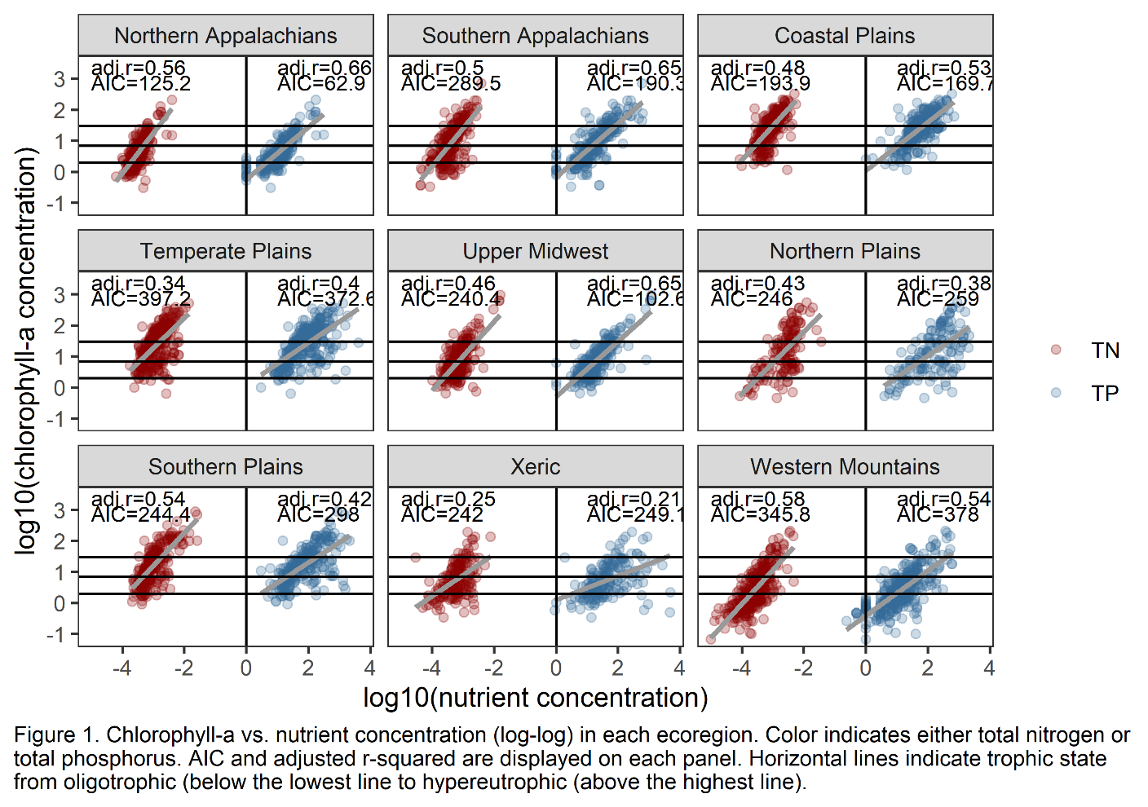

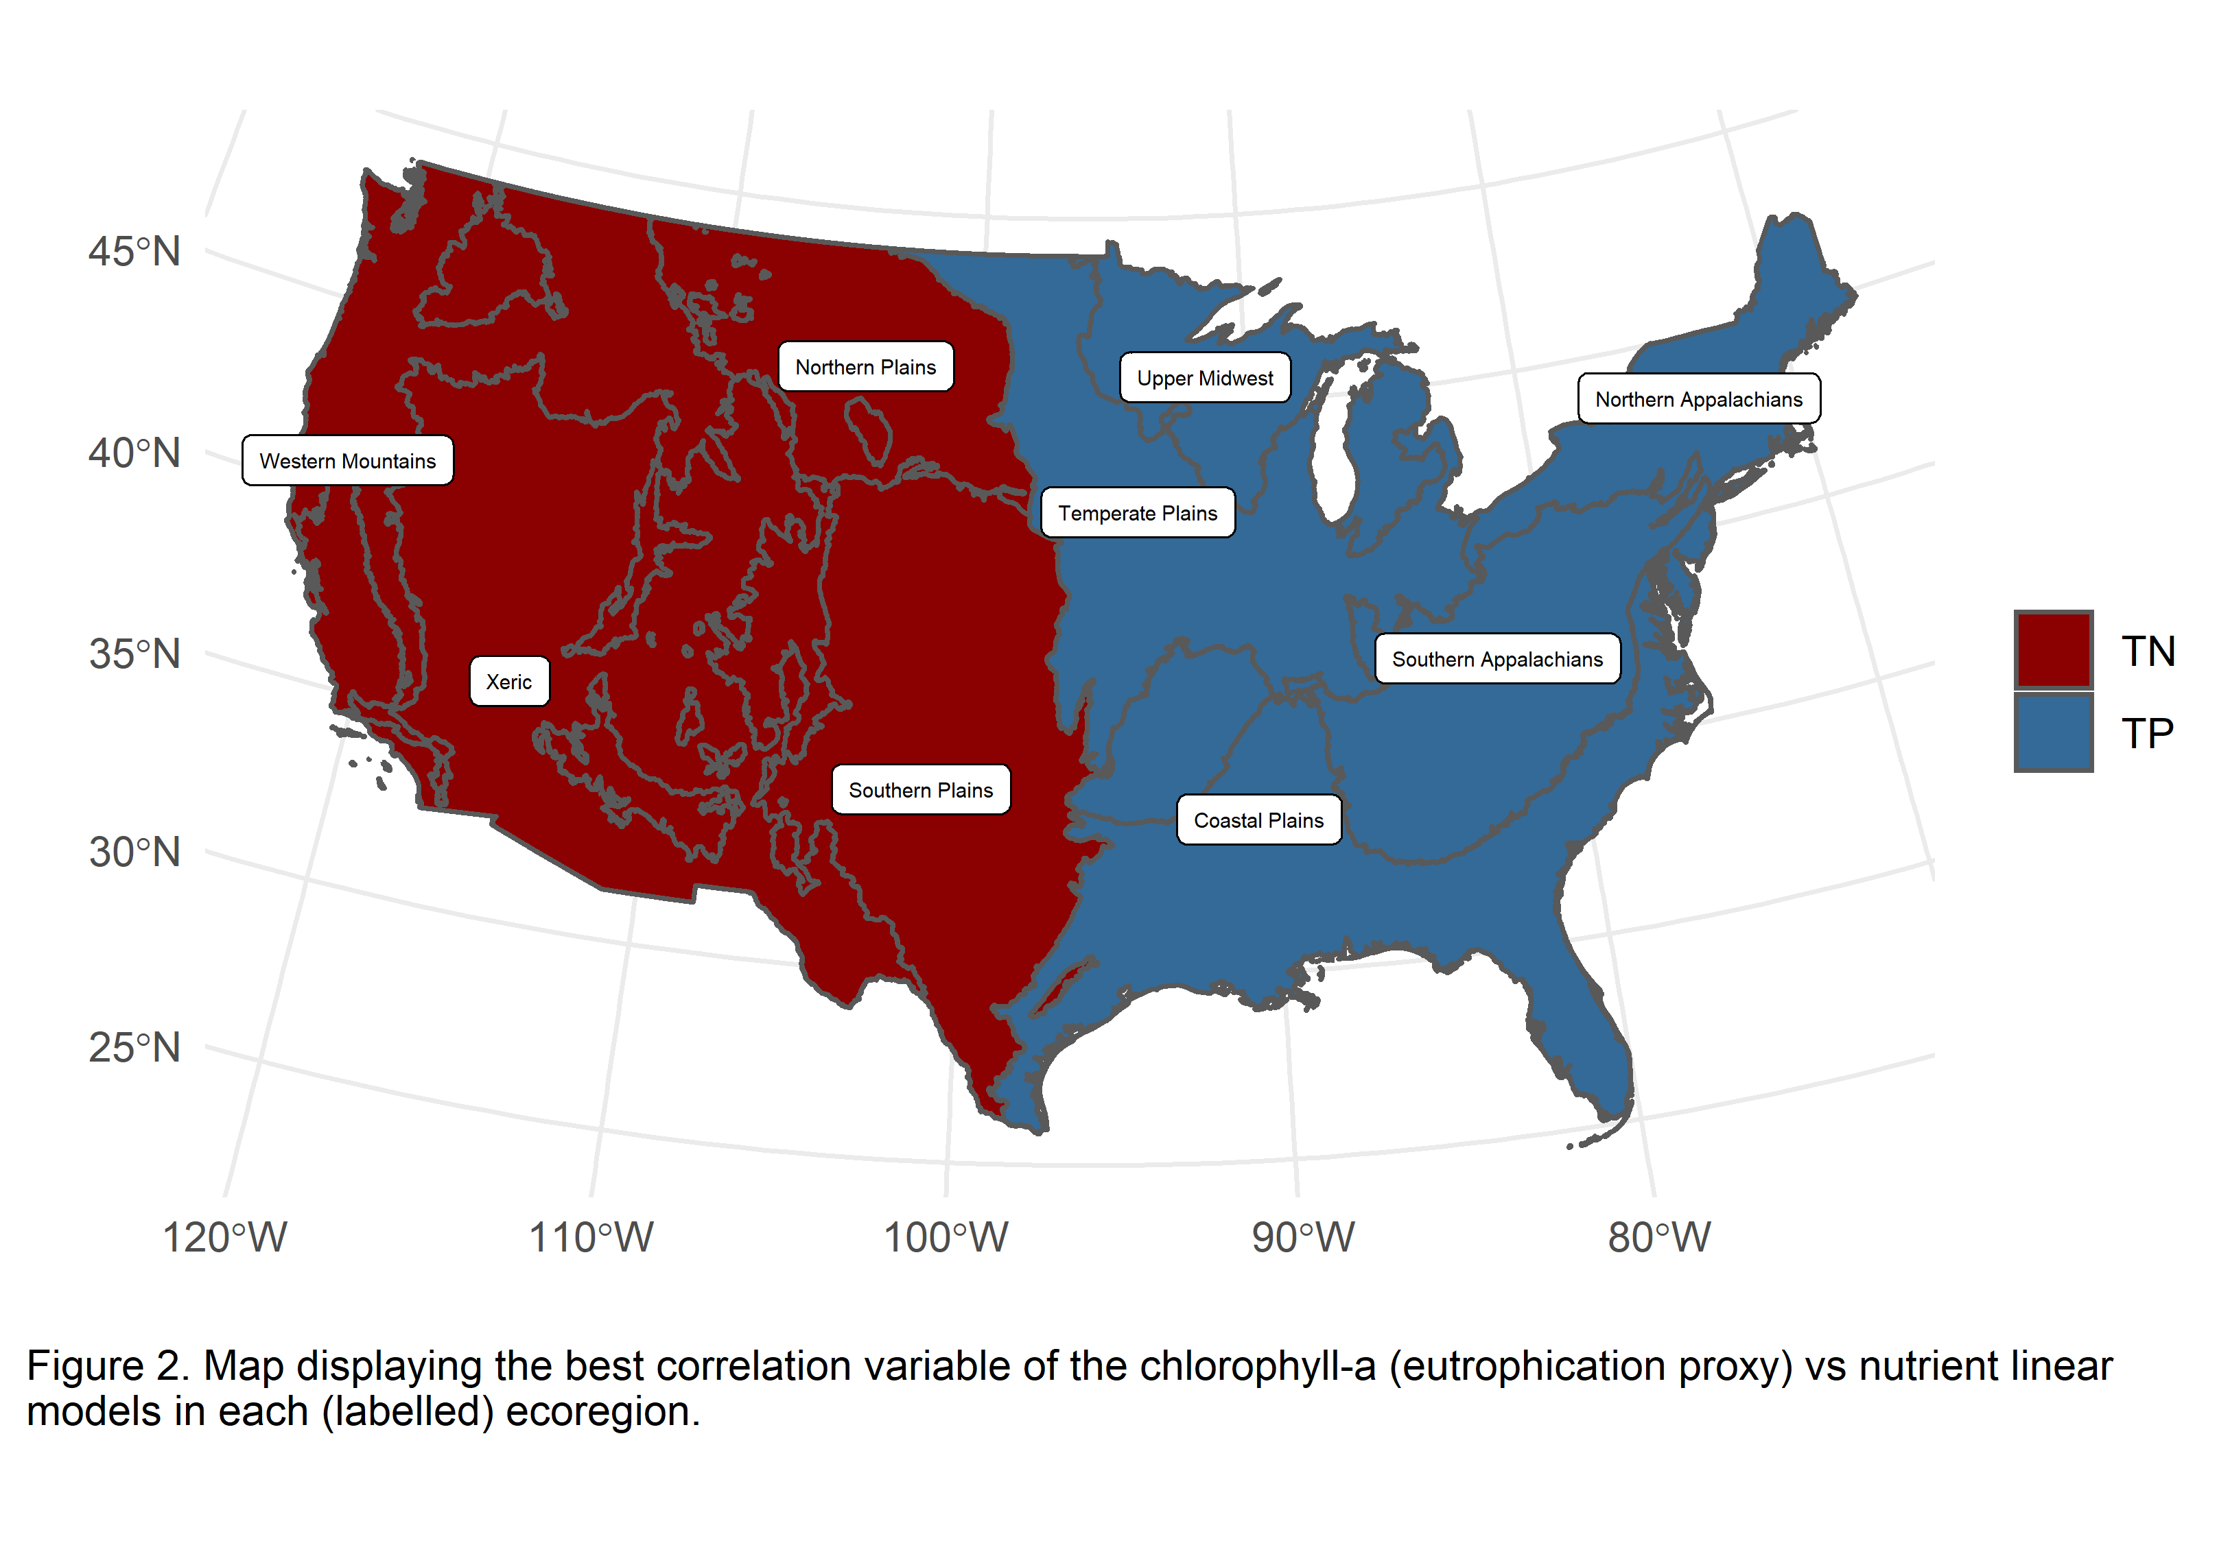

### Limitation shifts

There were 719 observations of P-limited lakes, 919 N-limited lakes, and 615 co-nutrient limited lakes across the entire dataset based on the criteria used (Table 1, Figure 3). The proportion of lakes in each limitation status varies across ecoregions and survey years (Figure 4). Nationally, in 2007, 21.5% of lakes were co-limited by both N and P, and that number increased to 35% in 2017. Approximately half of the lakes across the U.S. were N-limited and that number decreased by 7.3% between 2007 and 2017. And in 2007, 32.7% of lakes were P-limited and that number decreased to 26.4% in 2017. Among the ecoregions, the largest shifts in limitation occurred in the Upper Midwest and Southern Plains. In the Upper Midwest, co-nutrient limited lakes increased from 24.1% in 2007 to 77.4% in 2017. And in the Southern Plains, N-limitation increased from 3.6% to 37.8% in 2017.

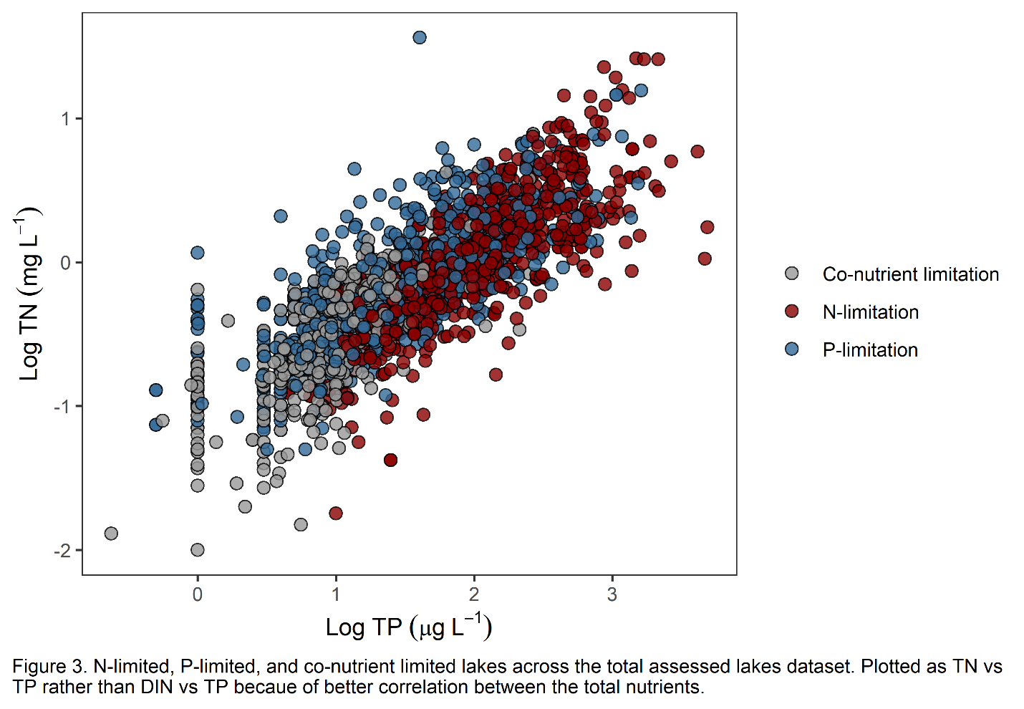

#### 

#### Resampled lakes

At the national scale among lakes sampled in both surveys (dotted lines in Figure 5a), there was a significant increase in co-nutrient limited lakes (16.2%) and a significant decrease in N-limited lakes (-10.1%). At the National scale, there was no net change in the percentage of P-limited lakes, but substantial changes within the nine aggregated ecoregions (Figure 5b). In the Northern Appalachians, lakes shifted from N-limitation (-19.9%) toward P-limitation (27.3%). The change in co-nutrient limited lakes as statistically insignificant as indicated by the error bar overlap with zero. The only change in the Coastal Plains was a positive shift in N-limited lakes (15.7%). Lakes in the Temperate Plains shifted from N-limited (-35.9%) toward P-limited (28.6%), with a non-statistically significant change in co-nutrient limited lakes. The Upper Midwest lakes shifted from being N-limited (-37%) and P-limited (-24.5%) toward co-nutrient limitation (61.4%). In the Northern Plains, lakes became more co-nutrient limited (21.8%) and less P-limited (-28%), with a statistically insignificant decrease in N-limited lakes. The Southern Plains showed the opposite pattern with a decrease in co-nutrient limitation (-17.9%), increase in N-limitation (12.3%), and non-significant increase in P-limited lakes. Western Mountains lakes shifted from P-limited (-33%) to co-nutrient limited (8.2%) and N-limited lakes (24.8%). In the Southern Appalachians and Xeric ecoregions, no shifts were significant.

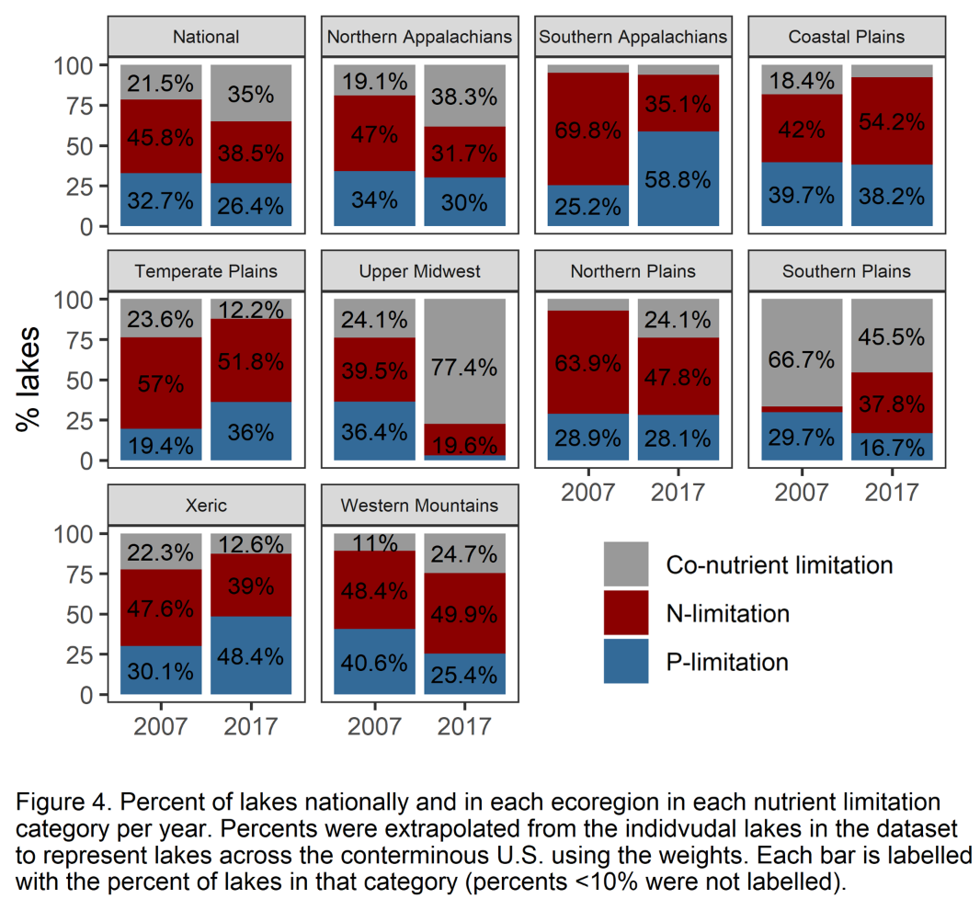

#### All surveyed lakes

When extrapolated to the entire population of lakes across the U.S. (solid lines in Figure 5a), co-nutrient limited lakes also increased (13.5%) and N-limited lakes decreased (-7.2%). Using the entire population of all surveyed lakes, there was a non-statistically significant change in P-limited lakes, which contrasts the results of the resampled population though the trend was still decreasing. The trends of the resampled lakes were generally representative of the full population in the ecoregions, though magnitudes differed and there were a few stark differences (solid lines in Figure 5b). For example, there was a change in the direction of the shift in co-nutrient limited lakes in the Northern Appalachians such that among the full population assessment, there was a 19.2% increase compared to a 7.4% decrease (though not statistically significant) in the resampled lakes. Similarly, the shift in co-nutrient limited lakes changed sign and was significant in the Temperate Plains (-11.4%, compared to 7.3% (insignificant) in resampled lakes). The Coastal Plains and Xeric ecoregions both experienced significant decreases in co-nutrient limitation among all surveyed lakes (-10.7% and -9.7%, respectively), compared to the non-statistically significant, but still negative, shifts among resampled lakes. The percentage of N-limited lakes in the Northern Plains changed signs and was statistically significant (-16.1%) in the assessment of all surveyed lakes compared to the resampled lakes assessment. In the Temperate Plains and Western Mountains, which demonstrated significant shifts in N-limitation among the resampled lakes (-35.9% and 24.7%, respectively), kept the same sign but were statistically insignificant among all surveyed lakes. There were no shifts in the percentage of P-limited lakes in the Northern Appalachians and Northern Plains in the assessment of all surveyed lakes, but the resampled population indicated the shifts were positive (27.3%) and negative (-28%), respectively. P-limited lakes in the Southern Appalachians and Xeric ecoregions indicated statistically significant positive shifts of 35.5% and 18.3%, respectively, rather than the insignificant positive shifts in the resampled lakes. In the Southern Plains, P-limited lakes decreased significantly by -13.1% among all surveyed lakes contrary to the non-significant increase in resampled lakes. The standard error of resampled lakes was greater and significantly different from all surveyed lakes (p < 0.01).

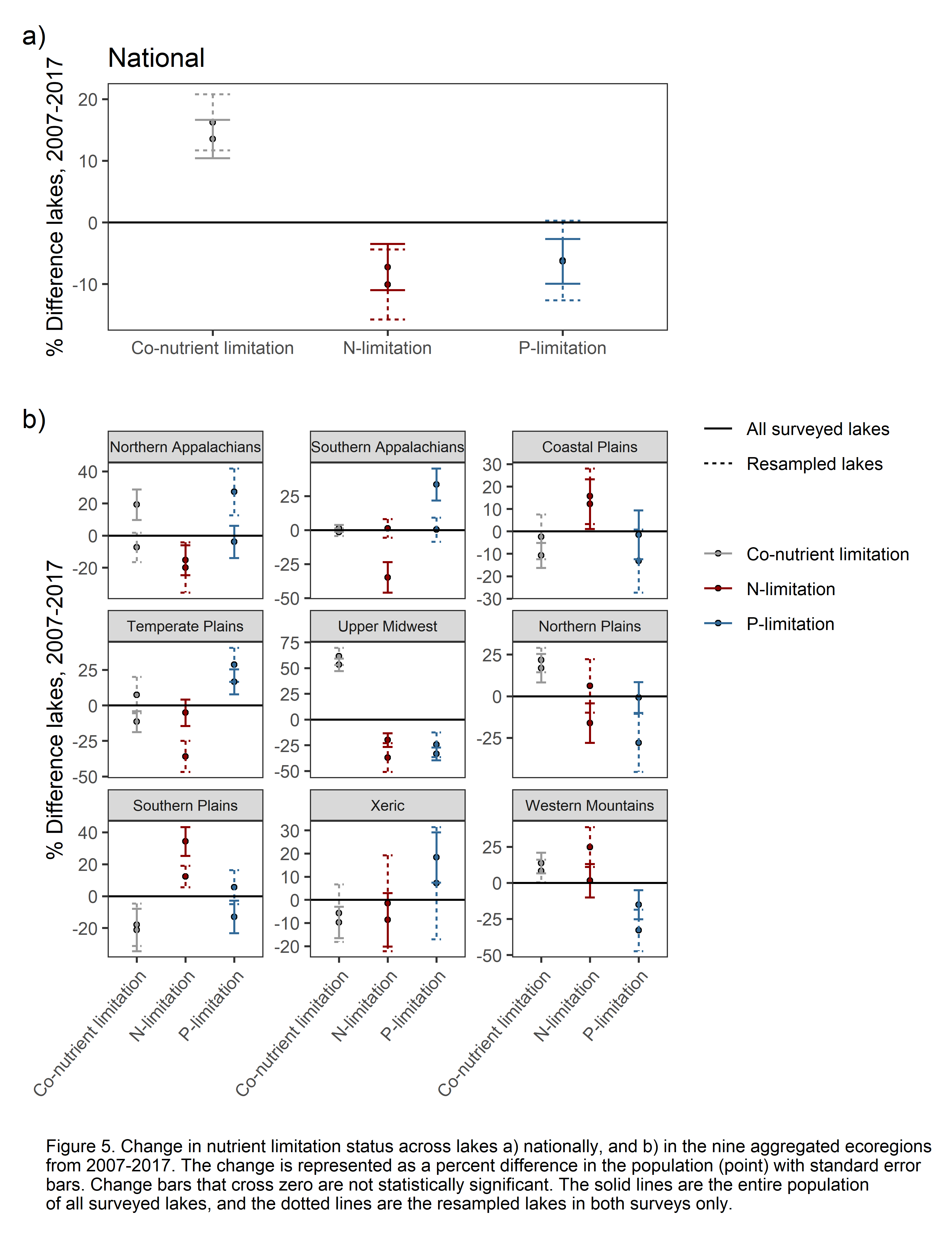

### Trophic state shifts

Using chlorophyll-a as a proxy for trophic state, the survey data indicate that there were 362 oligotrophic lakes (Oligo.), 716 mesotrophic lakes (Meso.), 692 eutrophic lakes (Eutro.), and 883 hypereutrophic lakes (Hyper.) among the surveyed observations. Between 2007 and 2017 lakes across the conterminous U.S. showed negligible changes in trophic state, though slight decreases in oligotrophic and mesotrophic systems and slight increases in eutrophic and hypereutrophic systems and in 2017, lakes considered eutrophic or greater made up 53.2% of lakes in the U.S. (Figure 6). These patterns varied across ecoregions. In the Xeric region, we observed a large increase in eutrophic lakes from 21.7% in 2007 to 42.7% in 2017, with both oligotrophic and hypereutrophic lakes decreasing. Yet in the Northern Plains, hypereutrophic lakes increased from 23.8% in 2007 to 39.5% in 2017. The Northern Appalachians and Western Plains both maintained at least >75% of lakes classified as oligotrophic or mesotrophic across both survey years and mesotrophic lakes. This is contrasted with the Coastal Plains, Temperate Plains, and Northern Plains which all maintained at least >67% eutrophic and hypereutrophic systems.

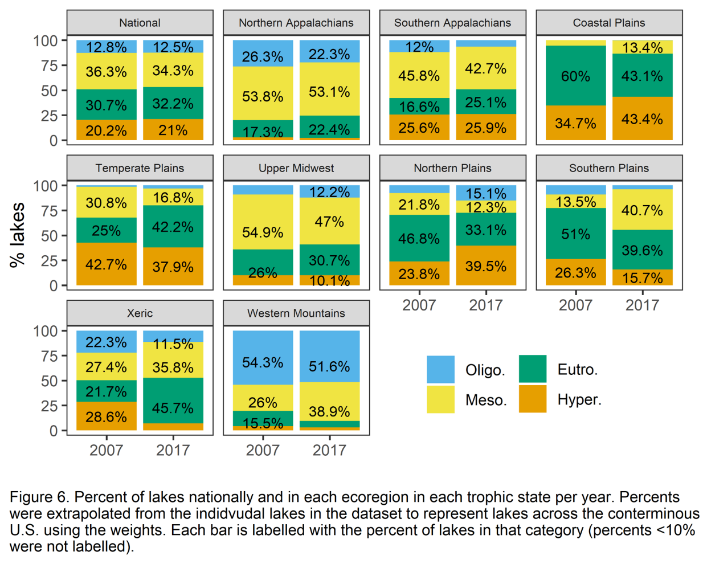

#### Resampled lakes

At the national scale, resampled lakes became less hypereutrophic (-8.3%) and more mesotrophic (9%), with no net change in oligotrophic and eutrophic lakes (top left panel of Figure 7, dotted lines). However, changes in trophic state varied depending on nutrient limitation (dotted lines in Figure 7). Co-nutrient limited lakes followed the overall national pattern, with these lakes becoming less hypereutrophic (-10.3%) and more mesotrophic (13.8%) with marginal changes in the percentage of oligotrophic or eutrophic co-limited lakes. The only substantial shift in trophic state of N-limited lakes occurred with an increase in hypereutrophic systems (14.5%). P-limited lakes showed the most widespread changes in trophic state. Specifically, the percentage of oligotrophic and hypereutrophic lakes decreased (-9.2% and -22.1% respectively), while the percentage of eutrophic lakes increased by 23.6%.

#### All surveyed lakes

The resampled lakes results differed in a few ways from the estimates of all surveyed lakes (solid lines in Figure 7). When considering all the lakes in the NLA survey years 2007 and 2017, there were no significant shifts across trophic states, indicated by the error bars crossing zero. Though there were nuances among trophic state within the different limitation categories. Co-nutrient limited lakes shifted from hypereutrophic (-3.9%) toward mesotrophic (9.5%) status with no significant change in oligotrophic of eutrophic status. N-limited lakes became less oligotrophic (-2.4%) and mesotrophic (-13%) and more eutrophic (4.1%) and hypereutrophic (11.4%). P-limited lakes showed a significant decrease in mesotrophic lakes (-7.8%) and a significant increase in eutrophic lakes (8.5%) with marginal changes in mesotrophic or hypereutrophic status lakes. The standard error of resampled lakes was greater and significantly different from all surveyed lakes (p < 0.01).

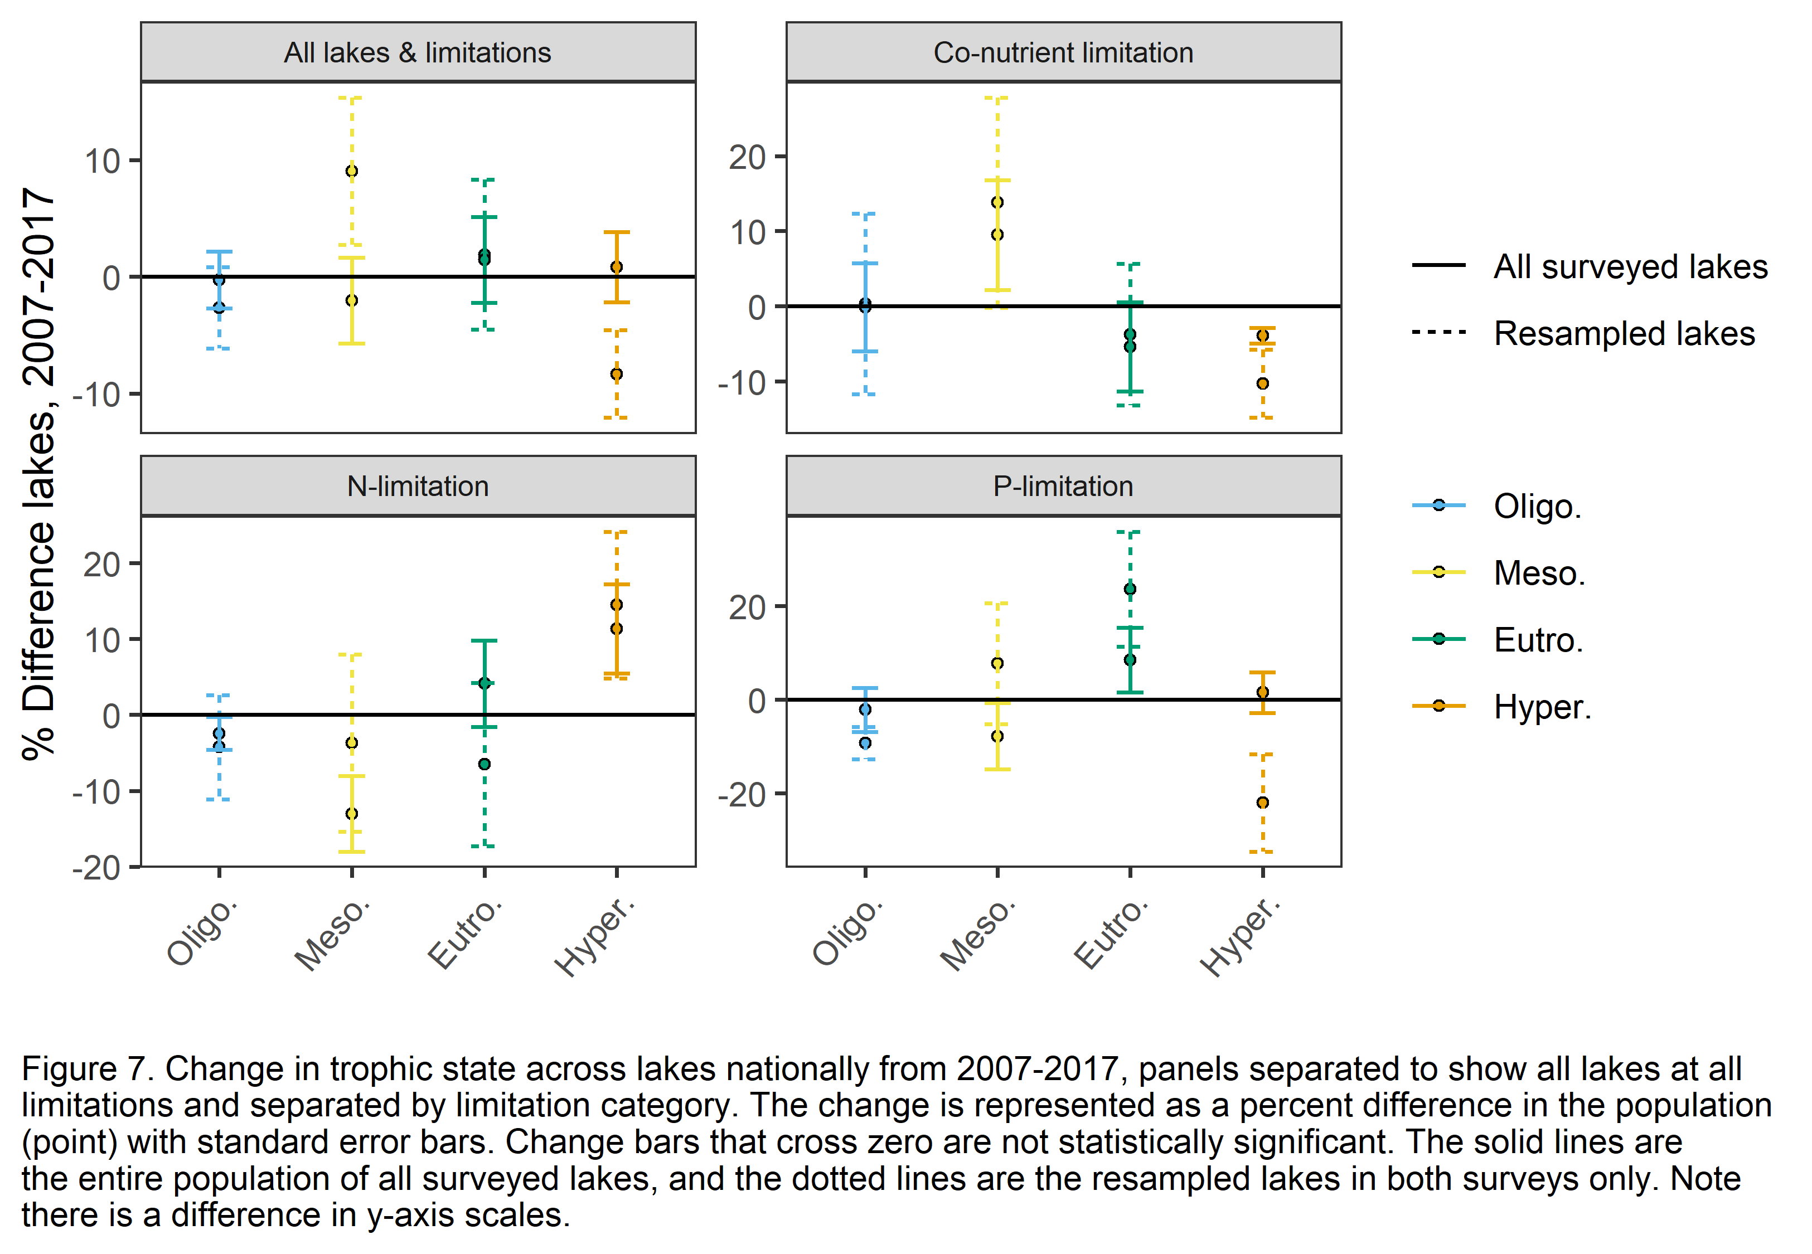

# Discussion

This study intended to explore questions of nutrient limitation and water quality in U.S. lakes and through that to support efforts related to nutrient management strategies. The pattern of TN more strongly controlling eutrophication in the Western U.S. compared to TP in the Eastern U.S. supports the idea that regional scale processes can influence nutrient composition in lakes (Figures 1,2). Potential explanations for this pattern include nutrient input dynamics, like N-deposition sensitivity (Burpee et al., 2022), and surrounding vegetation characteristics (Kopáček et al., 2000). The ecoregions of the Eastern U.S. are generally characterized by greater forest and agricultural land cover, whereas the Western U.S. is characterized by greater grasslands and pastureland cover. Moreover, N-deposition has demonstrated its potential detrimental impacts on Western ecosystems (Fenn et al., 2003) while legacy accumulation of P is much higher in the Eastern U.S. (Sabo et al., 2021). Understanding these differences can inform region-specific management strategies to mitigate the impacts of eutrophication.

The overall shifts toward co-nutrient limitation across the U.S. and away from single nutrient limitation suggests the critical importance of both N and P when assessing water quality in U.S. lakes (Figures 5). Co-limitation can occur when either both nutrients are at low concentrations, or when adding N, P, or both causes an increase productivity, either among various organisms or by stoichiometrically balancing resources to allow for greater nutrient assimilation by organisms (Arrigo, 2005). Likely, both scenarios are occurring across U.S. lakes. When nutrient concentrations are high in co-limited lakes, it indicates the extent of nutrient excess plaguing our freshwaters (Dodds et al., 2008, 2011) and the potential for these lakes to vacillate between limitation statuses. The shift away from hypereutrophic lakes toward mesotrophic lakes among co-nutrient limited lakes suggests that many of these lakes may be either improving condition or in a state of flux as mesotrophic systems are in a complex state of neither excess nor lack of nutrients.

Knowing where these shifts are occurring, and the magnitude can help to prioritize areas in need of management. For example, the Upper Midwest, an area notorious for high nutrient loading, may be in part driving the shift toward co-nutrient limitation and warrants further exploration into the nutrient balance in these lakes (Figure 5). While N-limitation generally decreased in the US, the Southern Plains experienced an over 30% increase in N-limited lakes across all surveyed lakes (Figure 5), and N-limited lakes were especially susceptible to hypereutrophication (Figure 7). Lakes that were N-limited demonstrated shifts among the most extreme trophic states with decreasing oligotrophication and increasing hypereutrophication compared to P-limitation, where mesotrophic lakes decreased, and eutrophic lakes increased in all surveyed lakes (Figure 7). This suggests the focus on a single nutrient may be counterproductive when the goal is eutrophication management.

Assessments from the lakes resampled in multiple NLA surveys led to different and sometimes contradictory results than assessments of all surveyed lakes (see dotted vs. solid lines in Figures 5,7). Although there was error around the shift estimates for both subsets of the data, the larger error in the resampled lakes suggests that estimating shifts in all surveyed lakes may provide more relevant information. Overall, using different subsets of the NLA surveys can influence results and any management inferences and care should be taken when applying conclusions to smaller management plans. There is a remaining question of which method more accurately describes the broad scale reality, and more research is needed to examine this inquiry further.

Understanding nutrient limitation impact and trophic state shifts in U.S. lakes can serve as a starting point for determining strategies toward improved water quality. The NLA data, which provide a comprehensive survey of U.S. lakes demonstrated the need for a balanced nutrient remediation approach. Balancing nutrient stoichiometry may be one way to remediate eutrophic lakes, while also controlling the input of excess nutrients (Stutter et al., 2018). For example, reductions in P pollution has led to the accumulation of N in large lakes across the world (Finlay et al., 2013). Managing only N or P can lead to unintended ecological consequences caused by availability of the other nutrient (Glibert, 2017; Paerl et al., 2016). Co-nutrient limitation illustrates a need for balanced nutrient management. For example, in the Upper Midwest in 2017, 77.4% of lakes were co-nutrient limited and 77.7% of lakes were in the potential flux category of mesotrophic and eutrophic. Furthermore, changing climate and other human-induced stressors will likely exacerbate eutrophication and the need for management and assuming a single nutrient is limiting can result in the export of other nutrients and increased productivity problems downstream (Wurtsbaugh et al., 2019). Connectivity of freshwaters across the landscape necessitates the need for stoichiometrically balanced nutrient management since along the continuum of freshwaters to the ocean, limitation may shift. Management strategies that focus on a sole nutrient could increase availability of the other limiting nutrient in subsequent waters, thus intensifying eutrophication downstream (Conley et al., 2009).

Through this broad scale analysis, we observed that N and P together can be consequential for water quality of lakes across the U.S. and that sole nutrient management focus may be a more reactive effort than proactive. We should note that in this study, we are assuming limitation for whole lake ecosystems and using total and dissolved nutrient pools rather than understanding specifics about the real species communities and their nutrient requirements. We acknowledge that limitation and trophic state likely depend on a lot of criteria, and here we are using the readily available nutrient and chlorophyll-a concentrations as proxy measurements. Rather than relying on experimental data, which requires extensive time and money, we hope this may serve as a method to estimate limitation and water quality using the resources available. Nutrient limitation varies through space and time and suggests that lakes are shifting toward co-nutrient limitation or may swing back and forth between N- and P-limitation. Future research should identify the drivers behind the magnitudes of these shifts in both limitation and trophic state categories and whether management interventions can prevent a widespread transition toward eutrophication.

# References

Arrigo, K. R. (2005). Marine microorganisms and global nutrient cycles. *Nature*, *437*(7057), 349–355. https://doi.org/10.1038/nature04159

Bergström, A. K. (2010). The use of TN:TP and DIN:TP ratios as indicators for phytoplankton nutrient limitation in oligotrophic lakes affected by N deposition. *Aquatic Sciences*, *72*(3), 277–281. https://doi.org/10.1007/S00027-010-0132-0/FIGURES/1

Bergström, A. K., & Jansson, M. (2006). Atmospheric nitrogen deposition has caused nitrogen enrichment and eutrophication of lakes in the northern hemisphere. *Global Change Biology*, *12*(4), 635–643. https://doi.org/10.1111/j.1365-2486.2006.01129.x

Burpee, B. T., Saros, J. E., Nanus, L., Baron, J., Brahney, J., Christianson, K. R., Ganz, T., Heard, A., Hundey, B., Koinig, K. A., Kopáček, J., Moser, K., Nydick, K., Oleksy, I., Sadro, S., Sommaruga, R., Vinebrooke, R., & Williams, J. (2022). Identifying factors that affect mountain lake sensitivity to atmospheric nitrogen deposition across multiple scales. *Water Research*, *209*, 117883. https://doi.org/10.1016/j.watres.2021.117883

Camargo, J. A., & Alonso, Á. (2006). Ecological and toxicological effects of inorganic nitrogen pollution in aquatic ecosystems: A global assessment. *Environment International*, *32*(6), 831–849. https://doi.org/10.1016/J.ENVINT.2006.05.002

Conley, D. J., Paerl, H. W., Howarth, R. W., Boesch, D. F., Seitzinger, S. P., Havens, K. E., Lancelot, C., & Likens, G. E. (2009). Controlling Eutrophication: Nitrogen and Phosphorus. *Science*, *323*(5917), 1014–1015. https://doi.org/10.1126/science.1167755

Correll, D. (1999). Phosphorus: A rate limiting nutrient in surface waters. *Poultry Science*, *78*(5), 674–682. https://doi.org/10.1093/ps/78.5.674

Dodds, W. K., Bouska, W. W., Eitzmann, J. L., Pilger, T. J., Pitts, K. L., Riley, A. J., Schloesser, J. T., & Thornbrugh, D. J. (2008). Eutrophication of U.S. Freshwaters: Analysis of Potential Economic Damages. *Environmental Science and Technology*, *43*(1), 12–19. https://doi.org/10.1021/ES801217Q

Dodds, W. K., Smith, V. H., & Lohman, K. (2011). Nitrogen and phosphorus relationships to benthic algal biomass in temperate streams. *Https://Doi.Org/10.1139/F02-063*, *59*(5), 865–874. https://doi.org/10.1139/F02-063

Downing, J. A., & McCauley, E. (1992). The nitrogen: Phosphorus relationship in lakes. *Limnology and Oceanography*, *37*(5), 936–945. https://doi.org/10.4319/LO.1992.37.5.0936

Dumelle, M., Kincaid, T. M., Olsen, A. R., & Weber, M. H. (2022). *spsurvey: Spatial Sampling Design and Analysis*.

Elser, J. J., Marzolf, E. R., Goldrnan, C. R., Marnoif, E. R., & Goldman, C. 8. (2011). Phosphorus and Nitrogen Limitation of Phytoplankton Growth in the Freshwaters of North America: A Review and Critique of Experimental Enrichments. *Https://Doi.Org/10.1139/F90-165*, *47*(7), 1468–1477. https://doi.org/10.1139/F90-165

Fenn, M. E., Baron, J. S., Allen, E. B., Rueth, H. M., Nydick, K. R., Geiser, L., Bowman, W. D., Sickman, J. O., Meixner, T., Johnson, D. W., & Neitlich, P. (2003). Ecological Effects of Nitrogen Deposition in the Western United States. *BioScience*, *53*(4), 404–420. https://doi.org/10.1641/0006-3568(2003)053[0404:EEONDI]2.0.CO;2

Finlay, J. C., Small, G. E., & Sterner, R. W. (2013). Human influences on nitrogen removal in lakes. *Science*, *342*(6155), 247–250. https://doi.org/10.1126/SCIENCE.1242575

Glibert, P. M. (2017). Eutrophication, harmful algae and biodiversity—Challenging paradigms in a world of complex nutrient changes. *Marine Pollution Bulletin*, *124*(2), 591–606. https://doi.org/10.1016/j.marpolbul.2017.04.027

Guildford, S. J., & Hecky, R. E. (2000). Total nitrogen, total phosphorus, and nutrient limitation in lakes and oceans: Is there a common relationship? *Limnology and Oceanography*, *45*(6), 1213–1223. https://doi.org/10.4319/lo.2000.45.6.1213

Havens, K. E. (1995). Secondary nitrogen limitation in a subtropical lake impacted by non-point source agricultural pollution. *Environmental Pollution*, *89*(3), 241–246. https://doi.org/10.1016/0269-7491(94)00076-P

Hellström, T. (1996). An empirical study of nitrogen dynamics in lakes. *Water Environment Research*, *68*(1), 55–65. https://doi.org/10.2175/106143096X127208

Hogan, E. J., McGowan, S., & Anderson, N. J. (2014). Nutrient limitation of periphyton growth in arctic lakes in south-west Greenland. *Polar Biology*, *37*(9), 1331–1342. https://doi.org/10.1007/s00300-014-1524-8

Kopáček, J., Stuchlík, E., Straškrabová, V., & Pšenáková, P. (2000). Factors governing nutrient status of mountain lakes in the Tatra Mountains. *Freshwater Biology*, *43*(3), 369–383. https://doi.org/10.1046/J.1365-2427.2000.00569.X

Oleksy, I. A., Baron, J. S., Leavitt, P. R., & Spaulding, S. A. (2020). Nutrients and warming interact to force mountain lakes into unprecedented ecological states. *Proceedings of the Royal Society B*, *287*(1930), 20200304–20200304. https://doi.org/10.1098/RSPB.2020.0304

Omernik, J. M. (1987). Ecoregions of the Conterminous United States. *Annals of the Association of American Geographers*, *77*(1), 118–125. https://doi.org/10.1111/J.1467-8306.1987.TB00149.X

Oviedo-Vargas, D., Royer, T. V., & Johnson, L. T. (2013). Dissolved organic carbon manipulation reveals coupled cycling of carbon, nitrogen, and phosphorus in a nitrogen-rich stream. *Limnology and Oceanography*, *58*(4), 1196–1206. https://doi.org/10.4319/LO.2013.58.4.1196

Paerl, H. W., Scott, J. T., McCarthy, M. J., Newell, S. E., Gardner, W. S., Havens, K. E., Hoffman, D. K., Wilhelm, S. W., & Wurtsbaugh, W. A. (2016). It Takes Two to Tango: When and Where Dual Nutrient (N & P) Reductions Are Needed to Protect Lakes and Downstream Ecosystems. *Environmental Science & Technology*, *50*(20), 10805–10813. https://doi.org/10.1021/acs.est.6b02575

Pebesma, E. (2018). Simple Features for R: Standardized Support for Spatial Vector Data. *The R Journal*, *10*(1), 439–446. https://doi.org/10.32614/RJ-2018-009

Ptacnik, R., Andersen, T., & Tamminen, T. (2010). Performance of the Redfield Ratio and a Family of Nutrient Limitation Indicators as Thresholds for Phytoplankton N vs. P Limitation. *Ecosystems*, *13*(8), 1201–1214. https://doi.org/10.1007/S10021-010-9380-Z/FIGURES/5

R Core Team. (2022). *R: A Language and Environment for Statistical Computing*. https://www.R-project.org/

Redfield, A. C. (1958). THE BIOLOGICAL CONTROL OF CHEMICAL FACTORS IN THE ENVIRONMENT. *American Scientist*, *46*(3), 230A – 221.

Redoglio, A., Radtke, K., & Sperfeld, E. (2022). How nitrogen and phosphorus supply to nutrient-limited autotroph communities affects herbivore growth: Testing stoichiometric and co-limitation theory across trophic levels. *Oikos*, *2022*(9), e09052. https://doi.org/10.1111/oik.09052

Reid, A. J., Carlson, A. K., Creed, I. F., Eliason, E. J., Gell, P. A., Johnson, P. T. J., Kidd, K. A., MacCormack, T. J., Olden, J. D., Ormerod, S. J., Smol, J. P., Taylor, W. W., Tockner, K., Vermaire, J. C., Dudgeon, D., & Cooke, S. J. (2019). Emerging threats and persistent conservation challenges for freshwater biodiversity. *Biological Reviews*, *94*(3), 849–873. https://doi.org/10.1111/brv.12480

Rhee, G. ‐Y, & Gotham, I. J. (1980). OPTIMUM N:P RATIOS AND COEXISTENCE OF PLANKTONIC ALGAE1. *Journal of Phycology*, *16*(4), 486–489. https://doi.org/10.1111/J.1529-8817.1980.TB03065.X

Sabo, R. D., Clark, C. M., Gibbs, D. A., Metson, G. S., Todd, M. J., LeDuc, S. D., Greiner, D., Fry, M. M., Polinsky, R., Yang, Q., Tian, H., & Compton, J. E. (2021). Phosphorus Inventory for the Conterminous United States (2002–2012). *Journal of Geophysical Research: Biogeosciences*, *126*(4), e2020JG005684. https://doi.org/10.1029/2020JG005684

Sinha, E., Michalak, A. M., & Balaji, V. (2017). Eutrophication will increase during the 21st century as a result of precipitation changes. *Science*, *357*(6349), 405–408. https://doi.org/10.1126/science.aan2409

Smith, V. H., & Schindler, D. W. (2009). Eutrophication science: Where do we go from here? *Trends in Ecology & Evolution*, *24*(4), 201–207. https://doi.org/10.1016/J.TREE.2008.11.009

Sterner, R. Warner., & Elser, J. J. (2002). *Ecological stoichiometry: The biology of elements from molecules to the biosphere*.

Stutter, M. I., Graeber, D., Evans, C. D., Wade, A. J., & Withers, P. J. A. (2018). Balancing macronutrient stoichiometry to alleviate eutrophication. *Science of The Total Environment*, *634*, 439–447. https://doi.org/10.1016/J.SCITOTENV.2018.03.298

USEPA. (2007a). Survey of the Nation’s Lakes. Field Operations Manual. EPA 841-B-07- 004. *U.S. Environmental Protection Agency, Washington, DC*. https://www.epa.gov/national-aquatic-resource-surveys/national-lakes-assessment-2007-field-operations-manual

USEPA. (2007b). Survey of the Nation’s Lakes: Integrated Quality Assurance Project Plan. EPA/841-B-07-003. *U.S. Environmental Protection Agency, Office of Water and Office of Research and Development, Washington, DC*. https://www.epa.gov/national-aquatic-resource-surveys/national-lakes-assessment-2007-quality-assurance-project-plan

USEPA. (2010). *National Aquatic Resource Surveys. National Lakes Assessment 2007 (data and metadata files)*. Available from U.S. EPA website: http://www.epa.gov/national-aquatic-resource-surveys/data-national-aquatic-resource-surveys

USEPA. (2017a). National Lakes Assessment 2017. Field Operations Manual. EPA 841-B-16-002. *U.S. Environmental Protection Agency, Washington, DC*. https://www.epa.gov/national-aquatic-resource-surveys/national-lakes-assessment-2017-field-operations-manual

USEPA. (2017b). National Lakes Assessment 2017. Laboratory Operations Manual. V.1.1. EPA 841‐B‐16‐ 004. *U.S. Environmental Protection Agency, Washington, DC*. https://www.epa.gov/national-aquatic-resource-surveys/national-lakes-assessment-2017-laboratory-operations-manual

USEPA. (2022a). *National Aquatic Resource Surveys. National Lakes Assessment 2017 (data and metadata files)*. Available from U.S. EPA website: http://www.epa.gov/national-aquatic-resource-surveys/data-national-aquatic-resource-surveys

USEPA. (2022b). National Lakes Assessment 2017: Technical Support Document. EPA 841‐R‐22‐001. *U.S. Environmental Protection Agency, Office of Water and Office of Research and Development*. https://www.epa.gov/national-aquatic-resource-surveys/national-lakes-assessment-2017-technical-support-document

USEPA, Gibson, G., Carlson, R., Simpson, J., Smeltzer, E., Gerritson, J., Chapra, S., Heiskary, S., Jones, J., & Kennedy, R. (2000). *Nutrient Criteria Technical Guidance Manual Lakes and Reservoirs. EPA-822-B00-001.* 232.

Wetzel, R. G. (2001). *Limnology*. Academic Press.

Wickham, H., Averick, M., Bryan, J., Chang, W., McGowan, L. D., François, R., Grolemund, G., Hayes, A., Henry, L., Hester, J., Kuhn, M., Pedersen, T. L., Miller, E., Bache, S. M., Müller, K., Ooms, J., Robinson, D., Seidel, D. P., Spinu, V., … Yutani, H. (2019). Welcome to the tidyverse. *Journal of Open Source Software*, *4*(43), 1686. https://doi.org/10.21105/joss.01686

Wurtsbaugh, W. A., Paerl, H. W., & Dodds, W. K. (2019). Nutrients, eutrophication and harmful algal blooms along the freshwater to marine continuum. *WIREs Water*, *6*(5), e1373. https://doi.org/10.1002/wat2.1373

Yao, X., Zhang, Y., Zhang, L., & Zhou, Y. (2018). A bibliometric review of nitrogen research in eutrophic lakes and reservoirs. *Journal of Environmental Sciences*, *66*, 274–285. https://doi.org/10.1016/j.jes.2016.10.022