**AR App Proposal**

**Student Name** : Lincoln Goh Xian Hong

**Student ID** : 2201890

**Class** : DAAA/FT/2A/03

1. **App Title**

AR Meme App

1. **App Features**
2. Core Functions: Scans for flat planes and 3D animated model pops up (which include an Among Us Crewmate, Roblox Bacon Hair, and Squid Game Personnel)
3. Sub Functions: Audio and animation plays when user taps on the 3D models.
   1. Among Us: Model pops out of a vent and screen darkens.
   2. Roblox: Model dances. 2D/3D Words: “Victory Royale” appears in bright gold at the top of the screen. Corresponding audio will be played.
   3. Squid Game: Model equip gun and starts shooting. Spark particle sfx and shooting audio will be played.
4. **App Information Architecture + UI Design**

There will be a hot bar near the bottom of the screen but right above the camera snapshot button. It is transparent in a black shade and has 3 circles that can be clicked/ selected by the user. When clicked, their circle will move upwards slightly as can be seen from the illustration below. The corresponding models then appear upon selection. From left to right, the green circle represents the **Roblox Bacon Hair Model**, the red circle represents the **Among Us Crewmate Model**, and the velvet pink circle represents the **Squid Game Personnel Model**.

UI Design

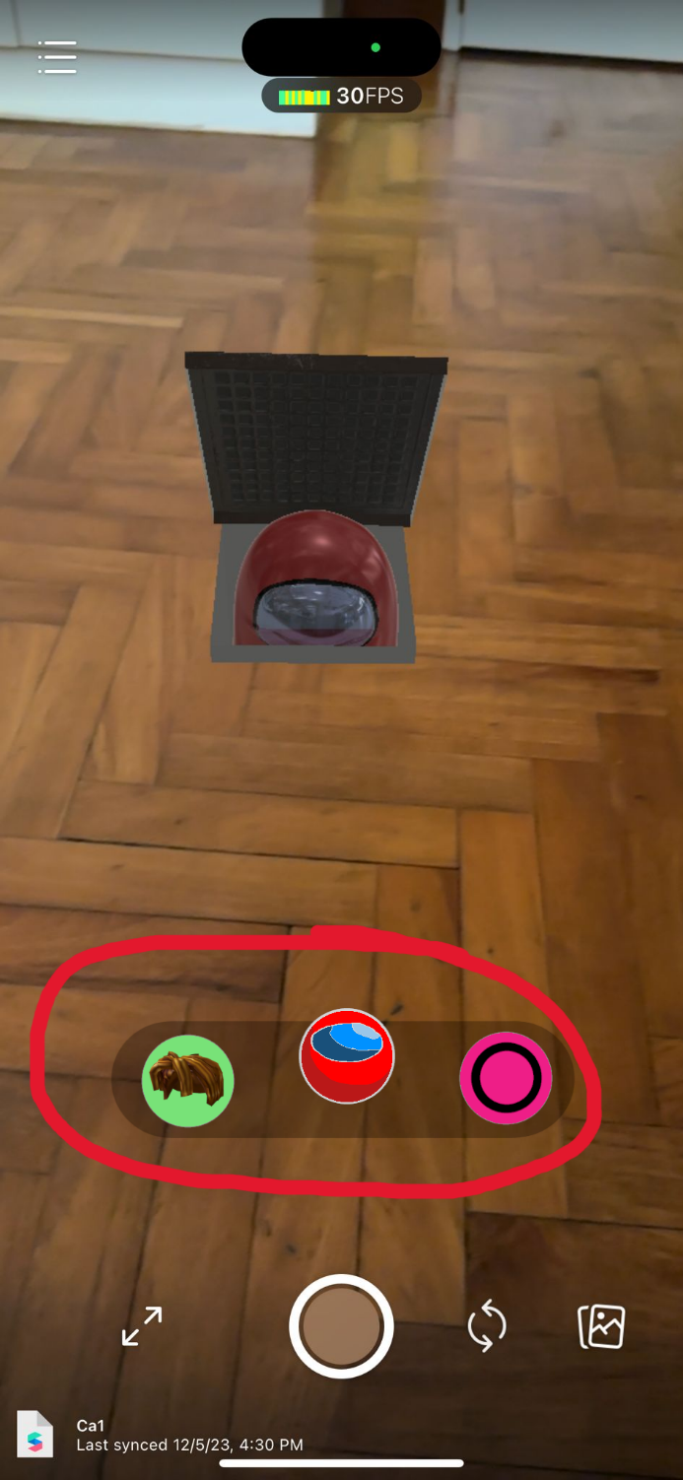

1. **List if using any 3D Models, Image Targets (if you choose fixed target tracker) and Audios etc**

3D Models

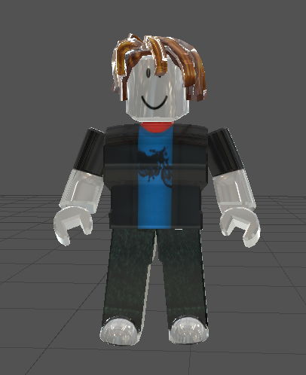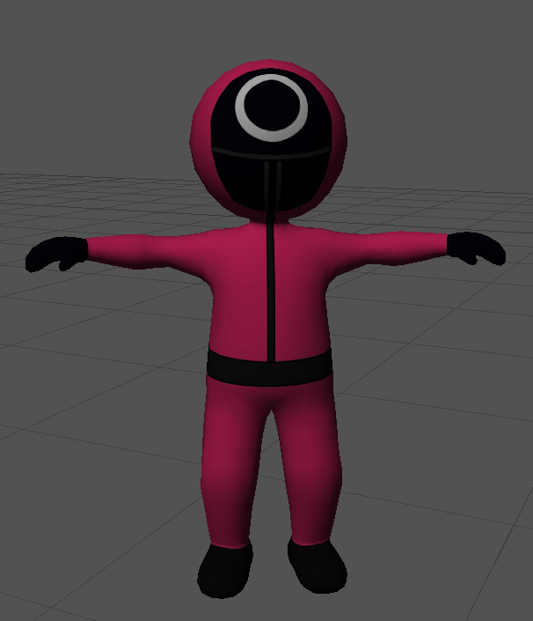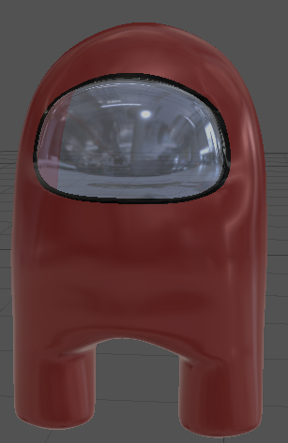

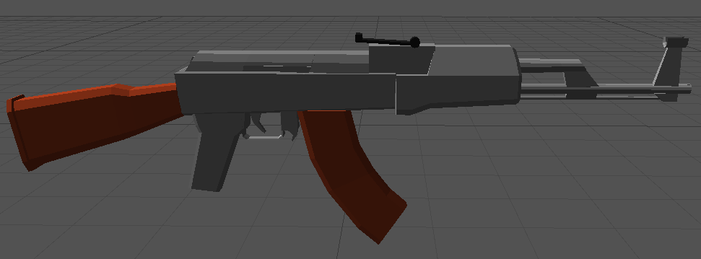

Credits:

|  |  |  |
| --- | --- | --- |
| Title | Source | Author |
| Among Us | <https://sketchfab.com/3d-models/among-us-e3f04536371641e68aa4997d530d5ba0> | Lucasio UwU (https://sketchfab.com/babacetadeo88) |
| Roblox Bacon Rigged | https://sketchfab.com/3d-models/roblox-bacon-rigged-3793527fdc8c4b859d78e6db015bbc6f | Trina.McCoy (https://sketchfab.com/Trina.McCoy) |
| Squid game Worker | <https://sketchfab.com/3d-models/squid-game-worker-d181e216fd6a402db7cc2626d6f78264> | 2Konseil  (https://sketchfab.com/2Konseil) |
| Guns Pack | <https://opengameart.org/content/guns-pack> | Zsky_01  (https://www.patreon.com/Zsky) |

Audio:

<https://www.myinstants.com/en/instant/among-us-35001/>

<https://www.myinstants.com/en/instant/fortnite-default-dance-music-9/>

https://www.myinstants.com/en/instant/machine-gun-fire-46212/

Animation:

<https://www.mixamo.com/#/?page=1&query=shooting&type=Motion%2CMotionPack>

<https://www.mixamo.com/#/?page=1&query=hip+hop+dancing>

Assets  
2D Sprites, 3D Models, Textures, Music, Sound Effects -  Unity Asset Store: <https://assetstore.unity.com/>

2D Sprites, 3D Models, Textures, Music, Sound Effects - Open Game Art: <https://opengameart.org/>

3D Character with Animation - Mixamo:  <https://www.mixamo.com/>

3D Models - Free3D: <https://free3d.com/>

3D Models -  TurboSquid: <https://www.turbosquid.com/>

Textures - Textures: <https://www.textures.com/>

Software  
Image Editing Tool - GIMP:  <https://www.gimp.org>

3D Modeling and Animation Tool - Blender: <https://www.blender.org/>