Setting up the ThetaMon-Probe
We use Visual-Studio Code together with the PlattformIo Plugin.

- Clone the project and open the directory „ThetaMon3/Probes/ThetaProbe/“ in VSC. Build the firmware and flash it to the ESP32 board.
- Prepare a file, named „MqttConfig.txt“ and place it in the „data“ directory. The content should be following:
setMqttHost 192 201 273 83 <-- Your Mqtt broker IP (use spaces instead of dots!)
setMqttPort 1883 <-- Your Mqtt broker Port
setMqttSpot "LivingRoom" <-- Name of the place, where the probe is placed
startWifi "<Your-SSID>" "<Your-SSID-Passphrase>"
The IP-Address must be given with blanks, instead of dots.
The Mqtt-Spot-Name, is used to connect to HomeAssistant, or alike.
The SSID and SSID-Passphrase have to be double-quoted.
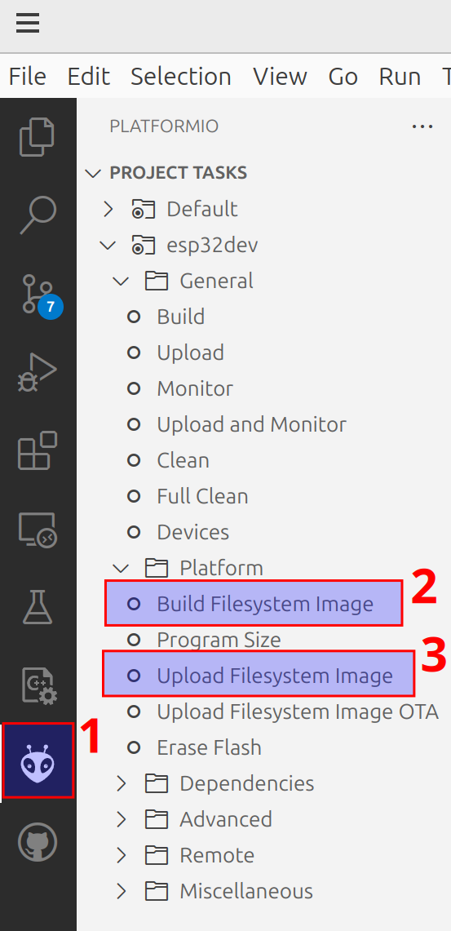
- In Visual Studio Code, go to PlattformIO, then „Build Filesystem Image“, then „Upload Filesystem Image“
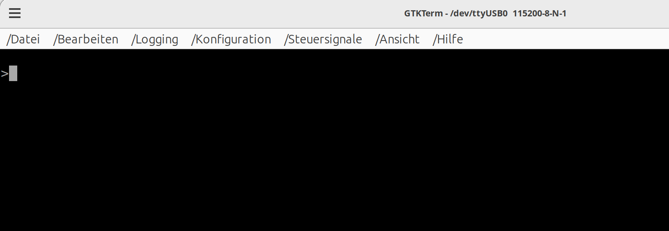
- Open a Terminal program, like GTK-Term, connect to the ESP32-console, press Enter and you should see a command prompt.
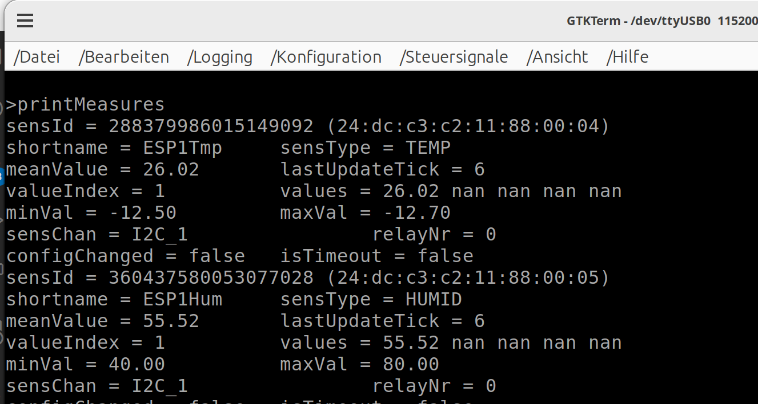
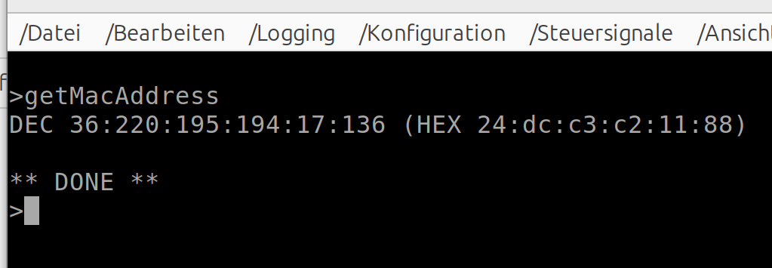
- Type „printMeasures“, you should see data of the connected sensors.
The BME280 Sensor has three entries for Hummidity, Air-Pressure and Temperature. Your printing may look different, because the sensor-Ids are not yet registered in “ID_Table_U64.txt”. The first six segments of the Id are the Mac-Address of your ESP device.
You could get the Mac-Address of your device, simply by typing „getMacAddress“ into the console:
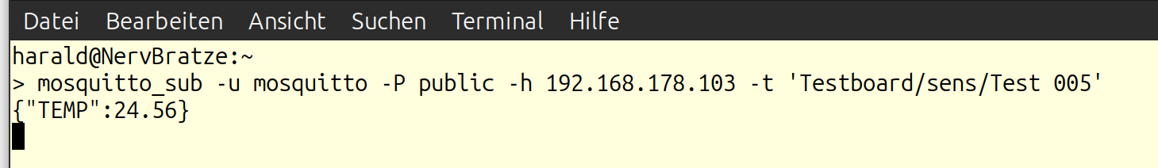
- Open „ID_Table_U64.txt“ in the data-directory. You see a collection of commands, that set up the sensor configuration. Every line can also be typed into the console.
Example line:
setSensId 288253003812035532 -12.5 -12.7 0 0 "WohnzTmp"
„setSensId“ is the command to define sensor attributes, followed by a hash-value of the sensor-address (more to this below).
-12.5: the lower threshold, where the relay-channel is switched on.
-12.7: the upper threshold, where the relay-channel is switched off,
0: (the first one) is the sensor-type.
0 – Temperature
1 – Humidity
2 – Pressure
3 – Relay (We treat Relays as sensor, to read their states)
0: (the second one) defines the relay-channel, that this sensor is bound to.
0 – No channel. This sensor doesn’t switch anything.
1 – Channel 1.
2 – Obviously, Channel 2.
Refer to the schematic, connector J2 to see, how to connect the corresponding relay-channels are to be connected. I use two-channel Arduino rely-boards.
"WohnzTmp": is the short Name of the sensor. It must be exactly eight characters long. This name is used together with the location-name in „MqttConfig.txt“ to build the Mqtt publishing name, in example “Testboard/sens/WohnzTmp” (note the ‚sens‘ in the middle!). If you have mosquitto installed at your machine, the following command shows the message updating the sensor data
> mosquitto_sub -u mosquitto -P public -h 192.168.178.103 -t 'Testboard/sens/Test 005'
Please note, that this message is sent only every five minutes.
- If you now type „printMeasures“ again, you will be shown the actual setting. Bring the hashes into your Id-Table-file, give every sensor a shortname and if you need it define the switching thresholds and the relay-binding.
To get out, which sensor belongs to which address, simply warm them up with your hands and print the measures again. Never ever use a lighter, this will destroy the sensor!
- Save this file into the data directory, build the file-system again and upload it. Reboot your ESP. Remember to close your terminal-connection before connecting with Visual Studio.
- Go back to your console-connection. Check that every sensor is recognized. Type „reboot“ and watch the output. If a sensor was set up correct, you get something like:
>setSensId 4179915027513875496 -12.5 -12.7 0 0 "INNEN_O2"
UpdateConfig done.
** DONE **
otherwise:
>setSensId 14484146576875228968 -12.5 -12.7 0 0 "Test 012"
SensId ignored: 14484146576875228968 (28:8f:56:45:92:06:02:c9)
** DONE **
Of course you could set all of your sensors into a single file and download it to all of your probes. Not connected sensors will simply be ignored.
- If everything went well, you are done. The probe will send the actual values every five minutes to your mqtt-broker.
There are some python tools, you could have a look at.

