Training-Free Recognition of Risk-Relevant Situations in Urban Road Scenes Using Vision Language Models
Ezra Ella¹ Linoy Halifa¹

¹ Afeka College of Engineering Tel Aviv, Israel

Abstract
Urban road environments are central to city safety, where unexpected situations involving vehicles, pedestrians, infrastructure problems and objects on the roadway may elevate risk and disrupt mobility. Continuous monitoring of urban road environments is essential for supporting safe and resilient mobility. However, most existing approaches depend on supervised learning and large labeled datasets, constraining their scalability and transferability across cities.
This work presents a training-free framework for recognizing risk-relevant anomalous situations in urban road scenes using pretrained vision–language models. Risk relevance is modelled as a semantic deviation from expected road-scene configurations, enabling the identification of unexpected objects, behaviours, or spatial arrangements without task-specific training or annotated risk data. The framework operates entirely at inference time and supports flexible adaptation through textual prompts.
Evaluation across diverse urban road scenarios demonstrates consistent recognition of visually and semantically anomalous situations relevant to pedestrian and driver safety. The results indicate that training-free semantic perception can serve as a practical component for scalable urban safety monitoring in smart city environments, particularly under data scarcity and privacy constraints.

Introduction
Urban road environments play a central role in shaping daily mobility, public safety, and quality of life in contemporary cities. As cities pursue sustainability and resilience, ensuring safe and reliable road infrastructure for pedestrians, cyclists, and drivers has become a critical challenge. Urban roads function not only as transportation corridors but as complex socio-technical spaces where infrastructure conditions, human behaviour, and environmental factors continuously interact.
Rapid urbanization, increased traffic density, and the diversification of mobility modes have intensified safety risks in urban road environments. While advances in regulation and infrastructure design have improved baseline safety, urban systems remain highly sensitive to unexpected situations such as misplaced objects, irregular pedestrian behaviour, abnormal vehicle positioning, or unusual spatial configurations. These situations can raise accident risk, disrupt traffic flow, and undermine the resilience of urban mobility systems.
To address these challenges, cities increasingly rely on sensing and data-driven technologies for real-time monitoring and decision support. However, many existing systems focus on predefined events or historical patterns, limiting their ability to respond to rare, novel, or context-dependent situations. This gap highlights the need for monitoring approaches capable of recognizing anomalous situations that are semantically relevant to urban safety, even when they have not been explicitly specified in advance.

Urban Road Safety and City Resilience
Urban road safety is a foundational element of sustainable and resilient cities. Safe road environments support inclusive mobility, reduce injuries and fatalities, and contribute to social well-being and economic stability. Conversely, unpredictable or poorly managed road conditions disproportionately affect vulnerable road users, particularly pedestrians and cyclists, and erode public trust in urban infrastructure.
Safety risks in urban road environments often emerge from subtle and context-dependent changes. Temporary obstacles, atypical vehicle behaviour, or unexpected pedestrian movements can significantly alter risk levels for both pedestrians and drivers. When such situations are not detected or addressed promptly, they may lead to cascading effects, including traffic disruption, congestion, and reduced robustness of urban mobility networks.
From a resilience perspective, urban road systems must maintain functionality not only under normal conditions but also under uncertainty and variability. This requires monitoring capabilities that go beyond rigid rule-based detection and support adaptive interpretation of complex urban scenes. The ability to recognize semantically meaningful anomalous situations is therefore essential for strengthening urban road safety and long-term city resilience.

Need for Continuous Urban Road Monitoring
Urban road environments are inherently dynamic, with conditions that evolve continuously due to human activity, environmental factors, and infrastructure usage. Safety risks often develop gradually, originating from subtle irregularities such as temporary obstructions, unusual object placement, or atypical spatial configurations. Early recognition of these situations enables timely intervention before risks escalate into accidents or severe disruptions.
Continuous monitoring is therefore a key component of proactive urban safety management. Unlike post-hoc accident analysis, real-time monitoring supports situational awareness as conditions unfold, which is particularly critical in dense urban settings where minor irregularities can have disproportionate impacts.
Existing monitoring approaches face significant limitations. Manual inspection and human-operated surveillance are costly, difficult to scale, and constrained by limited attention. Rule-based automated systems, while effective for predefined events, lack flexibility and struggle with novel or context-specific situations. Moreover, urban environments vary widely across cities, neighbourhoods, and conditions, making it difficult to design systems that generalize across diverse settings.
These challenges motivate the development of monitoring approaches that can continuously interpret complex urban scenes, adapt to variability, and recognize unexpected situations without exhaustive manual specification or frequent system redesign.

Limitations of Supervised Learning for Urban Safety Applications
Supervised learning methods are widely used in urban safety applications, including accident detection and infrastructure monitoring. However, their reliance on labeled data fundamentally limits their scalability and adaptability in real-world urban environments.
Many safety-relevant situations are rare, context-dependent, or evolve gradually, making them difficult to capture through explicit labels. Accident data represent only a narrow subset of urban risk, and models trained on such data may overlook early-stage irregularities that precede severe outcomes. Data scarcity, privacy constraints, and city-specific biases further restrict generalization across urban contexts.
In addition, maintaining supervised systems requires continuous data collection, annotation, and retraining as urban conditions evolve. For city-scale monitoring, this cycle is often costly and impractical, particularly when rapid adaptation to novel situations is required. These limitations highlight the need for alternative paradigms that can support continuous urban safety monitoring without dependence on extensive labeled datasets.

Semantic Perception for Risk-Relevant Situation Recognition
Effective urban road monitoring requires moving beyond predefined event detection toward semantic interpretation of complex scenes. We distinguish between risk prediction, which aims to forecast future incidents, and risk recognition, which focuses on identifying present situations that may elevate risk due to their semantic or contextual characteristics.
Many urban safety risks arise from semantic anomalies-configurations that deviate from expected urban patterns in ways that are meaningful for safety. A misplaced object, unusual pedestrian positioning, or atypical vehicle behaviour may not be inherently dangerous but can become hazardous depending on the surrounding context. Recognizing such anomalies enables early identification of emerging risks and supports proactive intervention.
Semantic perception integrates visual cues with contextual understanding, allowing systems to reason about what is unusual, why it matters, and who may be affected. Recent advances in vision–language models enable such capabilities through open-vocabulary, training-free inference, aligning visual observations with high-level semantic concepts relevant to urban safety.
By reducing reliance on labeled risk data and facilitating adaptation across diverse environments, vision–language-based semantic perception offers a practical foundation for scalable and resilient urban road monitoring systems.

1.5 Contributions
This paper presents a training-free framework for recognizing risk-relevant anomalous situations in urban road environments, aimed at supporting scalable and resilient urban safety monitoring. The approach focuses on early recognition of semantically abnormal situations that may elevate risk for pedestrians, cyclists, drivers, and urban infrastructure.
The framework leverages semantic alignment between visual observations and natural language concepts using vision–language models, enabling safety-oriented perception without reliance on labeled accident or risk data. Its training-free design reduces annotation costs, mitigates city-specific biases, and supports deployment across diverse urban contexts without retraining.
We empirically evaluate the framework across a range of urban road scenarios, assessing its ability to identify risk-relevant situations and provide semantically meaningful interpretations that enhance situational awareness. Finally, we discuss how training-free semantic perception can complement existing urban monitoring and decision-support systems, contributing to safer and more resilient cities.

2. Related Work

2.1 Urban Road Safety Monitoring

2.1.1 Vision-based road monitoring.
Smart city research in the domain of road safety increasingly relies on computer vision to continuously monitor urban environments at scale, leveraging readily available visual sources such as traffic cameras and street-level imagery (Arif et al., 2025; Azimjonov et al., 2022). Studies in urban environmental monitoring employ traffic camera images and CV techniques (e.g., object detection) to extract real-time features such as traffic volume and street characteristics, and to predict environmental indicators relevant to public health (Fan et al., 2024). In parallel, other works analyze neighbourhood visual environments using street-view imagery and CV-based ML methods to quantify perceptions of safety, aesthetics, and place experience, highlighting socio-spatial disparities as part of a broader perspective on safe and healthy urban environments (Wang et al., 2025).

2.1.2 Pedestrian and vehicle scene analysis.
Within the context of road safety, a substantial body of research focuses on analyzing urban scenes involving pedestrians and vehicles, ranging from human activity recognition to risk level estimation (Damarasingha et al., 2025). Beyond single-source models, there is a growing trend toward integrating heterogeneous data sources for comprehensive urban risk assessment. For example, multimodal learning frameworks combine street-level imagery with socio-spatial context to identify contributing risk factors for pedestrian injuries, while leveraging explainable AI (XAI) methods to assess the contribution of each data modality (Baek et al., 2024). A complementary research direction involves the development of CCTV-based monitoring systems for detecting safety-related abnormal events such as falls, violence, intrusion, or loitering, explicitly addressing challenges posed by weather conditions, illumination variations, and long-range urban viewpoints (Kim et al., 2024).

2.1.3 Limitations of rule-based and supervised approaches.
Despite notable progress, a large proportion of existing solutions remain dependent on rule-based logic or supervised learning and transfer learning paradigms. For instance, even advanced systems for human detection from unconventional viewpoints (e.g., overhead perspectives) typically require task-specific training or fine-tuning to achieve high performance (Ahmed et al., 2021). Similar limitations are observed in CCTV-based anomaly detection systems, where changes in city layout, infrastructure, or environmental conditions necessitate additional labeled data and model adaptation (Biswas et al., 2023). As a result, data-dependent approaches face significant challenges in scaling to city-wide deployment and in handling previously unseen situations.

2.2 Anomaly and Irregular Situation Recognition in Urban Scenes

2.2.1 Classical anomaly detection.
Anomaly detection in smart city systems has traditionally been framed as identifying deviations from normal patterns in operational signals or sensor-based measurements. A representative example is urban water infrastructure monitoring, where hybrid approaches combining sensor networks, physical models, and data-driven methods are employed to detect and localize anomalous events such as leaks or unauthorized usage (Wu et al., 2023). While such methods demonstrate the benefits of information fusion, they typically require continuous calibration, retraining, and extensive sensor infrastructure.

2.2.2 Deep learning-based approaches.
In visual urban environments, most anomaly recognition systems rely on deep learning models for object detection, human detection, or action recognition. CCTV-based systems have demonstrated strong performance in detecting predefined abnormal events, even under challenging environmental conditions (Wu et al., 2020). Additionally, during the COVID-19 pandemic, many vision-based systems were developed for social distancing monitoring, detecting normative violations (e.g., distance breaches) from urban video streams. A comprehensive survey presents a taxonomy of these approaches, datasets, and deployment challenges in real-world urban environments (Himeur et al., 2022).

2.2.3 Constraints in open-set and real-world deployment.
A fundamental challenge in real-world deployment is that anomalies in urban environments are inherently open set: not all abnormal situations can be predefined, and their manifestations vary across cities, neighbourhoods, and environmental conditions. Systems designed to detect a fixed set of anomalies, or trained on domain-specific datasets, often fail when confronted with unforeseen events or domain shifts (Mohamed et al., 2022). Surveys in the context of social distancing monitoring further emphasize practical limitations such as camera calibration dependency, crowd density, occlusions, illumination changes, and the lack of diverse annotated datasets (Himeur et al.,2022)

2.3 Vision–Language Models for Scene Understanding

2.3.1 Overview of pretrained VLMs.
Pretrained vision–language models (VLMs) enable the learning of shared semantic representations between images and textual descriptions, moving beyond rigid mappings to predefined visual categories. This paradigm facilitates urban scene understanding at a semantic level, allowing models to capture functional and risk-related meanings embedded in visual environments rather than solely detecting objects (Radford et al., 2021).

2.3.2 Zero-shot and training-free inference.
In smart city applications, the ability to perform zero-shot inference and operate without task-specific training is particularly valuable, as urban environments are dynamic and the cost of collecting and annotating data for every scenario is prohibitive. Leveraging pretrained models with generalization capabilities offers a promising pathway toward scalable anomaly detection solutions that do not rely on predefined abnormal classes (Zhang et al., 2025).
Recent work demonstrates that vision–language foundation models can achieve strong performance in zero-shot and training-free anomaly detection across industrial and natural image domains. Training-free frameworks integrating VLMs with semantic or logical reasoning enable the detection of structural, compositional, and semantic anomalies without task-specific fine-tuning (Xu et al., 2025; Ding et al., 2025; Torneiro et al., 2025; Gu et al.,2024). Beyond anomaly scoring, multimodal large language models have been shown to support anomaly reasoning, localization, and natural-language explanation of abnormal regions and their causes (Fang et al., 2025; Abdi et al., 2025).
In the urban context, early studies have begun exploring vision–language models for road anomaly monitoring and smart-city analytics, including the detection of surface defects, flooding, and traffic irregularities (Zheng et al.,2025; Almakhluk et al., 2025). However, these approaches are largely tailored to specific anomaly categories or infrastructure types and do not address the broader spectrum of safety-relevant semantic anomalies in complex urban scenes, such as pedestrian risk, accessibility hazards, vegetation-related dangers, or emerging security threats.

2.3.3 Relevance to semantic scene interpretation.
The primary strength of VLMs lies in their capacity to bridge visual perception and semantic reasoning, enabling differentiation between dangerous situations and visually unusual but benign conditions, as well as providing textual explanations for detected irregularities. Such capabilities are highly aligned with the research focus of Sustainable Cities and Society, which emphasizes decision support, urban resilience, and public safety.

2.4 Gaps in Existing Approaches

2.4.1 Lack of training-free solutions for safety-relevant urban monitoring.
The reviewed literature indicates that most vision-based approaches for urban safety rely on supervised learning or transfer learning, whether in human detection from unconventional camera viewpoints, CCTV-based abnormal event detection, or infrastructure monitoring systems integrated with digital twins. Even when systems incorporate components that do not require additional training, they typically assume a predefined set of events and still demand substantial data engineering efforts to handle edge cases.

2.4.2 Limited focus on semantic anomalies as early risk indicators.
Moreover, most existing works define anomalies as explicit events (e.g., falls or social distancing violations) or as statistical deviations in measured signals. In contrast, semantic anomalies-visually unusual situations that may indicate emerging safety risks-have received comparatively limited attention. Although studies in urban environment analysis and pedestrian safety highlight the importance of contextual and semantic interpretation, the literature remains sparse in offering generalizable, scalable, and training-free solutions for detecting semantic anomalies in urban scenes.

3. Problem Definition and Scope

3.1 Task Definition
We address the task of recognizing risk-relevant anomalous situations in urban road scenes from visual input. Given a single image captured in an urban road environment, the objective is to determine whether the scene contains configurations that deviate from expected urban patterns in ways that may elevate safety risk for road users or infrastructure.
A situation is considered risk-relevant if it introduces a potential hazard or increases uncertainty within the urban mobility system, even in the absence of an immediate incident. Such situations may arise from atypical object placement, unusual spatial relationships, unexpected interactions between road users, or environmental conditions that alter the safety context. Importantly, risk relevance does not imply the occurrence of an accident or violation, but rather the presence of a configuration that may compromise safety if left unaddressed.
The task explicitly focuses on risk recognition rather than risk prediction. The goal is not to forecast future accidents, behaviours, or trajectories, but to interpret the semantic content of the current scene and assess whether it contains anomalous configurations that are meaningful from a safety perspective. This formulation targets early-stage irregularities that may precede adverse outcomes and are often overlooked by prediction-oriented approaches.

3.2 Operational Assumptions
The proposed framework operates under three core operational assumptions that define its scope and intended use.
First, the system performs single-image perception. Each urban road scene is analyzed independently based on a single visual input, without reliance on temporal context or frame-to-frame continuity. While many safety scenarios evolve over time, numerous risk-relevant situations can be identified from static spatial configurations and contextual cues present in individual images.
Second, the framework does not incorporate temporal modeling. Trajectory prediction, motion estimation, intent inference, and behavioural forecasting are outside the scope of this work. Instead, the approach emphasizes semantic interpretation of the current scene and the identification of anomalous configurations that may elevate risk.
Third, the framework operates in a training-free manner. All visual and multimodal components are used in frozen form, without any parameter updates or task-specific optimization. Within this training-free setting, we investigate two complementary inference regimes: zero-shot semantic reasoning and few-shot semantic grounding. The zero-shot regime relies on open-vocabulary language-based reasoning, while the few-shot regime leverages a small number of reference examples to anchor visual–semantic alignment. Importantly, both regimes operate entirely at inference time and do not involve learning or adaptation to urban safety data. This design reduces dependence on labeled datasets, limits retraining costs, and supports deployment across diverse urban environments without city-specific adaptation.
Together, these assumptions define a lightweight and flexible perception framework designed for scalable urban road safety monitoring.

3.3 Intended Application Context
The proposed framework is intended for real-world urban road safety monitoring, where visual complexity, uncertainty, and variability are inherent. It is applicable to data collected from heterogeneous sensing sources, including fixed roadside cameras, vehicle-mounted cameras, and opportunistic imagery acquired by municipal services.
By operating in a single-image, training-free setting, the approach is well suited for large-scale urban monitoring scenarios characterized by limited annotation, diverse data distributions, and continuously changing conditions. Rather than relying on predefined rules or supervised models trained on narrow risk categories, the framework performs open-vocabulary semantic interpretation of urban scenes, enabling recognition of rare, context-dependent, or previously unseen safety-relevant situations.
The system is designed to provide interpretable, risk-oriented assessments that can support human operators or be integrated into higher-level urban monitoring and decision-support platforms. While it does not perform prediction or automated control, it functions as a core perception capability that enhances situational awareness and supports informed responses in complex urban road environments.

4. Training-Free Framework for Risk-Relevant Situation Recognition

4.1 Overview of the Framework
We propose a training-free, vision–language-based framework for recognizing risk-relevant anomalous situations in urban road environments. The framework operates on visual data acquired from ground-level urban sensing sources, including fixed roadside cameras, vehicle-mounted cameras, and images collected through municipal monitoring or civic reporting systems.
The input to the system is a single RGB image or video frame depicting an urban road or sidewalk scene. No temporal information, motion cues, or historical context are assumed, reflecting practical deployment constraints in large-scale urban monitoring systems. The output consists of a structured, risk-oriented interpretation of the scene, including (i) detection of risk-relevant anomalous situations, (ii) semantic descriptions expressed in natural language, (iii) binary risk classification (non-risk vs. potentially dangerous), and (iv) a continuous anomaly or severity score enabling prioritization.
All components of the framework operate in frozen form, without task-specific fine-tuning or parameter updates on urban safety data. Within this training-free setting, the framework supports different inference regimes for semantic interpretation, including zero-shot and few-shot configurations, both executed entirely at inference time and without learning. Inference is performed through a sequence of modular stages that transform raw visual input into interpretable, safety-oriented semantic judgments.
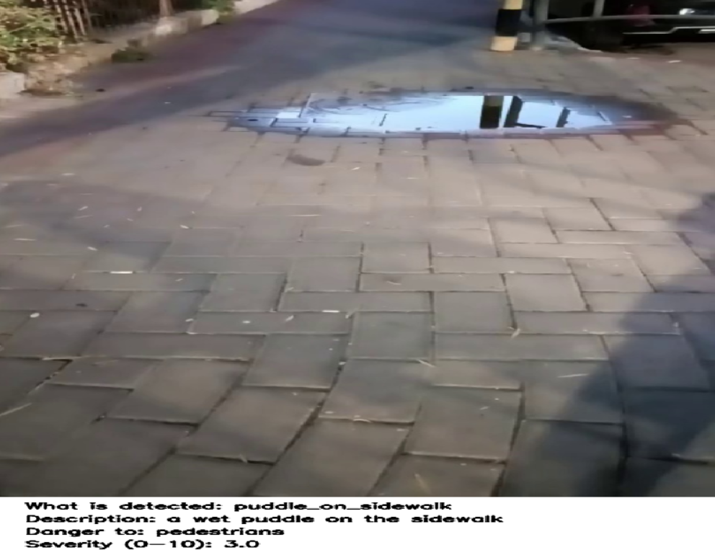
Figure 1- Zero-shot qualitative examples of risk-relevant situation recognition in urban environments. The figure presents two representative urban scenes analyzed using the proposed training-free framework in a zero-shot inference setting. The left image depicts a nighttime urban sidewalk partially obstructed by discarded packaging materials and bulky waste near pedestrian infrastructure, introducing accessibility limitations and increased slip-and-trip risk. The right image shows a roadway scene in which a large vehicle is overturned or laterally displaced across the driving lane, significantly disrupting normal traffic configuration. In both cases, risk relevance is inferred from semantic deviations from expected scene structure without task-specific training or fine-tuning.

Figure 2-Few-shot example of risk-relevant situation recognition on pedestrian infrastructure.
The image shows an urban sidewalk scene containing a wet puddle formed on the walking surface. The situation is analyzed using the proposed training-free framework in a few-shot inference configuration, where limited semantic exemplars are provided at inference time. The presence of standing water on the sidewalk represents a semantic deviation from expected pedestrian conditions and introduces a potential slip hazard. Risk relevance and severity are inferred without task-specific training or parameter updates.

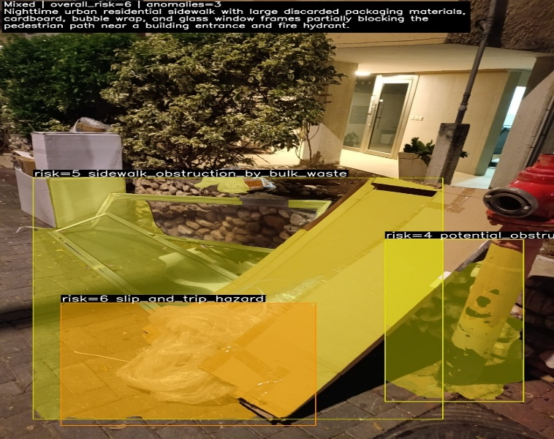

4.2 Visual Representation of Urban Road Scenes
Urban road environments exhibit high visual complexity, characterized by heterogeneous objects, structural elements, and varying materials. To capture safety-relevant deviations without task-specific training, the proposed framework relies on complementary visual representations at multiple spatial and semantic scales.
Image Preprocessing.
Each input image is processed in its original RGB format, with standard resizing applied only to meet the input requirements of pretrained visual encoders. No geometric normalization, domain-specific preprocessing, or manual annotations are introduced. This minimal preprocessing reflects realistic deployment conditions in urban monitoring systems, where images originate from heterogeneous cameras with varying viewpoints, resolutions, and lighting conditions. Region-Level and Scene-Level Representation
To represent diverse urban anomalies without task-specific training, the framework relies on complementary visual and semantic representations extracted from the entire scene. Dense visual embeddings capture global structure and fine-grained appearance patterns across the image, enabling sensitivity to subtle irregularities such as surface degradation, clutter, or material inconsistencies.
These visual representations are aligned with natural-language descriptions using pretrained vision–language models, allowing anomalous situations to be identified as semantic deviations from expected urban configurations. All components operate in frozen form, without explicit region selection or task-specific adaptation.
At the scene and patch level, dense visual representations capture fine-grained structural and textural patterns across the image, enabling the identification of subtle irregularities such as surface degradation, material inconsistencies, or localized hazards. Patch-level embeddings are aggregated to form a global scene representation that emphasizes anomalous visual configurations.
In the few-shot inference configuration, patch-level visual embeddings are further evaluated relative to a compact reference memory bank composed of representative urban scenes. This exemplar-based representation enables similarity-driven reasoning over local structural and appearance patterns, while preserving the fully training-free nature of the framework.
Formally, given an input image, the visual encoder produces a set of patch-level embeddings:

$$P_{1},P_{2},…,P_{N}∈R^{d}, \left(1\right)$$
In the few-shot configuration, a compact reference memory bank is defined as:
$$B=\left\{b_{1},…,b_{M}\right\}, (2)$$

4.3 Textual Representation of Expected and Unexpected Situations
Semantic interpretation in the proposed framework is enabled through natural-language representations of expected and unexpected urban situations. Rather than relying on predefined visual classes, urban safety knowledge is encoded through textual descriptions reflecting common and anomalous configurations encountered in real-world cities.
Prompt Design principles.
Textual prompts are formulated to be open-vocabulary, city-agnostic, and explicitly grounded in urban safety relevance. They encode descriptions of both normal, well-maintained urban conditions and deviations that may indicate potential risk. Prompts are expressed at multiple levels of semantic abstraction, ranging from global scene-level descriptions to specific hazard-related concepts, enabling reasoning about overall scene consistency as well as the presence of safety-relevant irregularities.
Safety-relevant semantic categories
Textual descriptions are organized into a small set of recurring safety-relevant categories, including surface and structural conditions, obstructions and accessibility hazards, vegetation-related risks, environmental clutter, and security-related anomalies. These categories are not tied to any specific dataset or annotation scheme but reflect common and widely occurring sources of urban risk.
Textual representations serve as semantic anchors for interpreting visual deviations, providing contextual grounding for subsequent risk assessment. By encoding urban safety knowledge in natural language, the framework leverages pretrained vision–language models to enable flexible, training-free semantic reasoning across diverse and heterogeneous urban environments.

4.4 Vision–Language Alignment and Similarity Scoring
Training-free semantic interpretation is achieved through alignment of visual and textual representations in a shared embedding space provided by pretrained vision–language models. Visual embeddings extracted from the input scene are compared directly with textual embeddings describing expected and anomalous urban situations.
Semantic similarity is computed using standard measures such as cosine similarity. For each visual representation, similarity scores are evaluated with respect to normal and anomalous textual descriptions. An anomaly score is derived by contrasting alignment with anomalous prompts against alignment with normal prompts, and scores are normalized to a bounded range to enable consistent interpretation and aggregation.
This similarity-based formulation supports open-set anomaly recognition, allowing the framework to identify previously unseen or rare situations as semantic deviations from expected urban patterns rather than as predefined classes. Grounding anomaly assessment in vision–language similarity ensures flexibility, interpretability, and scalability across evolving urban environments.
We define two semantic scores:

$$S_{normal}^{CLIP}\left(x\right)=\max_{t∈T normal} S_{CLIP}\left(x,t\right), (3)$$

$$S_{anomaly}^{CLIP}\left(x\right)=\max_{t∈T anomaly} S_{CLIP}\left(x,t\right), (4)$$
These semantic scores capture the strongest alignment between the visual input and textual descriptions of normal and anomalous urban situations, respectively. Their relative magnitudes provide an interpretable measure of semantic deviation, which is subsequently integrated into the overall anomaly assessment and risk scoring process.

4.5 Decision Mechanism for Anomalous Situation Recognition
The final stage of the framework aggregates visual and semantic evidence to produce a coherent assessment of anomalous situations and their potential safety relevance. Evidence is collected from complementary visual and semantic cues at the scene level and consolidated into a unified confidence measure reflecting the most safety-relevant deviation within the image.
The aggregation strategy emphasizes recall of potentially dangerous situations by prioritizing the strongest anomalous cues. The resulting score captures both explicit semantic anomalies (e.g., obstructed pedestrian infrastructure) and implicit structural irregularities (e.g., surface degradation).
To enhance interpretability, high-scoring observations are passed to a multimodal reasoning component that generates concise natural-language explanations describing the anomaly and its potential impact. For deployment, the framework supports both threshold-based risk classification (non-risk vs. potentially dangerous) and ranking-based prioritization, enabling flexible integration into large-scale urban monitoring systems.
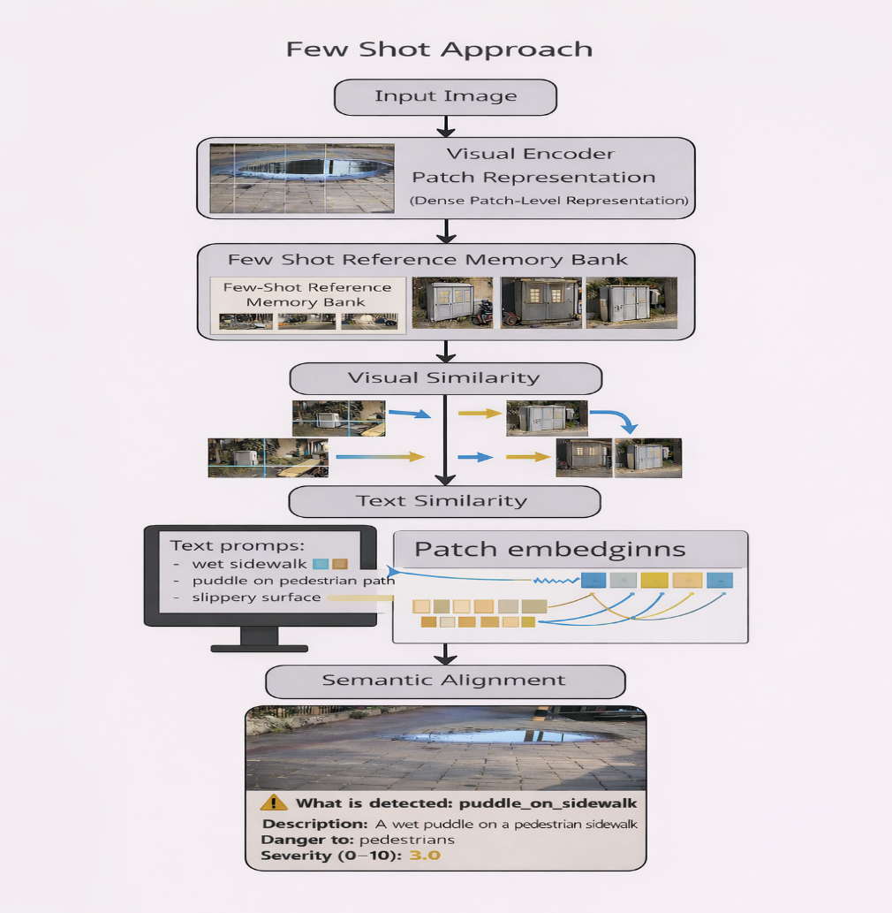
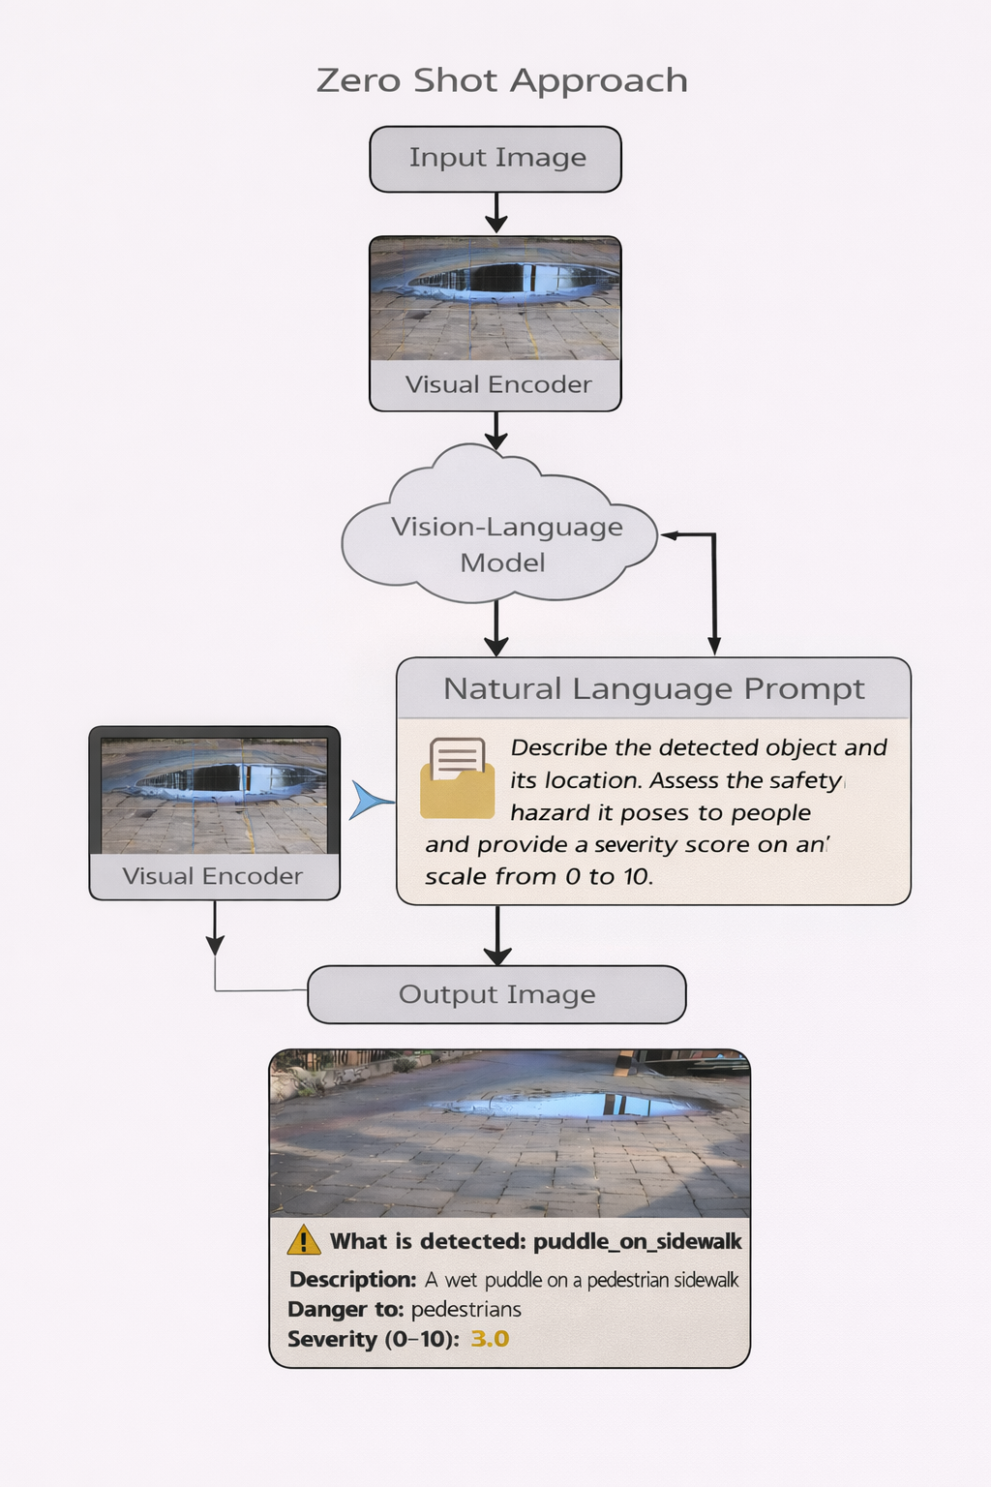
By decoupling anomaly recognition from rigid rule-based logic and supervised classification, the decision mechanism balances sensitivity, interpretability, and operational usability, aligning with the needs of sustainable and resilient urban mobility systems.
Figure 3-The figure illustrates two inference configurations within the proposed training-free framework for semantic interpretation of urban anomalies. Left: A few-shot configuration, in which dense patch-level visual representations extracted from the input image are matched against a compact reference memory bank. Semantic interpretation is achieved through joint visual similarity and vision–language alignment with safety-oriented textual prompts.
Right: A zero-shot configuration, where the input image is processed through a vision–language reasoning pipeline guided solely by natural language prompts, without relying on reference images or example-based similarity.
Both configurations operate without task-specific training and produce interpretable outputs, including anomaly identification, natural-language description, and a quantitative safety severity score, supporting scalable deployment in urban monitoring and risk-aware mobility systems.

5. Experimental Setup

5.1 Datasets and Urban Road Scenarios
To evaluate generalization across cities and anomaly types, we assess the proposed framework on a mixture of existing datasets originally created for road damage detection, pavement condition assessment, civic issue reporting, and driving scene understanding. No additional data collection or task-specific training is performed.
Street-view pavement damage datasets
We include street-view datasets for roadway and pavement damage detection, such as SVRDD [20], which contain cracks, potholes, and surface irregularities relevant to pedestrian and vehicle safety.
Civic-issue and waste datasets
Civic-issue image datasets covering potholes, garbage, and environmental cleanliness issues are used as sources of misplacement and accessibility anomalies [21]. Additional open waste datasets contribute examples of objects obstructing pedestrian paths.
Driving datasets repurposed for sidewalks
We repurpose large-scale driving datasets such as BDD100K [22] by focusing on sidewalks, roadside vegetation, and peripheral infrastructure. Frames spanning diverse weather, time-of-day, and geographic conditions are sampled, and anomalies are identified through the training-free pipeline and manually verified for evaluation.
Night urban datasets
We evaluate the framework on a dataset of 266 images collected in Israel, captured under night conditions and containing both anomalous and anomaly-free scenes. This dataset is used to assess both vision-based components and multimodal reasoning.
Urban anomaly benchmarks from recent VLM works
Where licensing permits, we align with urban anomaly subsets used in recent vision–language-based urban monitoring studies, including URA-VLMs and related traffic anomaly datasets [23].
All datasets are used exclusively for evaluation. Backbone vision and language models remain frozen. Where required, a limited subset of images is annotated with region-level anomaly and risk labels to support quantitative evaluation.
Mixed Urban Scenario datasets
To explicitly assess cross-domain generalization, we construct a mixed urban scenario dataset comprising 110 images from diverse geographic regions and environmental conditions. The dataset spans 11 scene categories, including atypical configurations such as animals on roadways. Model outputs are evaluated through a combination of automated scoring and human assessment of anomaly detection and semantic reasoning.

5.2 Evaluation Protocol
The evaluation protocol assesses the framework’s ability to identify, interpret, and prioritize risk-relevant anomalous situations in an open-set, training-free setting. Evaluation emphasizes detection performance, semantic correctness, and risk relevance.
Definition of Expected and Anomalous situations
Expected situations correspond to common, safe, and well-maintained urban configurations. Anomalous situations are visual configurations that deviate from these expectations and may indicate potential risk, including structural irregularities and contextual deviations.
Risk relevance is evaluated separately from anomaly presence and quantified through a continuous risk or severity score. For evaluation purposes, thresholding is applied to enable binary classification and computation of standard classification metrics, while the underlying representation remains score based.
Evaluation metrics
Image-level anomaly detection is evaluated using AUROC and AUPR. Risk classification performance is measured using accuracy, precision, recall, F1-score, and confusion matrices. Semantic interpretation quality is evaluated quantitatively by measuring the alignment between anomalous images and predefined textual descriptions using vision–language similarity scores. Performance is reported using Top-1 and Top-3 semantic matching accuracy, along with similarity statistics for ground-truth descriptions.

$$Accuracy=\frac{TP+TN}{TP+TN+FP+FN}, \left(5\right)$$

$$Precision=\frac{TP}{TP+FP}, \left(6\right)$$

$Recall=\frac{TP}{TP+FN}$, (7)

$F1-Score=2∙\frac{Presicion∙Recall}{Presicion+Recall}$ , (8)

5.3 Baselines and Comparisons
Zero-shot and vision–language baselines
We compare the proposed framework with publicly available training-free vision–language anomaly detection methods, including AnomalyCLIP [2], FiLo [3], LogSAD [5], and VLM/MLLM-based anomaly reasoning approaches such as AnomalyGPT [8].
Supervised and unsupervised references
Supervised and unsupervised anomaly detection methods have been widely studied in industrial inspection and infrastructure monitoring. These approaches typically rely on task-specific training, curated datasets, or domain adaptation to achieve high detection performance.
In contrast, the proposed framework is designed for training-free deployment in open and heterogeneous urban environments. Rather than competing directly with supervised or retrained unsupervised models, our approach is positioned to address complementary challenges of generalization, semantic interpretability, and practical deployment constraints in large-scale urban monitoring systems.

5.4 Implementation Details
All components of the proposed framework are used in frozen form, without task-specific fine-tuning or city-specific adaptation.
Model Configuration.
The framework relies on pretrained visual encoders for scene- and patch-level representation, pretrained vision–language models for semantic alignment, and a multimodal language model for high-level reasoning and explanation generation. All experiments operate on single images or frames, reflecting realistic constraints in large-scale urban monitoring systems. Computational complexity is controlled by limiting the number of visual representations evaluated per image.
Prompt Templates.
A compact set of textual prompts is used to describe expected conditions, anomalous situations, and risk-oriented interpretations in urban road scenes. Prompts are generic, safety-focused, and limited in number to balance semantic coverage and computational efficiency. Full prompt templates and representative examples are provided in the supplementary material.

6. Results

6.1 Quantitative Evaluation

6.1.1 Quantitative Evaluation – Few-Shot Configuration
We report quantitative results for the few-shot inference configuration, evaluated on a dedicated night-time urban dataset. This setting assesses the framework’s ability to discriminate between expected and anomalous urban scenes under challenging illumination conditions, using a compact reference memory bank.
The proposed framework achieves stable anomaly discrimination, as reflected by a ROC-AUC of 0.934 and a PR-AUC of 0.938, while maintaining balanced precision (0.893) and recall (0.818), resulting in an F1-score of 0.854 and an overall accuracy of 0.861. These results indicate effective separation between expected and anomalous configurations without task-specific training or parameter adaptation.
Figure X presents the confusion matrix for the few-shot setting, illustrating the distribution of correct and incorrect predictions across normal and anomalous samples. The results demonstrate robust performance with a limited number of false positives and false negatives, highlighting the suitability of the exemplar-based, training-free approach for night-time urban monitoring scenarios.
Thr | f1 | recall | precision | accuracy | pr_auc | roc_auc | Approach
0.7180 | 0.8537 | 0.8181 | 0.8925 | 0.8609 | 0.9375 | 0.9341 | Few Shot

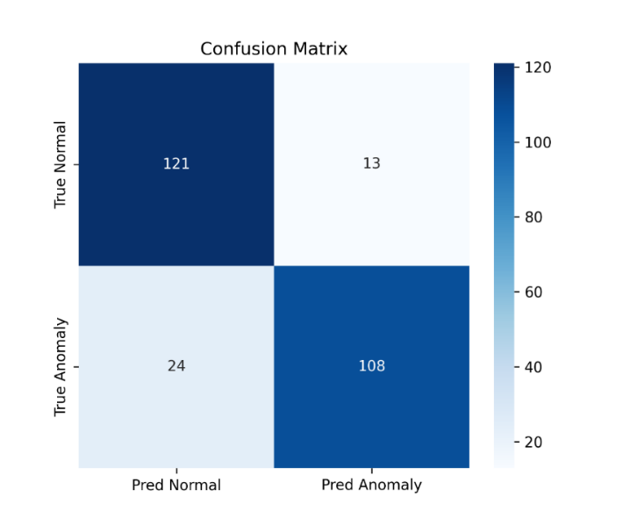

6.1.2 Quantitative Evaluation – Zero-Shot Configuration
The zero-shot configuration evaluates the framework’s ability to generalize to heterogeneous urban scenes without reference examples or dataset-specific adaptation. This setting was tested on a mixed collection of images capturing diverse locations, environmental conditions, and anomaly types.
In this configuration, the framework successfully identified anomalous situations in 103 out of 110 evaluated images, demonstrating strong generalization capability. The resulting confusion matrix (Table X) indicates a recall of 0.930, specificity of 0.958, precision of 0.988, and an overall accuracy of 0.936, corresponding to an F1-score of 0.958.
These results highlight the effectiveness of prompt-driven, training-free semantic reasoning for risk-relevant anomaly recognition across unseen urban environments, supporting deployment in open and evolving real-world settings.
 | Positive | Negative
Positive | 80 | 6
Negative | 1 | 23

6.1.3 Zero-shot learning reasoning scored 9.54 out of 10 and a median of 10.
Zero-shot semantic reasoning was evaluated based on the quality, correctness, and contextual relevance of the generated natural-language explanations. In this setting, the model operates without predefined anomaly labels and produces free-form descriptions of the detected situations, their surrounding context, and the associated safety implications. A total of 81 images were evaluated, containing 185 detected anomalous situations. Each generated explanation was assessed by human evaluators using a graded scoring scheme on a scale of 0 to 10, reflecting semantic correctness, contextual understanding, and risk relevance.
The zero-shot reasoning component achieved an average score of 9.54 out of 10, with a median score of 10. Notably, 172 out of 185 explanations received the highest possible score, indicating highly consistent and reliable semantic interpretation across diverse urban scenarios.
The model demonstrated the ability to reason beyond surface-level visual cues, identifying indirect or contextual risks, anticipating potential hazard dynamics, and distinguishing genuine safety threats from benign visual irregularities. These results highlight the effectiveness of zero-shot semantic reasoning for interpretable and context-aware urban risk assessment.

6.1.4 Few Shot Text Alignment evaluation
In the few-shot configuration, semantic evaluation focuses on the ability of the framework to correctly align detected anomalous images with their corresponding semantic anomaly labels. Anomaly detection is driven by DINO-based patch-level representations, while the vision–language component is used exclusively for semantic alignment and label assignment.
Evaluation was performed on anomalous samples detected in the night-time urban dataset. For each anomalous image, cosine similarity was computed between the image embedding and a predefined set of textual anomaly descriptions. Semantic alignment performance was assessed using Top-1 and Top-3 label matching accuracy, as well as the mean cosine similarity score with respect to the ground-truth label.
The results show that the correct anomaly label was ranked as the top prediction in 77.3% of the cases, and appeared within the top three predictions in 84.1% of the samples. The mean similarity score to the ground-truth textual label was 0.3065. These findings indicate that the semantic alignment component reliably associates detected anomalies with meaningful textual descriptions, supporting interpretable anomaly characterization in the few-shot setting.

0.7727 | Top-1 Label Accuracy
0.8409 | Top-3 Label Accuracy
0.3065 | Mean GT Similarity

6.2 Qualitative Analysis
Qualitative analysis highlights the framework’s ability to detect and interpret risk-relevant anomalies across diverse urban scenarios, including structural damage, hazardous vegetation, obstructed pedestrian pathways, and abnormal human or vehicle configurations under varying lighting, weather, and geographic conditions.
Semantic alignment supports the generation of meaningful natural-language descriptions for detected anomalies, enabling intuitive interpretation of visual deviations in complex urban scenes. Qualitative inspection of semantic label assignment indicates consistent alignment between detected anomalies and their corresponding textual descriptions, reinforcing the interpretability of the framework without influencing the underlying anomaly detection process.
In addition, multimodal large language models were examined qualitatively for their role in anomaly explanation and risk prioritization. The models demonstrated the ability to contextualize detected anomalies, distinguish benign irregularities from genuinely hazardous situations, and reason about potential risk dynamics. Failure cases were also observed, particularly in scenes involving AI-generated visual artifacts, which occasionally misled semantic interpretation. These observations underscore both the strengths and limitations of semantic reasoning components in real-world urban monitoring settings.

6.3 Sensitivity and Robustness Analysis
Robustness was evaluated under increased scene diversity and visual degradation. Zero-shot generalization was assessed on a mixed dataset spanning diverse urban and suburban environments, climates, and geographic regions. The framework maintained high accuracy, recall, and F1-score across heterogeneous scenes without retraining.
Sensitivity to visual quality was examined through systematic image downsampling and blurring. While global scene understanding was preserved, anomaly and risk scores decreased for degraded inputs, particularly for mid- to high-severity anomalies. This reduction was statistically significant, indicating reliance on fine-grained visual cues for confident risk assessment.

Despite reduced confidence, semantic reasoning remained stable. Sentence-level similarity and human evaluation confirmed that explanations for degraded images were consistent with those for original images, albeit less detailed. This suggests that high-level semantic interpretation is robust even when fine structural evidence is partially lost.

7. Discussion

7.1 Implications for Urban Safety Monitoring
The results demonstrate that training-free vision-language reasoning enables early recognition of risk-relevant situations in urban road environments without task-specific supervision. Rather than focusing on predefined damage categories or rare accident events, the proposed framework captures subtle semantic and structural deviations that may escalate into safety hazards if left unaddressed.
This capability is particularly valuable for proactive urban safety monitoring, where early signals-such as partially obstructed sidewalks, hazardous vegetation, or unusual object placement-can support timely intervention. The framework is designed to complement existing traffic management and municipal maintenance systems by providing interpretable, semantically grounded risk cues that enhance situational awareness rather than replacing downstream decision-making processes.

7.2 Scalability and Deployment Considerations
A key advantage of the proposed approach is its fully training-free design. By relying on frozen vision–language models and open-vocabulary reasoning, the framework avoids dependence on city-specific annotations, reducing deployment costs and enabling rapid adaptation across diverse urban contexts. The observed generalization across cities, lighting conditions, and scene types suggests suitability for large-scale, heterogeneous urban environments without retraining.
From a deployment perspective, the framework supports privacy-preserving operation, as it does not perform identity recognition or personal profiling. Analysis is limited to scene-level risk configurations, aligning with regulatory and ethical constraints commonly associated with smart city infrastructures.

7.3 Limitations
The framework has several limitations. First, it operates on single images and does not model temporal dynamics, restricting its ability to reason about evolving risks or causal sequences. Second, risk severity is expressed in relative rather than calibrated quantitative terms, which may be required for certain policy or insurance applications. Finally, the approach depends on visual observability and cannot reliably assess hazards that are occluded or not visually apparent.
These limitations point to directions for future work, including temporal integration, multi-sensor fusion, and principled calibration of risk scores to better support operational urban decision-making.

8. Implications for Sustainable and Resilient Cities
The proposed framework contributes to the broader goals of sustainable and resilient cities by strengthening urban mobility safety, enhancing situational awareness, and reducing operational overhead in urban monitoring systems.

8.1 Contribution to safer urban mobility
By enabling early recognition of risk-relevant situations that may affect pedestrians, cyclists, and drivers, the framework supports proactive safety management rather than reactive incident response. Identifying semantically abnormal configurations—such as obstructed sidewalks, hazardous vegetation, or atypical object placement—allows municipalities to intervene before minor irregularities escalate into accidents. This proactive capability directly supports inclusive and safer urban mobility, particularly for vulnerable road users.

8.2 Role in smart city monitoring infrastructures
The training-free and open-vocabulary nature of the framework makes it well suited for integration into existing smart city sensing infrastructures. Rather than replacing current monitoring solutions, the proposed system can operate as an additional semantic perception layer that continuously interprets visual data streams from heterogeneous sources. Its ability to generalize across cities and conditions enables consistent risk awareness without the need for city-specific model customization.

8.3 Integration with decision support systems
The framework produces interpretable outputs, including semantic descriptions, risk classifications, and prioritization scores, which are directly consumable by human operators and automated decision-support platforms. These outputs can inform maintenance scheduling, targeted inspections, or traffic management actions, supporting evidence-based decision-making under uncertainty. Importantly, the system augments human judgment by highlighting safety-relevant situations rather than enforcing automated control.

8.4 Sustainability benefits of training-free approaches
From a sustainability perspective, the training-free design reduces the environmental and economic costs associated with large-scale data annotation, model retraining, and computationally intensive learning cycles. By leveraging pretrained models and avoiding repeated retraining across cities, the framework supports long-term deployment with lower energy consumption and reduced operational complexity. This aligns with sustainable urban development goals that emphasize efficient use of resources, scalable infrastructures, and adaptive city management.

9. Conclusion
This paper presented a training-free framework for recognizing risk relevant. anomalous situations in urban road environments using vision-language semantic reasoning. The proposed approach departs from traditional supervised and rule-based urban monitoring systems by focusing on semantic risk recognition rather than predefined event detection or accident prediction. By operating entirely at inference time and without task-specific training, the framework enables scalable and adaptable urban safety monitoring across diverse cities and conditions.
Experimental results demonstrate that the framework achieves strong performance in identifying and prioritizing safety-relevant situations across heterogeneous datasets, lighting conditions, and urban contexts. Quantitative evaluation highlights a favourable performance-complexity trade-off, while qualitative analysis confirms the system’s ability to generate meaningful, interpretable explanations that support situational awareness. Importantly, semantic alignment enhances robustness to previously unseen configurations, reinforcing the suitability of training-free perception for open-ended urban environments.
Beyond detection performance, the framework offers practical value for sustainable and resilient cities. Its training-free design reduces annotation and retraining costs, supports privacy-preserving operation, and facilitates integration into existing smart city monitoring infrastructures. By providing interpretable risk cues rather than automated control, the system complements human-centered decision-making processes in urban safety management.
Looking forward, this work points toward a new generation of safety-oriented urban perception systems that emphasize semantic understanding, adaptability, and operational feasibility. Several directions for future research remain open. Incorporating temporal modeling could enable reasoning about evolving risks and causal dynamics. Extending the framework to multimodal sensing, including depth, thermal, or acoustic inputs, may improve robustness under challenging conditions. Finally, tighter integration with urban decision-support pipelines, such as maintenance scheduling and traffic management systems, would further enhance the framework’s impact on real-world urban safety and resilience.

10. reference
- Zhang, Y., Li, T., Wang, H., & Liu, X. (2025). Towards Training-Free Anomaly Detection with Vision and Language Foundation Models. CVPR 2025.:contentReference[oaicite:29]{index=29}
- Zhou, Q., Pang, G., Tian, Y., He, S., & Chen, J. (2023). AnomalyCLIP: Object-Agnostic Prompt Learning for Zero-Shot Anomaly Detection. ICLR 2024.:contentReference[oaicite:30]{index=30}
- Gu, Z., Zhu, B., Zhu, G., Chen, Y., Li, H., Tang, M., & Wang, J. (2024). FiLo: Zero-Shot Anomaly Detection by Fine-Grained Description and High-Quality Localization. ACM Multimedia 2024.:contentReference[oaicite:31]{index=31}
- Ronecker, M. P., Foutter, M., Elhafsi, A., Gammelli, D., Barakaiev, I., Pavone, M., & Watzenig, D. (2025). Vision Foundation Model Embedding-Based Semantic Anomaly Detection. arXiv:2505.07998.:contentReference[oaicite:32]{index=32}
- Xu, J., Lo, S.-Y., Safaei, B., Patel, V. M., & Dwivedi, I. (2025). Towards Zero-Shot Anomaly Detection and Reasoning with Multimodal Large Language Models. CVPR 2025.:contentReference[oaicite:33]{index=33}
- Ding, H., et al. (2025). Urban Road Anomaly Monitoring Using Vision–Language Models for Enhanced Safety Management. Applied Sciences, 15(5), 2517.:contentReference[oaicite:34]{index=34}
- Anonymous. (2025). Towards General Urban Monitoring with Vision-Language Models. arXiv:2510.12400.:contentReference[oaicite:35]{index=35}
- Gu, Z., Zhu, B., Zhu, G., Chen, Y., Tang, M., & Wang, J. (2023/2024). AnomalyGPT: Detecting Industrial Anomalies Using Large Vision-Language Models. AAAI 2024 & arXiv:2308.15366.:contentReference[oaicite:36]{index=36}
- Fang, Q., Lv, W., & Su, Q. (2025). AF-CLIP: Zero-Shot Anomaly Detection via Anomaly-Focused CLIP Adaptation. ACM Multimedia 2025.:contentReference[oaicite:37]{index=37}
- Abdi, L., Valiuddin, A., Caetano, F., Viviers, C., & van der Sommen, F. (2025). Zero-Shot Image Anomaly Detection Using Generative Foundation Models. ICCV 2025 Workshops (ADFM).:contentReference[oaicite:38]{index=38}
- Biswas, D., et al. (2025). MMVAD: A Vision–Language Model for Cross-Domain Video Anomaly Detection. Expert Systems with Applications.:contentReference[oaicite:39]{index=39}
- Zheng, Y., et al. (2025). Video-Based Traffic Anomaly Detection with Vision-Language Models. IEEE ITSC 2025 (preprint).:contentReference[oaicite:40]{index=40}
- Almakhluk, A., Baroudi, U., & El-Alfy, Y. (2025). Intelligent Road Anomaly Detection with Real-time Notification System for Enhanced Road Safety. arXiv:2505.08882.:contentReference[oaicite:41]{index=41}
- Liu, H., Li, C., Wu, Q., & Lee, Y. J. (2023). Visual Instruction Tuning. NeurIPS 2023 (LLaVA).:contentReference[oaicite:42]{index=42}
- Radford, A., Kim, J. W., Hallacy, C., et al. (2021). Learning Transferable Visual Models From Natural Language Supervision. ICML 2021 (CLIP).:contentReference[oaicite:43]{index=43}
- Yu, F., Chen, H., Wang, X., et al. (2020). BDD100K: A Diverse Driving Dataset for Heterogeneous Multitask Learning. CVPR 2020.:contentReference[oaicite:44]{index=44}
- Ren, M., et al. (2024). An Annotated Street View Image Dataset for Automated Road Surface Condition Assessment (SVRDD). Data in Brief.:contentReference[oaicite:45]{index=45}
- Anonymous. (2025). Urban Civic Issues Image Dataset: Potholes and Garbage. Mendeley Data, V1, 2025.:contentReference[oaicite:46]{index=46}
- Imran Ahmed , Gwanggil Jeon , Abdellah Chehri , Mohammad Mehedi Hassan, “Adapting Gaussian YOLOv3 with transfer learning for overhead view human detection in smart cities and societies”, Sustainable Cities and Society,2021
- Zheng Yi Wu, Alvin Chew, Xue Meng, Jianping Cai, Jocelyn Pok , Rony Kalfarisi,
Kah Cheong Lai, Sock Fang Hew, Jia Jie Wong,” High Fidelity Digital Twin-Based Anomaly Detection and Localization for Smart Water Grid Operation Management”, Sustainable Cities and Society,2023
- Jeongyeop Baek, Lisa Lim, “Unveiling pedestrian injury risk factors through integration of urban contexts using multimodal deep learning” , Sustainable Cities and Society , 2024
- Hyungmin Kim, Hobeom Jeon, Dohyung Kim, Jaehong Kim, “Elevating urban surveillance: A deep CCTV monitoring system for detection of anomalous events via human action recognition” Sustainable Cities and Society, 2024
- Siqin Wang , Jooyoung Yoo , Wenhui Cai , Fan Yang , Xiao Huang , Qian Chayn Sun , Shaokun Lyu , “Reducing the social inequity of neighborhood visual environment in Los Angeles through computer vision and multi-model machine learning” , Sustainable Cities and Society , 2025

- Zhiguang Fan , Yuan Zhao , Baicheng Hu , Li Wang , Yuxuan Guo , Zhiyuan Tang , Junwen Tang , Jianmin Ma , Hong Gao , Tao Huang , Xiaoxuan Mao ,“Enhancing urban real-time PM2.5 monitoring in street canyons by machine learning and computer vision technology “ , Sustainable Cities and Society, 2024
- Yassine Himeur , Somaya Al-Maadeed , Noor Almaadeed , Khalid Abualsaud ,Amr Mohamed , Tamer Khattab , Omar Elharrouss, “Deep visual social distancing monitoring to combat COVID-19: A comprehensive survey, Sustainable Cities and Society , 2022
- Raveena Marasinghe, Tan Yigitcanlar *, Severine Mayere, Tracy Washington, Mark Limb , “Computer vision applications for urban planning: A systematic review of opportunities and constraints” , Sustainable Cities and Society , 2024
- Simon Elias Bibri *, Jeffrey Huang , “Generative AI of things for sustainable smart cities: Synergizing cognitive augmentation, resource efficiency, network traffic, cybersecurity, and anomaly detection for environmental performance”, Sustainable Cities and Society, 2025
- Mohamed R. Ibrahim, James Haworth, Tao Cheng , “Understanding cities with machine eyes: A review of deep computer vision in urban analytics” , Cities , 2020
- Ranjan Sapkota , Manoj Karkee, “Object detection with multimodal large vision-language models: An in-depth review” , Information Fusion , 2026
- Zehua Ji , Weifeng Lv , Junlin Hu , Member, IEEE, Yuhui Jin , Zekun Qiu, and Jian Huang , “Dual-Stream Anomaly Detection Network for Real-World Traffic Scenarios” , IEEE TRANSACTIONS ON INTELLIGENT TRANSPORTATION SYSTEMS , 2024
- Yuxin Zheng, Wei Zhou, Graduate Student Member, IEEE, Stefan Nastic3 and Chen Wang, Member, IEEE, “Video-Based Traffic Anomaly Detection with Vision-Language Models: A Survey” ,
- Guangli Wu, Zhenzhou Guo, Leiting Li, Chengxiang Wang , “Video Abnormal Event Detection Based on CNN and LSTM”, proceeding in IEEE 5th International Conference on Signal and Image Processing , 2020
- Shail Damarasingha, Obiora A. Nnenea, Mark H. P. Zuidgeesta , “Detecting Pedestrians and Vehicles on Urban Roads using Computer Vision” , proceeding in African Transport Research Conference 2024
- Juan Terven, Diana-Margarita Córdova-Esparza and Julio-Alejandro Romero-González , “A Comprehensive Review of YOLO Architectures in Computer Vision: From YOLOv1 to YOLOv8 and YOLO-NAS”, machine learning and knowledge extraction,2023
- Katikapalli Subramanyam Kalyan Akmmus AI, Trichy, “A Survey of GPT-3 Family Large Language Models Including ChatGPT and GPT-4” , arXiv , 2023
- Shukang Yin, Chaoyou Fu, Sirui Zhao, Ke Li, Xing Sun, Tong Xu and Enhong Chen, “A survey on multimodal large language models” , 2024
- Yunyi Liu , Yingshu Li, Zhanyu Wang , Xinyu Liang , Lingqiao Liu , Lei Wang , Leyang Cui , Zhaopeng Tu , Longyue Wang , Luping Zhou, “A systematic evaluation of GPT-4V's multimodal capability for chest X-ray image analysis” , Meta-Radiology , 2024
- Zhongzhi Chen, Guang Liu, Bo-Wen Zhang1, Fulong Ye
Qinghong Yang, Ledell Wu, “AltCLIP: Altering the Language Encoder in CLIP for Extended Language Capabilities” , arXiv , 2022
- Daniel Fährmann, Laura Martín, Luis Sánchez, Naser Damer , “Anomaly Detection in Smart Environments: A Comprehensive Survey” , IEEE Access , 2023
- Ao Sun, Yanting Li,Xiao-Hua Zhou, “Biomarker combination based on the Youden index with and without gold standard” , arXiv,2024
- Xue-Yang Hou, Yilihamu Yaermaimaiti *, Shuo-Qi Cheng , “CLIP-IML: A novel approach for CLIP-based image manipulation localization” , Journal of Electronic Science and Technology , 2025
- Oquab et al., “DINOv2: Learning Robust Visual Features without Supervision”, Transactions on Machine Learning Research , 2024
- Ronen Fluss*, David Faraggi, and Benjamin Reiser , “Estimation of the Youden Index and it’s associated cutoff point”
- Yenduri et al., “GPT (Generative Pre-trained Transformer) – A Comprehensive Review on Enabling Technologies, Potential Applications, Emerging Challenges, and Future Directions , arXiv,2023
- OpenAI , “GPT-4 Technical Report” , arXiv,2024
- Taslim Arif ,Abu Salyh Muhammad Mussa ,Moshiur Rahman,Mahbubul Alam Joarder , “Vision-based real-time traffic flow monitoring system for road intersections in Dhaka city” , Applied Intelligence, 2025
- Jahongir Azimjonov, Ahmet Ozmen, Metin Varan, “A vision-based real-time traffic flow monitoring system for road intersections, Multimedia Tools and Applications , 2023
- Ariba Zahid, Tehreem Qasim, Naeem Bhatti, Muhammad Zia, “A data-driven approach for road accident detection in surveillance videos” , Multimedia Tools and Applications , 2024
- Ravi , et al ., “Segment Anything in Images and Videos” , arXiv , 2024
- Deng et al., “Segment Anything Model (SAM) for Digital Pathology: Assess Zero-shot Segmentation on Whole Slide Imaging” , arXiv , 2023
- Kirillov et al., “Segment Anything , arXiv, 2023
- Norman Mu, Alexander Kirillov, David Wagner, Saining Xie , UC Berkeley , “SLIP: Self-supervision meets Language-Image Pre-training” , arXiv , 2021
- Zeyi Sun , et al ., “Alpha-CLIP: A CLIP Model Focusing on Wherever You Want” , proceeding in CVPR conference , 2023

11. Supplementary

Risk evaluation table
Risk Level | Name / Category | Meaning (Human-Level Interpretation) | Typical Visual Cues | Example Situations
1 | Minimal | No meaningful safety threat. Fully controlled, predictable environment. | Empty road, wide margins, controlled traffic, no anomalies. | Parked vehicles, pedestrian far on sidewalk, stable driving.
2 | Very Low | Slightly increased complexity but still safe. | Minor occlusion, light congestion, low-speed scenario. | Car ahead slowing gently, pedestrian standing far from curb.
3 | Low | Mild risk; situation requires awareness but not intervention. | Moderate traffic, small dynamic elements, mild occlusion. | Pedestrian approaching curb but still waiting; car changing lanes properly.
4 | Mild / Emerging Risk | Potential for danger exists; a safety-relevant event could develop. | Uncertain behavior, mild violations, trajectory conflicts beginning. | Pedestrian stepping off curb slowly; vehicle edging toward lane boundary.
5 | Moderate | Clear anomalous behavior that could escalate without attention. | Incomplete stops, close distances, ambiguous motions. | A vehicle partially crossing lane; cyclist approaching vehicle blind spot.
6 | Elevated | Noticeably dangerous behavior; intervention or caution is now required. | High relative speed, obstructed views, close proximity conflicts. | Car overtaking closely, pedestrian mid-road without priority.
7 | High | Strong indicators of a hazardous event. High probability of collision if behavior persists. | Wrong-way motion, sudden braking, sharp swerves, near misses. | Car entering opposite lane, pedestrian running across traffic.
8 | Very High | Danger is imminent. Human reaction time becomes critical. | Abrupt trajectory conflicts, physical instability, loss of control. | Skidding car, pedestrian in direct path, uncontrolled intersection behavior.
9 | Severe | Collision highly likely. Extremely dangerous situation requiring immediate avoidance. | Violent motion, clear crash trajectory, multi-agent dynamic conflict. | Two vehicles converging at high speed, imminent side-impact.
10 | Critical / Collision | Crash occurring or unavoidable. Catastrophic risk. | Direct impact, rollover, major hazard striking agents. | Actual collision frame, vehicle spinning into pedestrian, direct impact moment.

Risk evaluation table (short version)
Bucket | Numerical Levels | Meaning
Low Risk | 1–3 | No meaningful threat; safe environment.
Moderate Risk | 4–6 | Situation could escalate; requires attention.
High Risk | 7–8 | Strong danger indicators; likely collision path.
Critical | 9–10 | Imminent or active collision.

Reasoning evaluation table
Score | Label | Reasoning Accuracy Description (Urban/Suburban Risk Evaluation)
10 | Fully accurate | All objects are visible and correctly identified; anomalies are real, relevant, and well-grounded in the image; risk scores are proportional and explicitly justified with no speculation.
9 | Near-perfect | Correct scene and objects; no false positives; minor omissions or imprecise phrasing; risk reasoning is sound and does not affect conclusions.
8 | Mostly correct | Core scene understanding is correct; minor speculative assumption (e.g., inferred motion or intent); slight risk over/under-estimation but directionally correct.
7 | Correct scene, weak anomaly logic | Scene and objects are correct; anomaly identification is debatable or weakly justified; risk score plausible but not tightly linked to visible evidence.
6 | Mixed accuracy | Scene mostly correct; some objects missed or one incorrect object added; anomaly mischaracterized; risk loosely connected to visual evidence—usable with caution.
5 | Ambiguous but grounded | Partial and incomplete scene description; anomaly vague or generic; risk score appears template-driven; no explicit hallucination but weak evidential grounding.
4 | Early hallucination | Scene type may be misclassified (road vs. sidewalk); at least one non-visible object introduced; anomaly inferred without visual support; risk based on assumptions.
3 | Partial hallucination | Mix of real and invented objects; core anomaly does not exist; risk justification contradicts the image despite internally coherent reasoning.
2 | Strong hallucination | Fundamental misunderstanding of the scene; multiple invented objects or events; risk assessment largely meaningless relative to the image.
1 | Total hallucination | Description unrelated to the scene; fabricated context, objects, and risks; no usable signal for evaluation.

Supplementary image: frame with glass element, and blockage of fire hydrant

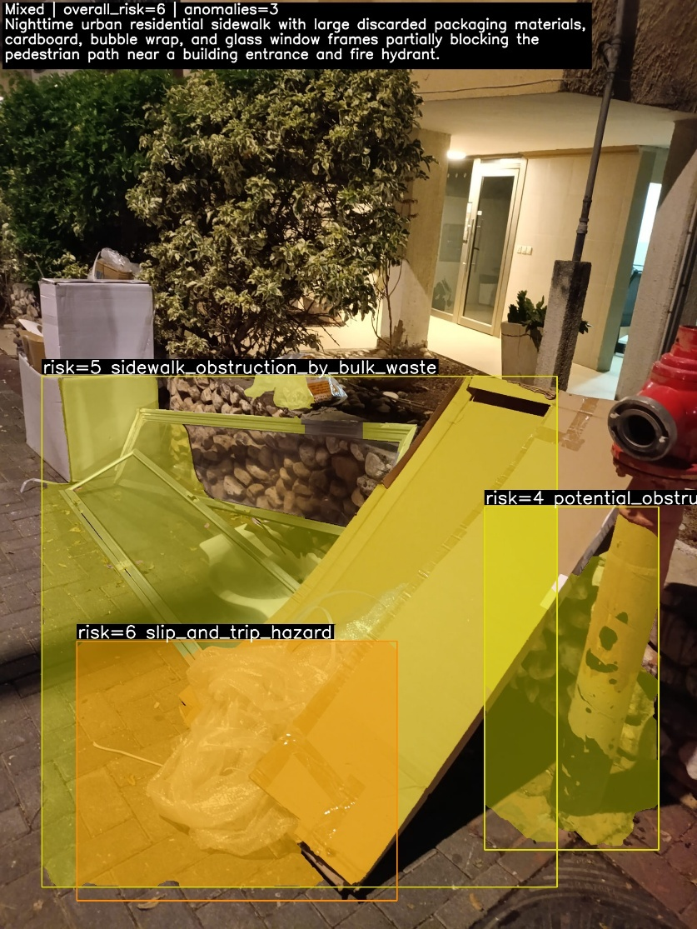
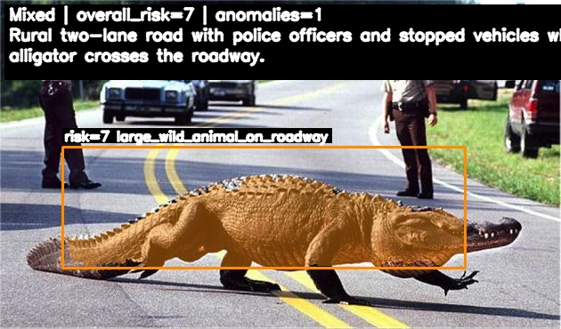
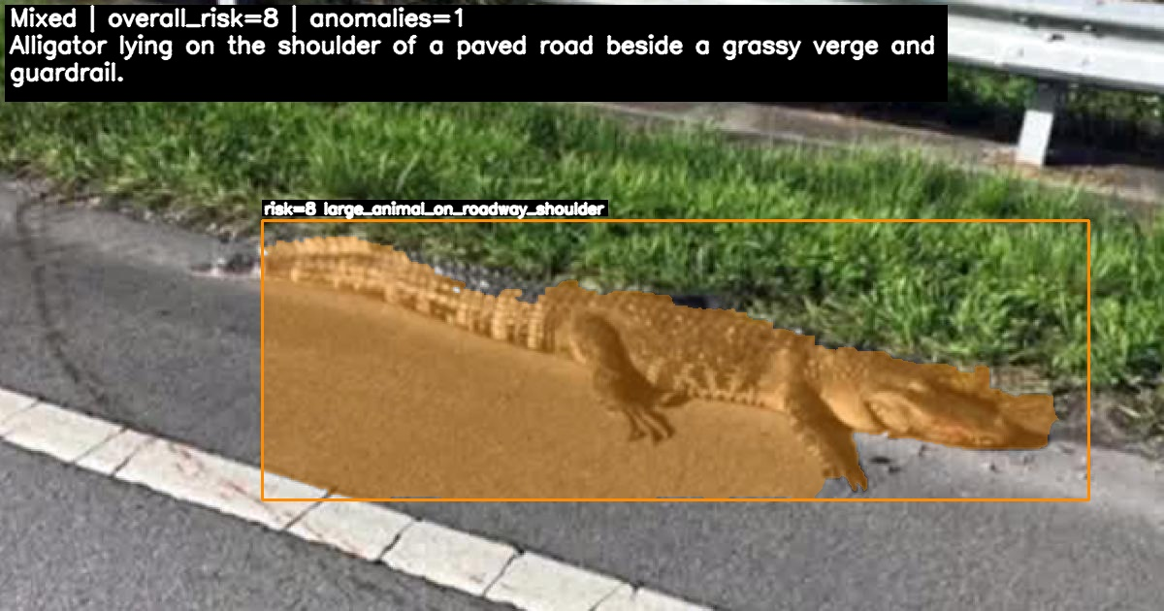

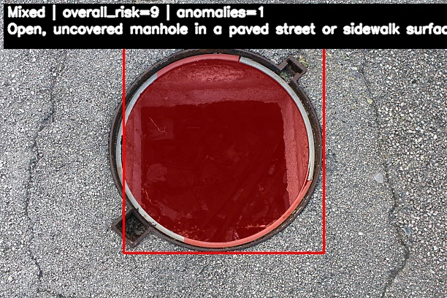
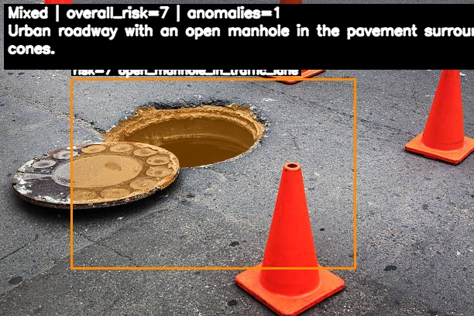

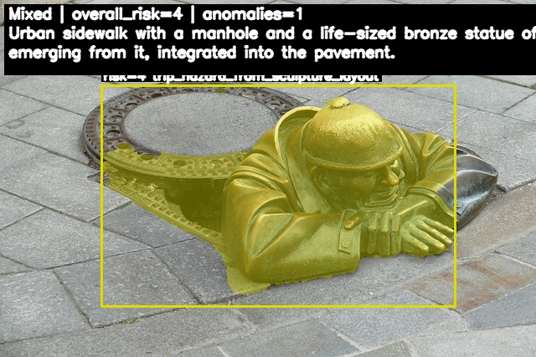

Supllementary image: an overturned truck on the road, this scene was ended in a car crash about 10 frames latter . 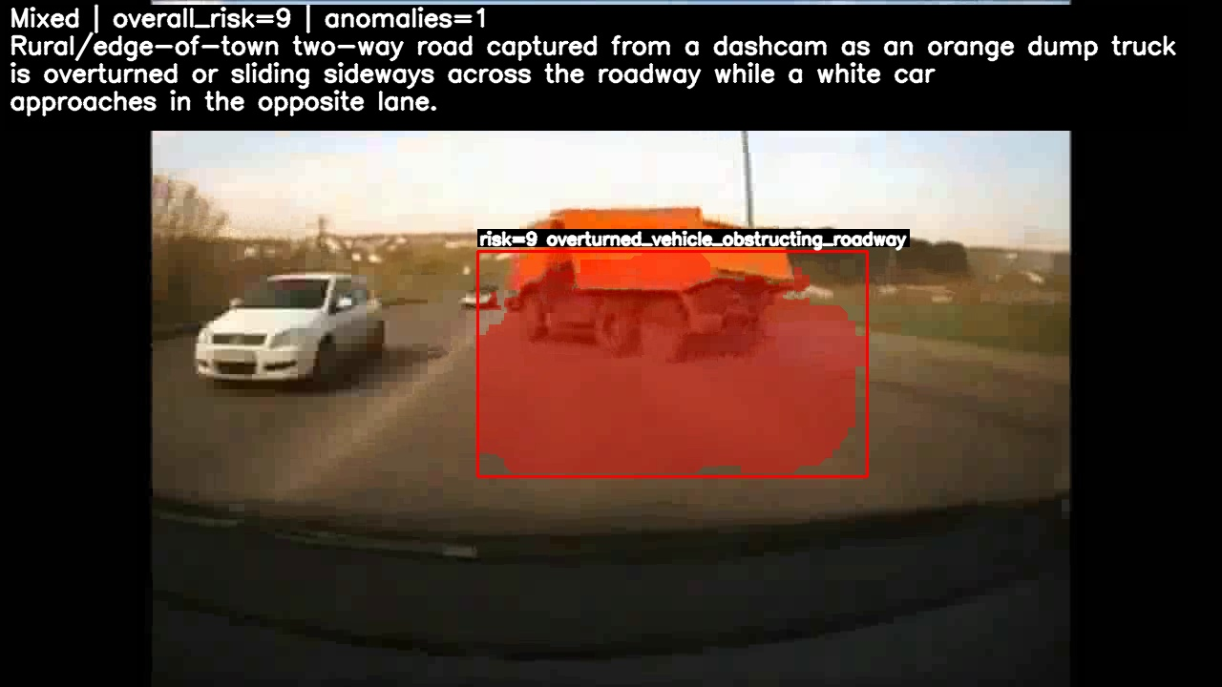
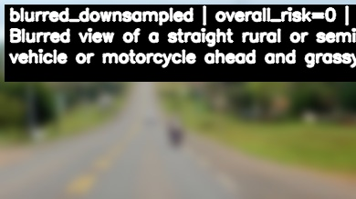
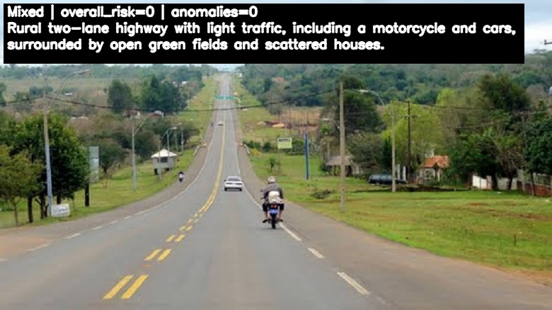
Supplementary image: Image down-sampling and blurring.

Supplementary code: code used to down-sampling and blurring of images:
mkdir -p out_DSx0.5_blur5
for f in *.jpg; do
magick "$f" -filter Lanczos -resize 50% -blur 0x5 "out_DSx0.5_blur5/${f%.*}_DSx0.5_blur5.jpg"
done
Supplementary table: statistic test for before and after down-sampling and blurring.
Statistic | Value
N images (paired) | 111
Mean overall risk (Mixed) | 4.95
Mean overall risk (DSBlurred, aggregated) | 2.63
Mean Δ overall risk (DS - Mixed) | -2.32
95% CI for mean Δ overall risk | -2.821 to -1.809
Paired t-test p (overall risk) | 9.03E-15
Wilcoxon p (overall risk) | 1.43E-12
Pearson r (overall risk) | 6.08E-01
Pearson p | 1.42E-12
Spearman ρ (overall risk) | 6.37E-01
Spearman p | 5.59E-14
Mean #anomalies (Mixed) | 0.99
Mean #anomalies (DSBlurred, aggregated) | 0.48
Mean Δ #anomalies (DS - Mixed) | -0.51
95% CI for mean Δ #anomalies | -0.628 to -0.399
Paired t-test p (#anomalies) | 2.36E-14
Wilcoxon p (#anomalies) | 1.84E-11
Mean anomaly-type Jaccard | 0.27
% exact type match (Jaccard=1) | 27.03

Supplementary table reasoning of original image vs. down-sampled & blurred image, in yellow: common ground between two text.
Image | Original | DS + blurred
1.png | Nighttime urban street with several cars and large yard waste and a plastic container obstructing part of the sidewalk near a crosswalk. | Blurred nighttime urban street with sidewalk, curbside vegetation, and a vehicle on the road.
2.png | Paved pedestrian sidewalk with a standing water puddle near a pole; no vehicles or people on the walkway. | Blurred view of a paved pedestrian surface with a puddle of water in the middle area.
3.png | Evening urban sidewalk with cars parked along the curb and bulky debris and bedding obstructing the pedestrian path. | Narrow street or driveway with closely parked vehicles, including a white car in the foreground and another vehicle ahead, leaving very limited passage space.
4.png | Evening urban sidewalk with a single pedestrian walking away from the camera beside a low stone wall and parked cars. | Urban sidewalk with a single pedestrian walking away from the camera alongside a building and a low wall.
5.png | Well-lit urban sidewalk at night next to a roadway, with streetlights, fencing, and vegetation; no people or vehicles close to the camera. | Nighttime view of a well-lit, empty paved sidewalk running alongside a road with streetlights, vegetation, and a wall or fence.

