Training-Free Urban Anomaly Recognition Using Vision and Language Models

Linoy Halifa¹, Ezra Ella¹, Yehudit Aperstein¹
¹Afeka academic collage
Abstract
Urban environments contain a wide variety of safety-critical anomalies, including sidewalk cracks that endanger blind pedestrians, overgrown vegetation obstructing walkways or contacting power lines, dry bushes that increase fire risk, mispositioned trash bins, and the presence of dangerous objects or factors such as illegal weapons and shooters. Manually enumerating and training models on all such anomaly types is infeasible because their appearance, scale, and semantics vary dramatically across cities and contexts. Recent advances in vision–language models (VLMs) and multimodal large language models (MLLMs) suggest a promising alternative: training-free anomaly detection and reasoning using powerful pre-trained foundation models.
Up for today, the work in few shot, or training-free anomaly detection was limited to a very sterile environment, where numbers of anomalies, the diversity and the noise were relatively very limited. Here in this work we first tested self supervised frameworks like DINO (DIstillation with NO labels) and real-time object detection systems as YOLO (You Only Look Once) assisted by CLIP (Contrastive Language-Image Pretraining), and the image segmentation model SAM (Segment Anything Model) also assisted by CLIP, To select the best model suitable for anomaly detection in the noisy urban environment with vision–language models and large multimodal assistants [1-4,8-10], we also proposed a framework for training-free urban anomaly recognition that uses a prompt based large language model (LLM) to provide anomaly detection and risk reasoning.
Our system accepts images or video frames from heterogeneous datasets without any fine-tuning. It extracts region-level proposals, computes zero-shot anomaly similarity scores using frozen VLMs such as CLIP and LLaVA-like models [14,15]. Candidate regions are scored with zero-shot “normal vs. abnormal” prompts and urban hazard prompts, then passed to an LLM that assigns semantic categories and a risk-aware label: green (benign anomaly) or red (potentially dangerous anomaly), with a focus on risks to civilians, accessibility, and infrastructure safety. We plan to evaluate the framework on a mixture of existing open datasets for road damage, urban waste, and street-view infrastructure, and on repurposed driving datasets originally collected for autonomous driving. Evaluation will cover anomaly detection, localization, and risk classification. As a proof of concept, this work aims to show that training-free multimodal reasoning can generalize to diverse urban anomalies and support future smart-city deployments without requiring costly new data collection or retraining.

Introduction
Urban environments are dynamic, complex, and often fragile systems. Where even small anomalies as cracks in sidewalks, loose paving stones, misaligned manhole covers, overgrown vegetation, or improperly placed trash containers, can create serious risks for pedestrians, cyclists, and drivers. At the same time, more acute hazards such as fallen trees, flooded roads, fires, or the presence of weapons and violent actors pose immediate threats to public safety and infrastructure. Recent studies on urban road safety emphasize that such anomalies, along with broader traffic incidents, are a major cause of accidents and economic loss in cities worldwide[11,18].
Automatically detecting these diverse anomalies at scale remains challenging. Traditional computer vision pipelines for road or infrastructure monitoring typically rely on supervised detectors trained for specific categories such as potholes, cracks, or manholes[11]. Although highly effective in narrow domains, such models struggle to generalize to new cities, novel anomaly types, or long-tail corner cases. Even large road-damage datasets and street-view benchmarks (covering multiple countries and damage categories) do not fully capture the spectrum of semantically abnormal urban situations encountered in the real world [16,17]. For smart-city applications that aim to monitor pedestrian accessibility, vegetation risks, or context-specific hazards, re-annotating and re-training models for every new anomaly type is unsustainable.
In parallel, foundation models for vision and language have undergone rapid progress. Contrastive vision language models such as CLIP learn powerful open-vocabulary visual representations from web-scale image - text pairs, enabling zero-shot recognition of unseen categories[3]. Multimodal instruction-tuned models such as LLaVA extend this paradigm by connecting vision encoders to large language models and training them to follow natural-language instructions about images, yielding rich visual reasoning and explanation capabilities[4]. These advances naturally motivate training-free approaches to anomaly detection, in which pre-trained models are reused without dataset-specific fine-tuning.
Recent work has shown that vision-language foundation models can achieve strong performance in zero-shot or training-free anomaly detection across industrial and natural image domains. Zhang et al. proposed a training-free framework that integrates vision–language models with logical reasoning for structural and compositional anomaly detection, demonstrating state-of-the-art performance without additional training [5]. AnomalyCLIP adapts CLIP with object-agnostic prompt learning to capture generic “normal” and “abnormal” semantics, achieving superior zero-shot anomaly segmentation on diverse benchmarks [6] FiLo further refines this direction by generating fine-grained anomaly descriptions using LLMs and improving localization via multi-scale cross-modal interaction [7]. Complementary work by Ronecker et al. shows that high-level embeddings from vision foundation models can be exploited for purely semantic anomaly detection without any retraining or prompt engineering [8].
Beyond image-level anomaly scores, several studies now investigate anomaly reasoning with multimodal large language models. Xu et al. introduced Anomaly-OneVision, a framework that combines multimodal LLMs with zero-shot anomaly detection and explicit reasoning about abnormal regions and their causes [9]. AnomalyGPT integrates large vision–language models with simulated anomaly data to detect industrial anomalies, localize defects, and provide natural- language explanations without manual threshold tuning [10]. More recent methods such as AF-CLIP and diffusion-based generative approaches further expand the landscape of foundation-model- based anomaly detection, showing that lightweight adapters or generative scores can significantly improve zero-shot anomaly performance [11].
In the urban domain, vision-language models have started to be applied to road anomaly monitoring and smart-city analytics. Ding et al. proposed Urban Road Anomaly VLMs (URA-VLMs) for detecting road surface defects, garbage, floods, and other roadway anomalies in real time [12]. A concurrent survey on vision–language models for urban monitoring classifies emerging applications across traffic, infrastructure, and environmental monitoring, highlighting both the promise and open challenges of multimodal foundation models in cities [13]. Additional work explores VLMs and MLLMs for traffic anomaly detection in video, cross-domain video anomaly detection, and explanation of abnormal traffic events [14]. However, existing systems are typically tailored to road surfaces, traffic scenes, or industrial defects; they rarely address the full spectrum of urban anomalies relevant to pedestrians, accessibility, vegetation, fire risk, and security threats.
In this work, we target training-free urban anomaly recognition using vision and language models. We consider a broad definition of urban anomaly, including (i) structural hazards such as cracks, broken sidewalks, and misaligned infrastructure; (ii) environmental and vegetation-related risks such as overgrown plants blocking walkways, invasive species threatening local flora, or dry bushes that are easily ignited; (iii) misplacement anomalies such as trash bins or construction elements blocking paths; and (iv) high-risk security anomalies such as visible weapons or shooters in public space. Rather than training task-specific detectors for each class, we propose to leverage the open-vocabulary perception and reasoning capabilities of frozen VLMs and LLMs to detect previously unseen anomalies and to assess whether they pose a danger to civilians.
Our main contributions are:
- Define a training-free framework for urban anomaly recognition that combines frozen vision–language encoders with LLM-based risk reasoning to detect and categorize anomalies without any fine-tuning on target-city data.
- Introduce a risk-aware anomaly taxonomy in which anomalies are first detected broadly and then filtered by an LLM that classifies them as non-risk (green) or safety-critical (red), focusing on risks to civilians, accessibility, and infrastructure.
- Propose a dataset protocol that reuses existing open datasets for road damage, civic issues, and street scenes (e.g., BDD100K, street-view pavement damage datasets, and civic-issue image collections) as sources of diverse urban conditions without collecting new data [15].
- Outline an evaluation methodology for anomaly detection, localization, and risk classification across multiple anomaly categories, designed to test generalization across cities and datasets.

Methods
Problem Formulation
We consider images or video frames of urban environments captured from ground-view cameras (e.g., vehicle-mounted cameras, fixed roadside cameras, or citizen reports). Given an image or video frame, the system must:
- If exist, identify one or more anomalous regions that deviate from expected urban semantics.
- Assign each region a semantic description e.g., “deep crack across the sidewalk”, “overgrown tree branches touching power line”, “trash bin blocking wheelchair ramp”.
- Classify each anomaly as either non-risk (green) or potentially dangerous (red) for civilians and/or infrastructure.
Formally, for each image or video frame we seek a set of regions R = {r₁, …, r_K}, each with a bounding box or mask, anomaly score a_k in [0,1] textual description d_k, and risk label ℓ_k in {green,red}. The framework is training-free in the sense that all visual and language encoders are used in frozen form; no fine-tuning is performed on task-specific urban anomaly data. Any future fine-tuning or adapter-based optimization is left for subsequent work.

Model Components: Vision–Language Backbone
For open-vocabulary perception, we employ CLIP-like vision-language encoders trained on large-scale image-text corpora. Specifically, we plan to use publicly available CLIP or OpenCLIP variants as backbone encoders, accessing their image and text embedding spaces. The image encoder produces a feature map F with dimensions H × W × D for each image, while the text encoder maps prompts into the same embedding space for similarity-based scoring.
For higher-level reasoning and description generation, we use an open multimodal assistant similar in spirit to LLaVA, which connects a vision encoder to a large language model and is instruction-tuned on multimodal data. This model is used without any task-specific fine-tuning to (i) generate region-level descriptions and (ii) perform risk-aware reasoning based on visual cues and anomaly candidates.
Best model selection
As mentioned above, the models presented in the work of Zhang et. al. focused on anomaly detection in a sterile environment, where numbers of anomalies, the diversity and the noise are relatively very limited. To select the best model suitable for anomaly detection in the noisy urban environment, we have tested the performance of YOLO, DINO, and SAM: computer vision models used for identifying and analyzing objects within images, enforced by CLIP as the multimodal bridge that connects visual concepts with natural language. below are the station combinations used to this section, we present the details of our multimodal anomaly detection framework, demonstrating how each component collaboratively identifies both object-level and scene-level anomalies in complex urban environments. As illustrated in Fig. 1, our system combines vision–language foundation models and employs a sequence of complementary detection stations, each operating at a different granularity to capture diverse types of anomalies. The details are presented as follows.
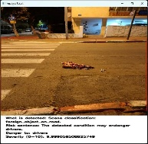
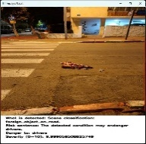
Memory Bank Patches
Self Patches
Stage 1
object detection and embeddings analysis
CLIP+YOLO
Normal labels
Embedding
Score
Anomaly labels
Stage 2
Segmentation and embeddings analysis
CLIP+SAM
Normal labels
Embedding
Score
Anomaly labels
Stage 3
Patch Matching
DINO
Embedding
Score
Fusion Final scoring

GPT
Take The Highest Score of the Three Stages
Multimodal Output
GPT
Foreign object on the road
Risk sentence: The detected condition may danger to drivers
Severity: 9.99

Figure 1:The Multimodal Anomaly Detection Pipeline. The diagram illustrates the complete 3-stages pipeline of the proposed multimodal anomaly-detection system. An input image passes sequentially through four independent detector stations, each responsible for a different form of visual or logical analysis. The system fuses the results to produce a final calibrated anomaly score and an interpretable textual explanation.

YOLO enforced by CLIP
Station 1 integrates YOLO-based object detection with CLIP’s multimodal semantic representations to classify scene elements as normal or anomalous. bounding boxes are cropped by YOLO model and encoded using the CLIP image encoder to obtain a visual embedding $v$. This embedding is compared against two sets of normalized text embeddings representing normal and anomalous scene descriptions. Cosine similarity is used as the matching criterion:
$$Sim\left(t,v\right)=\frac{t∙v}{\left\|t\right\|∙⟦v⟧}, (1)$$
Where $\left\|t\right\|$ is the length of the text vector and $\left\|v\right\|$ is the length of the image vector.
The anomaly score is defined as follows:
$$Label=\left\{\begin{aligned}Normal, if\max\left(sim_{normal}\right)≥\max\left(sim_{anomaly}\right) \\ Anomaly otherwise \end{aligned}\right., (2)$$
We compute the maximum similarity to the normal and anomalous text sets:
$$s_{\text{normal}}(r_{i})=\underset{t∈T_{\text{normal}}}{max⁡}\text{ cosine}(v_{r_{i}},v_{t}) \\ s_{\text{anomaly}}(r_{i})=\underset{t∈T_{\text{anomaly}}}{max⁡}\text{ cosine}(v_{r_{i}},v_{t})$$where $r_{i}$ is the image region, the $v_{r_{i}}$ is the embedding image of this area and the $v_{t}$ is the text embedding
For each region $r_{i}$, we compute a score defined as the difference between its normal-alignment score and its anomaly-alignment score:
$$Δ_{i}=s_{\text{anomaly}}(r_{i})-s_{\text{normal}}(r_{i})$$
to normalize the score relative to the distribution of normal images, we standardize $∆_{i}$ using the mean $μ$ and standard deviation $σ$ computed for station 1 from normal images:
$$z_{YOLO+CLIP}=\frac{∆_{YOLO+CLIP}-μ_{YOLO}}{σ_{YOLO}}$$finally, we map the standardized value to a sigmoid function:
$$σ=\frac{1}{1+e^{-z}}$$
$$S_{YOLO+CLIP}=σ(z_{YOLO+CLIP})$$
this procedure produces a anomaly score in $[0,1]$ where values close to 1 indicate strong evidence of anomalous.

SAM enforced by CLIP
Station 2 detects anomaly by combining the Segment Anything Model (SAM) with CLIP’s multimodal semantic matching. this station provides a segmentation process that ensures the system can detect anomalies. SAM first generates a set of segmentation masks covering diverse structural elements in the scene.
Each region is cropped and encoded using the CLIP image encoder, producing a visual embedding $v$. Similar to Station 1, this embedding is evaluated against two sets of text embeddings: a set of normal scene descriptions and a set of anomaly descriptions. for each region, cosine similarity is computed between the region embedding and each textual embedding:
$$Sim\left(t,v\right)=\frac{t∙v}{\left\|t\right\|∙⟦v⟧}, (4)$$
the region classified as normal if:
$$Label=\left\{\begin{aligned}Normal, if\max\left(sim_{normal}\right)≥\max\left(sim_{anomaly}\right) \\ Anomaly otherwise \end{aligned}, (5)\right.$$
to obtain a anomaly score, we compute the anomaly margin:
$$Δ=s_{\text{anomaly}}-s_{\text{normal}}$$The $∆$ values from all SAM regions are then normalized using station-specific statistics computed from normal reference images:
$$z_{SAM+CLIP}=\frac{Δ-μ_{SAM}}{σ_{SAM}}$$The final anomaly score is obtained via:
$$S_{SAM+CLIP}=σ(z_{SAM+CLIP})$$

DINO as stand alone
Station 3 performs fine-grained anomaly detection at the patch level using DINOv2 feature embeddings. Unlike the first two stations, which operate on object proposals or region masks, this station analyses the entire image at a uniform patch granularity, enabling the detection of subtle structural or texture-level anomalies that may not be captured by higher-level semantics. Given an input image, the DINOv2 encoder extracts a set of $N$ patch embeddings:
$$P_{1},P_{2},…,P_{N}∈R^{d}$$
every patch embedding $P_{i}$ is a $d$ dimensional vector in the real-valued space $R^{d}$.
The method computes two complementary anomaly measures:
- deviation from a memory bank of normal patches
- deviation from patches within the same image (self-similarity).
A memory bank is constructed by encoding patches from a collection of normal images:
$$B=\{b_{1},…,b_{M}\}$$the matrix of normalized embeddings from these normal images.
For each input image patch $p_{i}$, we compute its maximum cosine similarity to the normal patch bank:
$$S_{normal}\left(P_{i}\right)=\underset{b∈B}{max⁡} cos⁡(P_{i},b)$$
with cosine similarity defined as:
$$cos⁡(u,v)=\frac{u⋅v}{∥u∥ ∥v∥}$$
The corresponding anomaly measure is:
$$a_{\text{normal}}(p_{i})=1-s_{\text{normal}}(p_{i})$$
A low value indicates that the patch is similar to normal patch in the memory bank.
Each patch is also compared against all other patches from the input image:
$$s_{\text{self}}(p_{i})=\underset{k≠i}{max⁡}cos⁡(P_{i},P_{k})$$The anomaly measure becomes:
$$a_{\text{self}}(p_{i})=1-s_{\text{self}}(p_{i})$$This captures rare, unique patches within the same image indicative of structural anomalies.
For each patch we take:
$$a(p_{i})=max⁡\left(a_{\text{normal}}(p_{i}), a_{\text{self}}(p_{i})\right)$$
and the image-level anomaly score for Station 3 is defined as:
$$S_{DINO}=\max_{i}{a(p_{i})}$$
This score range is $[0,1]$ and reflects the strongest structural deviation detected among all patches.

GPT Fusion Final Scoring and Multimodal Output
In this stage, GPT computes a logic-based anomaly score calibrated by visual evidence from the previous stages. GPT receives the anomaly label, textual description, visual scores, and detected objects, and returns:
$$L_{raw}∈[0,1]$$
The visual confidence is the maximum score among the three visual detectors:
$$C_{v}=\max{(S_{YOLO+CLIP}, S_{SAM+CLIP}},S_{DINO})$$
$$C_{v}∈[0,1]$$
The final logic reasoning score is:
$$S_{GPT}=C_{v}∙L_{raw}$$
$$S_{GPT}∈[0,1]$$
This final component generates a structured natural-language explanation of the anomaly, combining visual evidence, the global severity score, and predefined safety logic. The output includes four elements:
(1) what is detected, (2) risk description, (3) who is in danger, (4) normalized severity (0–10).

In this model, object detection (YOLO) and segmentation (SAM) are used as attention-based evidence extraction mechanisms rather than as primary localization objectives. These components isolate semantically meaningful regions that enable more accurate vision–language alignment with CLIP and support interpretable anomaly reasoning. Although bounding boxes and masks are produced for visualization, anomaly decisions are made at the image level, and spatial outputs are not evaluated quantitatively.

DINO enforcement by CLIP
Following the high score of DINO we keep this model in order to detect anomaly but in addition we add to this Station a semantic layer based on CLIP. While the underlying anomaly detection mechanism remains unchanged and continues to rely on DINOv2 patch embeddings, the additional semantic layer enables image-text alignment between the input image and predefined textual descriptions of normal and anomalous scenarios.
given an input image $x$, CLIP encodes it into a global image embedding $v$. In parallel, a predefined set of textual descriptions $\left\{t_{j}\right\}$ representing normal and anomalous scenarios is encoded into text embeddings $\left\{u_{j}\right\}$. Semantic similarity is computed using cosine similarity:

$$S_{CLIP}=\left(x,t_{j}\right)=\cos{(v,u_{j})}$$

We define two semantic scores:

$$S_{normal}^{CLIP}=\max_{t∈T normal}=S_{CLIP}(x,t)$$

$$S_{anomaly}^{CLIP}=\max_{t∈T anomaly}=S_{CLIP}(x,t)$$
Where $T_{normal}$ and $T_{anomaly}$ denote sets of textual prompts describing normal and anomalous situations, respectively.
the use of CLIP is not intended for direct anomaly detection but rather functions as a semantic probe for label assignment and interpretability. this design enables open-vocabulary semantic understanding while preserving the unsupervised nature of the core anomaly detection mechanism.
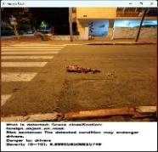
Stage 3
Patch Matching
DINO+CLIP
Embedding
Score
Multimodal Output
GPT
Foreign object on the road
Risk sentence: The detected condition may danger to drivers
Severity: 9.99
Figure XXX-Describes the new pipeline after we use only DINO and CLIP.

Memory Bank Patches
Self Patches

Region Proposal and Embedding Extraction
Given an input image, we first extract candidate regions that may contain anomalies. To remain training-free and general, we leveraging off-the-shelf, pre-trained segmentation or region proposal models (e.g., generic object detectors or segment-anything style models) to obtain a set of region proposals covering foreground objects, surfaces (sidewalks, roads, walls), and structures (poles, fences, vegetation clusters).
For each region proposal r_k, we pool its visual features from the backbone feature map F (for example, using masked average pooling) to obtain a region-level embedding v_k in a D-dimensional space. This yields a compact representation of each candidate region that can be compared against text embeddings.

Training-Free Anomaly Scoring
We adopt a two-stage anomaly scoring strategy inspired by training-free and zero-shot anomaly detection methods[18]. First, we define generic “normal vs. abnormal” prompts such as:
- “a normal, well-maintained urban sidewalk”
- “an urban scene with no damage or obstacles”
- “a damaged or broken sidewalk that is unsafe for pedestrians”
- “vegetation growing in a dangerous way, blocking a path or touching power lines”
- “a dangerous object or person, such as a gun or shooter, in a public place”
These prompts are encoded by the text encoder to yield text embeddings t_j. For each region embedding v_k, we compute cosine similarities s(k,j) = cos(v_k, t_j). A generic anomaly score a_k is obtained by comparing similarities to normal vs. abnormal prompts, for example:
a_k = σ( max over j in A of s(k,j) - max over j in N of s(k,j) ),
where A and N index the sets of abnormal and normal prompts, and σ is a sigmoid or calibration function. This stage captures whether a region is visually more consistent with “normal” or “abnormal” urban semantics without any training on anomaly labels.
Second, following ideas from FiLo and AnomalyGPT, we augment generic prompts with fine-grained descriptions derived from an MLLM. For each high-scoring region r_k, we query the multimodal LLM with context-aware questions such as:
- “Describe any damage, obstacles, or unusual objects in this region of the sidewalk.”
- “Does this vegetation pose a risk (e.g., blocking the way or touching electrical infrastructure)?”
- “Is there anything in this region that could endanger pedestrians or vehicles?”
The LLM’s textual descriptions are then re-encoded by the vision-language text encoder to form fine-grained anomaly prompts, refining the anomaly scores and improving localization, especially for subtle cracks or small obstacles.
Risk-Aware LLM Reasoning
Once candidate anomalies and fine-grained descriptions are available, we perform risk-aware reasoning using the LLM in a purely training-free manner. For each region r_k, we construct a structured textual context containing:
- Short description generated by the MLLM (e.g., “deep crack across the walking path”).
- Coarse anomaly type inferred from prompts (e.g., “surface damage”, “vegetation”, “trash”, “person”, “vehicle”).
- Global scene cues (e.g., presence of crosswalks, wheelchairs, children, or power lines) inferred by the MLLM.
We then ask the LLM to assign a risk label and explanation, for example:
- “Classify this anomaly as green (not dangerous) or red (dangerous) with respect to civilians. Give a short justification.”
Because the model has access to high-level world knowledge, it can reason about risks that are rarely, if ever, seen in the training data, for example, distinguishing between a small cosmetic crack and a deep fissure that could cause a wheelchair to tip, or determining that dry vegetation near a busy road constitutes a fire hazard. This risk reasoning layer is central to our goal: not only detecting anomalies, but also deciding which ones should be reported or prioritized.
Quantitative assessment of automated anomaly detection and risk reasoning via GPT-driven pipelines
To produce a robust results, we have wrote a local API code that automatically send images to ChatGPT 5.1 model for evaluation with a similar prompt for all images, the results are then stored in jsonl file, and are both imported into an excel file for human evaluation and add a description of the scene, score of anomalies and highlight on each image. The full workflow and code can be found as supplementary data at GithubLocation

Datasets
To demonstrate generalization across cities and anomaly types, we plan to evaluate the framework on a mixture of existing datasets originally created for road damage detection, pavement condition assessment, civic issue reporting, and driving scene understanding, all without any new data collection.
- Street-view pavement damage datasets. We include street-view image datasets for roadway and pavement damage detection, such as SVRDD, which provides annotated pavement damages in street-view images and is explicitly designed for automated road maintenance applications [20]. These datasets contain cracks, potholes, and surface irregularities relevant to sidewalk and road anomalies.
- Civic-issue and waste datasets. We leverage civic-issue image datasets that include potholes, garbage, and environmental cleanliness issues, such as the Urban Civic Issues Image Dataset, which provides annotated images of potholes and garbage for urban infrastructure monitoring and waste management [21]. Additional open trash/waste datasets are used as sources of misplacement anomalies as trash bins blocking paths.
- Driving datasets repurposed for sidewalks. We repurpose large-scale driving datasets such as BDD100K, originally collected for autonomous driving and multi-task learning, by focusing on sidewalks, roadside vegetation, and infrastructure in the periphery of the driving scene [22]. Frames are sampled to include diverse weather, time-of-day, and geographic conditions, and anomalies are mined via the training-free pipeline and manually verified for evaluation.
- Day and night from sidewalks and roads...dataset contained 266 images taken by us at day and night scenes in Israel, the dataset contained both anomalies and anomaly free images, and was used to test both computer vision models, and the LLM model. For stations tasting we have used 100 night images, as it required high computational power. To compare DINO with the LLM we have used the whole 266 images of the same dataset.
- Urban anomaly benchmarks from recent VLM works. Where licenses permit, we will reuse or align with urban anomaly subsets used in recent VLM-based anomaly detection and urban monitoring works e.g., URA-VLMs for road anomalies, traffic anomaly datasets processed by VLMs and MLLMs [23].
All datasets are used only for evaluation; the backbone models and LLMs remain frozen and are not fine-tuned on these data. Where necessary, a small subset of images is annotated with region-level anomaly and risk labels to support quantitative evaluation of detection, localization, and risk classification.
Mixed dataset for generalization evaluation
To evaluate the ability of zero-shot strategy to generalize, we have created a folder with mixed situations from different locations in the world, containing images from urban, and sub-urban regions, of western and far-eastern cities, with animals on road and different climate conditions, in total this folder contained 110 images (10 images per scene, 11 different scenes) that were further analyzed and evaluated first by ChatGPT 5.1 and then manually compared to the human score based on scoring tables (supplementary table XXX) and reasoning level (subjective evaluation by the scorer).

Evaluation Protocol
Tasks and Metrics
We consider three main evaluation tasks:
- Anomaly detection (image-level). Determine whether an image contains at least one anomaly. We compute standard metrics such as AUROC and AUPR over per-image anomaly scores e.g., maximum region anomaly score.
- Anomaly localization (region-level). Detect and localize anomalous regions. We evaluate region-level performance using metrics such as mean Average Precision (mAP) for anomaly detection at various IoU thresholds and pixel- level IoU where segmentation masks are available.
- Risk classification. Distinguish between non-risk (green) and dangerous (red) anomalies. For regions labeled as anomalies, we compute precision, recall, F1-score, and confusion matrices over risk labels. Category-level breakdowns e.g., cracks, vegetation, trash, security threats are reported in a summary table.
Baselines
We plan to compare our training-free framework against recent vision-language anomaly detection baselines that are freely available, including:
- AnomalyCLIP, which learns object-agnostic prompts for zero-shot anomaly detection [24]
- FiLo, which introduces fine-grained anomaly descriptions and high-quality localization using CLIP and LLM-generated prompts [25].
- Training-free VLM anomaly detection frameworks such as LogSAD: a novel multi-modal framework that requires no training for both Logical and Structural Anomaly Detection [26].
- VLM/MLLM anomaly reasoning methods including AnomalyGPT and other foundation-model-based anomaly detectors where configurations are available without commercial licenses [27].
Where methods require training on auxiliary industrial datasets (e.g., AF-CLIP), we will either use publicly released models or report qualitative comparisons rather than re-training on new urban data [28].
Implementation Considerations
Because the framework must remain training-free and reasonably simple, we avoid using complex metadata or city-specific knowledge. Instead, we rely on the generalization capabilities of vision-

language encoders and LLMs. To keep computational cost manageable for a proof of concept, we focus on:
- Single-frame analysis with optional temporal smoothing for video sequences.
- A moderate number of region proposals per frame e.g., top-K regions by saliency or objectness.
- A compact prompt set that covers generic normal/abnormal semantics and a small number of hazard archetypes e.g., structural, vegetation, waste, security.
Real-time performance and large-scale deployment as across entire cities are considered future work. In this article, we concentrate on validating whether training-free multimodal reasoning can reliably identify and prioritize urban anomalies using only existing models and datasets.
Reasoning evaluation
Models’ reasoning was scored by human evaluation with the score ranging from 1 to 10, when 10 stands for a very accurate reasoning and 1 stands for hallucination/totally incorrect description of the scene (see full evaluation reasoning table in supplementary table XXX), the final score given to the model was a simple average and median of all observations.
To evaluate the change in reasoning when image was down-samples and blurred, we compared the change in reasoning compared to reasoning of model on original image, for this we used text similarity parameters, as Sentence-BERT cosine similarity and human evaluation.
Image down-sampling and blurring
To evaluate robustness under realistic visual degradation, we generated a degraded variant of each input frame by applying deterministic downsampling followed by Gaussian blurring. For each original image I with dimensions (W,H), we first resized the image to ([0.5W],[0.5H]), corresponding to a uniform spatial scaling factor of ×0.5 in both width and height. Downsampling was performed using Lanczos resampling, which applies a high-quality low-pass filter prior to subsampling in order to suppress aliasing artifacts while preserving global structure.
Following downsampling, we applied an isotropic Gaussian blur with standard deviation σ = 5 pixels to the resized image. This operation removes high-frequency visual details while retaining coarse spatial layout, thereby simulating realistic sensing degradations such as motion blur, defocus, or low-quality optics.
Both transformations were implemented using ImageMagick (fast Fourier transform), and the same command sequence was applied to all frames (See suppl. Text XXX) , ensuring deterministic and fully reproducible results across datasets. Model predictions were computed on both the original images and their degraded counterparts, enabling direct measurement of robustness in risk detection, spatial grounding, and causal reasoning under controlled visual perturbations.

Results
Quantitative Benchmarking and the Performance Dominance of DINO-Based Architectures
We first evaluate the anomaly detection performance of each station independently, as well as all possible combinations of stations. Table X summarizes the results in terms of ROC-AUC, PR-AUC, accuracy, precision, recall, and F1-score.
The performance evaluation of the three individual stations and their ensemble combinations reveals a clear distinction in model efficacy and trade-offs between precision and recall (see below, table XXX). STATION3 (DINO) demonstrated the most robust performance among standalone models, achieving the highest F1-score (0.8225) and Accuracy (0.8196). Notably, STATION3 also yielded a Precision of 0.9444, indicating a superior ability to minimize false positives compared to STATION1 (YOLO+CLIP) and STATION2 (SAM+CLIP).
In contrast, STATION2 prioritized Recall (0.9142), the highest across all test groups. While this makes it highly effective for comprehensive detection, its lower Precision (0.6274) suggests a higher susceptibility to false alarms. The ensemble results indicate a plateau in performance enhancement; specifically, the combination of STATION1+STATION2+STATION3 produced results identical to the STATION2+STATION3 pairing (F1: 0.8130, Accuracy: 0.8114). This suggests that the inclusion of STATION1 in a multi-model pipeline may be redundant when STATION2 and STATION3 are already active.

גם בטקסט למעלה וגם בטבלה להוריד מספרים לשלוש ספרות, ארבע זה עמוס מידי, זה משהו שצריך לעשות באקסל ולהעתיק שוב
Thr | f1 | recall | precision | accuracy | pr_auc | roc_auc | Station
0.6278 | 0.7412 | 0.7571 | 0.7260 | 0.6967 | 0.6394 | 0.6057 | STATION1 (YOLO+CLIP)
0.6407 | 0.7441 | 0.9142 | 0.6274 | 0.6393 | 0.5612 | 0.5321 | STATION2 (SAM+CLIP)
0.6795 | 0.8225 | 0.7285 | 0.9444 | 0.8196 | 0.9196 | 0.8824 | STATION3 (DINO)
0.6407 | 0.7441 | 0.9142 | 0.6274 | 0.6393 | 0.5612 | 0.5321 | STATION1+STATION2
0.6795 | 0.8225 | 0.7285 | 0.9444 | 0.8196 | 0.9091 | 0.8521 | STATION1+STATION3
0.6814 | 0.8130 | 0.7142 | 0.9433 | 0.8114 | 0.9116 | 0.8642 | STATION2+STATION3
0.6814 | 0.8130 | 0.7142 | 0.9433 | 0.8114 | 0.9116 | 0.8642 | STATION1+STATION2+STATION3
Table XXX-summarization of the detection performance of individual stations and their combinations

Performance Evaluation of the Integrated DINO+CLIP Configuration
Following the identification of STATION3 (DINO) as the most robust standalone detector, the final system architecture was refined by integrating an additional CLIP-based semantic layer. This integration was designed to augment the structural precision of DINO with the semantic interpretability of CLIP without compromising the underlying detection logic.
As detailed in Table XXX, the DINO+CLIP configuration yielded a significant performance uplift across all key metrics. The system achieved a ROC-AUC of 0.93 and a PR-AUC of 0.94, representing a substantial improvement over the standalone DINO model. The model attained a Precision of 0.89 and a Recall of 0.82, culminating in an F1-score of 0.85 and an overall Accuracy of 0.86. These results indicate that the hybrid approach successfully leverages dual-stream processing to enhance anomaly discrimination in complex environments.
Thr | f1 | recall | precision | accuracy | pr_auc | roc_auc | Station
0.7180 | 0.8537 | 0.8181 | 0.8925 | 0.8609 | 0.9375 | 0.9341 | STATION3+CLIP
Table XXX- reports the performance of the final DINO+CLIP configuration
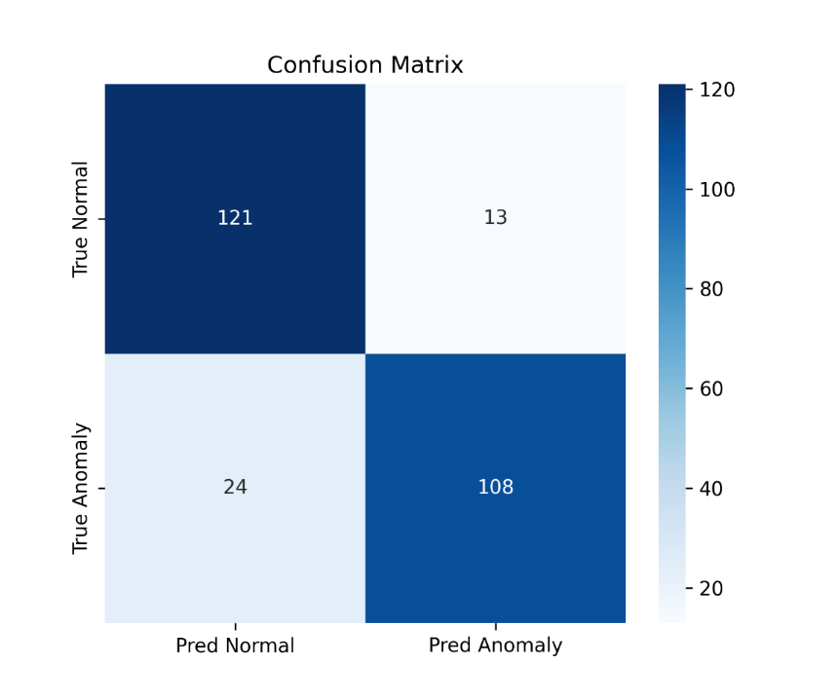
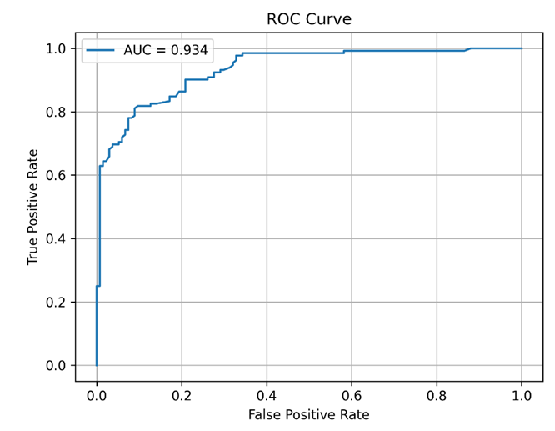
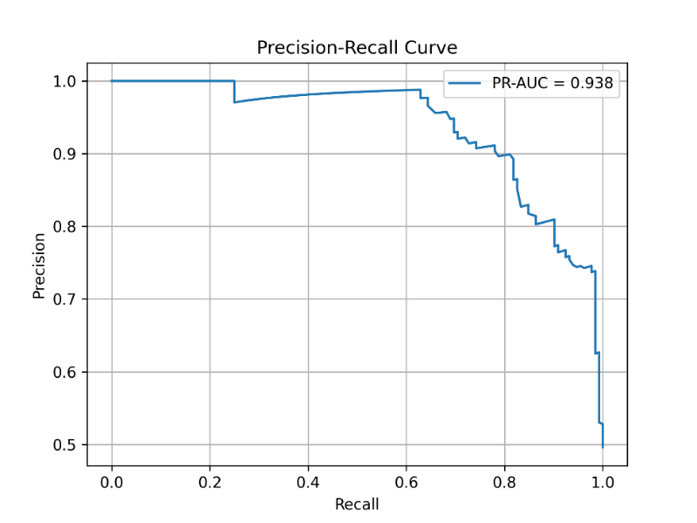
Figure XXX -presents the confusion matrix of the DINO+CLIP model

Figures XXX-shows the a. precision–recall and b. ROC curves of the DINO+CLIP model

CLIP Semantic Label Matching for Anomalous Images
This evaluation metric was designed to quantify the ability of CLIP to correctly associate anomalous images with their corresponding semantic anomaly labels. In the proposed framework, anomaly detection itself is performed by a DINO-based visual model, while CLIP serves as a complementary semantic component responsible for assigning meaningful textual labels to images identified as anomalous. Accordingly, this analysis focuses exclusively on anomalous samples and measures how accurately CLIP aligns each anomalous image with its correct anomaly label using cosine similarity between image and text embeddings. Top-1 and Top-3 label matching accuracy, along with the similarity score of the ground-truth label, were used to assess CLIP’s semantic consistency. These results reflect the effectiveness of CLIP in providing correct semantic interpretation of detected anomalies, rather than performing anomaly detection independently.

0.7727 | Top-1 Label Accuracy
0.8409 | Top-3 Label Accuracy
0.3065 | Mean GT Similarity
Table XXX:

The semantic label matching performance of CLIP was evaluated on anomalous images detected by the DINO-based anomaly detector. The results show that CLIP correctly assigned the ground-truth anomaly label as the top prediction in 77.3% of the cases, while in 84.1% of the samples the correct label appeared within the top three predictions. In addition, the mean cosine similarity between anomalous image embeddings and their corresponding ground-truth textual labels was 0.3065. These findings indicate that CLIP provides reliable semantic grounding for detected anomalies, effectively associating anomalous visual patterns with meaningful textual descriptions in a zero-shot setting.

Based on the empirical evaluation of all detection stations and their combinations, we chose the DINO+CLIP configuration as the final anomaly detection strategy in the few-shot setting. anomaly detection is driven by DINOv2 patch-level representations, which enable the identification of structural and contextual deviations without requiring task-specific training or labeled anomaly samples. The CLIP component is integrated as a semantic alignment module, allowing the detected anomalies to be associated with predefined textual descriptions of normal and anomalous scenarios in an open-vocabulary manner.

Qualitative Analysis of LLM-Driven Anomaly Interpretation and Risk Severity Ranking
We evaluated the capacity of two large language models (LLMs), ChatGPT-5.1 and Gemini-2.5 Pro, to detect visual anomalies and to infer the associated risks for pedestrians, cyclists, and drivers. Both models were able to identify anomalies; however, ChatGPT-5.1 demonstrated the highest interpretative accuracy, providing clearer and more precise explanations of the observed abnormalities (Fig. XXX a-b). We also noticed that both LLMs recognized AI-generated glitches like wrong numbers, or upside symbols as major anomalies in the image, and failed to detect the risky anomalies, suggesting that AI generated images can mislead LLM that would fail at the reasoning step (Fig. XXX).
We further assessed ChatGPT-5.1 & Gemini 2.1 by presenting two distinct images and requiring the model to determine which scenario represented a more severe risk. Both models successfully ranked the images according to the relative severity of the hazards posed to civilians and did so using a consistent and intuitive rationale. While ChatGPT-5.1 marked trash cans at the collection day as a risk, Gemini 2.5Pro has decided that this anomaly is normal for trash collection day and kept the original image with no anomaly highlights (Fig. XXX).
When an enhanced the prompt for better reasoning, and tested the results in zero-shot using ChatGPT-5.1 Pro, in result, the chat has managed to recognize driving directions, provide a score and create an overlay with risk scores on the image (Fig. XXX)

Figure XXX
Original image | ChatGPT 5.1 | Gemini 2.5Pro | Best model
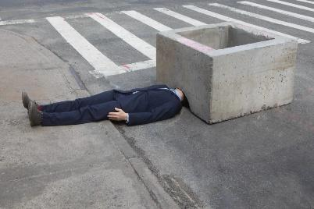 | 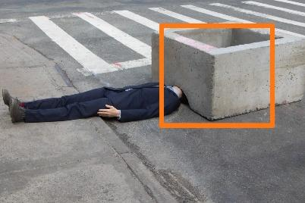 | 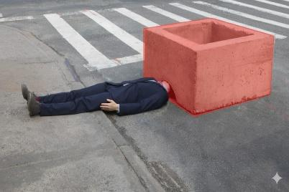 | Gemini: better highlight of abnormality
Text | The image shows a person in a suit lying on the ground with their head positioned under a very large concrete block.  In reality, this would be extremely dangerous and likely impossible without injury, so it’s almost certainly staged or an art installation. Still, the scene looks alarming because:  - The person is lying flat in the street.  - Their head is underneath the heavy concrete structure.  - The block appears far too heavy for a person to be safely beneath | The main issue is a person dressed in a suit who is lying flat on the public sidewalk.  What makes this especially strange is that their head and shoulders are inserted into the opening of a large, square concrete planter (or barrier). This is not a normal or safe position for a person to be in | ChatGPT: better understanding that the image is a part of scene

Figure XXX
Original image | ChatGPT 5.1 | Gemini 2.5Pro | Best model
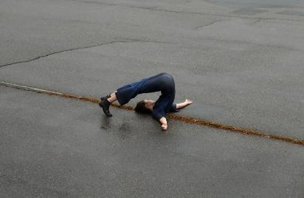 | 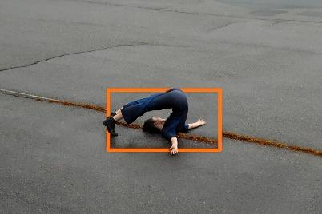 | 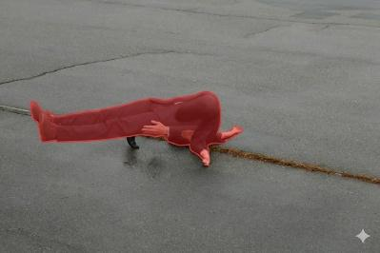 | ChatGPT: Kept original image
Text | The person’s body is bent backward in an extreme arch, but the bend is far beyond normal human spinal flexibility.  Their head and shoulders are pressed flat against the ground while their legs remain fully extended upward, forming a continuous curve that looks more like a rubber mannequin than a real spine.  The pose crosses the boundary of biological movement—it appears to be either:  a digitally manipulated image,  a staged artistic illusion,  or a doll/prop rather than an actual person.  Nothing in the environment is dangerous—it's purely the body posture that is unnatural. | The anomaly is the person lying on their back in the middle of a wet asphalt surface, with their legs inverted over their head in what appears to be a yoga or acrobatic pose. While the pose itself might be intentional, it's highly unusual and out of place to be performed casually in the middle of what looks like a street or parking lot, especially given the wet ground. The unusual context makes it an anomaly. | Gemini: Better interpretation of the situation and context.

Figure XXX c
Original image | ChatGPT 5.1 | Gemini 2.5Pro | Best model
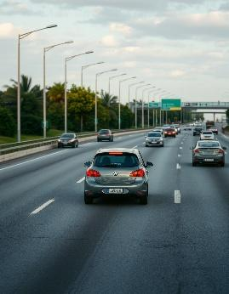 | 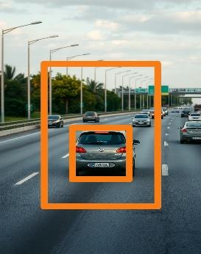 | 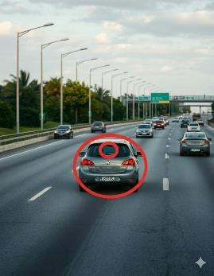 | None: Both failed to detect cars traveling in the opposite direction
Text | The central car (the Volkswagen) shows a rear license plate that is clearly impossible / nonsensical — the characters are distorted in a way that real plates never are.  This usually indicates:  an AI-generated plate,  privacy blurring gone wrong,  or digital manipulation.  Everything else (lanes, cars, lighting) looks normal. | The Volkswagen (VW) logo on the back of the grey car in the foreground is upside down. | ChatGPT: managed to understand it’s not a real image
Figure XXX
Original images | ChatGPT 5.1 | Gemini 2.5Pro
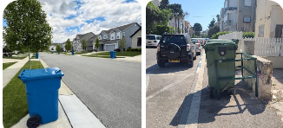 | 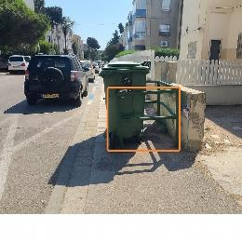  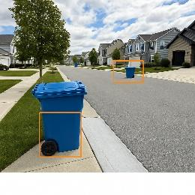 | 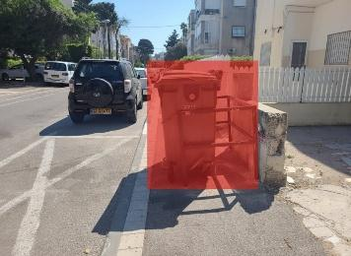
Text | Image 2 is significantly more dangerous.  Reason:  - It creates a direct and constant pedestrian safety hazard, especially for children, elderly, and disabled people.  - It forces foot traffic into the road, where cars are close and visibility is limited.  - The risk is systemic, not a one-time anomaly.  By comparison, Image 1 has road obstructions that can cause issues but in a quieter, controlled residential setting with wider visibility. | Image 2 is significantly worse and poses a much greater risk.  Image 1 depicts a normal, safe situation.(no changes were done to the image)  Image 2 shows a permanent-looking obstruction that creates an active and immediate danger for any pedestrian trying to use the sidewalk.

Figure 3: Zero shot risk analysis by ChatGPT with an enhanced prompt.
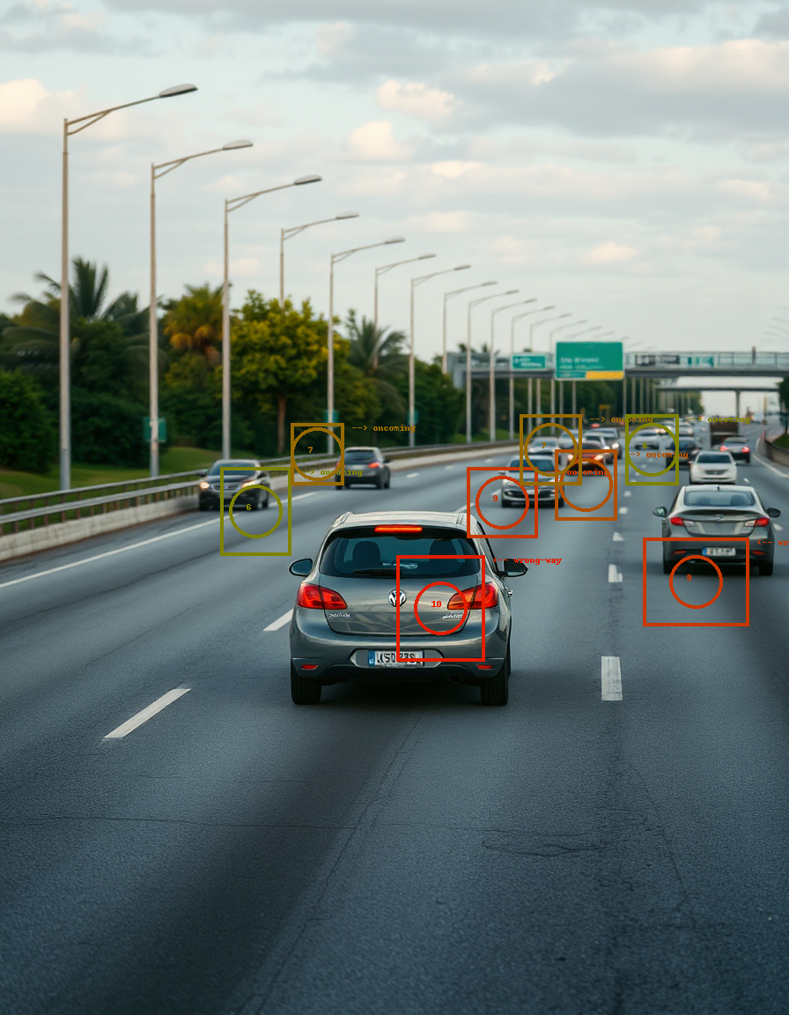

Initial results of the code: We tested our data (not in its entirety) in the model that the authors of the article “Towards Training-free Anomaly Detection with Vision and Language Foundation Models” propose and these are the initial results we received. (tableXXX)

category | K-shots | F1-Max(image) | AUROC(image) | F1-Max (logical) | AUROC (logical) | F1-Max (structural) | AUROC (structural)
cars | 4 | 83.33 | 67.56 | 66.67 | 70 | 76.92 | 66.33
Table XXX
Anomaly assessment using zero-shot
Anomaly is defined as something that deviates from what is standard, normal, or expected, acting as an exception, irregularity, or abnormality within a pattern or system. In this case sunset would not be defined as anomaly, however; we noticed that since that our prompt focused on safety and risks, phenomena like sunset, bad weather, and even low street lighting were considered as anomalies as it poses a risk to the drivers and pedestrians in the urban areas (tagged and non-tagged images can be found as supplementary data at GithubLocation). The detected anomalies showed a gaussian distribution with a median value of 6.07, interestingly there were no anomalies ranked with the score 1 or 2 (graph XXX Anomalies distribution).

Zero-shot learning demonstrated robust generalization capabilities in risk detection tasks
The Zero-shot strategy was tested on mixed images from different situations (see methodology), and found to provide a very robust result with the ability of the model to generalize on different scenarios, locations and environmental conditions. In general, the model successfully classified the anomalies and correctly assessed the risk for 103 out of 110 images (see confusion matrix table XXX) resulted in recall of 0.930, specificity of 0.958, accuracy of 0.936, precision of 0.988, and an F1 score of 0.958.
 | Positive | Negative
Positive | 80 | 6
Negative | 1 | 23

Zero-shot learning reasoning scored 9.54 out of 10 and a median of 10.
For the 81 tagged images the model provided explanation for each of the 185 detected anomalies; some images contained few anomalies. Most of the reasoning scores were with the highest score of 10, averaging to the total of 9.54 with a median of 10, where 172 out of 185 reasoning were evaluated ty the highest score 10. This score was supported by the ability of the model to understand and evaluate some very complex situations, by the meaning of the dynamic of the scene:
what is seen and what can go wrong, for instance a glass frame on the sidewalk was not s standard risk (supp. Image XXX), but also a risk for injuries from breaking glass, or in another case the model could predict a true car crash based on a single image.
The model also tested the actions done for ameliorating the risk: an open manhole considered to be riskier than one with cones around it, and the presence of officers reduced the total risk level even in cases where wild animals as crocodile were involved in the scene (Supp. images XXX) .
The model could also detect where the risk is a fake, like statues or other public art installation and reduce the risk accordingly.

Image Blurring and down sampling reduced risk assessment of the model
When applying the same images to the model after down-sampling of ×0.5 and blur of σ=5 (see methods, supplementary image XXX), we noticed that while the global context of the scene was preserved, the overall risk assessment by the model was reduced for many scenes, where the most affected were anomalies with risk score between 5 to 9. The difference between the groups; before and after down-sampling and blurring was statistically significant, where the mean overall risk was reduced from 4.95 to 2.63 in the DS-blurred group, the effect was observed for both: between groups, and between anomalies: change per anomaly, (see suppl. tableXXX)

Reasoning of down-samples & blurred images is similar to reasoning of original image
The reasoning text was evaluated by Sentence-BERT cosine similarity and by human user, evaluating if the reasoning of the modified image was similar to this of the original image. , Sentence-BERT cosine similarity..., the human user output was that both reasoning texts described the same scenes, where the details level was higher for the original image (see suppl. tableXXX).

Discussion
The Case for Architectural Simplicity: Why Standalone DINO Outperforms Multi-Station Ensembles
The comparative analysis of the data reveals critical insights into model selection and operational efficiency. While ensemble methods are often utilized to boost performance, the data suggests a trend of diminishing returns. The standalone STATION3 model (DINO) actually outperformed the triple-station ensemble in Accuracy, F1-score, and ROC_AUC.
From a cost-effectiveness perspective, this finding is significant. Implementing a triple-model ensemble (STATION1+2+3) requires substantial computational overhead, increased latency, and higher infrastructure costs. Given that the triple ensemble does not provide a marginal gain over STATION3, and in some cases performs slightly worse, the most cost-effective architecture is the deployment of STATION3 alone. This approach optimizes the balance between high-fidelity detection and resource conservation. Furthermore, if the specific use case demands maximum sensitivity, STATION2 (SAM+CLIP) offers the highest recall at a lower threshold, though it requires more manual verification due to its lower precision.
Strategic Synergies in Hybrid Vision-Language Architectures
The final evaluation confirms that the integration of DINO and CLIP provides a superior framework for urban anomaly detection. While DINO provides the structural foundation necessary to isolate physical irregularities with high spatial accuracy, the addition of CLIP serves as a "semantic filter," bridging the gap between raw visual detection and human-interpretable categories.
From a technical perspective, this synergy is highly effective: DINO excels at unsupervised object localization and boundary detection, while CLIP provides zero-shot semantic context. By combining them, the system minimizes the typical "semantic gap" found in pure vision models, leading to a more resilient system that doesn't just detect a change, but understands its context. Furthermore, this hybrid configuration maintains high operational efficiency; by using DINO as the primary "trigger" and CLIP as a lightweight semantic overlay, the system achieves state-of-the-art results (0.86 accuracy) without the prohibitive computational costs of massive, end-to-end multi-modal ensembles.
Structural Precision and Open-Vocabulary Reasoning: A Modular Strategy for Reliable Risk Assessment
The evaluation of the CLIP component’s label-matching performance underscores its efficacy as a semantic bridge within the integrated DINO+CLIP framework. Achieving a Top-1 accuracy of 77.3% and a Top-3 accuracy of 84.1% in a zero-shot setting demonstrates that CLIP is highly capable of translating abstract visual anomalies into human-interpretable categories. While the mean cosine similarity of 0.3065 might appear numerically modest, it is consistent with standard open-vocabulary benchmarks where the objective is relative ranking rather than absolute magnitude.
The decision to decouple the system, using DINOv2 for structural detection and CLIP for semantic alignment, addresses a critical bottleneck in urban monitoring. DINOv2 provides superior patch-level representations that detect deviations in geometric and contextual consistency (the "that" of the anomaly), while CLIP’s open-vocabulary nature provides the "what." This modularity is particularly cost-effective; it allows for high-level interpretative depth without the need for exhaustive task-specific retraining. Furthermore, the high Top-3 accuracy suggests that even in cases where the primary label is missed, the system maintains a narrow and relevant semantic focus, providing a robust fail-safe for human-in-the-loop verification or automated risk assessment.

LLMs are capable for both anomaly detection and reasoning
The qualitative results suggest that multimodal LLMs as ChatGPT-5.1are capable of higher-order visual reasoning involving anomaly detection, causal inference, and risk prioritization. This combination is rare among existing AI models and indicates substantial progress toward unified vision-language systems that can assist in real-world safety analysis.
Zero-shot showed high level of reasoning for anomaly assessment
At first glance, we were surprised to discover that ChatGPT has tagged “normal” cases as sunset or bad lighting as anomalies, however; after reading the description of the scene we had to align with its decision and to admit that the described phenomenon, even if not an anomaly per-se, has a potential for risk escalation in the scene and therefor the decision to tag as anomaly and provide risk score is correct.
The chat also has showed a high ability to understand complex situations and predict risk, for example, it could predict a car crash based on the understanding of the dynamic of the road from a single image and assess some risks in complex situations.
Anomalies distribution around the average risk of 6 correlated to the fact that not all of the selected images in the mixed folder were catastrophic, but from different situations, interestingly the fact that the chat has choose not to score any anomaly with the score 1-2, is very interesting and show a logic which is very similar to human logic: it is more likely to successfully score an extreme high risk than to score an extreme low risk, as it could be controversial: risk or normal.
LLMs can generalize as urban and sub-urban safety agents without further training
Here we showed that by using the right prompt, a sophisticated LLM as ChatGPT 5.1 can detect and evaluate correctly a wide range of anomalies from different environments: crowded cities, sub-urban scenes, with different weather conditions and anomalies types: the risk was evaluated objectively as a risk, if it was an animal on the road, an obstacle on the sidewalk, or even a stormy day with risky weaves on the beach. Actually the only image that was detected as falls negative was an image of urban beach with weaves (image 075), this images was tagged by human as a risky beach due to the rough sea, that can pose a risk to the beachgoers, however; at that moment there were no beachgoers detected, so at this case the model decided to ignore the risk, which even if not align with human’s evaluation, it has its own persuasive logic to explain the reason to ignore anomaly.
Model’s reasoning in most cases is similar to this of the human evaluation
The high score of 9.54 that the ChatGPT 5.1 obtained for reasoning as risk evaluator on a very different scenes, suggesting that LLMs has the ability to generalize on computer vision mission with reasoning level that in most cases would be similar to human’s evaluation and in some cases even higher, due to the ability of the model detect and analyze any detail in the image. We noticed that the model had the ability to catch small but important nuances in the images that the human eye could easily skipped, like where pedestrians and vehicles receiving green signals at the same time: at first glance, all looks fine: the pedestrians are crossing the road in a safe situation, but the model has pointed that a co-signals of green light can pose a risk the pedestrians which cross the street. Such reasoning level requires not only evaluation of specific risk per object, but also a deeper understanding of scene dynamic.
While image Blurring and down sampling reduced model’s risk judgment ability reasoning remained solid
We noticed that between the two groups: the original and the down-sampled & blurred images, there was a significant difference when it comes to risk assessment and anomalies detection: the model noticed less details and therefore has assumed less assumptions that could help in detecting risk in the image. From some points of view the reduction of risk and the loose judgment in result were very similar to this of heavily drunk person. However, we noticed that the overall reasoning level was high and described the same scenes, pointed out similar risks and affected group (car, pedestrians, bikers, scooters etc.). This observation supports the assumption that in the LLM as ChatGPT the risk evaluation is calculated as the risks derive from all object combinations, and providing the top risks in the images as anomaly.

References
- Zhang, Y., Li, T., Wang, H., & Liu, X. (2025). Towards Training-Free Anomaly Detection with Vision and Language Foundation Models. CVPR 2025.:contentReference[oaicite:29]{index=29}
- Zhou, Q., Pang, G., Tian, Y., He, S., & Chen, J. (2023). AnomalyCLIP: Object-Agnostic Prompt Learning for Zero-Shot Anomaly Detection. ICLR 2024.:contentReference[oaicite:30]{index=30}
- Gu, Z., Zhu, B., Zhu, G., Chen, Y., Li, H., Tang, M., & Wang, J. (2024). FiLo: Zero-Shot Anomaly Detection by Fine-Grained Description and High-Quality Localization. ACM Multimedia 2024.:contentReference[oaicite:31]{index=31}
- Ronecker, M. P., Foutter, M., Elhafsi, A., Gammelli, D., Barakaiev, I., Pavone, M., & Watzenig, D. (2025). Vision Foundation Model Embedding-Based Semantic Anomaly Detection. arXiv:2505.07998.:contentReference[oaicite:32]{index=32}
- Xu, J., Lo, S.-Y., Safaei, B., Patel, V. M., & Dwivedi, I. (2025). Towards Zero-Shot Anomaly Detection and Reasoning with Multimodal Large Language Models. CVPR 2025.:contentReference[oaicite:33]{index=33}
- Ding, H., et al. (2025). Urban Road Anomaly Monitoring Using Vision–Language Models for Enhanced Safety Management. Applied Sciences, 15(5), 2517.:contentReference[oaicite:34]{index=34}
- Anonymous. (2025). Towards General Urban Monitoring with Vision-Language Models. arXiv:2510.12400.:contentReference[oaicite:35]{index=35}
- Gu, Z., Zhu, B., Zhu, G., Chen, Y., Tang, M., & Wang, J. (2023/2024). AnomalyGPT: Detecting Industrial Anomalies Using Large Vision-Language Models. AAAI 2024 & arXiv:2308.15366.:contentReference[oaicite:36]{index=36}
- Fang, Q., Lv, W., & Su, Q. (2025). AF-CLIP: Zero-Shot Anomaly Detection via Anomaly-Focused CLIP Adaptation. ACM Multimedia 2025.:contentReference[oaicite:37]{index=37}
- Abdi, L., Valiuddin, A., Caetano, F., Viviers, C., & van der Sommen, F. (2025). Zero-Shot Image Anomaly Detection Using Generative Foundation Models. ICCV 2025 Workshops (ADFM).:contentReference[oaicite:38]{index=38}
- Biswas, D., et al. (2025). MMVAD: A Vision–Language Model for Cross-Domain Video Anomaly Detection. Expert Systems with Applications.:contentReference[oaicite:39]{index=39}
- Zheng, Y., et al. (2025). Video-Based Traffic Anomaly Detection with Vision-Language Models. IEEE ITSC 2025 (preprint).:contentReference[oaicite:40]{index=40}
- Almakhluk, A., Baroudi, U., & El-Alfy, Y. (2025). Intelligent Road Anomaly Detection with Real-time Notification System for Enhanced Road Safety. arXiv:2505.08882.:contentReference[oaicite:41]{index=41}
- Liu, H., Li, C., Wu, Q., & Lee, Y. J. (2023). Visual Instruction Tuning. NeurIPS 2023 (LLaVA).:contentReference[oaicite:42]{index=42}
- Radford, A., Kim, J. W., Hallacy, C., et al. (2021). Learning Transferable Visual Models From Natural Language Supervision. ICML 2021 (CLIP).:contentReference[oaicite:43]{index=43}
- Yu, F., Chen, H., Wang, X., et al. (2020). BDD100K: A Diverse Driving Dataset for Heterogeneous Multitask Learning. CVPR 2020.:contentReference[oaicite:44]{index=44}
- Ren, M., et al. (2024). An Annotated Street View Image Dataset for Automated Road Surface Condition Assessment (SVRDD). Data in Brief.:contentReference[oaicite:45]{index=45}
- Anonymous. (2025). Urban Civic Issues Image Dataset: Potholes and Garbage. Mendeley Data, V1, 2025.:contentReference[oaicite:46]{index=46}
Supplementary
Risk evaluation table
Risk Level | Name / Category | Meaning (Human-Level Interpretation) | Typical Visual Cues | Example Situations
1 | Minimal | No meaningful safety threat. Fully controlled, predictable environment. | Empty road, wide margins, controlled traffic, no anomalies. | Parked vehicles, pedestrian far on sidewalk, stable driving.
2 | Very Low | Slightly increased complexity but still safe. | Minor occlusion, light congestion, low-speed scenario. | Car ahead slowing gently, pedestrian standing far from curb.
3 | Low | Mild risk; situation requires awareness but not intervention. | Moderate traffic, small dynamic elements, mild occlusion. | Pedestrian approaching curb but still waiting; car changing lanes properly.
4 | Mild / Emerging Risk | Potential for danger exists; a safety-relevant event could develop. | Uncertain behavior, mild violations, trajectory conflicts beginning. | Pedestrian stepping off curb slowly; vehicle edging toward lane boundary.
5 | Moderate | Clear anomalous behavior that could escalate without attention. | Incomplete stops, close distances, ambiguous motions. | A vehicle partially crossing lane; cyclist approaching vehicle blind spot.
6 | Elevated | Noticeably dangerous behavior; intervention or caution is now required. | High relative speed, obstructed views, close proximity conflicts. | Car overtaking closely, pedestrian mid-road without priority.
7 | High | Strong indicators of a hazardous event. High probability of collision if behavior persists. | Wrong-way motion, sudden braking, sharp swerves, near misses. | Car entering opposite lane, pedestrian running across traffic.
8 | Very High | Danger is imminent. Human reaction time becomes critical. | Abrupt trajectory conflicts, physical instability, loss of control. | Skidding car, pedestrian in direct path, uncontrolled intersection behavior.
9 | Severe | Collision highly likely. Extremely dangerous situation requiring immediate avoidance. | Violent motion, clear crash trajectory, multi-agent dynamic conflict. | Two vehicles converging at high speed, imminent side-impact.
10 | Critical / Collision | Crash occurring or unavoidable. Catastrophic risk. | Direct impact, rollover, major hazard striking agents. | Actual collision frame, vehicle spinning into pedestrian, direct impact moment.

Risk evaluation table (short version)
Bucket | Numerical Levels | Meaning
Low Risk | 1–3 | No meaningful threat; safe environment.
Moderate Risk | 4–6 | Situation could escalate; requires attention.
High Risk | 7–8 | Strong danger indicators; likely collision path.
Critical | 9–10 | Imminent or active collision.

Reasoning evaluation table
Score | Label | Reasoning Accuracy Description (Urban/Suburban Risk Evaluation)
10 | Fully accurate | All objects are visible and correctly identified; anomalies are real, relevant, and well-grounded in the image; risk scores are proportional and explicitly justified with no speculation.
9 | Near-perfect | Correct scene and objects; no false positives; minor omissions or imprecise phrasing; risk reasoning is sound and does not affect conclusions.
8 | Mostly correct | Core scene understanding is correct; minor speculative assumption (e.g., inferred motion or intent); slight risk over/under-estimation but directionally correct.
7 | Correct scene, weak anomaly logic | Scene and objects are correct; anomaly identification is debatable or weakly justified; risk score plausible but not tightly linked to visible evidence.
6 | Mixed accuracy | Scene mostly correct; some objects missed or one incorrect object added; anomaly mischaracterized; risk loosely connected to visual evidence—usable with caution.
5 | Ambiguous but grounded | Partial and incomplete scene description; anomaly vague or generic; risk score appears template-driven; no explicit hallucination but weak evidential grounding.
4 | Early hallucination | Scene type may be misclassified (road vs. sidewalk); at least one non-visible object introduced; anomaly inferred without visual support; risk based on assumptions.
3 | Partial hallucination | Mix of real and invented objects; core anomaly does not exist; risk justification contradicts the image despite internally coherent reasoning.
2 | Strong hallucination | Fundamental misunderstanding of the scene; multiple invented objects or events; risk assessment largely meaningless relative to the image.
1 | Total hallucination | Description unrelated to the scene; fabricated context, objects, and risks; no usable signal for evaluation.

Supplementary image: frame with glass element, and blockage of fire hydrant
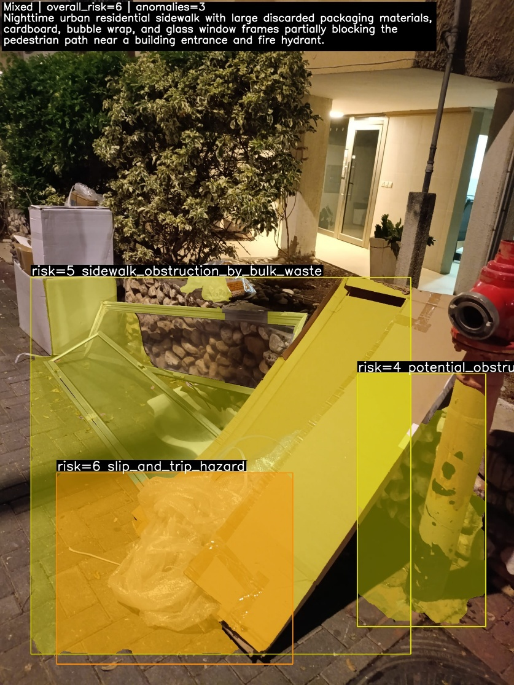
Supplementary image: crocodile under supervision
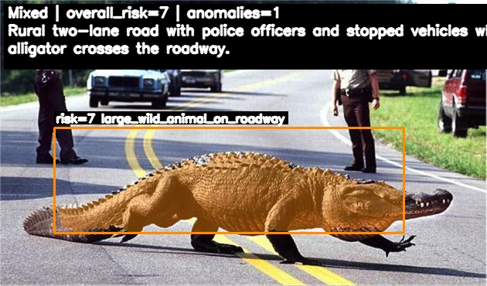
Supplementary image: unsupervised crocodile.
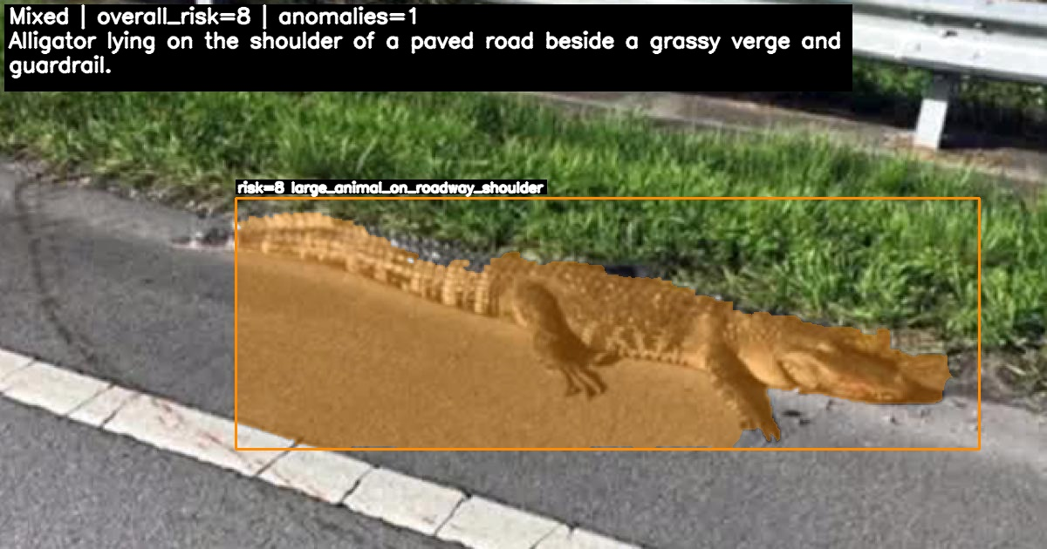
Supplementary image: Open manhole
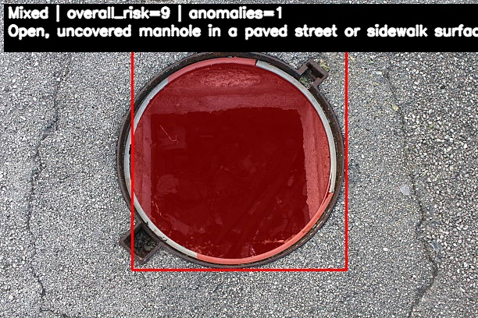
Supplementary image: open manhole with cones around
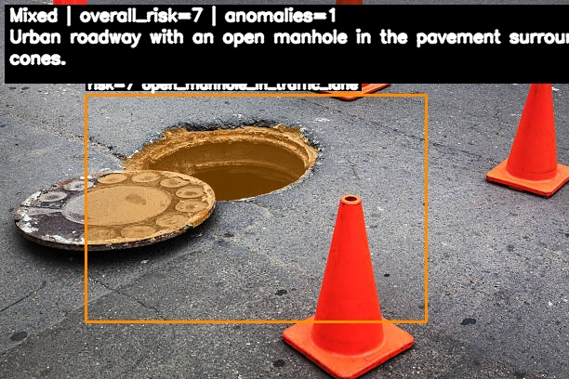
Supplementary image: Bronze status of a man in an open manhole
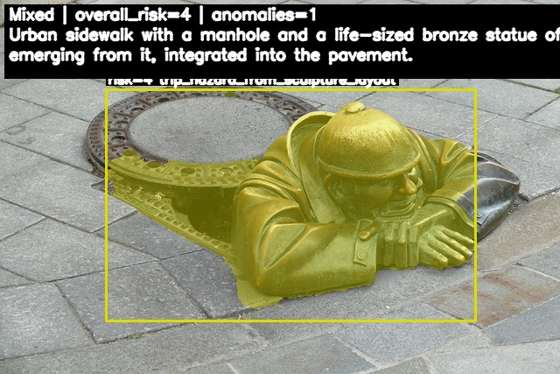
Supllementary image: an overturned truck on the road, this scene was ended in a car crash about 10 frames latter. 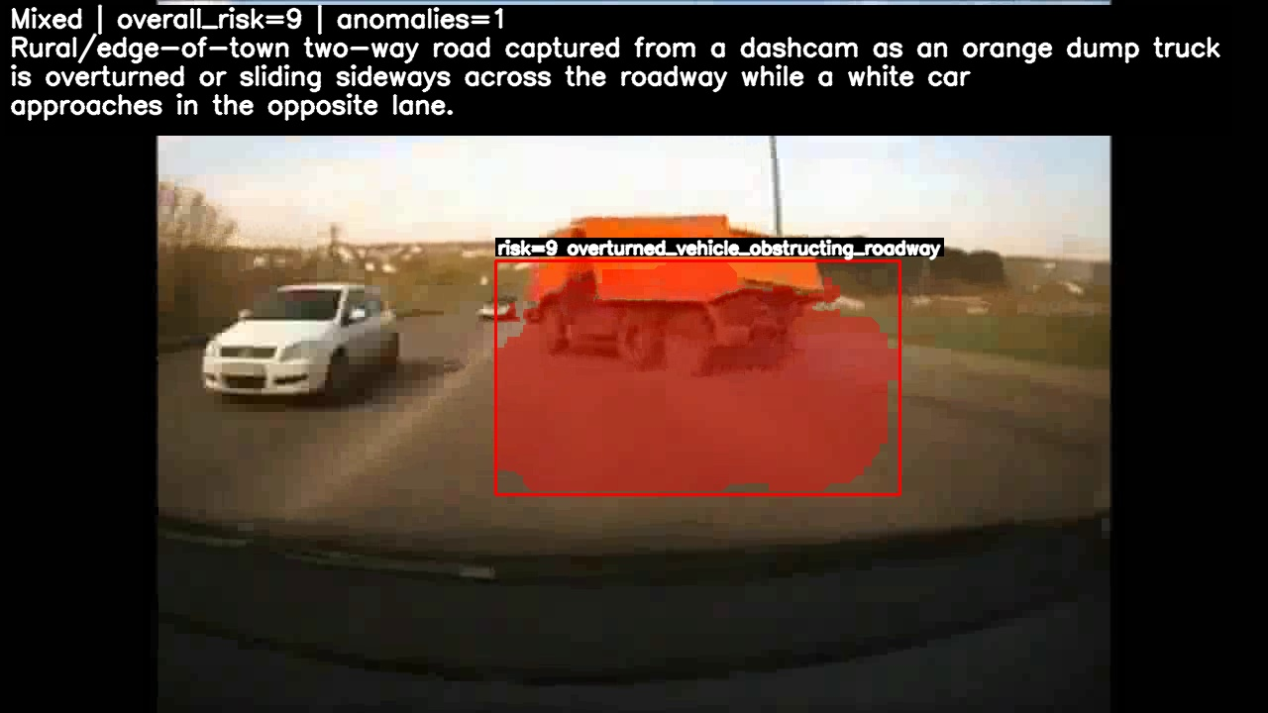
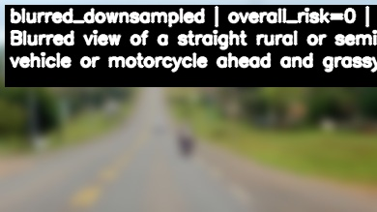
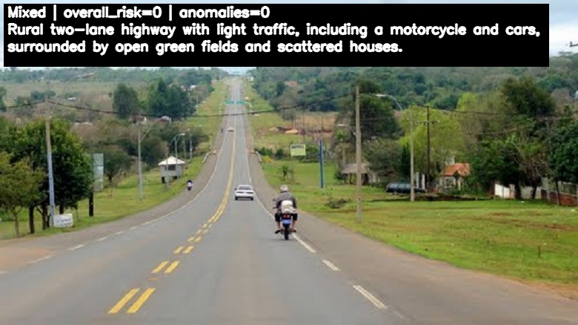
Supplementary image: Image down-sampling and blurring

Supplementary code: code used to down-sampling and blurring of images:
mkdir -p out_DSx0.5_blur5
for f in *.jpg; do
magick "$f" -filter Lanczos -resize 50% -blur 0x5 "out_DSx0.5_blur5/${f%.*}_DSx0.5_blur5.jpg"
done
Supplementary table: statistic test for before and after down-sampling and blurring.
Statistic | Value
N images (paired) | 111
Mean overall risk (Mixed) | 4.95
Mean overall risk (DSBlurred, aggregated) | 2.63
Mean Δ overall risk (DS - Mixed) | -2.32
95% CI for mean Δ overall risk | -2.821 to -1.809
Paired t-test p (overall risk) | 9.03E-15
Wilcoxon p (overall risk) | 1.43E-12
Pearson r (overall risk) | 6.08E-01
Pearson p | 1.42E-12
Spearman ρ (overall risk) | 6.37E-01
Spearman p | 5.59E-14
Mean #anomalies (Mixed) | 0.99
Mean #anomalies (DSBlurred, aggregated) | 0.48
Mean Δ #anomalies (DS - Mixed) | -0.51
95% CI for mean Δ #anomalies | -0.628 to -0.399
Paired t-test p (#anomalies) | 2.36E-14
Wilcoxon p (#anomalies) | 1.84E-11
Mean anomaly-type Jaccard | 0.27
% exact type match (Jaccard=1) | 27.03

Supplementary table reasoning of original image vs. down-sampled & blurred image, in yellow: common ground between two texts.
Image | Original | DS + blurred
1.png | Nighttime urban street with several cars and large yard waste and a plastic container obstructing part of the sidewalk near a crosswalk. | Blurred nighttime urban street with sidewalk, curbside vegetation, and a vehicle on the road.
2.png | Paved pedestrian sidewalk with a standing water puddle near a pole; no vehicles or people on the walkway. | Blurred view of a paved pedestrian surface with a puddle of water in the middle area.
3.png | Evening urban sidewalk with cars parked along the curb and bulky debris and bedding obstructing the pedestrian path. | Narrow street or driveway with closely parked vehicles, including a white car in the foreground and another vehicle ahead, leaving very limited passage space.
4.png | Evening urban sidewalk with a single pedestrian walking away from the camera beside a low stone wall and parked cars. | Urban sidewalk with a single pedestrian walking away from the camera alongside a building and a low wall.
5.png | Well-lit urban sidewalk at night next to a roadway, with streetlights, fencing, and vegetation; no people or vehicles close to the camera. | Nighttime view of a well-lit, empty paved sidewalk running alongside a road with streetlights, vegetation, and a wall or fence.

